**The Right Teacher For Every Child**

State of Teachers, Teaching and Teacher Education Report for India 2023

**Media Coverage**

1. **Maharashtra Times, 19-01-24**

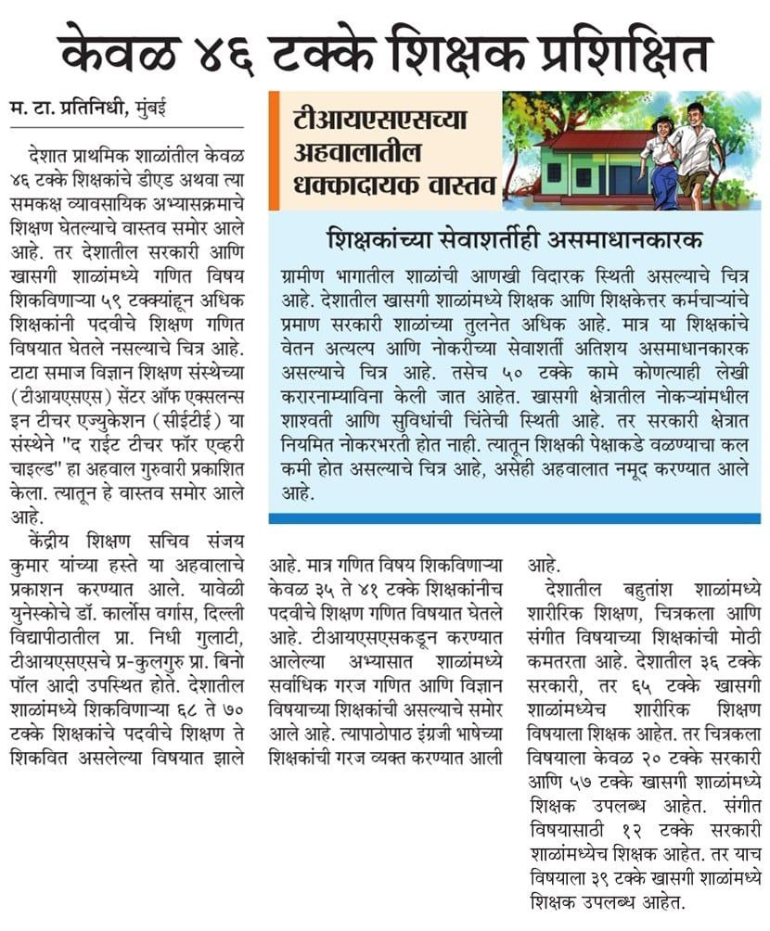

**2. FPJ, 19-01-24**

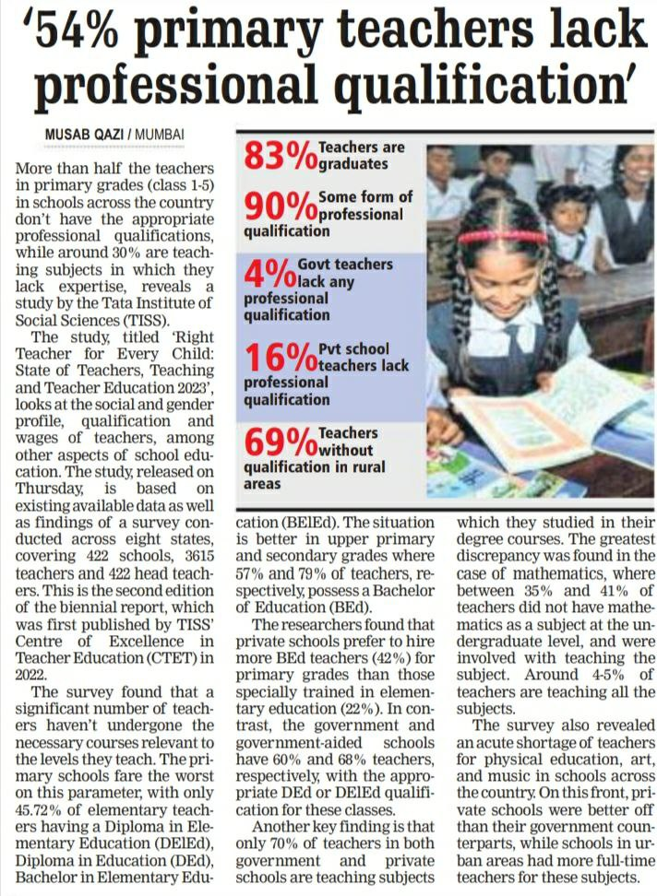 [**https://www.freepressjournal.in/mumbai/54-primary-school-teachers-lack-professional-qualification-tiss-survey-report**](https://www.freepressjournal.in/mumbai/54-primary-school-teachers-lack-professional-qualification-tiss-survey-report)

**3. Indian Express, 19-01-24** [**https://indianexpress.com/article/education/41-percent-maths-teachers-did-not-study-maths-at-ug-level-tiss-report-9116649/**](https://indianexpress.com/article/education/41-percent-maths-teachers-did-not-study-maths-at-ug-level-tiss-report-9116649/)

**22-01-24**

[**https://indianexpress.com/article/explained/sottter-tiss-teacher-report-9118698/**](https://indianexpress.com/article/explained/sottter-tiss-teacher-report-9118698/)

**4. Pune Times Mirror, 19-01-24**

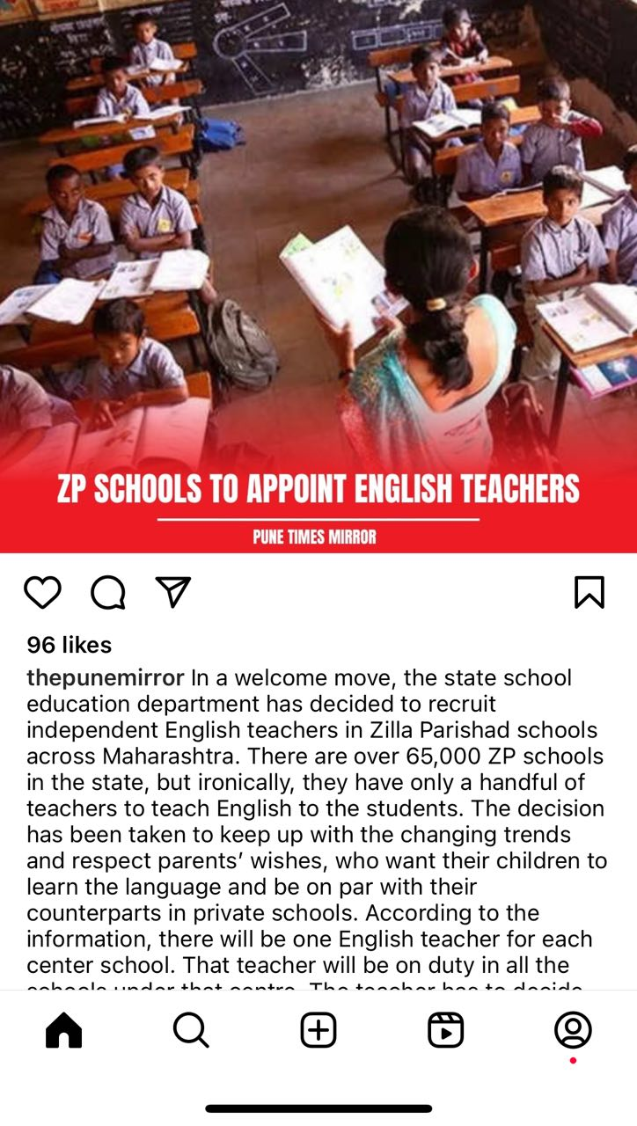 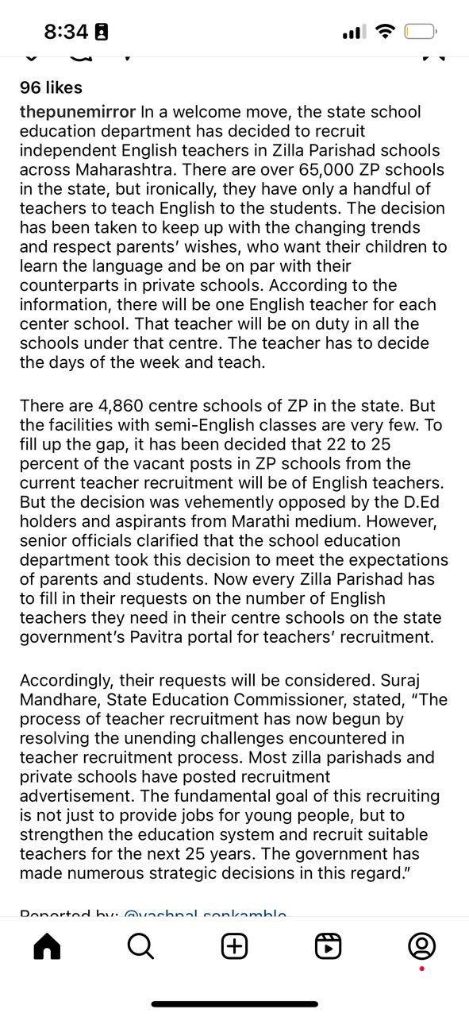

**5. Hindustan Times, Maharashtra, 19-01-24**

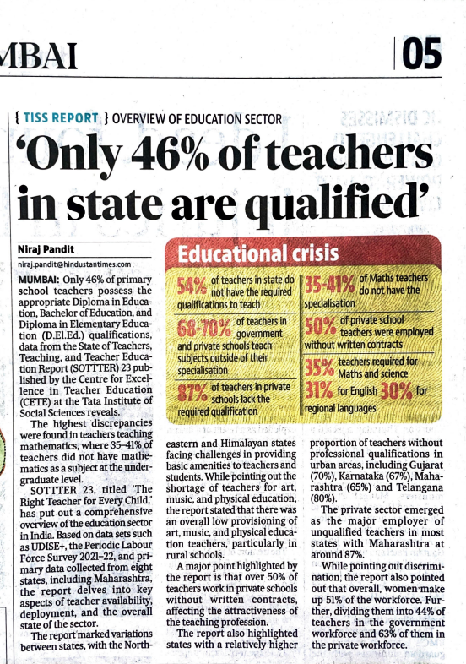

**6. Times of India, Mumbai, 19-01-24**

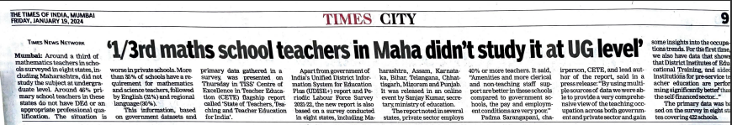

[**https://timesofindia.indiatimes.com/education/news/tiss-report-reveals-41-maths-teachers-lack-expertise-in-the-subject/amp_articleshow/106983652.cms**](https://timesofindia.indiatimes.com/education/news/tiss-report-reveals-41-maths-teachers-lack-expertise-in-the-subject/amp_articleshow/106983652.cms)

**7. Brainfeed Magazine, 20-01-2024**

[**https://brainfeedmagazine.com/tiss-report-represented-disparities-in-the-recruitment-of-school-teachers/**](https://brainfeedmagazine.com/tiss-report-represented-disparities-in-the-recruitment-of-school-teachers/)

**8. The Hindu, Mumbai, 19-02-24**

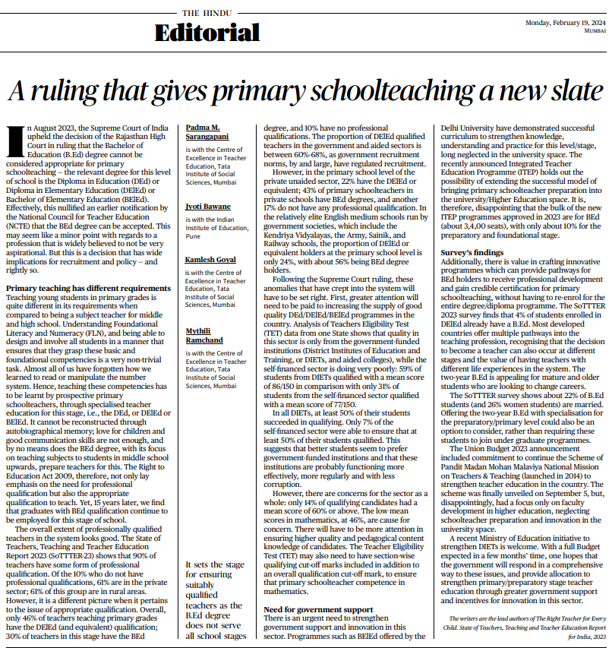

[**https://www.thehindu.com/opinion/lead/a-ruling-that-gives-primary-schoolteaching-a-new-slate/article67861303.ece**](https://www.thehindu.com/opinion/lead/a-ruling-that-gives-primary-schoolteaching-a-new-slate/article67861303.ece)

**9. Indian Express, Bangalore, 29-02-24**

[**https://indianexpress.com/article/explained/sottter-tiss-teacher-report-9118698/**](https://indianexpress.com/article/explained/sottter-tiss-teacher-report-9118698/)

**10. Indian Express, Bangalore, 29-02-24**

[**https://indianexpress.com/article/opinion/columns/open-book-exams-a-step-towards-learning-without-burden-for-students-9184811/**](https://indianexpress.com/article/opinion/columns/open-book-exams-a-step-towards-learning-without-burden-for-students-9184811/)