FIELDWORK SUMMARY
TEMPLATE

DIET NAME: District Institute of Education & Training Baruasagar, Jhansi

DIVISION: Jhansi Division

FIELD TEAM: Paavana Barman (Research Assistant),Vaishnavi & Khushal
DATES OF VISIT: 6th-10th December, 2022 DURATION: 5 days

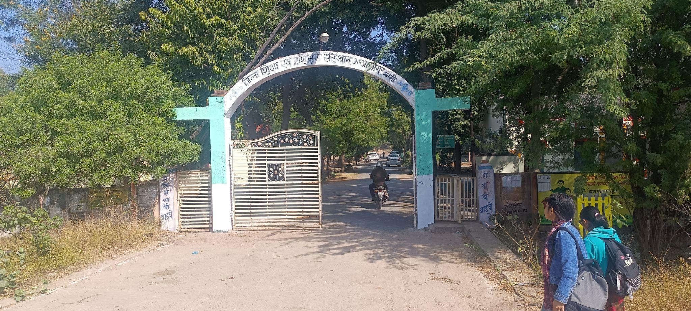

The DIET in Jhansi was located around 20 kms away from the main town area. It was established in the year 1989. As its established at the outskirts the physical space is maximum with a huge playground. The BRC is also located within it’s premises along with a KGBV(Kasturba Gandhi Awasi Balika Vidyalaya) right at the backyard of it. Besides this a new building is recently constructed as seminar hall, the foundation for a hostel is laid off. Since the BRC falls within it’s vicinity the plans for development of this institution gets approved and in future too it’s in the vision to bring in within the centre of excellence.
- OBSERVATIONS DIETS

- DIET Infrastructure (Staffroom, Classroom Labs, Library, Sports facilities, ICT Lab, SUPW Room)
The DIET in Jhansi had 14 classrooms, 1 computer lab with 45 working computers, and there was a fairly large playground which was occupied with major sports activities like football, cricket. There seemed to be an active sports culture present at this DIET, but there seemed to be a lack in functioning libraries at the DIET’s. Even though there was a room dedicated to books it didn't seem to be consistent. The classroom within the DIET’s also lacked in proper seating facilities, it was noted that there weren't any desks or benches for students to sit and attend classes properly. They usually sat on rugs or mats. Besides this the lecturers also mentioned how there aren't any proper staff rooms or ICT room with projectors present. Guest rooms were also lacking. There were hostels but only for boys, there is a need to implement girls hostel. The washrooms weren't in a good state, it wasn't very well maintained and also appeared to be very unhygienic. The Principal’s Office looked spacious enough, but the room which the teachers were settled in looked very unorganized and confined. This also seemed to impact on their work levels. There was a new seminar hall built at the backyard, the entire DIET was mainly divided into two prime buildings a two storey academic block which had all the classrooms and a two storey administrative block which included the Principal's office, library, a science lab, computer room and a common room for teachers.
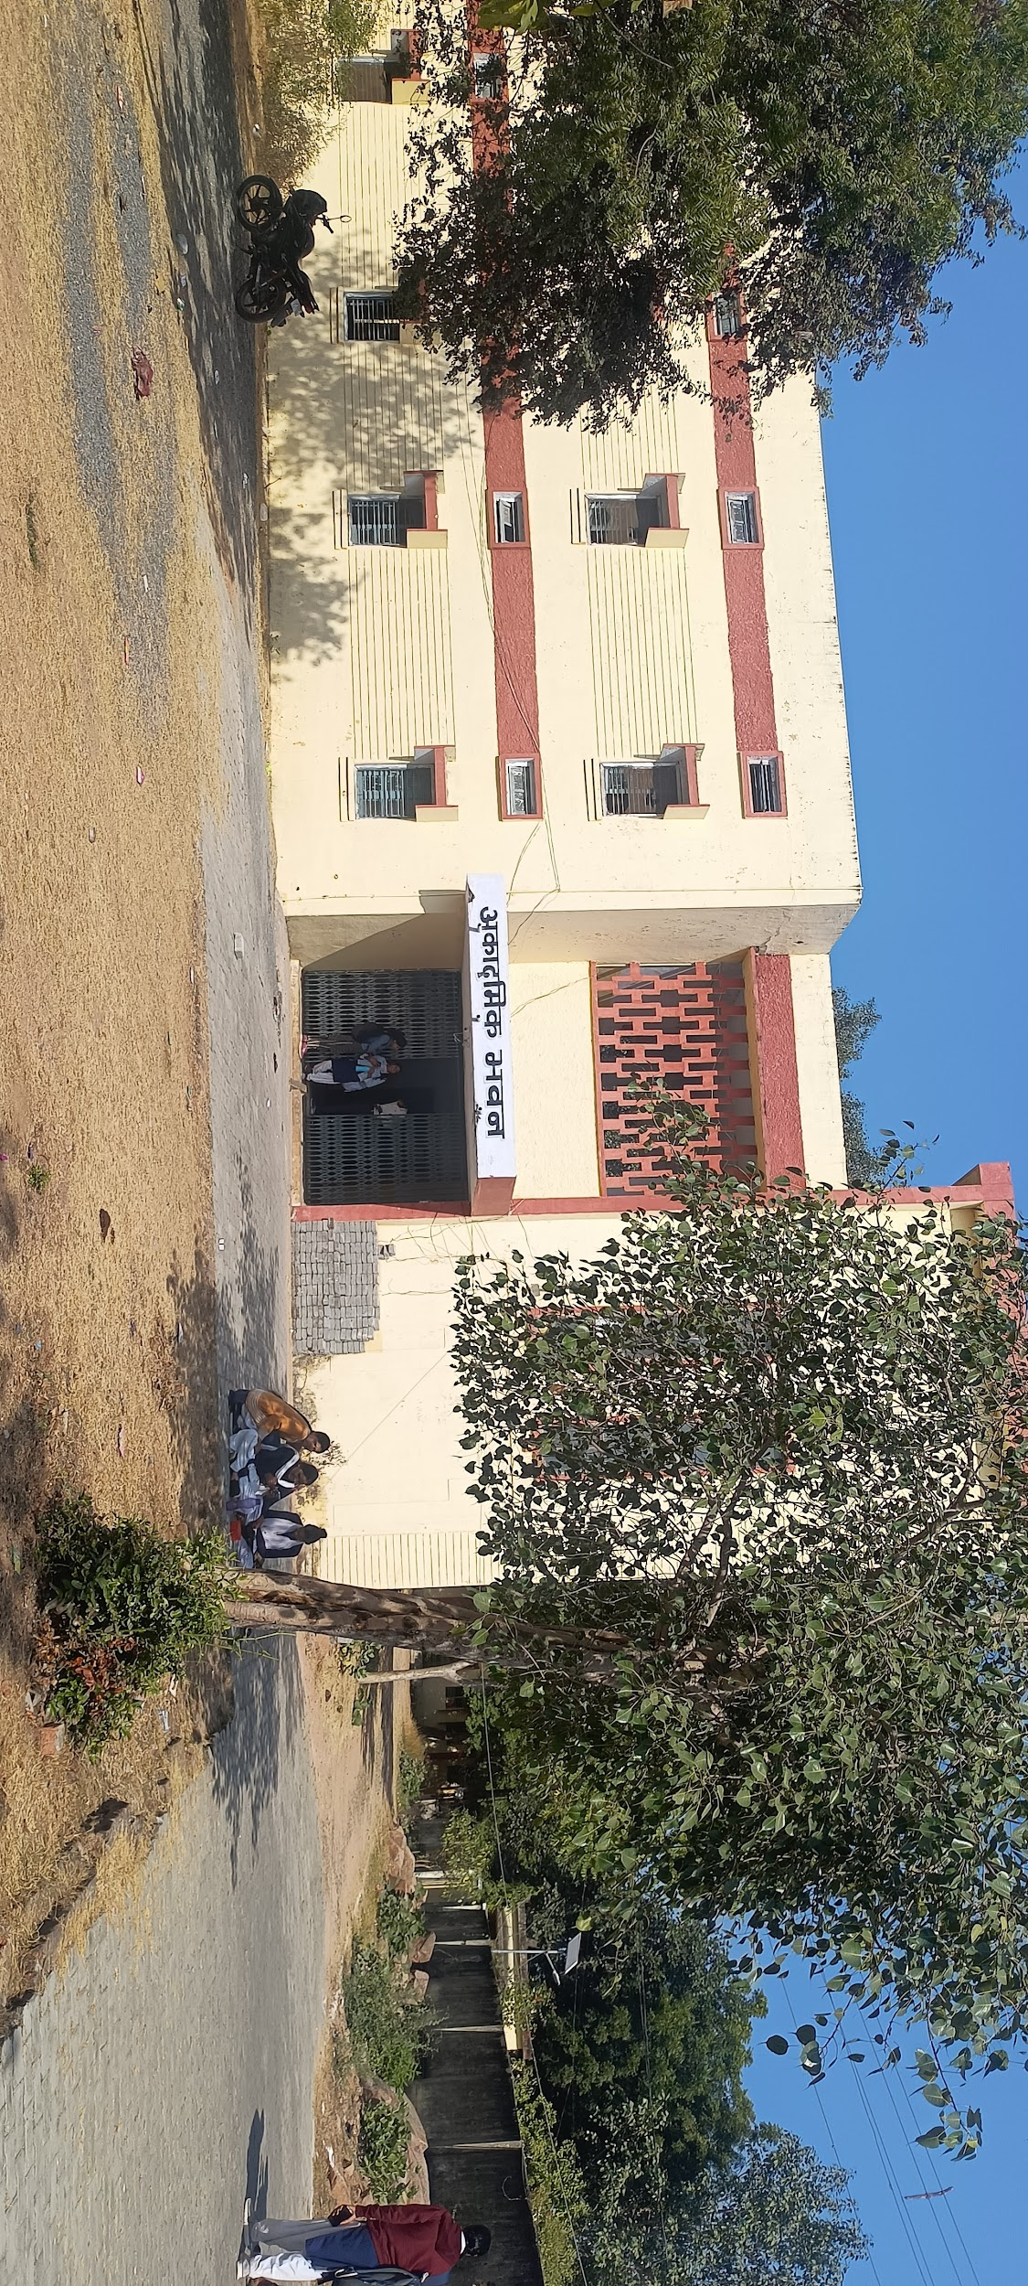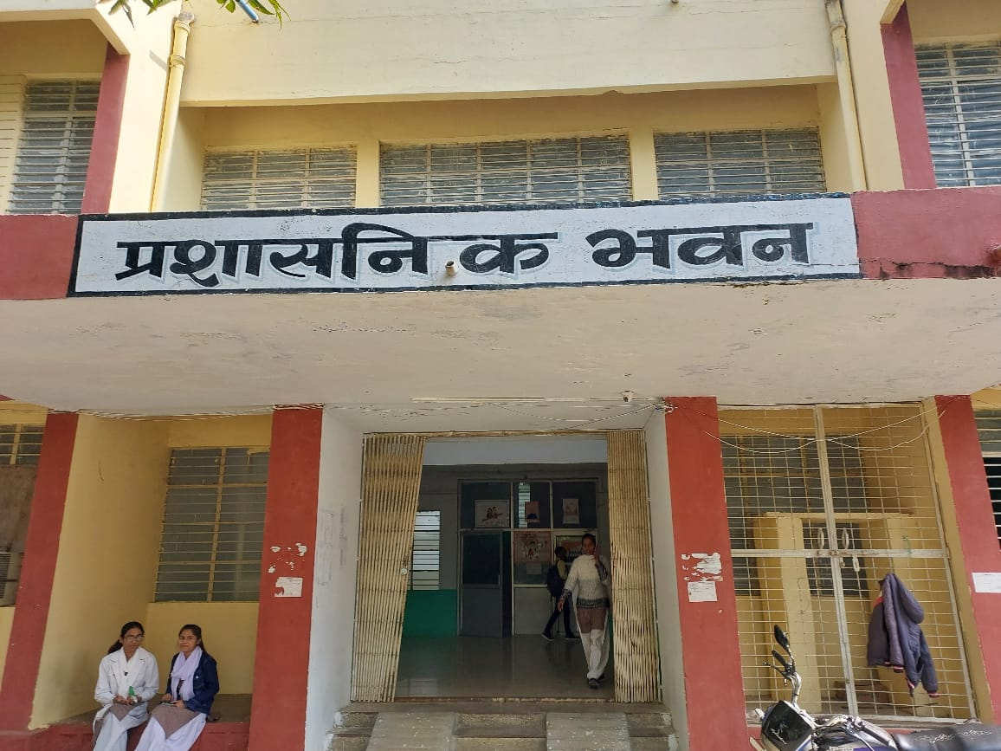

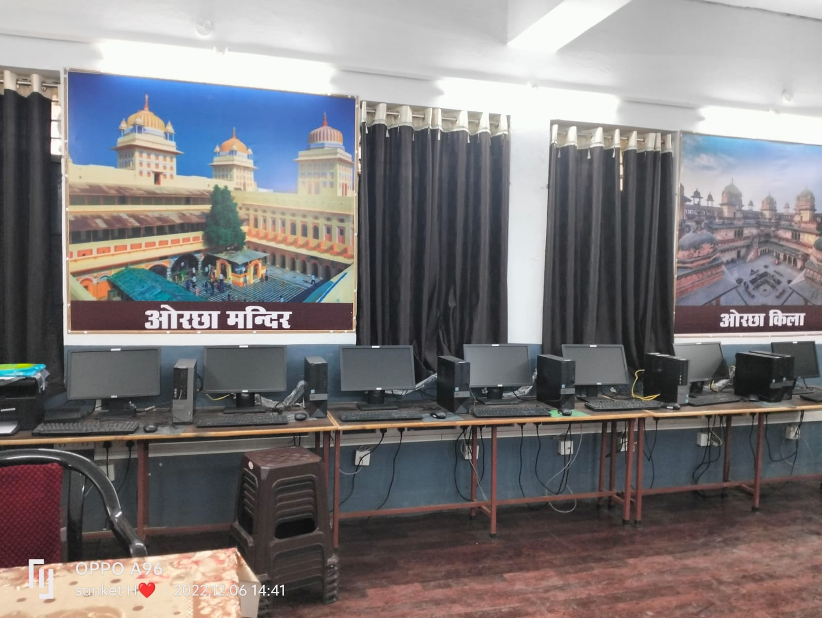
Computer Room

- Teaching Learning Resources ( Books, posters, displays)
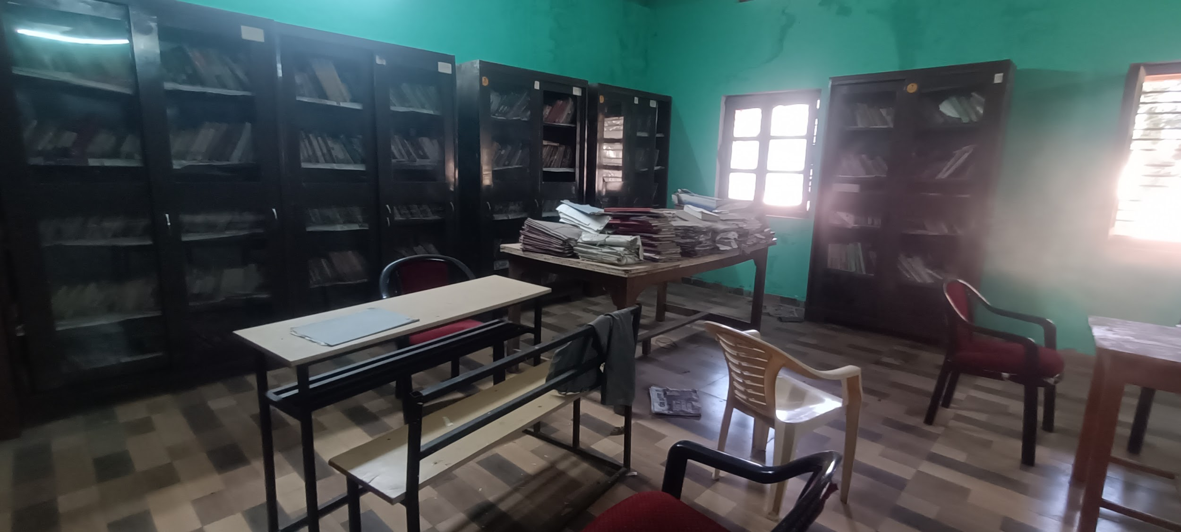The library was not in active mode, and it was also away from the main academic building. There was no such register to maintain the records. The books were quite old and were not used by the students as well as the lecturer for their academic and overall development. The TLMs available and used were very few and outdated; most of them were posters, textbooks, charts, and maps, but there were no audio materials or audiovisual mediums (powerpoint slides, overhead projectors) observed.
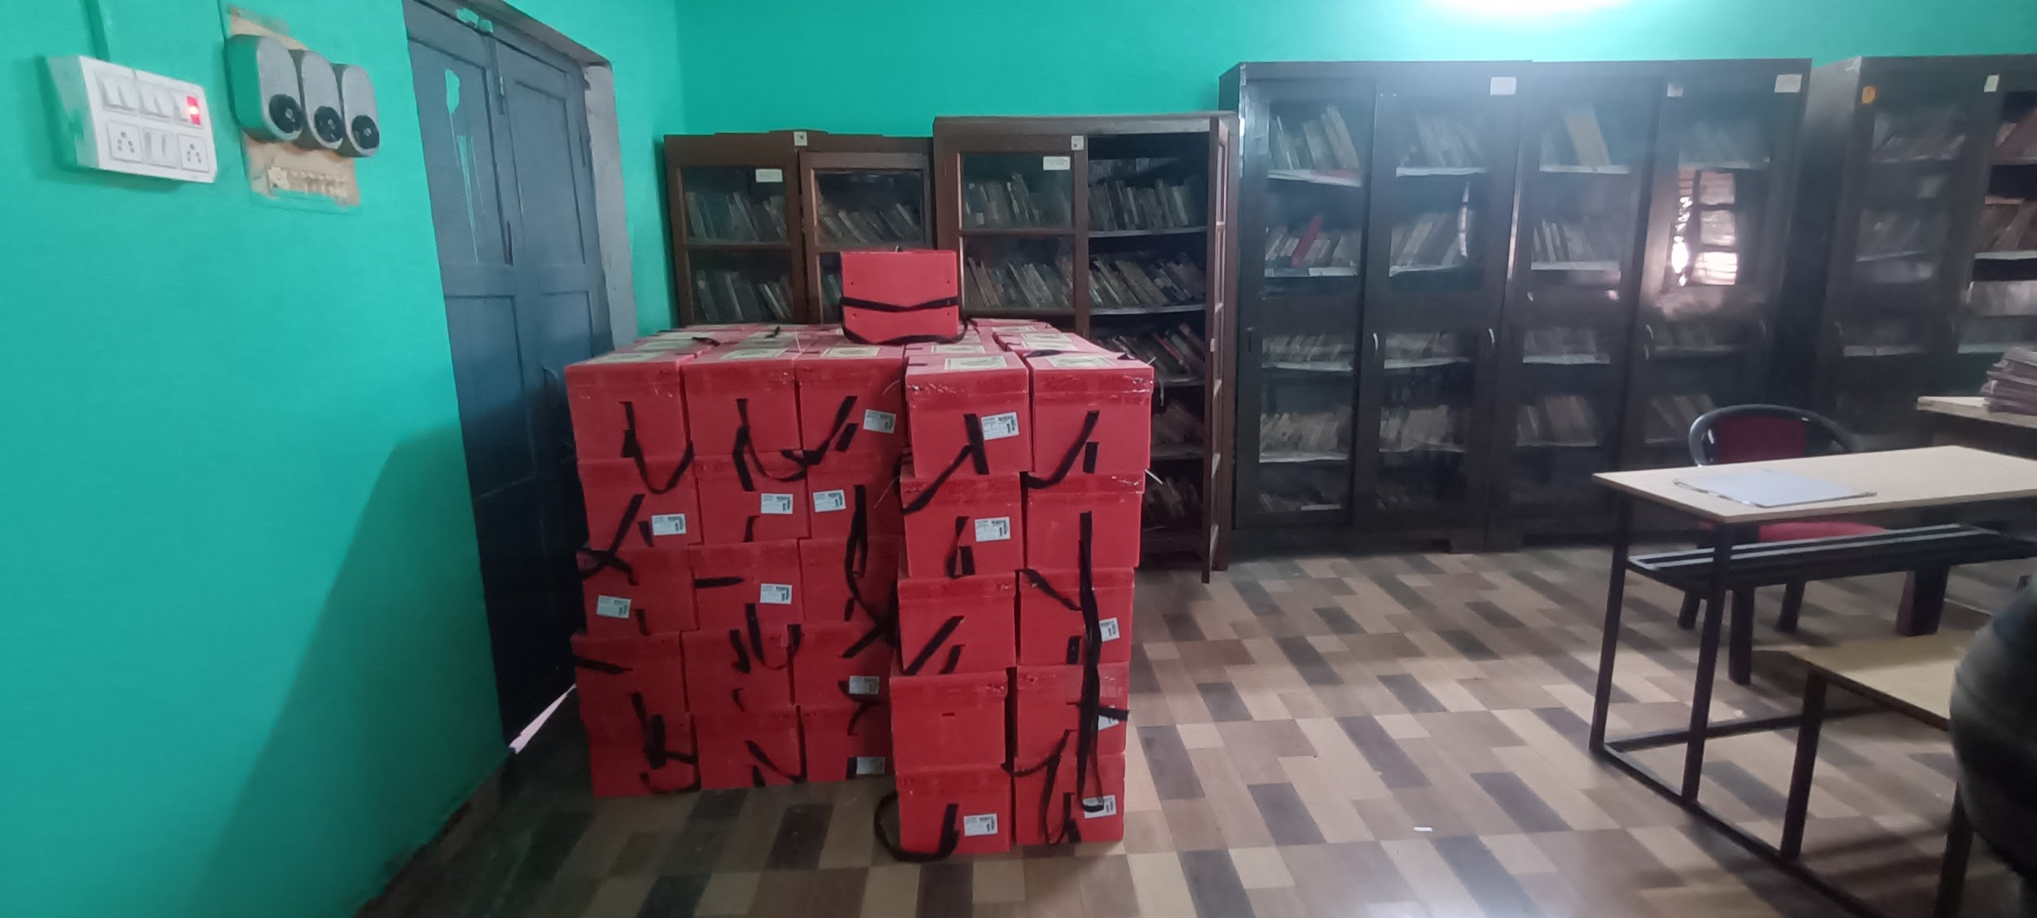

- D.El.Ed Class Observation (Pedagogy, Interactions etc.)

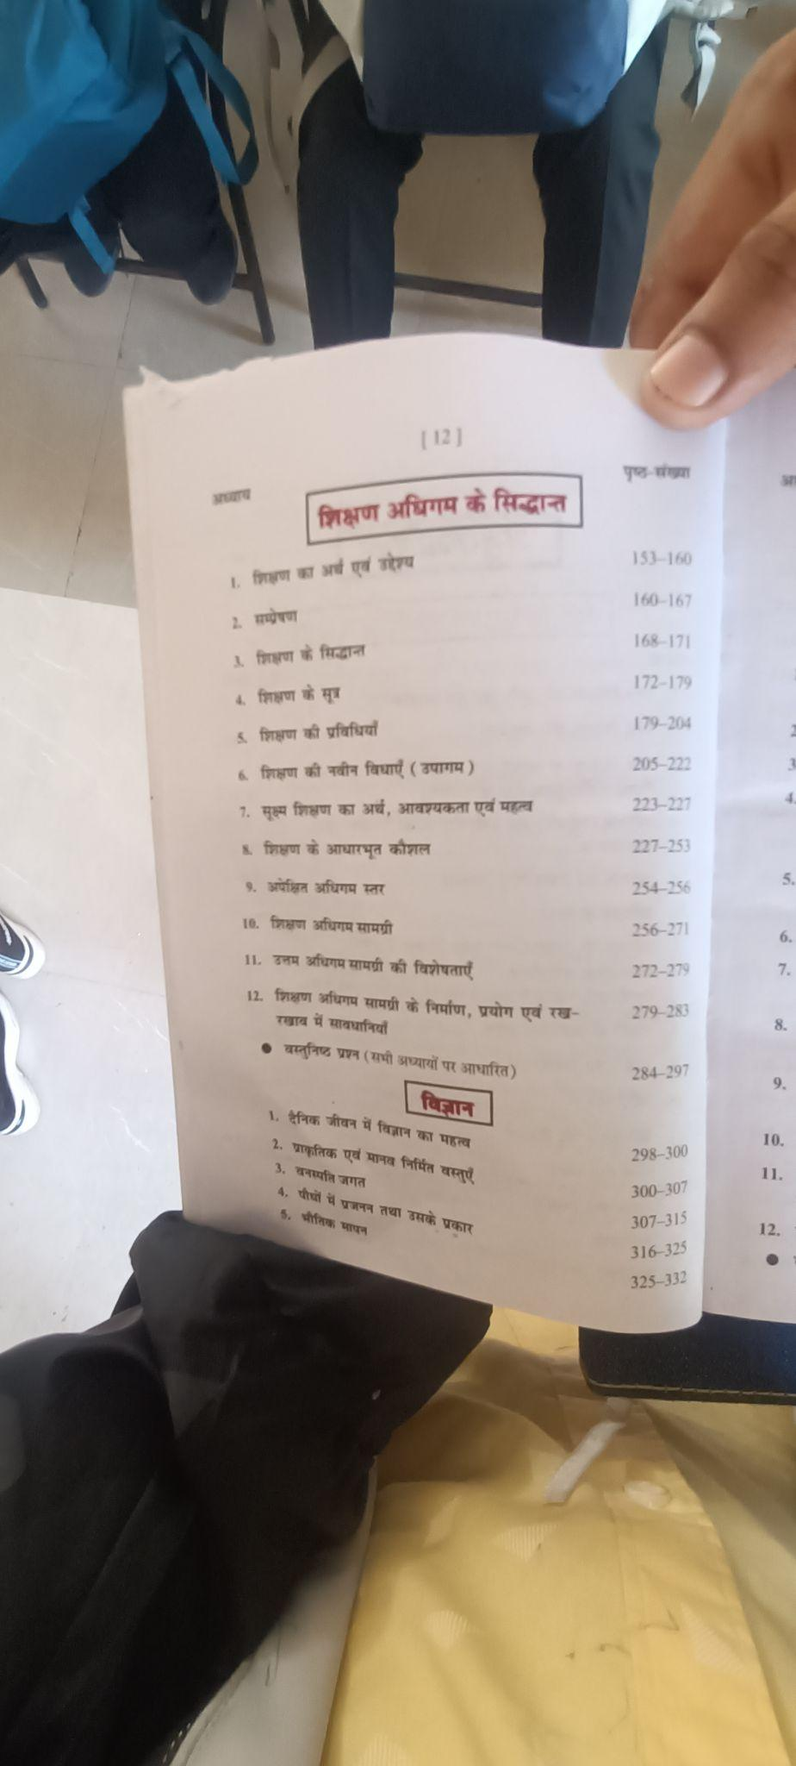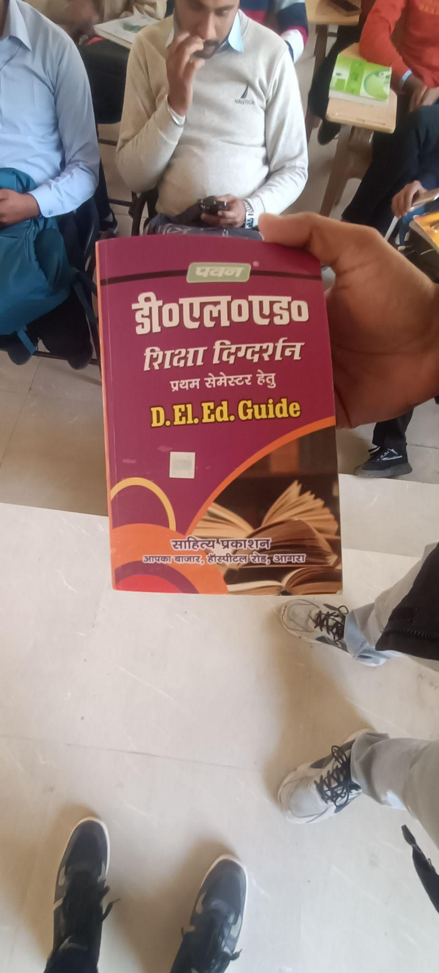

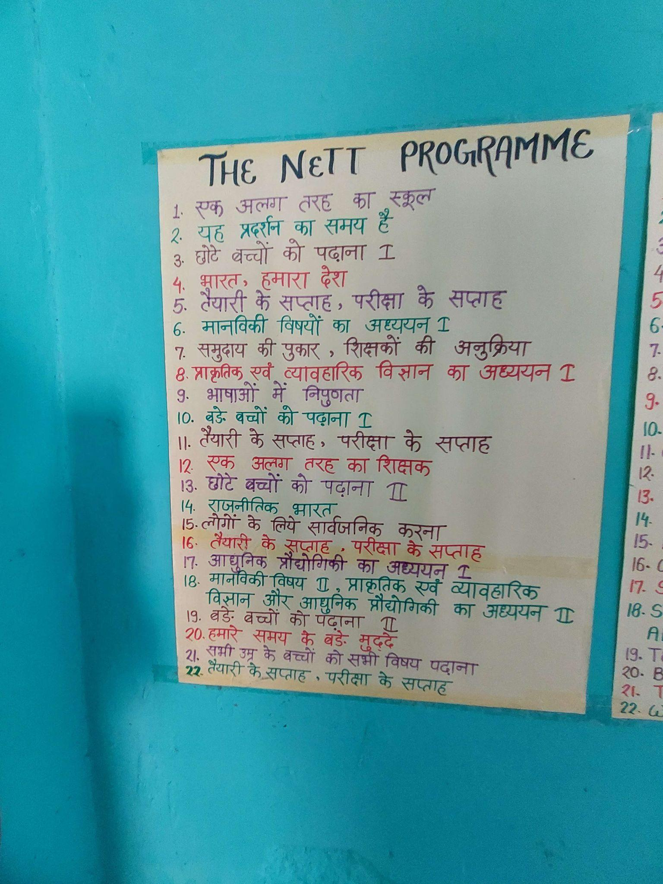
Displays
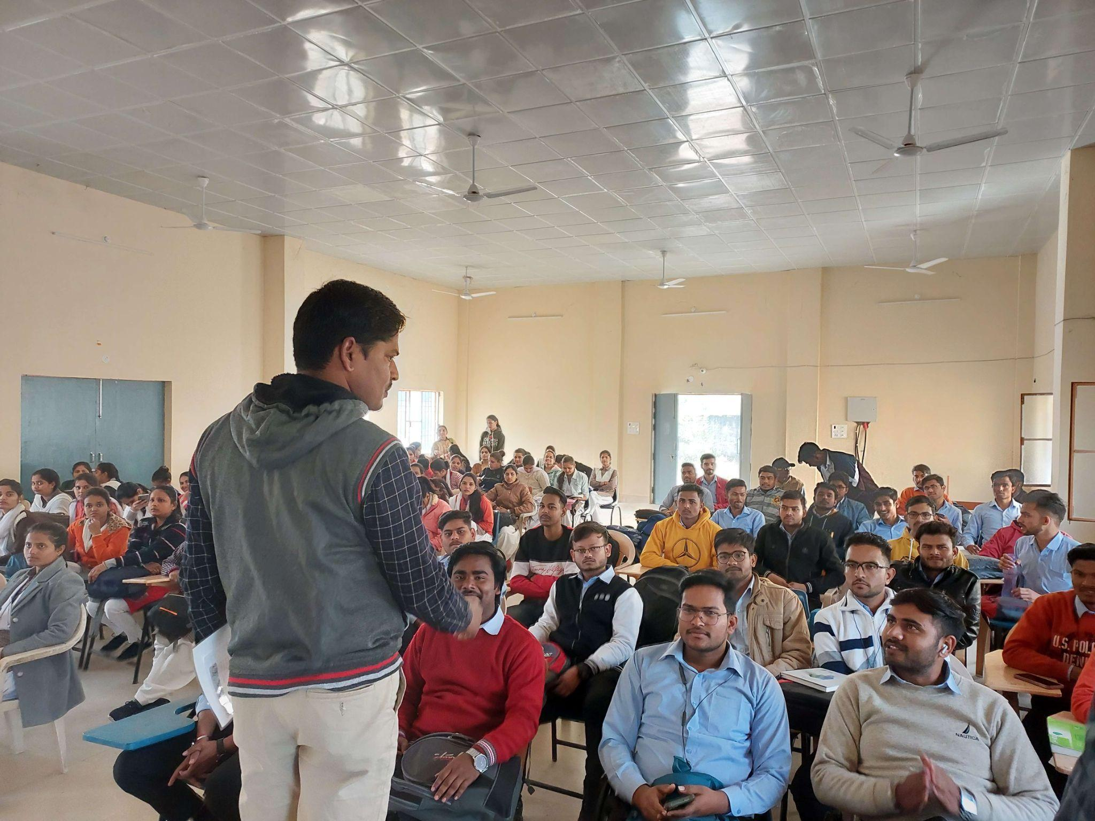
Students and teachers interactions during session
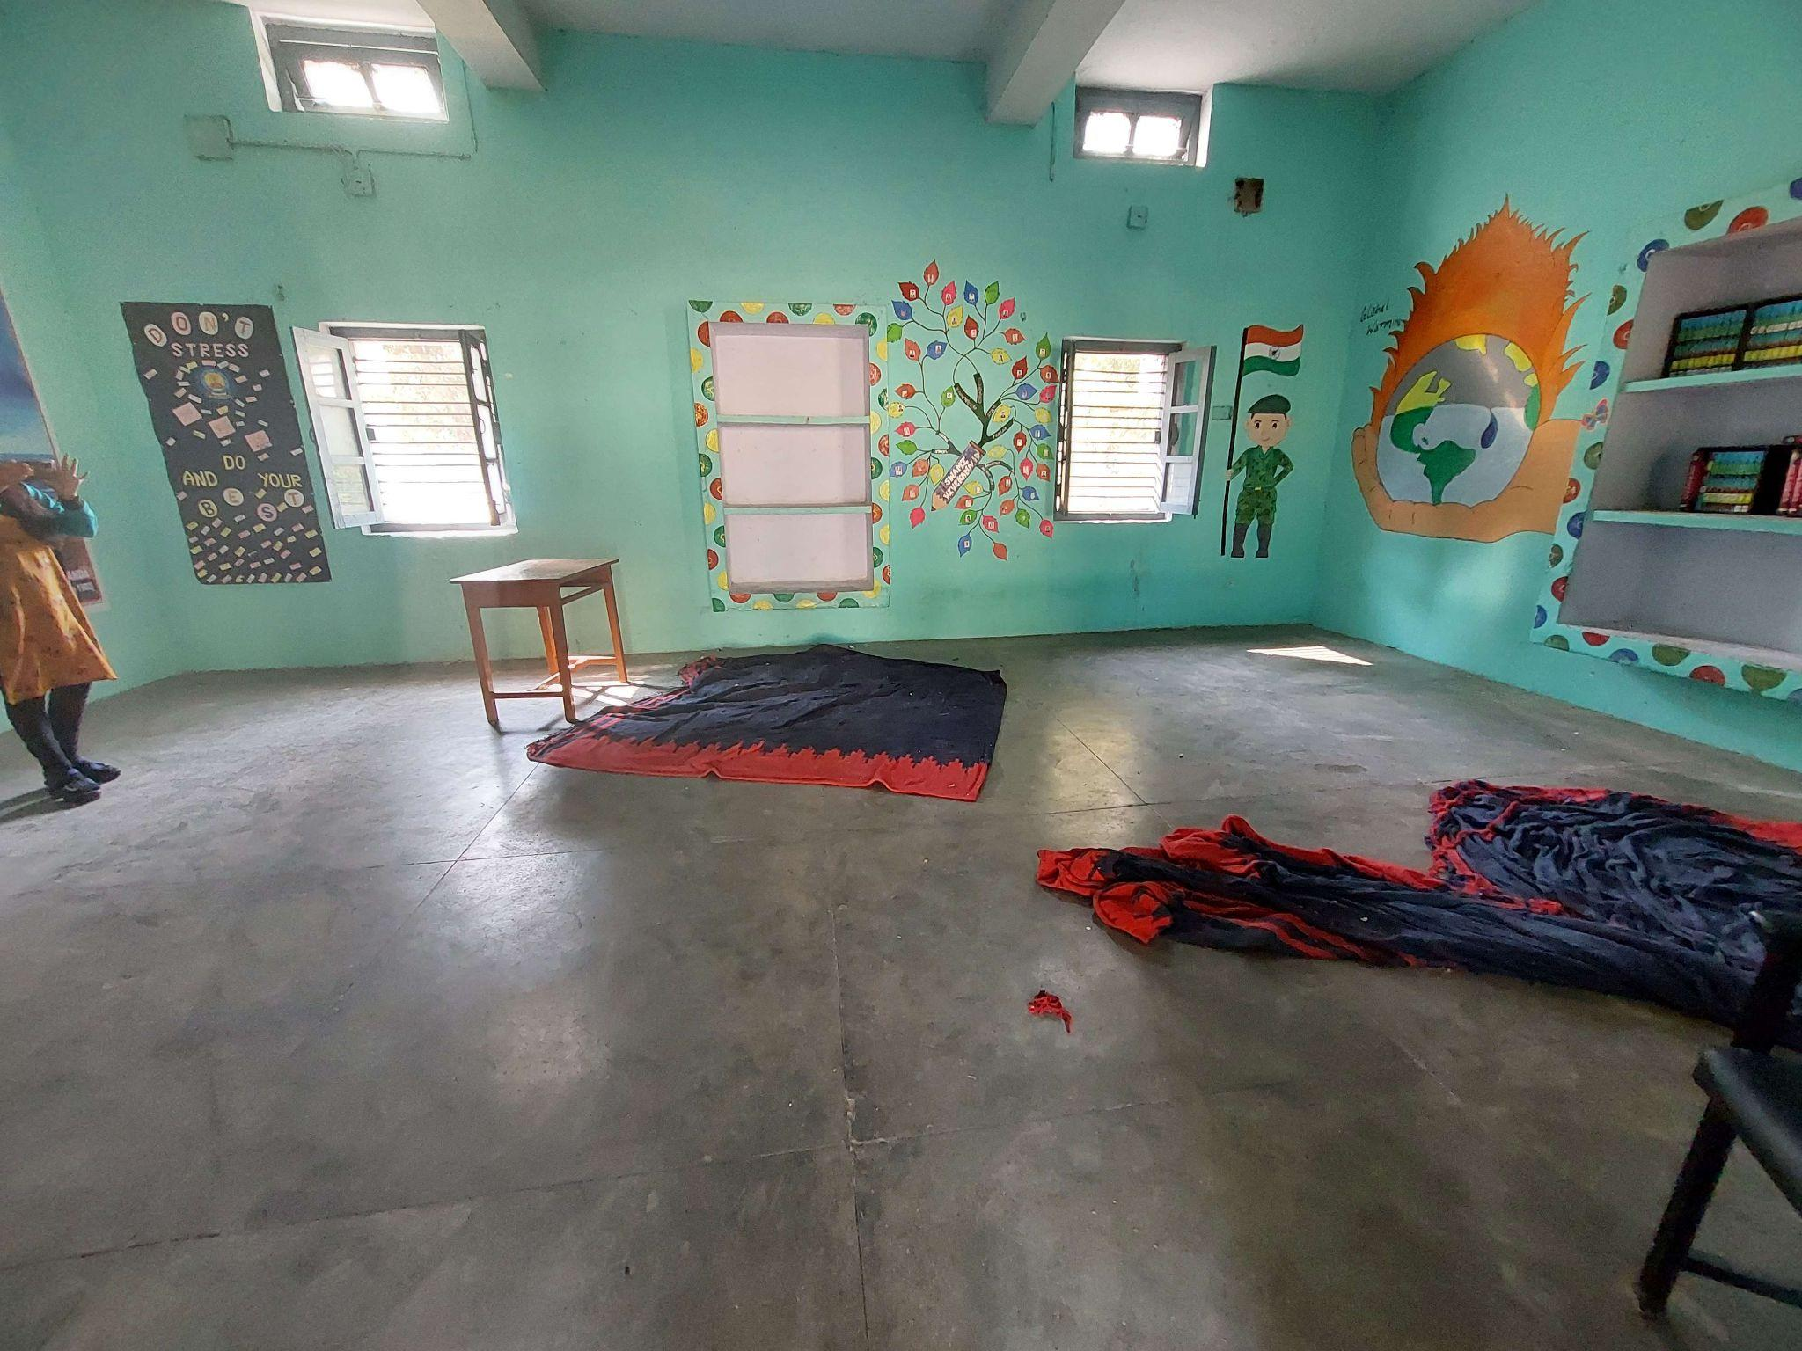
Classroom

There were two D.El.Ed classes observed, one was science and the other was Maths. In the Math session a student -teacher was asked to take the class. This was a micro-teaching skill which was observed, the student-teacher was having more of a Q and A session with the other student on different concepts of triangle like SAS(Side Angle Side). Black-board teaching drawing of figures, the students seemed to be active during the session. The class also seemed to be distracted at times as there were too many students present as it was being held at the newly constructed seminar room. The teacher educators mainly seem to start the session with a related concept connecting previous with present knowledge and they were following the first step of Introduction under macro teaching. At the start it seemed a bit active as the teachers were asking questions but towards the end it got a bit distracting. We also noted that there was more focus on the teachers to present the best way of teaching since we were observing and also asking questions repeatedly to only a particular section of students.

- D.El Ed Student-teacher Interactions ( Aspirations, goals, feedback on the programme etc.)

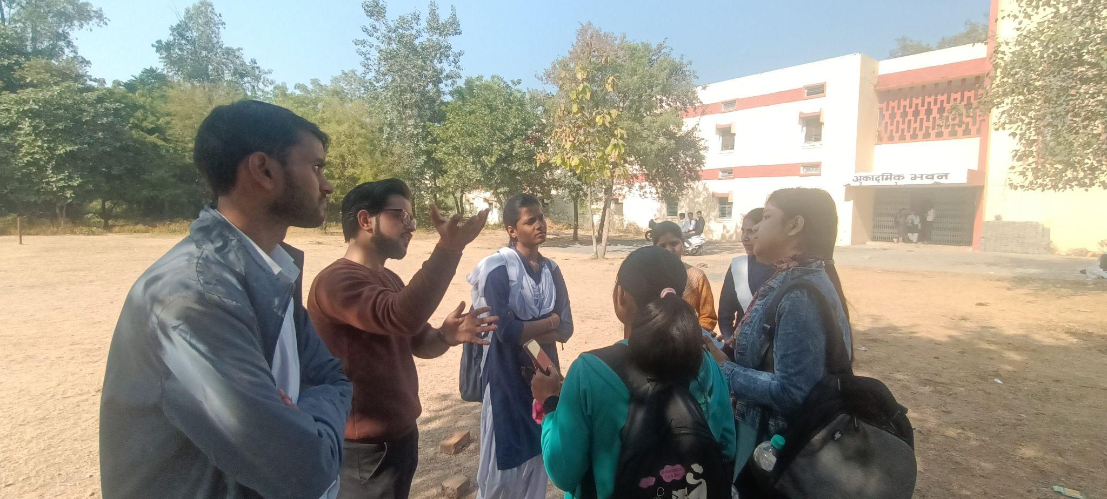

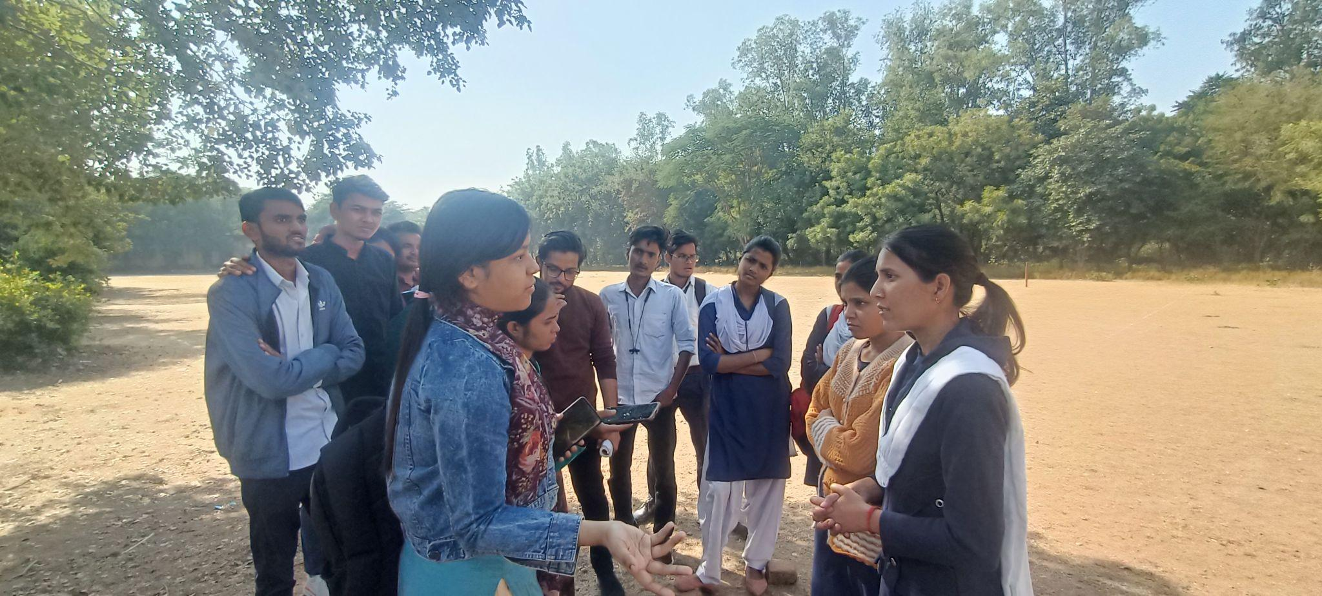

2nd year student interactions

There were two informal interactions held between the student-teachers of both first and second year. In both these two groups a lot of active involvement was noted, the main response to being a teacher was to bring change to a very defective system from the grassroots. Feedback on the programme was mainly given on the 30 day working internship programme this they referred to as the main essence of it where in they actually got to apply what they learnt in practice.They also mentioned that not all taught especially the theories within psychology sometimes becomes too western in their context and they don’t see an alignment, other than that the teaching principles like known to unknown, general to specific was very useful.It was also bought up that during the 30 day internship program sometimes these student teachers are made to extra administrative work and focus diverts from the academic and macro-teaching aspect.

- Workshops / Inservice Training Observed -
There weren't any workshops or internship programmes observed.

- NGOs Presence -
The NGO Humana People to People India have been working consistently within the field of teacher training. Some projects launched within Jhansi District on teacher trainees NeTT(Necessary Teacher Training Programme) which has a successful graduates of 3476 trainee teachers. Next is the Kadam Programme which bolsters the foundational learning skills of children through targeting competencies in four subject areas of English, Maths, Hindi and Environmental Science. At present this NGO is trying to build up the ICT aspect within the Jhansi DIET. It has provided around 50 computers to the Institute.

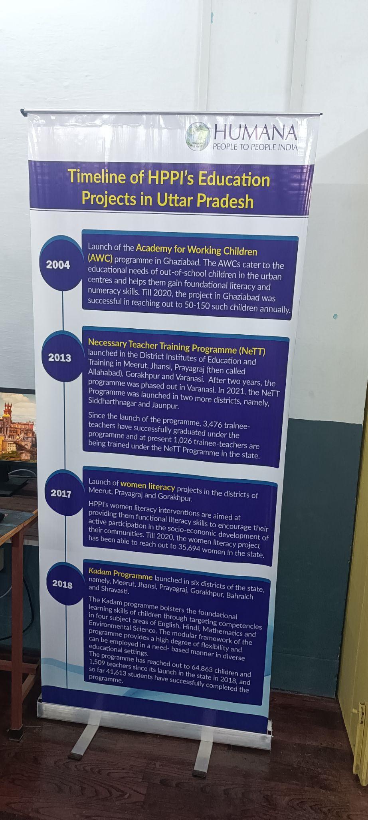

- Other Observations (Co-curricular activities, Assembly etc.)
On the first day of our visit, we observed yoga training for the in-service in the DIET, which was interesting because the instructor was from their teaching community. The participants were from all blocks of the district. We also saw the assembly in the morning around 10 a.m., and morning prayer, thoughts of the day, history related to that day, the national anthem, and instructions for that day were part of the assembly. The arrangement was based on gender and class; the lecturer was observing the pre-service student teacher and also inculcating skills like management, leadership, and communication. 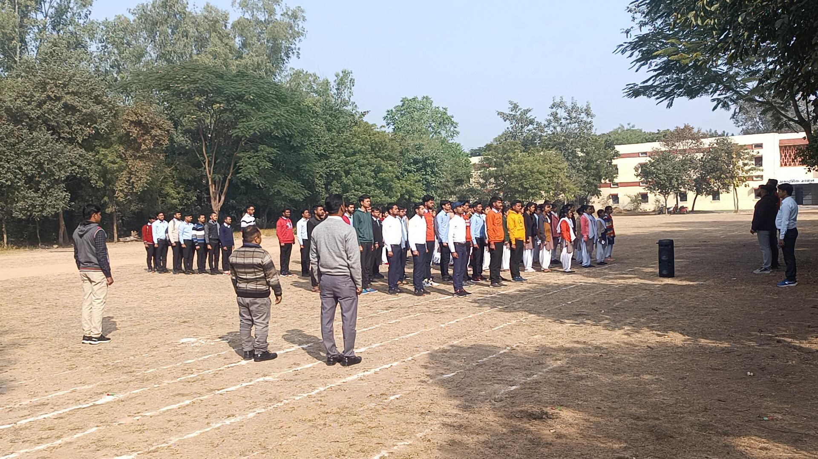

Assembly

B. INTERVIEW SUMMARY ( Principal / Vice Principal / Sr Lecturer / Junior Lecturer)

Interviewee -- Principal / Vice Principal / Sr Lecturer / Junior Lecturer
Principal-
Role-The principal has six years of experience and therefore has to manage the work of DIET in the absence of the senior lecturer.
The lecturers support the clerical staff and the principal in their respective work to overcome the insufficient staff. The same issue has arisen with 4th class staff; there is a shortage of librarians, lab assistants, peons, and other personnel. Lecturers had extra baggage with supportive supervision work and the administrative work assigned by the senior officers and principal to overcome the shortage of staff.

- Institutional Identity and Focus: [Understand the DIETs identity through the focus areas of work, goals, objectives and its ability and capacity to function as an independent and autonomous institute leveraging state and national schemes]
The main objective is to provide pre-service training to the student teachers. This two year programme provides students with best capacity building within the profession. Our main objective is to focus on pedagogy- How to know the way children learn? To obtain the NIPUN lakshya is another objective, to reduce the learning gaps during COVID.Execution/ Deliverance of all sorts of policies at the academic level to the teachers to be a consistent supervisory support. To help teachers face challenges at the grassroots level. How will you teach students in a class of 100 students or to manage a school with no clerical staff and only 1 or 2 teachers. In post-service we try to upgrade the teachers with the new techniques in the teaching learning process. We look into especially those enrollment rates, attendance rate, motivating/facilitation of teachers to bring children back to school,and work towards 100% attendance. DIET’s are not functioning as an autonomous body; everything is planned from the upper level at the SCERT.

- Systemic location and relation to other institutions: [Understand the DIETs positioning vis-à-vis the state education system, including SCERT and BRCs-CRCs.]
Initially DIETs were engaged in the capacity building but the type of programmes it conducted was decided at the states level, mostly by the SCERT in view of which most of the programmes it conducts were not necessarily need based and as per the requirement of teachers. Because of this, over a period of time, DIETs and its programme lost their significance, and capacity building was left to the Block Resource Centers, which have now become the main agency for imparting capacity building programs, earlier under the aegis of DPEP, Sarva Shiksha Abhiyan, and now also under the newly integrated Samagra Shiksha (Abhiyan) programme.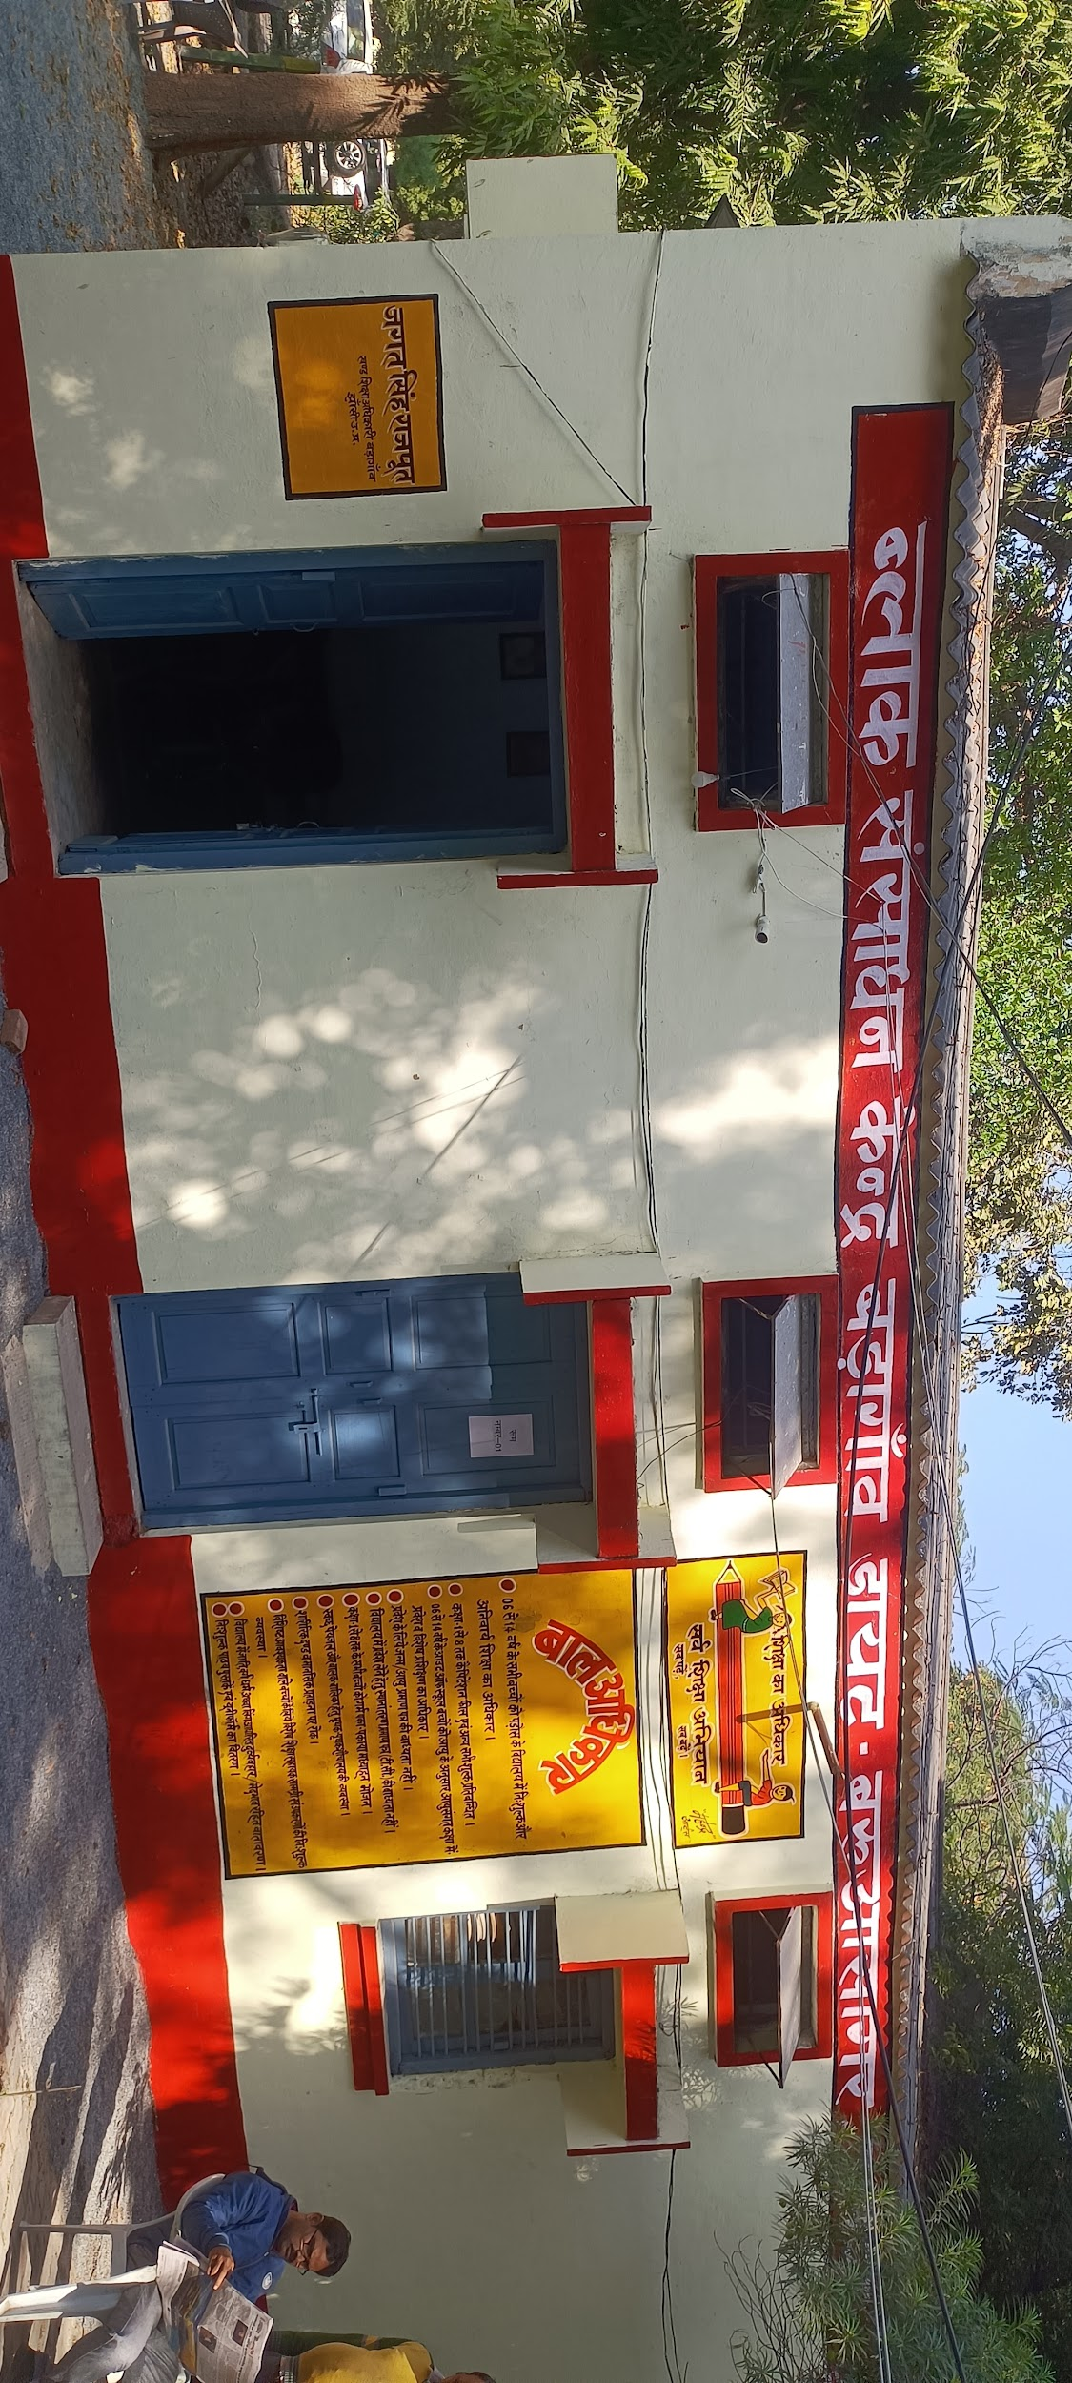

Geography Lecturer- He has been a lecturer in geography since the past three years. He acts as supportive mentor for the schools assigned to his block.His other external academic role besides the DIET includes being an expert mentor for the competitive exams of IAS and PCS.
- Institutional Identity and Focus: [Understand the DIETs identity through the focus areas of work, goals, objectives and its ability and capacity to function as an independent and autonomous institute leveraging state and national schemes]
The main objective of the DIET before 2015 there pre-service they were given the designation as basic teacher, but after 2015 it has bec
The In-service teachers are given training which are basically refresher courses given on new teaching techniques. Time table is provided by SCERT and they are given training on it. The NIPUN Bharat Mission especially focuses on excelling the Foundational Literacy and numeracy among primary school children. Along with it at present more focus is given on training them in making TLM’s.
In alignment with goals of DIET with NEP 2020 there isn't much mention about DELED, maybe in future there can be the possibility of alignment of 4-year B.ed course within the DIET’s.
The goal of DIET is to move the pedagogy towards a more activity based learning which according to me is also the ultimate aim of the policies at the national level, and in this sense I see the alignment.”

- Systemic location and relation to other institutions: [Understand the DIETs positioning vis-à-vis the state education system, including SCERT and BRCs-CRCs.]-
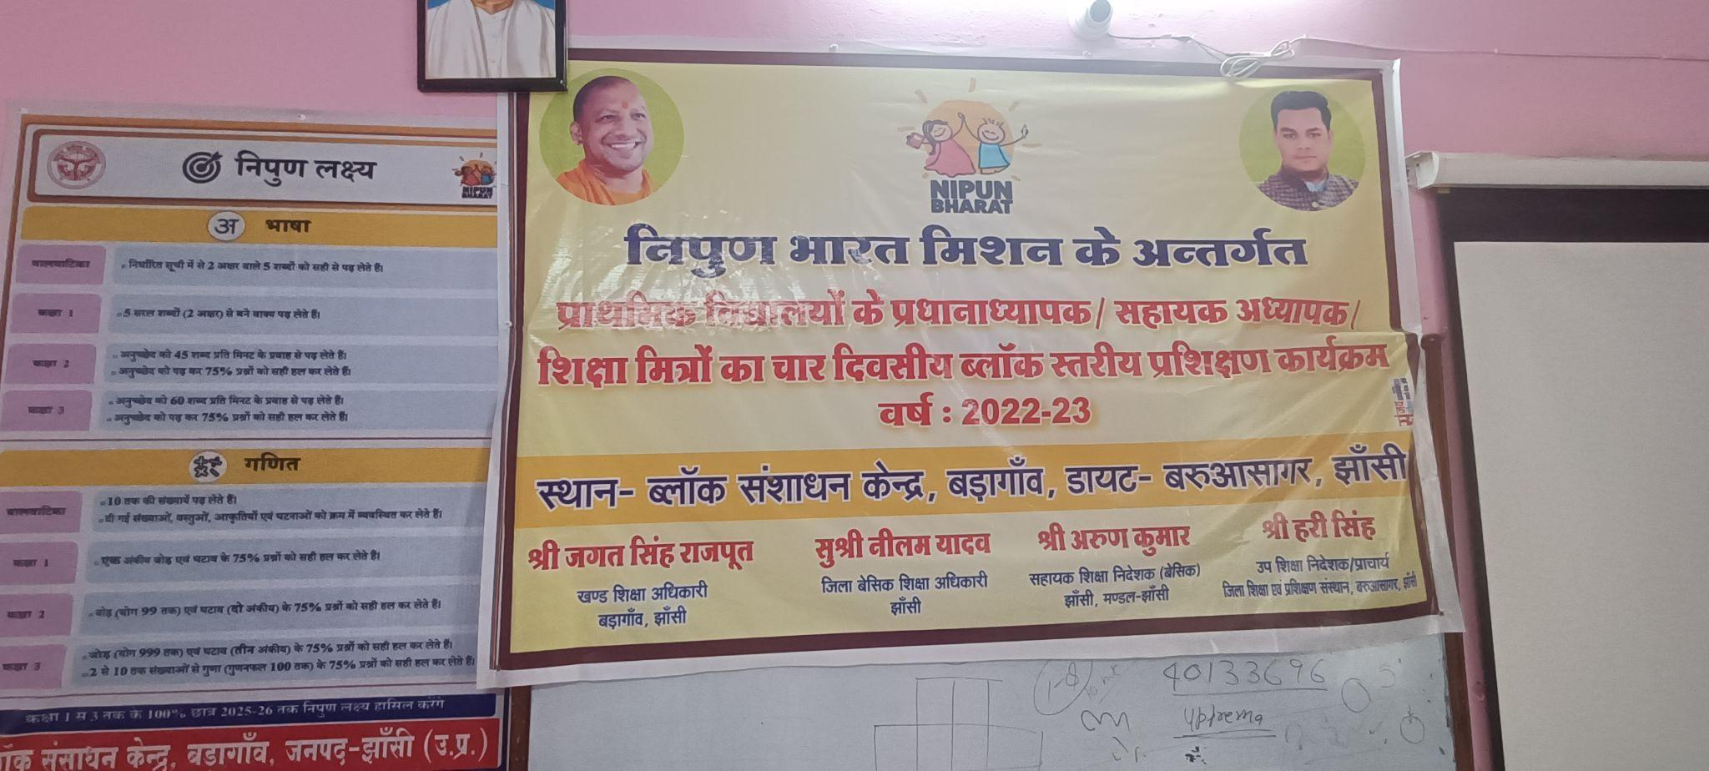The coordination within the SCERT is mainly with the lecturer in Research Methodology. For academic support or any other administrative support we usually get in touch with the higher educational officers, clerical staff. The interaction is mainly with BEO under the BRC, we basically act as NODAL officers, we mainly train the District level NODAL Officers, they then go and train in-service teachers at the BRC level. These District level NODAL officers further give training at the CRC(cluster level Resource). The BRC aren't so resourceful but we are trying from the DIET level to enrich and develop the BRC.

Home-Science Lecturer-
I was appointed as a Home Science lecturer for 3 years.
Administrative work- Remedial Teaching for in-service teachers, organizing ICT Competition for basic schools, poetry and story competition.

- Institutional Identity and Focus: [Understand the DIETs identity through the focus areas of work, goals, objectives and its ability and capacity to function as an independent and autonomous institute leveraging state and national schemes]
Main goal of the DIET is to improve and enrich at the basic level. To enrich them within the subjects of the curriculum, besides this also provide them the knowledge of how to deal or manage a school with only 2 or 3 teachers. The practical aspects, how to create a bond with small children which is a must before even teaching them.Eg- making student teachers sit on the floor and do certain activities, as this would be something they might have to do while in service. Towards in-service training it’s mainly organized with the training that are received from the SCERT, monitoring of these training and how are the outputs. In terms of alignment within the State every aspect of the functioning of the DIET’s comes from instruction of the SCERT, we simply follow these instruction. There isn't much the DIET is able to do independently. Sometimes suggestions are taken to organize any activities within the DIET, but before conducting this permission is taken from the SCERT.

Gaps noted- There is lack of basic infrastructure, lack of guest room, smart classes, and staff rooms.Mainly enriching the environment of the DIET’s.

- Systemic location and relation to other institutions: [Understand the DIETs positioning vis-à-vis the state education system, including SCERT and BRCs-CRCs.]
Every month meeting is organized by SSA(Samagrah Shiksha Abhiyaan) wherein the BEO, SRG, ARP, BSA(Basic Siksha Adhikari), DC, all the lecturers of DIET are present and we discuss on the issues faced at the block level we mainly interact with BEO who further looks into the matters. As DIET falls under the Higher Education Institutions, all the stakeholders come under it despite their rank and as such we get good cooperation from them. There are 9 blocks in the district and for each there is DIET mentor, we mainly are connected to the BEO’s of the block assigned as mentors. The reasons for interaction are usually academic like issues related to supervision, new schemes to be introduced at the basic level, infrastructure etc. Supportive supervision is one main function through which we interact with BRC’s. The interaction with the community is through inviting the parents and other important community people to certain events organized within DIET’s. Here they are mostly made aware of the role/functioning of DIET’s and BRC’s.
Opinions/Issues expressed- Home Science should be established as an external subject.

Hindi Lecturer-
My role since the time I have come into service, has been purely academic. I have been appointed as a supportive supervision at Gursarai Block. There are some challenges which I have faced are usually the clerical staff not being present at the DIET level, a lot of work gets delayed due to this. The budget or finance does not arrive at the expected time for which educational functioning gets impacted. At the block level I have observed that there is the issue of absence or students not being present in these primary schools. This has been due to the lack of awareness of the parents on the importance of education. Issues in relation to connectivity of certain apps like DIKSHA.

- Institutional Identity and Focus: [Understand the DIETs identity through the focus areas of work, goals, objectives and its ability and capacity to function as an independent and autonomous institute leveraging state and national schemes]
The main objective of DIET around pre-service trainees is to provide a certified course of Diploma in Elementary Education(D.el.Ed). The previous name was BTC now changed to DELED. The students who come after graduation are taught within those parameters fixed within the framework of NCTE and NCERT. To basically help them become impactful and also reflective teachers at the primary level.At the in-service level the goal is to provide refresher courses at different times so that they get upgraded with the new techniques in teaching. DIET is not autonomous in itself for any infrastructural or developmental improvements it needs to get the approval of the SCERT. Towards better sustainability in future of the DIET’s human resources, infrastructure, Subject teacher and timely funds to be provided to enrich it more in a holistic way. There is proper communication with the SCERT mainly paperwork or sending in applications. Besides this the SCERT also selects experienced lecturers from the DIETS in creating the curriculum.

- Systemic location and relation to other institutions: [Understand the DIETs positioning vis-à-vis the state education system, including SCERT and BRCs-CRCs.]
BRC’s functioning within the district is immense, but at present in every DIET there is an ARP who looks into the entire cluster. Supportive supervision to these schools and they are provided guidance and other support by the DIET’s or its assigned mentors. This is the main interaction between the DIET’s and BRC’s.
The BRC tries to align community on the functioning of the blocks and the DIET’s by bringing in resourceful, experienced and academically inclined person to the certain events or organizations within the DIET’s.The School Management Committee is another way of bringing them closer to the functioning, but the parents form the members of this committee who are usually not aware or literate and as such it would be more appropriate if educated people from these gramins are nominated to these committees so that the impact of education is more.

Principal & Faculty insights on the following themes-

- Development of Faculty and Staff: [Understand the current roles and responsibilities, staffing needs of DIETs, the recruitment processes, leadership roles, vacancies, capacity building of DIET heads, faculty and staff and nurturing a professional culture/community.]-
Roles of DIET
1. DIET would continue to be the nodal institution at the district level to conduct preservice and inservice training for elementary and secondary school teachers.
2. It would arrange need-based training for teachers in the district.
3. DIET would also organize and support teachers' professional and leadership development programmes for head teachers, senior teachers, and school management committees on a continuing basis.
4. It would serve as an education resource center for the district in conjunction with BITEs, BRCs, CRCs, etc.
5. Despite the absence of 4th grade personnel, clerical personnel, senior lecturers, and full-time principals, DIET is working within its own culture so that it will run efficiently. 6. Recruitment is the must-need need for being a sufficient human resource, which means that other things can be manageable.If vacancies in the state's capacity are filled, DIET's ability to work independently will be greatly enhanced.
7.

- DIET functions and Activities: [Understand the different functions and activities implemented by the DIETs by way of inputs, processes, outputs, and outcomes, including teacher development, both pre-service and in-service, DIETs as resource and teaching-learning centers and institutes for local curriculum and material development]-
Functions and Activities of DIET:
1. Training and orientation of elementary and secondary school teachers (both pre-service and in-service) on various school subjects
2. Orientation of Heads of School Complexes on New Trends in Education
3. Academic and resource assistance to the district's elementary and secondary education systems.
4. To undertake action research to deal with the specific academic problems of the district in achieving the objectives of education.
5. To familiarize the stakeholders in school education in the district with new trends and approaches in education.
6. To organize seminars and workshops on various educational topics that would enhance the abilities of teachers and teacher-educators.
7. Extension activities and interaction with the field.
8. Act mainly as a resource and learning center for teachers and trainees.
9. Development of locally relevant materials as teaching aids, evaluation tools, etc.
10. To serve as an evaluation center for elementary and secondary school programmes.

- Financial Aspects: [Understanding the financial aspects such as provisioning of infrastructure, resources, staff and faculty positions and other facilities.]
The financial aspect noted was mainly their salary and how it is not that regular. It comes every 3 months, and during COVID, it gets delayed to even 5 or 6 months. Most lecturers advise the Center and the state government to set up a fund for their salaries for a year so that they can be paid within that time frame.

- Collaborations and Partnerships: [To understand DIETs working with partners such as universities, DIETs within and across states, NGOs, and multilateral funding agencies towards gaining access to expertise, capacity building, networking and institution building.]
Humana People to People India is an NGO that collaborates with the DIET primarily for their computer lab, but they also provide lecturers for subjects when they are unavailable at the DIET. DIET had no contact with universities; individuals connected in their own capacities, whether through old contacts in universities while studying. The autonomy of DIET is very low; therefore, they are mainly dependent on the higher bodies and authorities for capacity building, networking, and institution building.

- COVID-19 Impact: [ Overall impact of lockdown and pandemic-related issues]
COVID affects the operation of DIETs, BRCs, and schools, changing from completely offline to almost completely online. Online induction program from SCERT, eg-computer training, psychological training, duties in control room. Online supervision of the schools, connecting with phones of the head teachers and taking full details on how things are progressing. Through PrePrepare a lot of E-content. DIET classes are entirely online when the lecturer visits DIET on alternate days, and one of them also has a YouTube channel. One of the system changes is the introduction of mohalla classes.It was also mentioned by one of the lecturers that during the second wave of the pandemic the interests of the student teacher towards the course seem to decrease.

C. INTERVIEW SUMMARY STAKEHOLDERS ( BSA | BEO/BRP | SRG |DCT |ARP)
This aspect has not been able to be covered due to BEO not being available on transfer related issues. The team tried to get a hold of the ARP’s, DCT but they too were not present at the office during the field work. However there was a one hour interview conducted with an office assistant who knew about the functioning and the structure. Some insights put forth are-

- In every block there is a meeting held in a month for the head teachers or the teacher in charge at these BRC’s
- Distribution of books(NCERT) to the schools, information of MDM(Mid-Day-Meal) and also other educational records to the authorities. Previously bags uniforms were distributed but now that doesn't fall under the functioning of the BRC’s.
- Training of in-service teachers. Currently NIPUN Bharat training is being conducted.
- The current BEO who got transferred is looking into two blocks wherein he has to look into 100-150 in each block.
- It also looks into any sort of legal course of action taken on a teacher who is on suspension. We usually prepare the paperwork like drafting letters or applications on such matters.
- To maintain records on the teachers who are to be sent here for in-service training, seating & food arrangements during this training. But when these trainings happen at the DIET level we are not much involved within it. Fundings to provide training come at different levels to be conducted at the DIET and BRC levels.
- When the in-service trainings happen at the BRC’s the DIET lecturers come and monitor these trainings. They even interact with these teachers on the different pedagogical aspects.
- Even after working hours the teachers usually call the people working under BRC’s to inform on salary related issues of the mid-day meal cooks.
- The DIET’s however seem to provide infrastructural support in conducting training at the BRC level. Since the number of rooms and space at the BRC is quite less they sometimes conduct these trainings at the DIET.
- Monitoring of bank accounts of the students at these primary schools. Making the teachers aware of how to link aadhaar card to their account so that money gets transferred into their accounts.
- Monthly attendance tracking of the students coming to these primary schools.

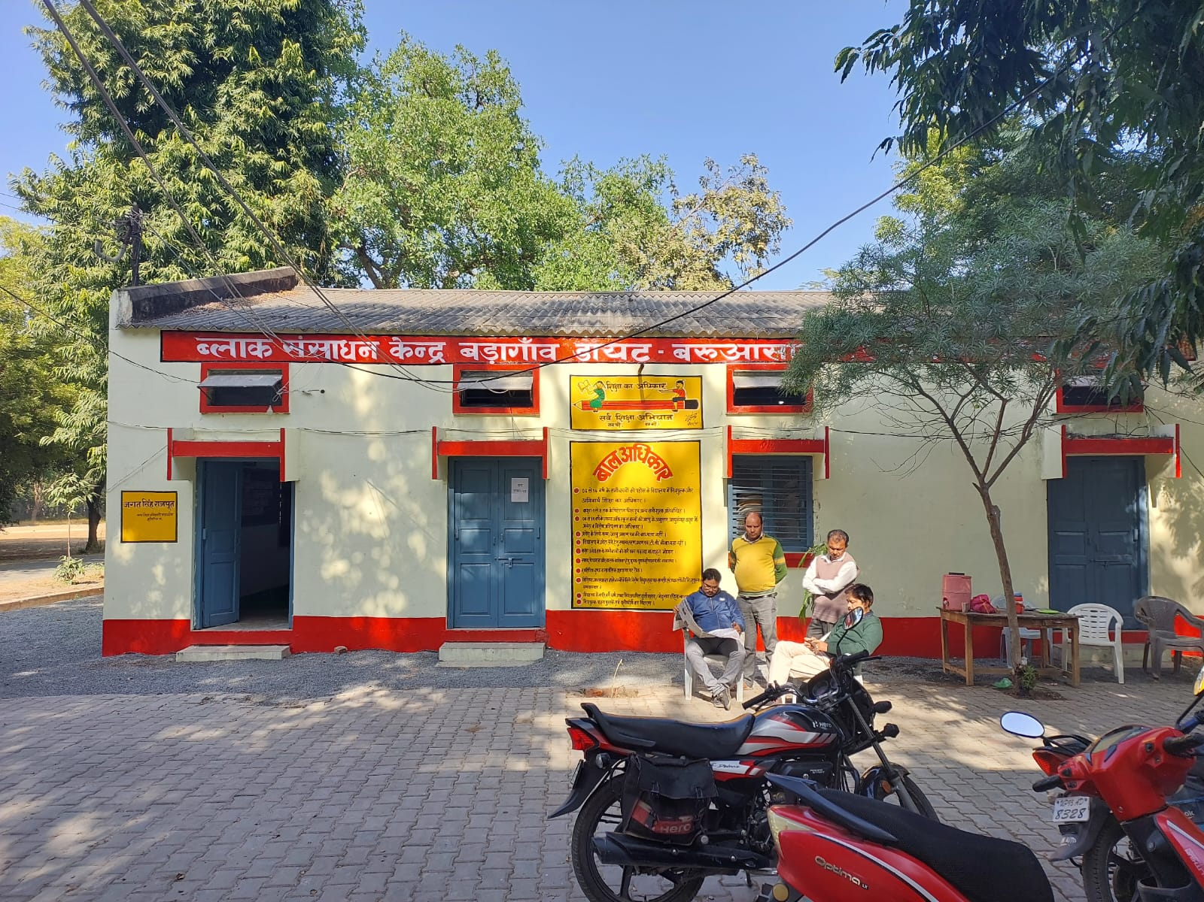

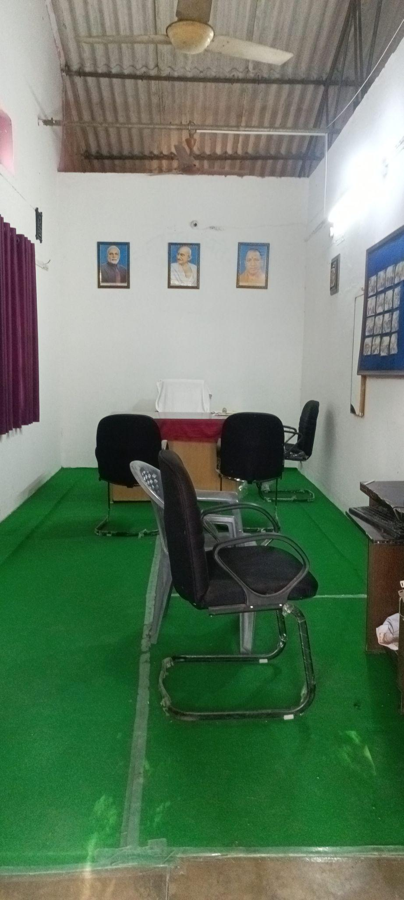

D.OBSERVATIONS SCHOOLS
School Type (Primary, Upper Primary, Composite, KGBV)

K.G.B.V. Baruasagar UDISE CODE - 9360415502
PIN Code: 284304
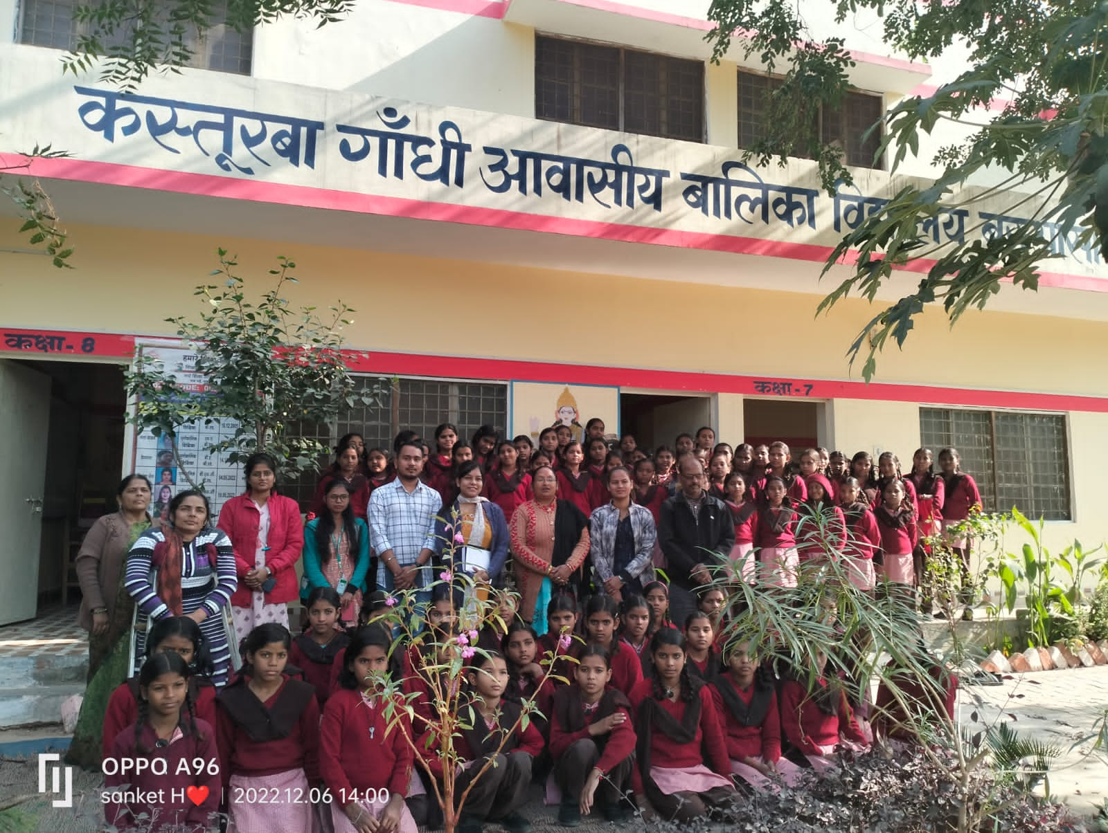
It is an Upper Primary Level school from grades 6-8. It is an all girls school in nature and Hindi is the medium of instruction.
School Location /Surroundings-
The K.G.B.V. Baruasagar is located under the DIET precinct. It is situated in the Baragaon block of the Jhansi District of Uttar Pradesh. This is more towards the interiors around 20 kms away from the main town of Jhansi.

Infrastructure (Staffroom, Classroom, Playground, Drinking Water, ICT Lab, Toilets, Facilities for special needs students/students with disabilities)-
There are a total of three classrooms present at this school. One Principal’s office, no staff rooms were noted within the building. Drinking water facility was mainly a tap water system. There was a room on the first floor of the building with 5 computers and one Smart TV but none of them were in proper functioning. This room also had Cupboards with books in it and a sewing machine. Due to lack of space one single room was converted into a library and ICT Lab. In the first floor of the building there were also the hostel rooms for these girls. Three hostels were present where both the girls and the teachers would adjust, sound 10 beds with 10 attached wall cupboards and two Almirahs each were present. There were two bathrooms present at the backyard along with 4 other washrooms present within the girls hostel: one washing machine, one kitchen.

Teaching Learning Resources ( Books, posters, displays) -
They were mostly following the books prescribed by the SCERT. The posters and Displays within the classrooms reflected creative art, poems on Women Empowerment, inspiring quotes, importance on the environment(save water, save the earth), maps, musical instruments etc. Besides, there were a lot of handmade crafts noted in each classroom by the students.
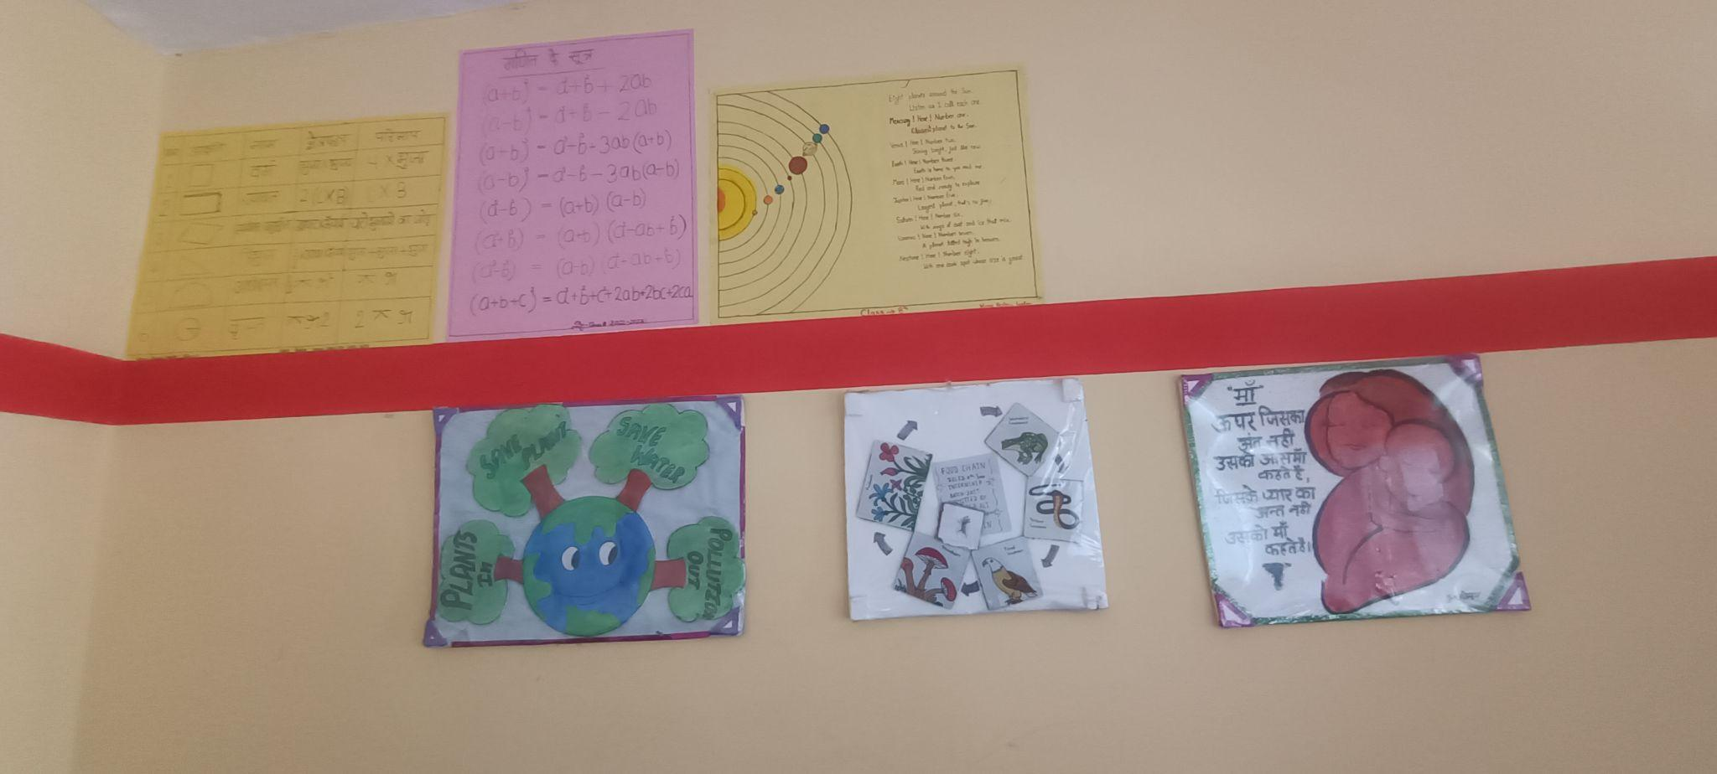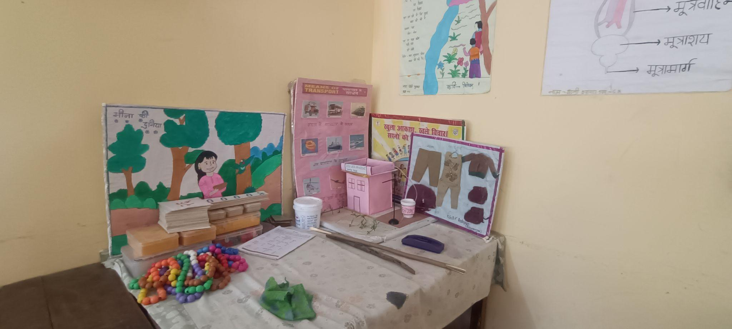

Class Observation (students, blackboard, Seating, Pedagogy, Interactions etc.)-
In the classes we observed that there were two rows with seating arrangements in benches of four capacities. There were blackboards and the pedagogy was mainly a lecture method, but the students were observed to be listening intently and response was immediate when the teacher asked them questions. The teacher would also write things at the blackboard in between the class and ask them questions to keep it more interactive.
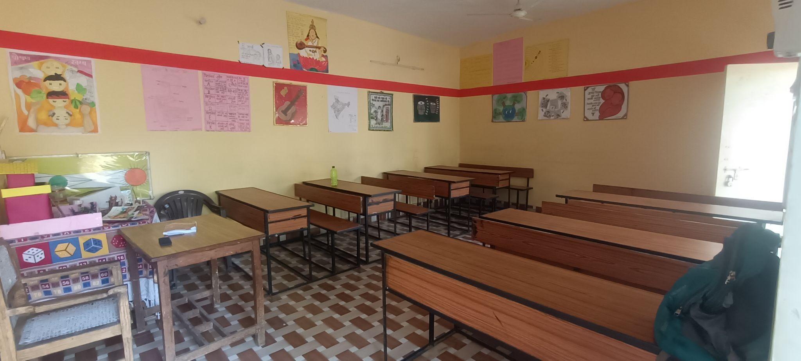

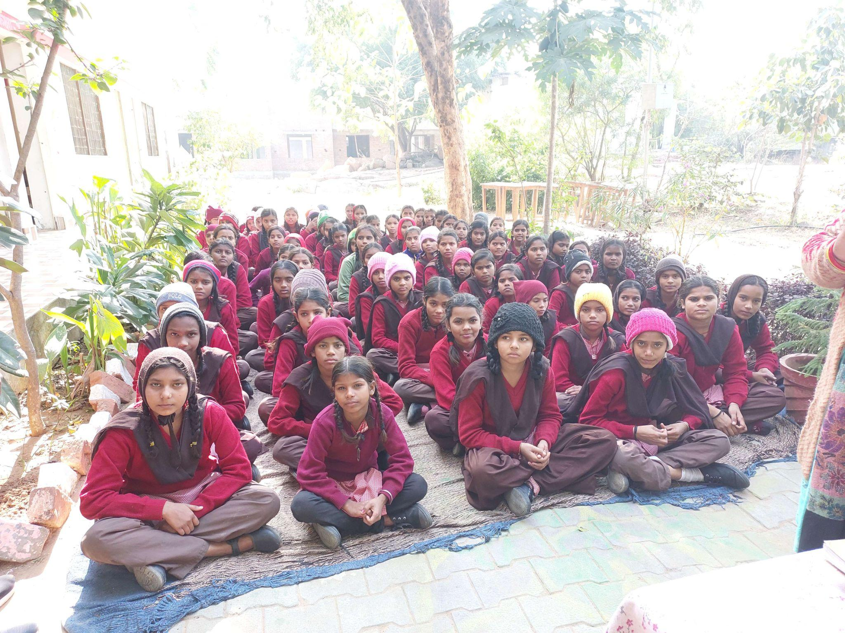
Dropout, students lagging behind attending class outside

Interaction with headteacher/teacher-
The headteacher of the KGBV school extended a lot of cooperation on giving her insight about the school. One main concern which seemed to come up was that the space was really less. It was very difficult to conduct all classes in only these three rooms at once .There were classes held for those students who usually lag just outside the classrooms in the small confined space, they were sitting on mats and somehow managing. The Principal mentioned an important aspect of how there were adolescent girls who were tracked from these interiors and brought back to these schools. Some of these girls had dropped out due to puberty, some others were never sent to school and have directly enrolled into Cls-6. So these students were observed to be given extra classes outside.

NGOs Presence -
There weren't any NGO’s presence observed within the KGBV School of Jhansi.

Other Observations (Co-curricular activities, Assembly etc.)-
Due to the lack of a proper playground there weren't any co-curricular activities observed within the premises.Even at the backyard also the team didn't notice any space or sort of sports facilities for the students.

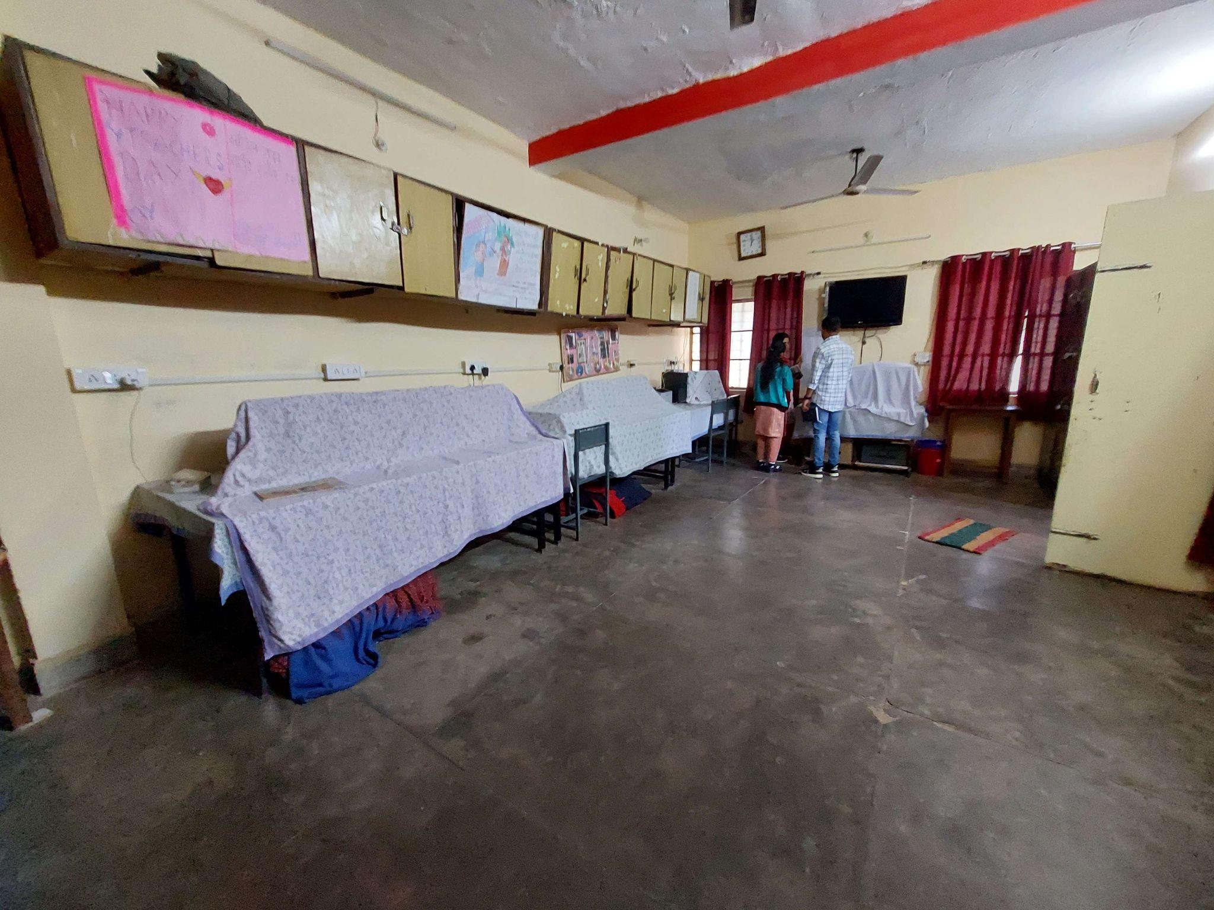
Computer room+ library
P.V.D.C. Baruasagar UDISE CODE - 09360413701
Pincode : 284201
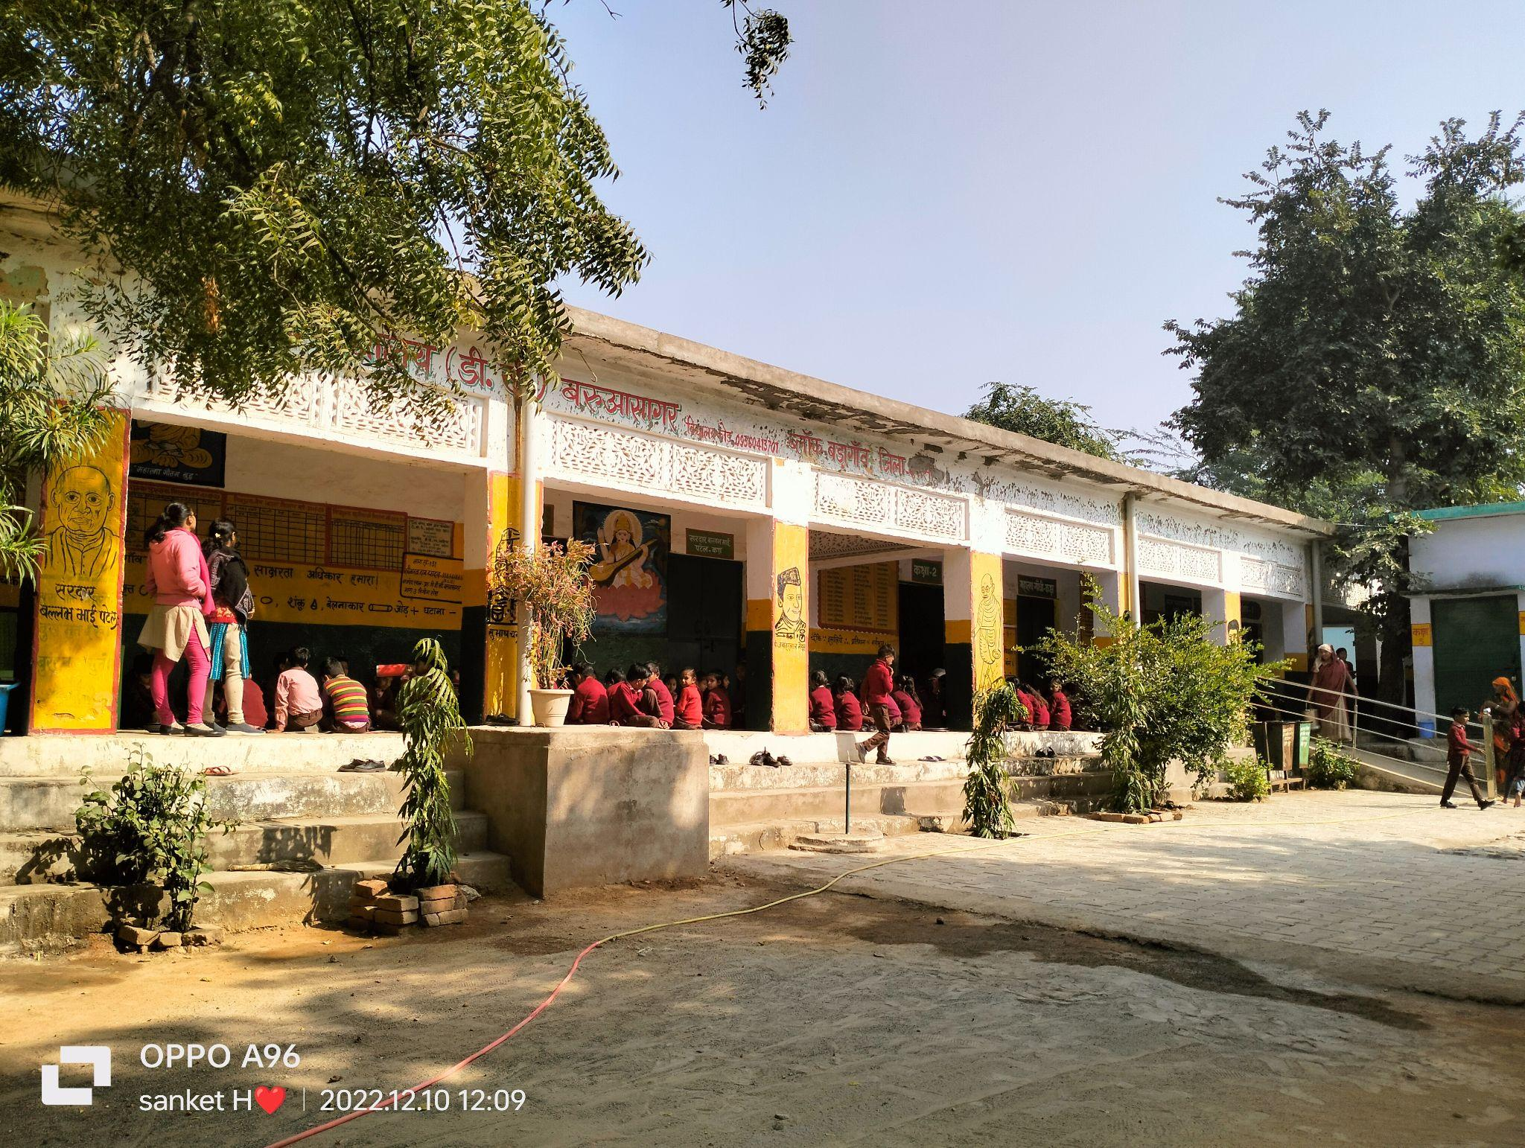
The school is located in the state of Uttar Pradesh, in a rural area. It is managed by the Department Education and was established in 1966 & 1961 respectively. The medium of instruction is Hindi. This school has a regular pucca boundary wall made of bricks. It is approachable by an all-weather road. There are 05 classrooms in all. All the classrooms are in good condition.

School Location /Surroundings (Rural or Urban)
All these three schools were mainly located within a rural setting. Baruasagar is the nearest city to these schools. The economy is mainly based on agriculture, and the per capita income is lowest in the region as compared to the surrounding districts.

Infrastructure (Staffroom, Classroom, Playground, Drinking Water, ICT Lab, Toilets,

Playground-
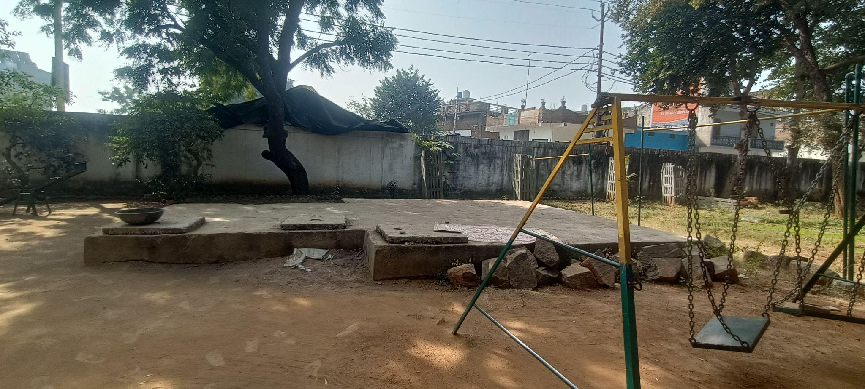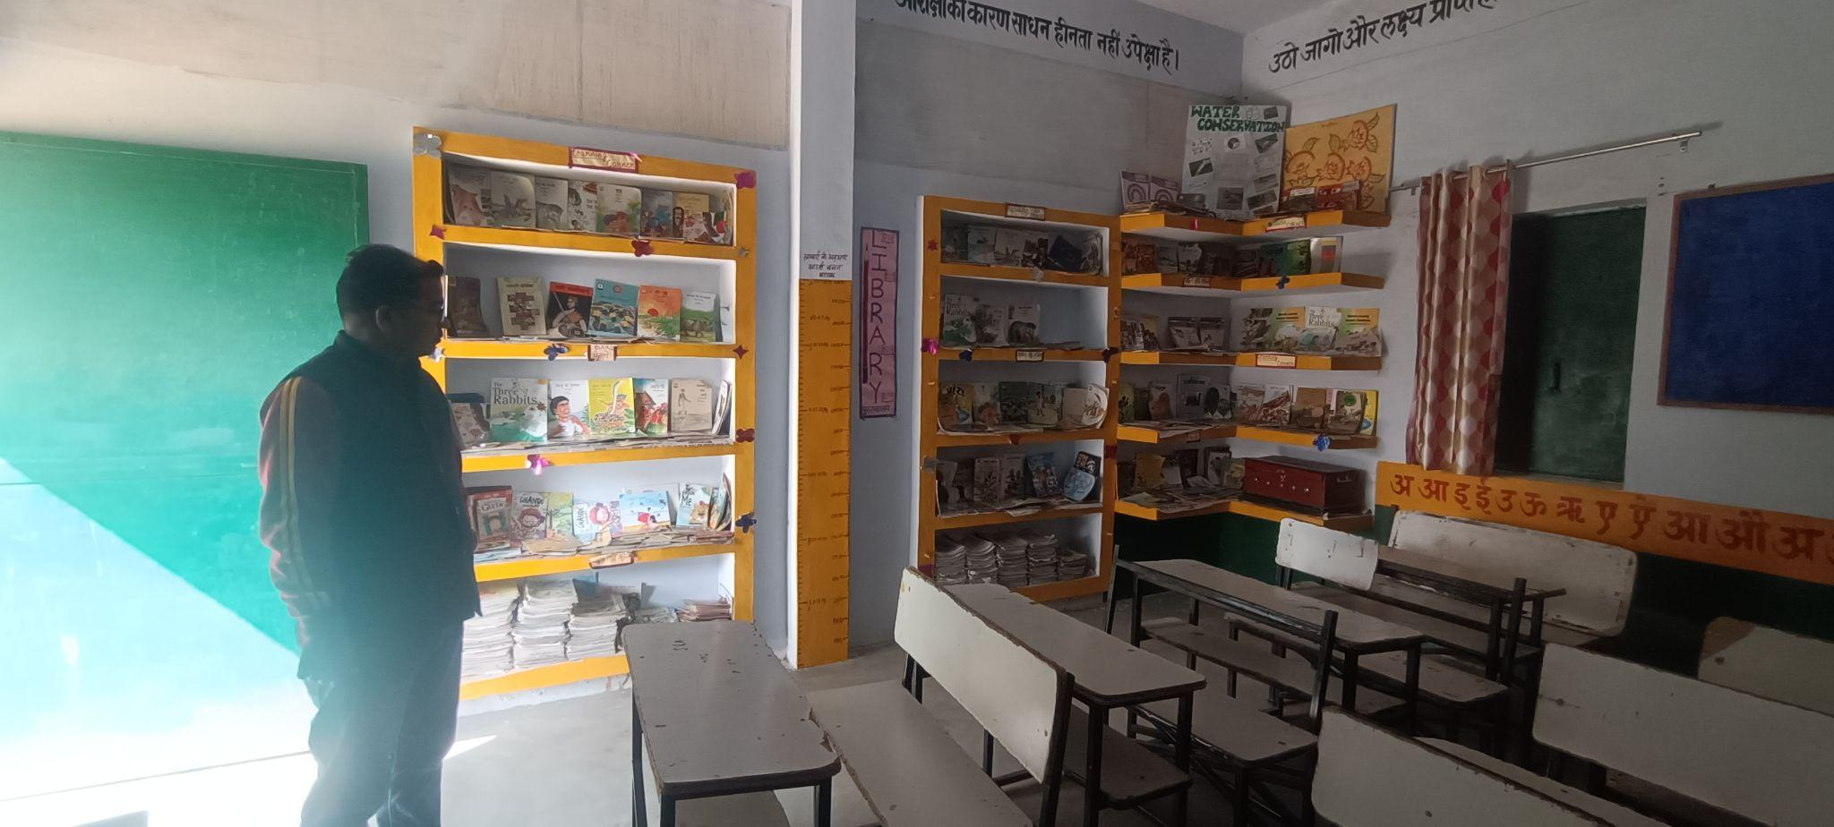
Library-

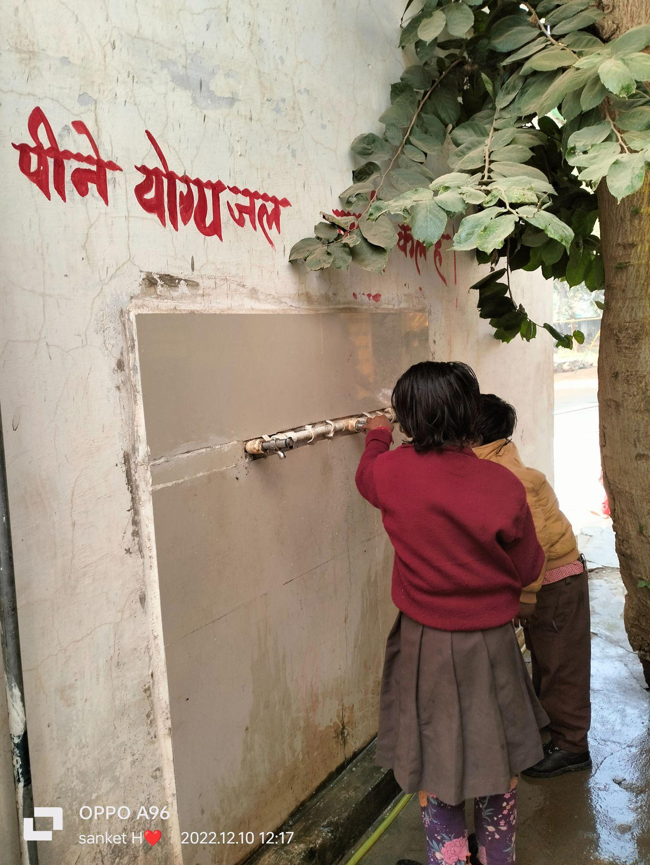

Drinking Water facility
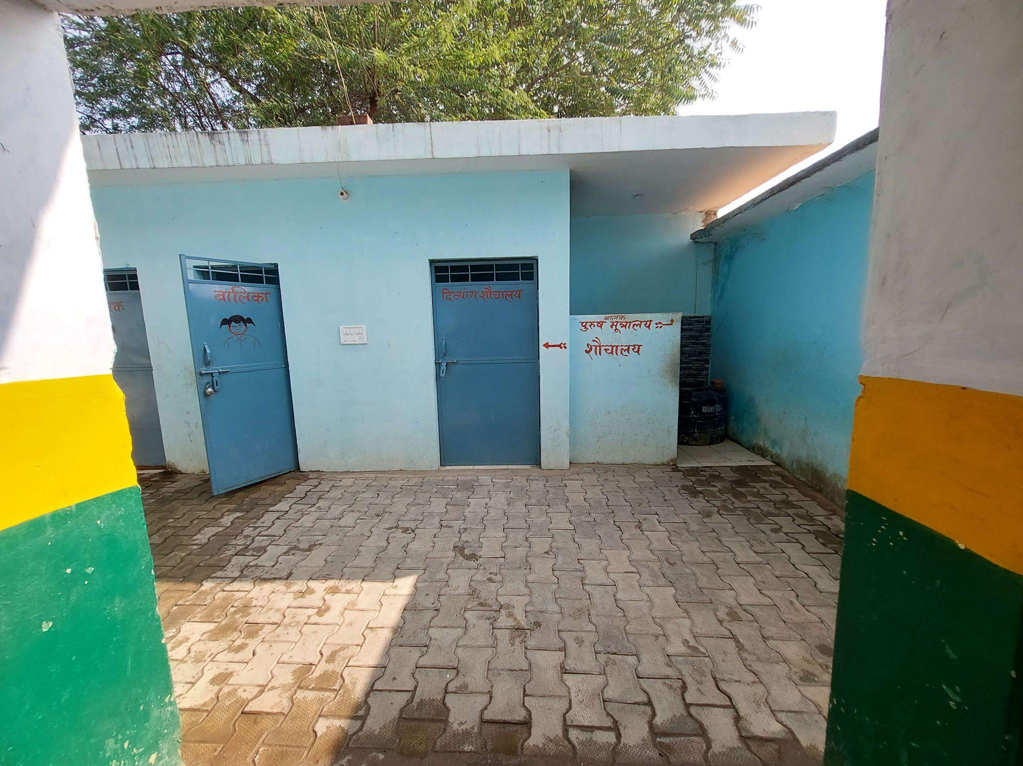

Washrooms

(Facilities for special needs students/students with disabilities)
The PV school at Baruasagar was observed to be quite spacious, there was a huge compound which consisted of see-saw’s, swings. It had a total of five classrooms, 1 extra room which was a computer room previously now turned into a classroom. There was a library behind the main building. It was well maintained with books having a lot of illustrations and arranged in different shelves, reading corners were also arranged along with proper sitting arrangements and board. The sitting arrangements in the classroom were also fairly well maintained; children attended classes sitting on the desks and benches. There was also one Android TV present with internet connectivity. No staff rooms were noticed, two washrooms for boys and girls, a kitchen for preparing Mid-Day-Meal was also present and one Principal’s Office.The drinking water facility was basically in running water form and taps were attached to these basins.There weren’t any washrooms or other facilities like ramp noticed for special child.
The Kasturba School which was located within the premises of the DIET’s were observed to have less space

Teaching Learning Resources ( Books, posters, displays)
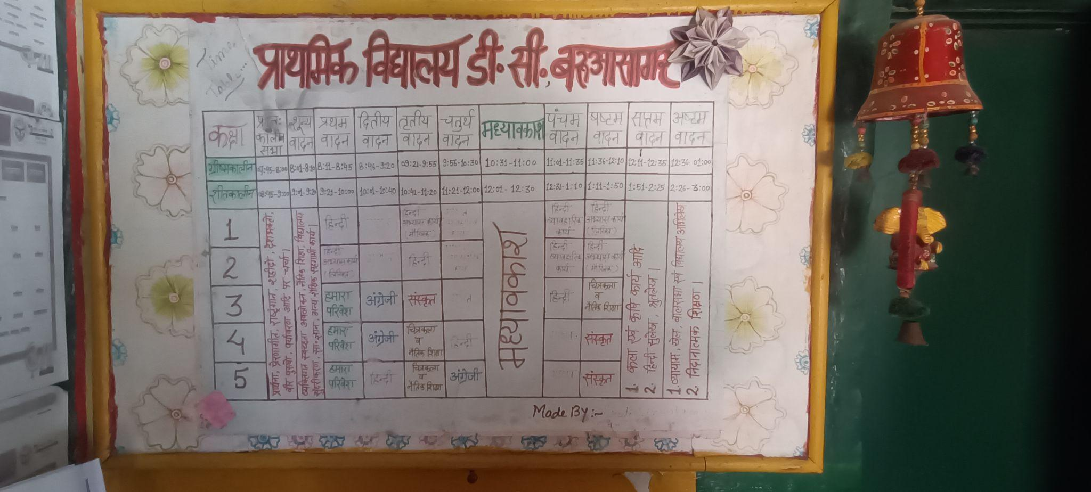
The books which were followed as a part of the curriculum were SCERT books. It also included an illustrated book on the importance of learning co-curricular activities. Eg- to learn how to play tabla was shown through creative story depiction. The posters which were on display in the classrooms were noted to be TLM's on learning numbers, addition, subtraction, tables. There was also the presence of both Math as well as Science kit which the teachers mentioned they used often. Motivational Quotes like ‘Work is our only Religion’, ‘Always be true to your promises’. Besides these posters depicting human anatomy, flags of different nations, maps, stories with pictures, days of week, different sorts of fruits. In class-v we also observed that the teachers used to hang a lot of hand-crafted work on the students. Pictures of Lord Buddha, Goddess Saraswati, Gandhi, Nehru etc.

Class Observation (students, blackboard, Seating, Pedagogy, Interactions etc.)
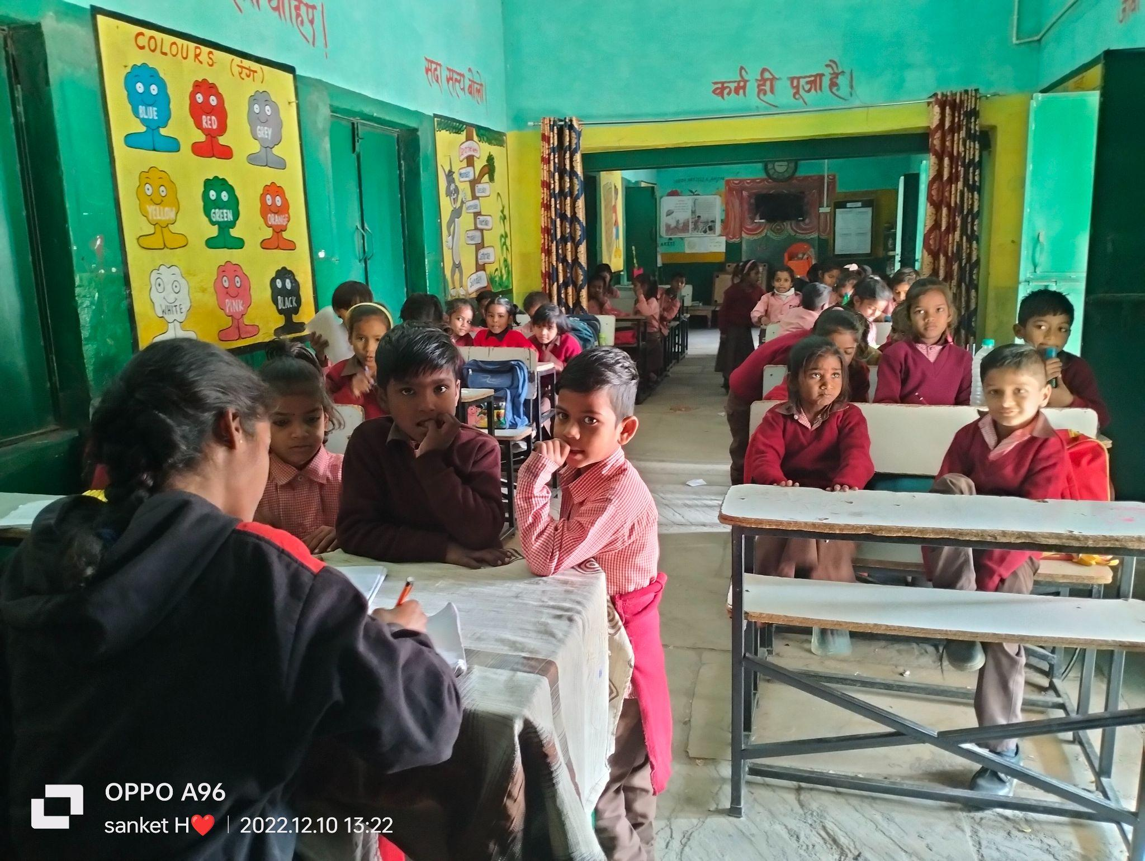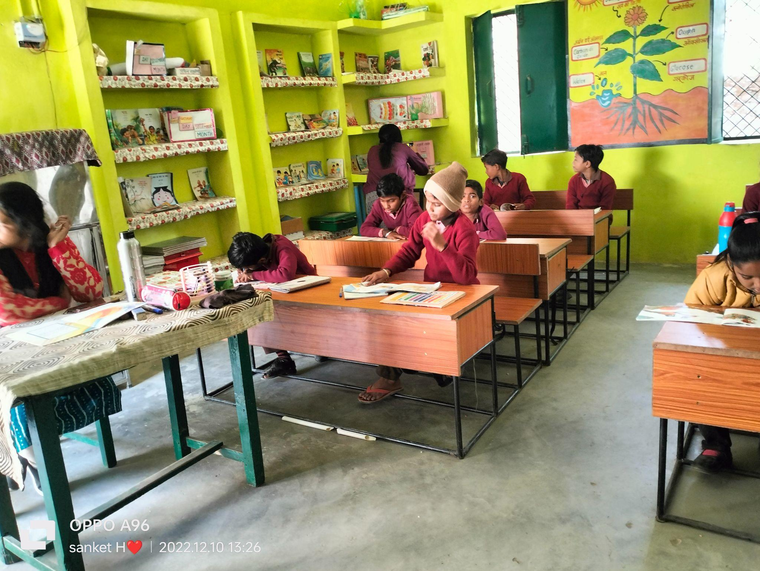

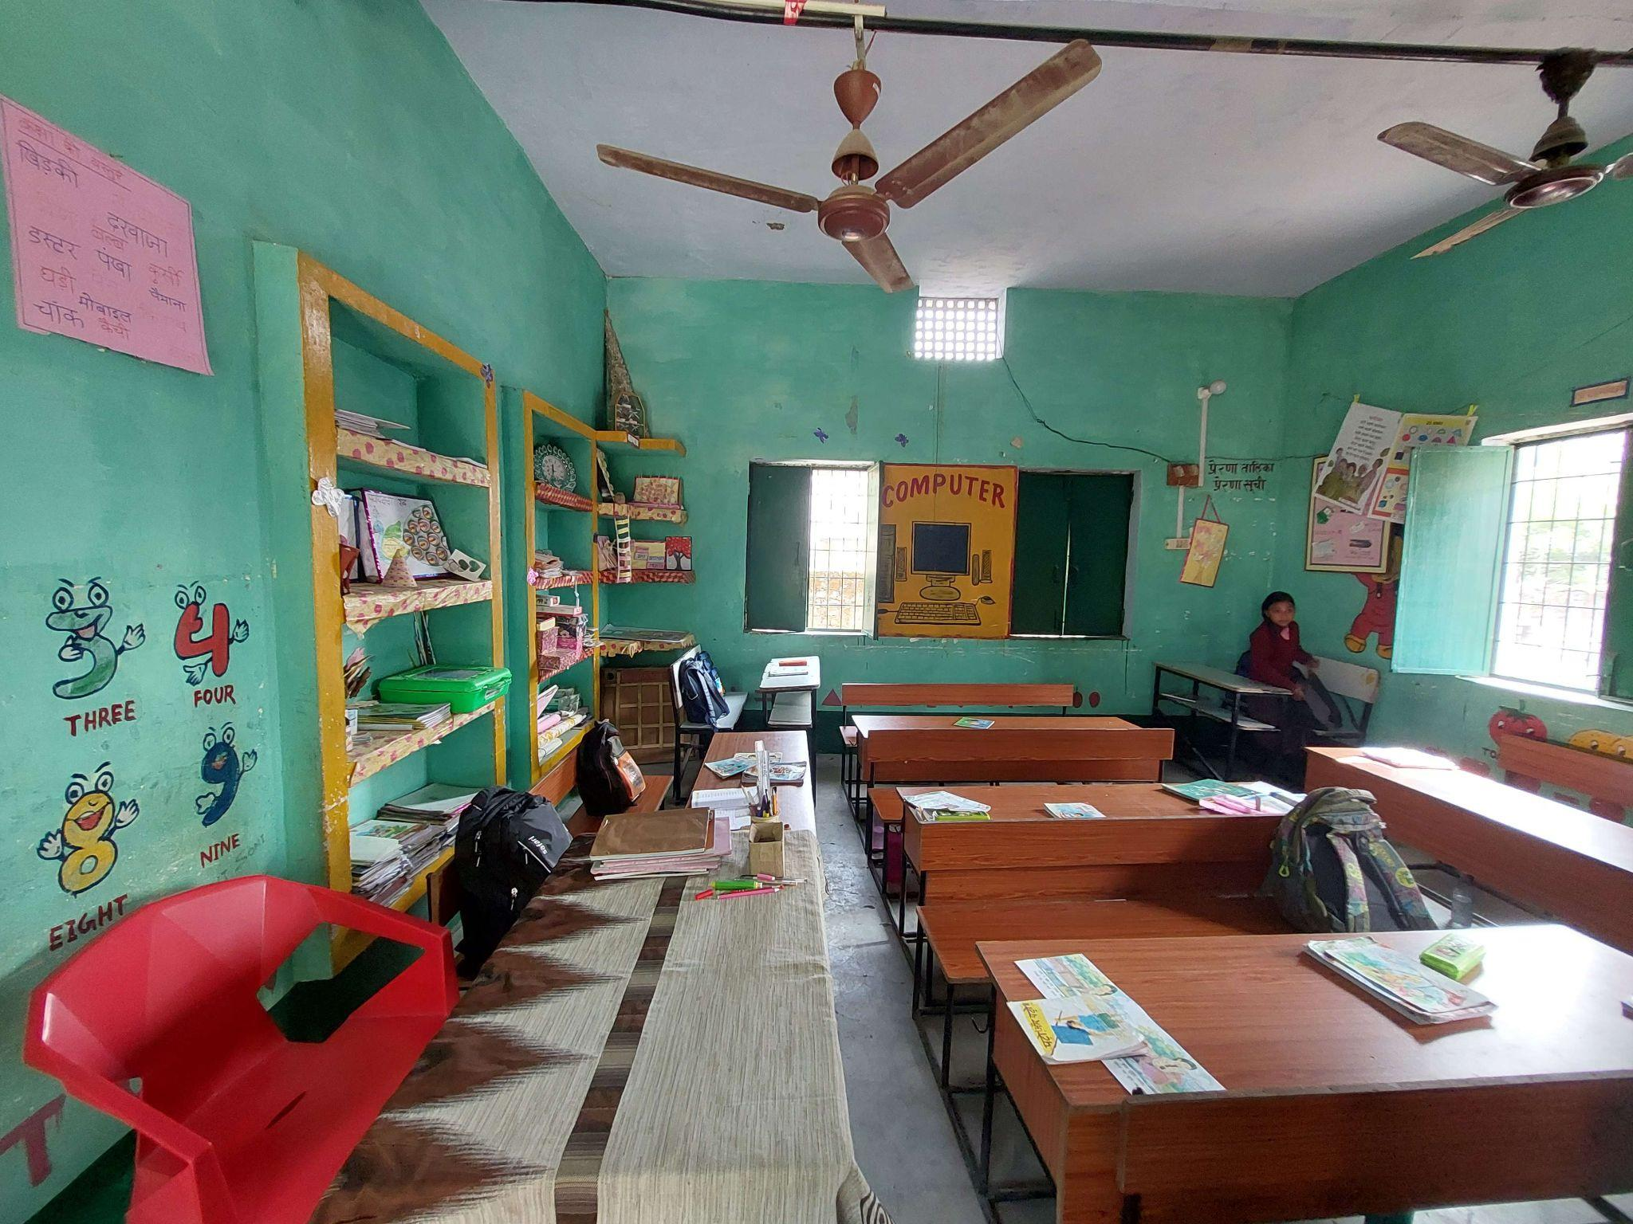
Earlier a computer room now converted into classroom due to non-functional computers

In the school of PV Baruasagar there were three classroom observations done. In all these classes we observed mainly an activity centered session where the teacher had basically given students tasks like to draw, read. The students fairly seemed involved; it was mainly an afternoon session. The seating arrangement was done in two rows, two classrooms had benches and desks with two seating capacity and one had the capacity of 4 seaters. In the ICT room two rows are arranged. The black board teaching method where the teacher wrote a passage on the board and asked students to identify tense was noted. One other interesting session attended where the students were made to act out on songs about ‘cleanliness’ and also a story about a ‘butterfly’.

Interaction with headteacher/teacher-
The interaction with the head-teacher seemed to be a co-operative and engaging one. In relation to the DIET’s the student-teachers are trained with managing certain aspects of the schools like register, sometimes make them Principal in-charge. They are also trained as a single teacher who would handle an entire school. An important aspect pointed out by the head teachers of both these two schools was that they prioritized learning things in a more activity-oriented form.

NGOs Presence -
There was no NGO collaboration in regards to these schools.The Head teacher of this school felt that the NGO’s couldn't relate well to the contextual realities of the school, the training.

Other Observations (Co-curricular activities, Assembly etc.)
The co-curricular activities in the P.V. Baruasagar school was observed to be very active. Students were involved in a lot of activities, like physical training in an innovative way through dancing to patriotic songs.
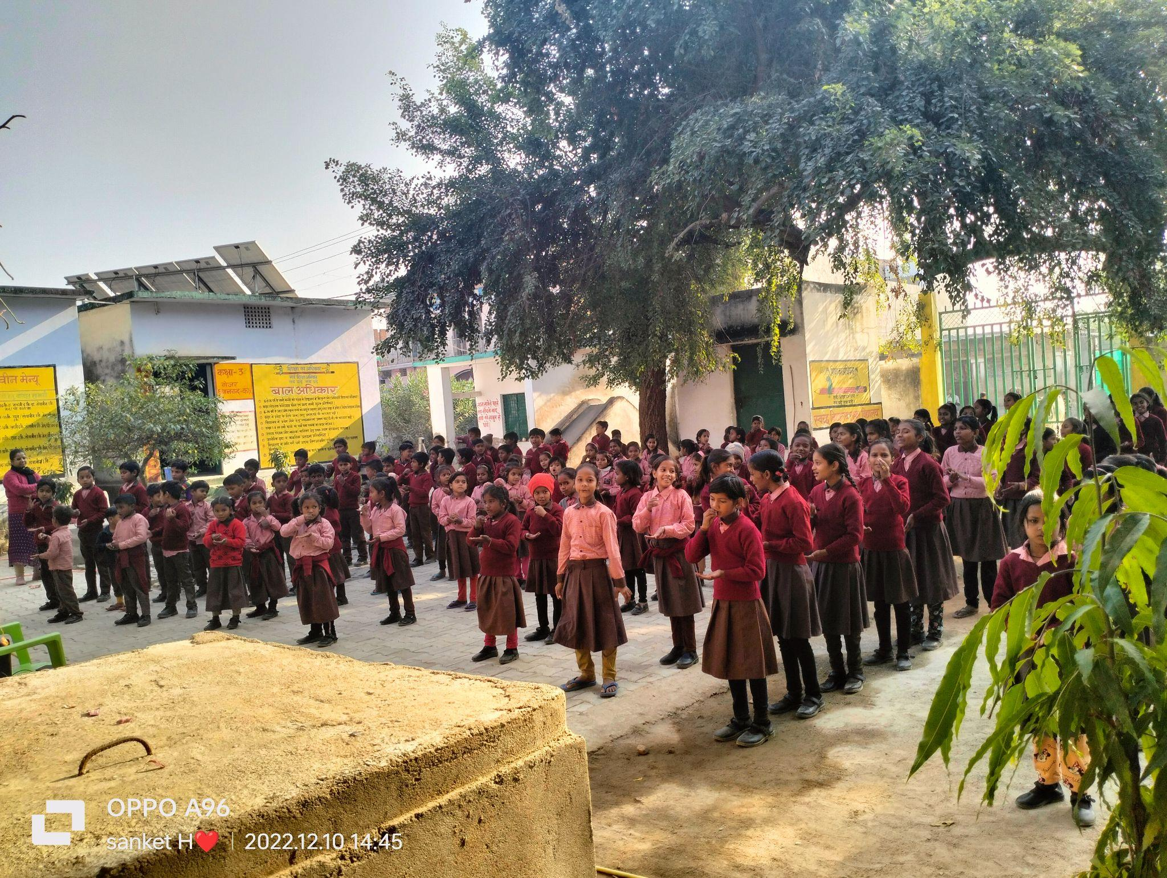
Swach Bharat Abhiyan Session

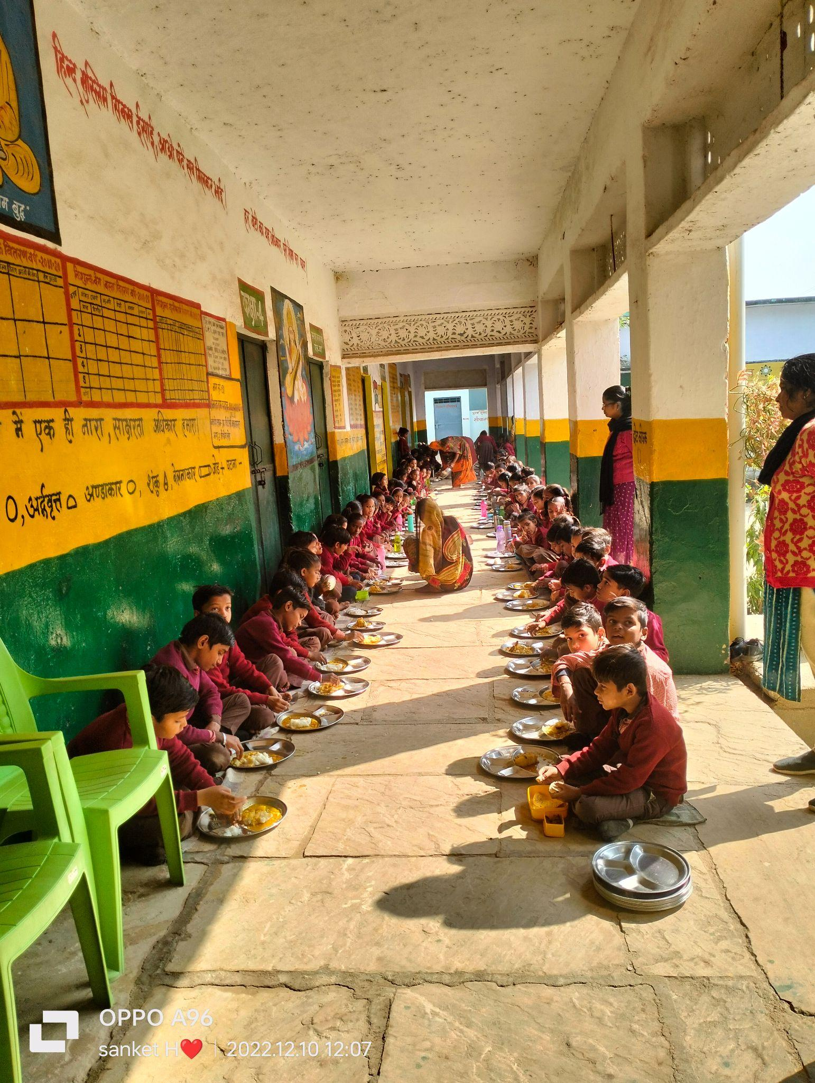
Mid-Day-Meal(MDM)

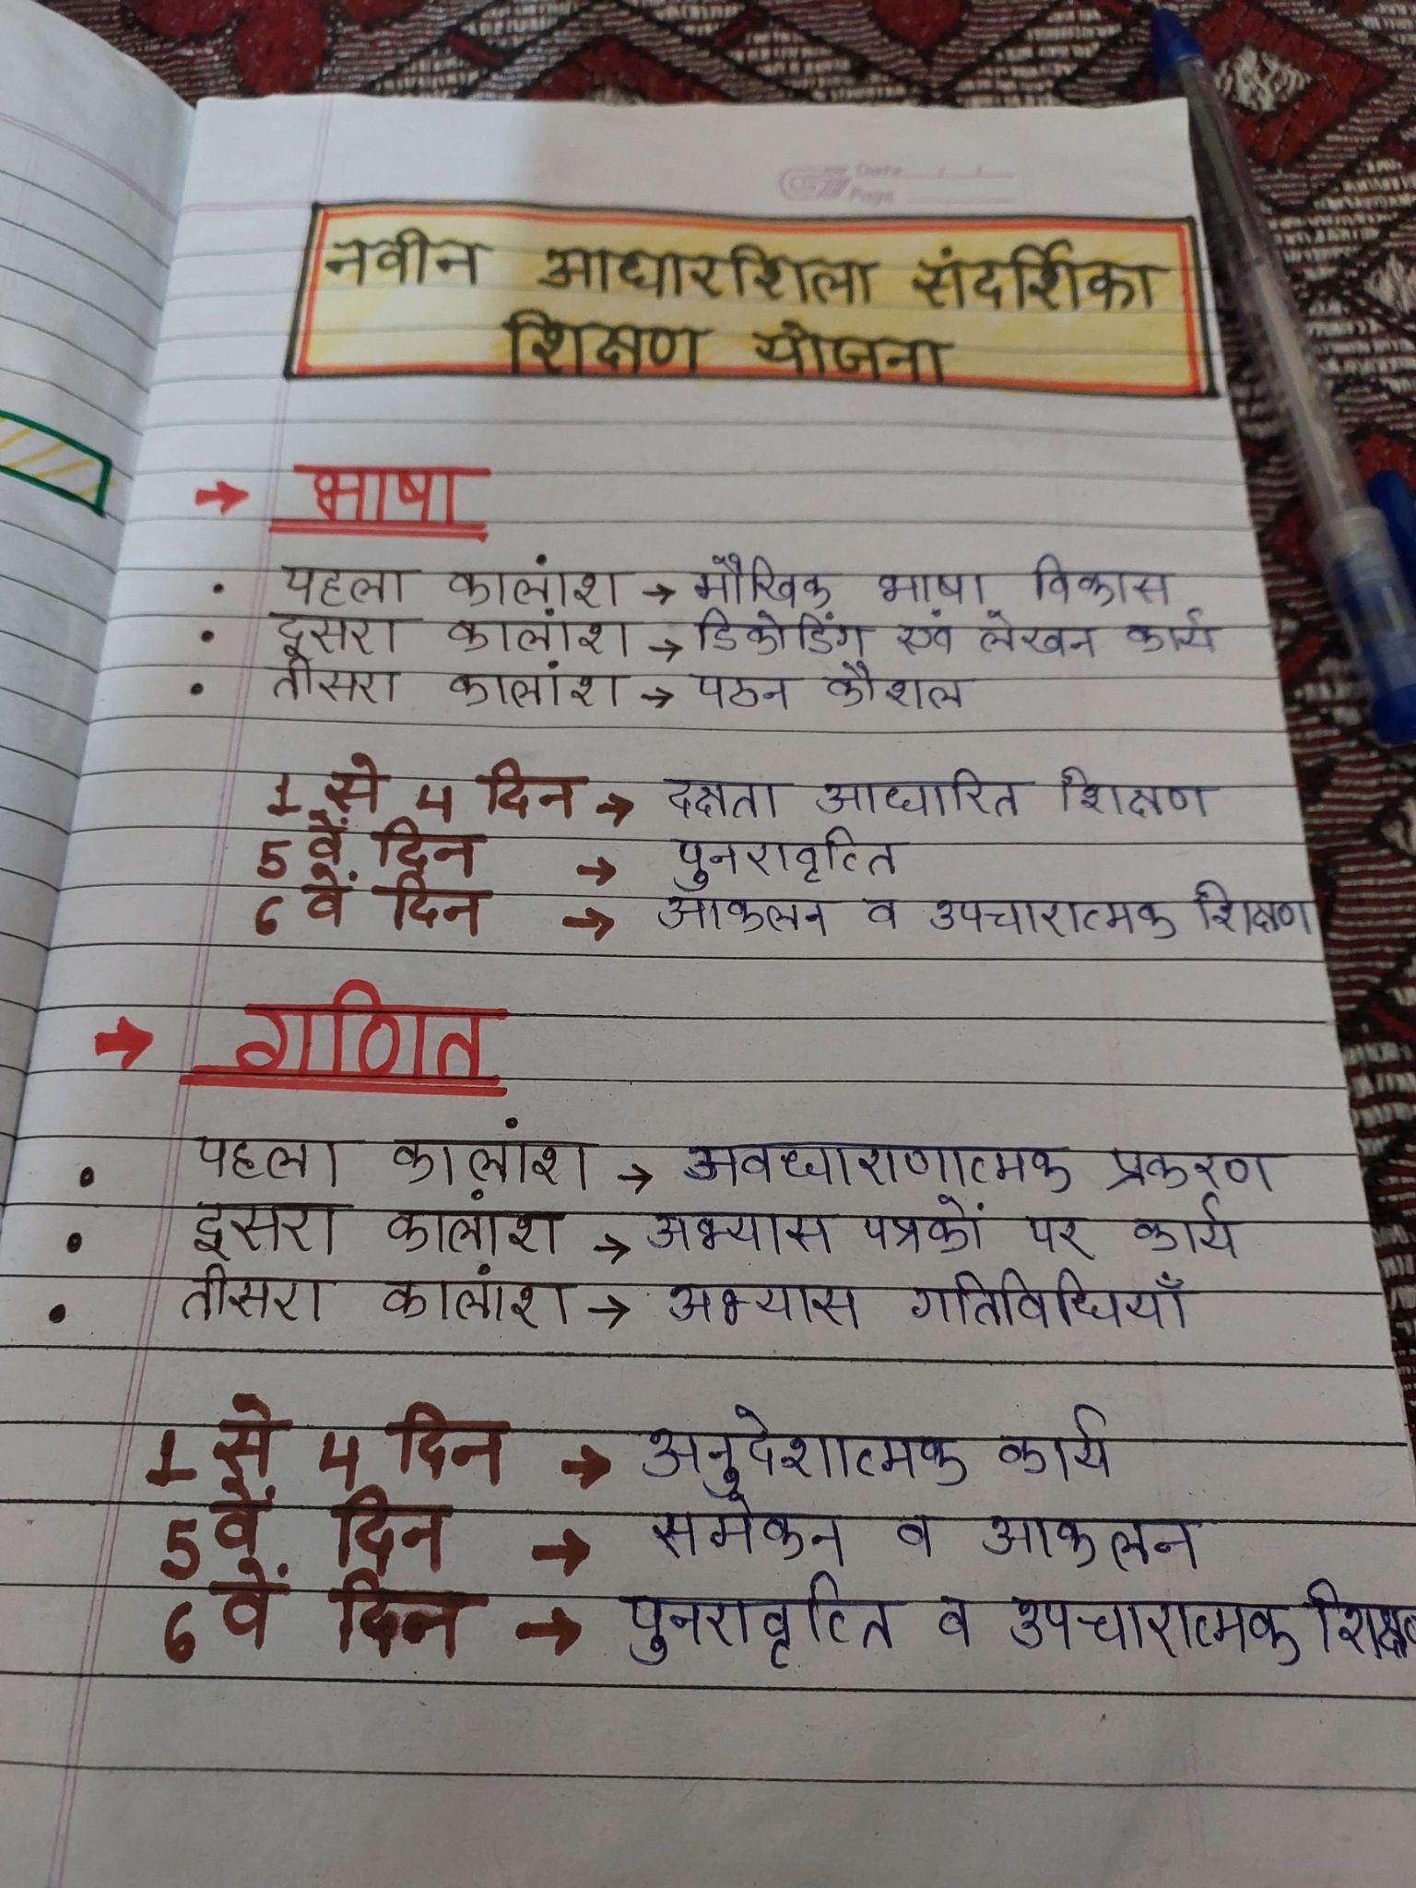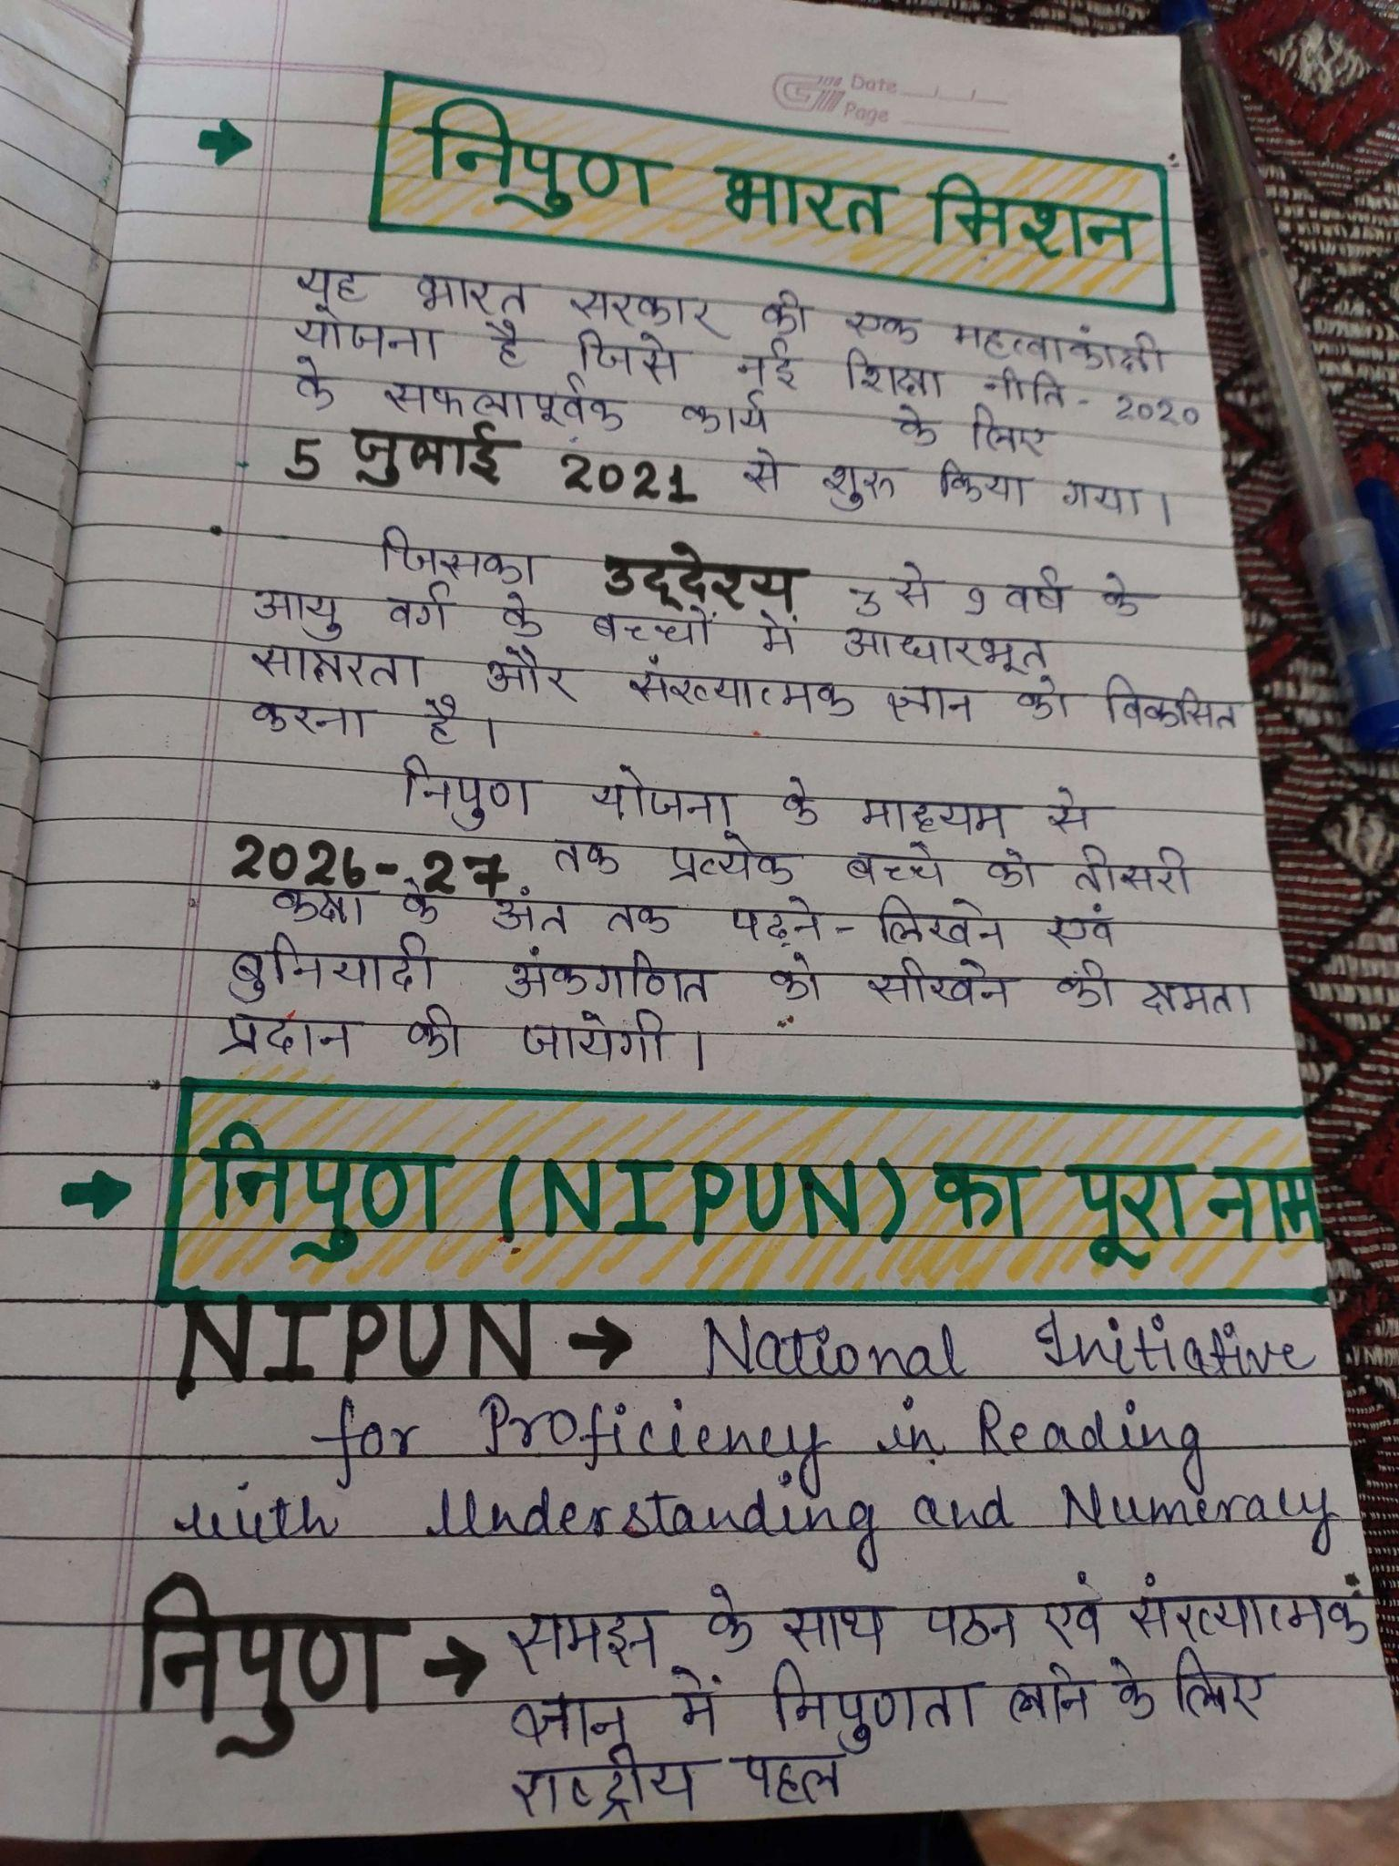

NIPUN Bharat Framework for subjects (math, language)

P.V. MATWANA, BARUASAGAR UDISE CODE - 09360409201
PIN CODE - 284121
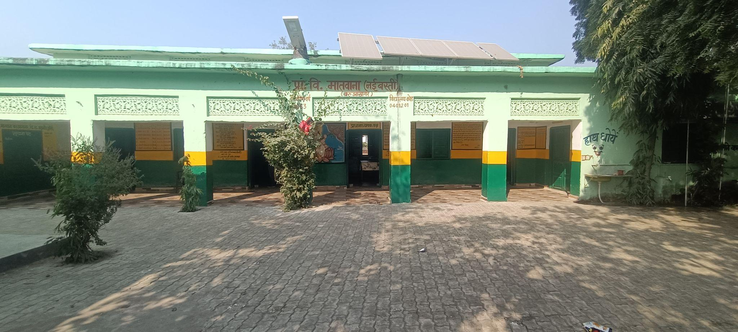The school is located in Baruasagar (Block - Baruasagar), Jhansi state of Uttar Pradesh in an urban area. It is managed by the Department of Education and was established in 1961.

General Information
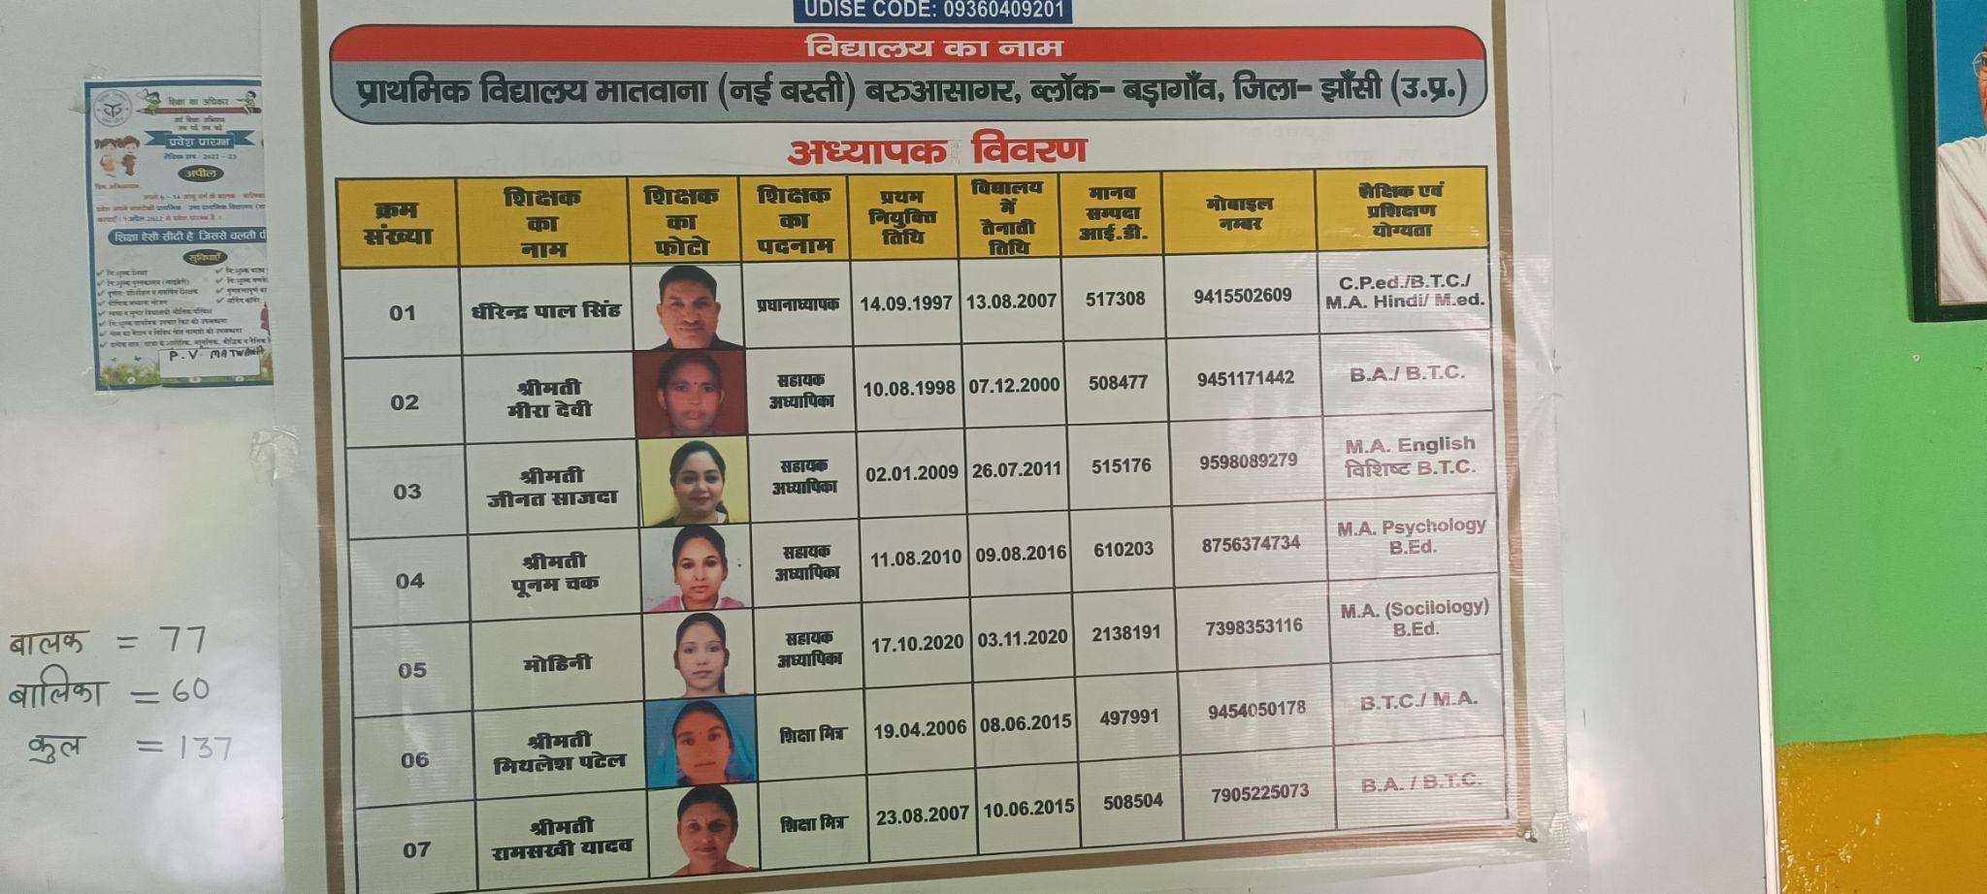The school has classes from grades 1 to 5. The school is registered as a co-ed school. The medium of instruction is Hindi. It is non- residential in nature. There is no pre-school attached to the school.
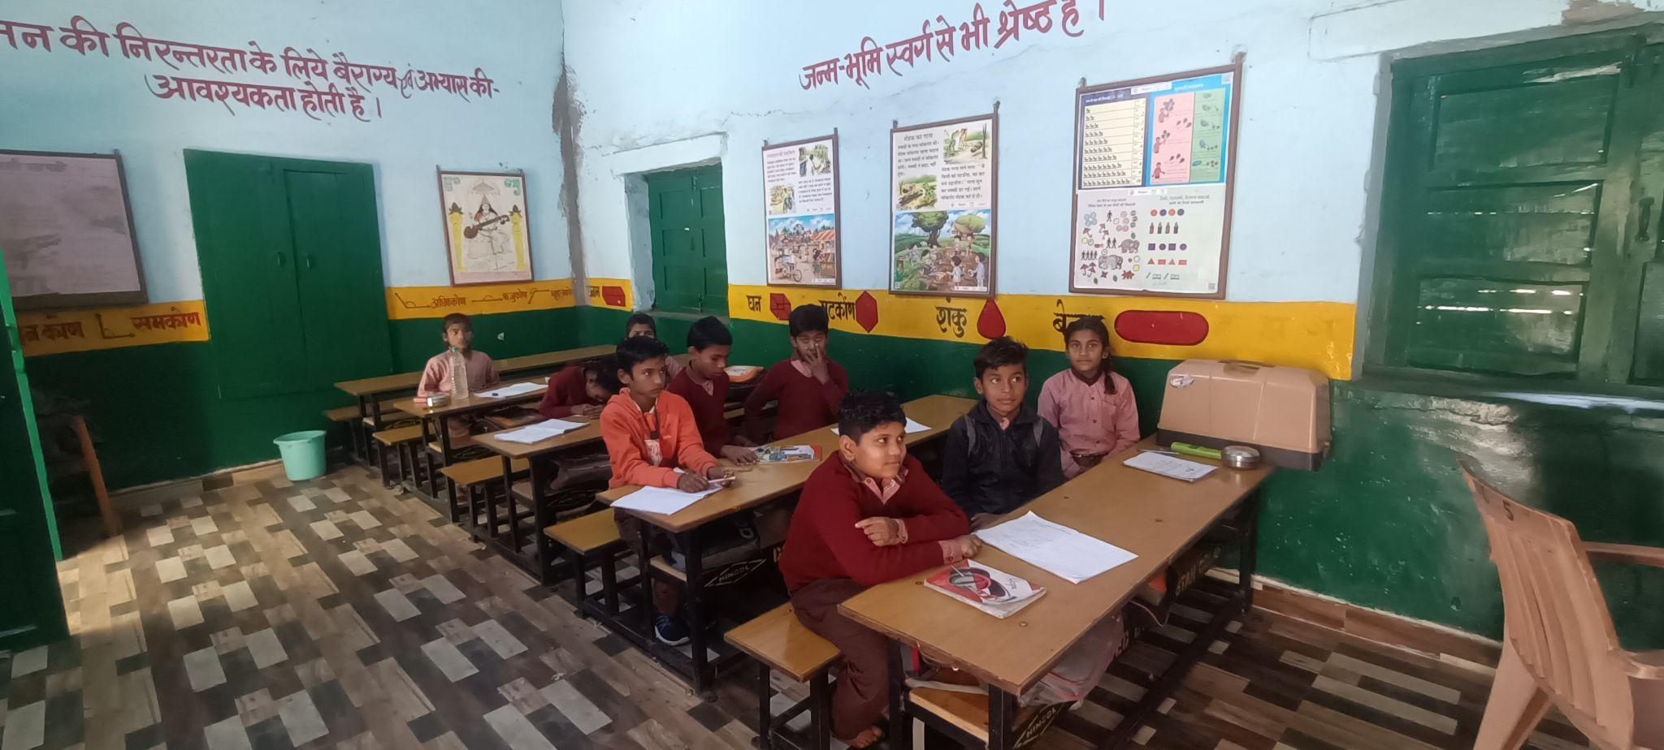

Infrastructure and building
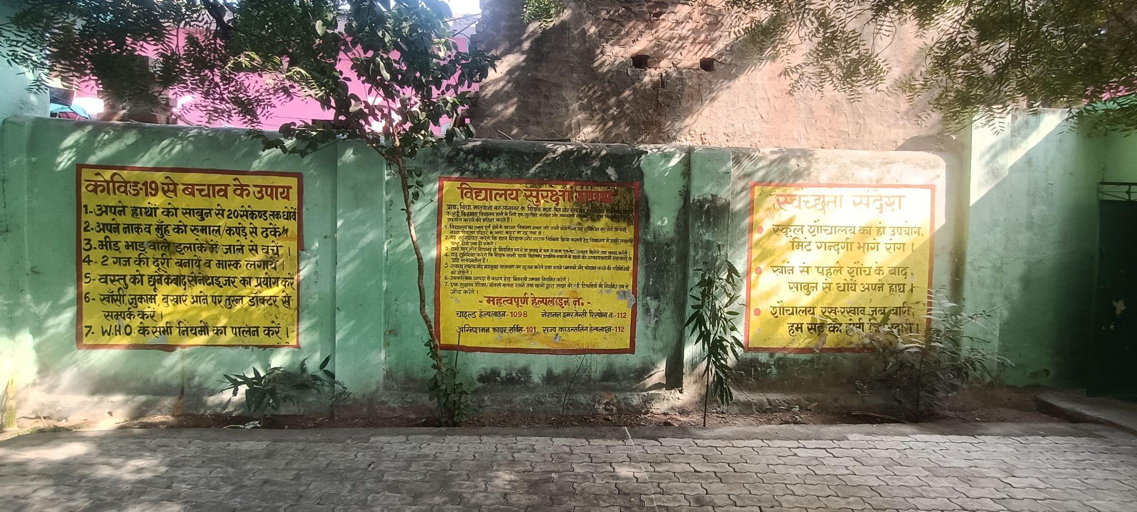This school has a regular pucca boundary wall made of bricks. It has a government building. It is approached by an all-weather road. There are 6 classrooms in all. All the classrooms are in good condition.

Playground and Library
Playground: This school has a playground.
Library: The school has a library. The library is stocked with 100 books.

Drinking Water and Sanitation
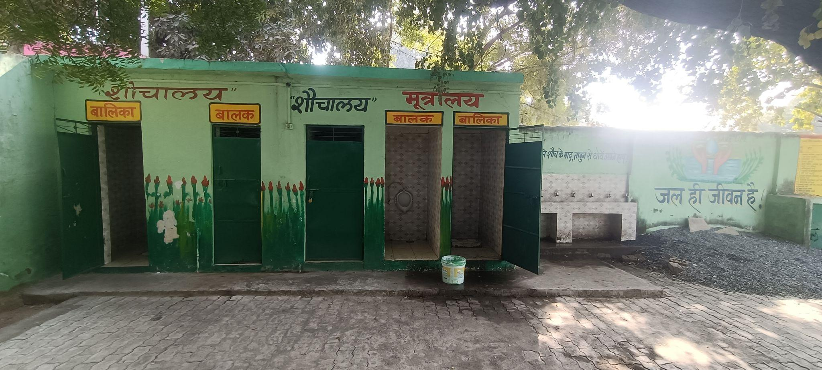
Drinking water is available in the school, via hand pump and tap.
There are(is) 1 functional girl’s toilet(s).
There are(is) 1 functional boy’s toilet(s).

Information Technology Facilities
The school does not have a computer room or computer-aided learning lab.

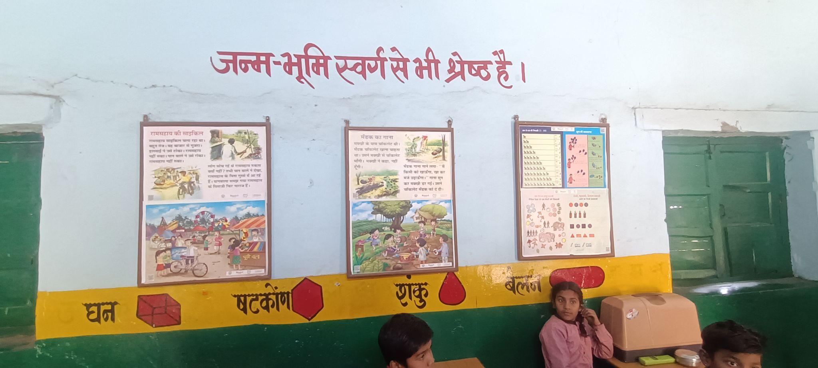

A School Observation Report
The head teacher, sir, demonstrated good, structured, and systematic practices. There were different types of students in the classroom, but he knew all the students by name and addressed academic and non-academic problems by their names. He also knows about everybody's level of understanding in mathematics and Hindi. We observed that he was very hardworking but also tries to keep a balance with his work and personal life.

Classroom Observation
The primary-level mathematics vision and the class teacher's teaching approach are inextricably linked. The educator wants to develop mathematical logic rather than rote memory and is also trying to develop an enjoyable environment for mathematics education, and the students took great interest in this. The majority of students are fearless and work in a relaxed manner. As we were sitting in the last row of that classroom, no one felt uncomfortable nor they were looking at us. The classroom environment was rich in TLM or posters, but it was quite clean and well-ventilated. Firstly, the educator introduces mathematical addition; students know about the number system and can also identify what numbers are. During the probing, the educator used the blackboard in a very orderly and systematic manner, taking excellent life examples from the various communities (for the Rewari community, she used goats, sheep, and so on). It was all about creating an enjoyable environment and using a problem-solving method of teaching mathematics. For correct answers, the educator also does clapping activities for fun and to encourage. Other important aspects were that if someone was incorrect, other classmates assisted each other and checked each other's notebooks or exercise books. Without a good and motivated facilitator, these things are not possible, and for these good and effective processes, handwork is necessary.

Academic and Pedagogical Perspective:
The entire class was having a good time, and many students were participating in peer learning. In the same class, there are different levels of students, and the educator differentiates them based on their level. It was observed in class two, that the pupils did not hesitate while we were present. In terms of the teaching-learning process, the teachers' instructions were very clear. It was not a silent classroom; the pupils were very talkative. The educator's method of teaching math is good, and the examples are very interesting and funny. Students feel free, not only in her class but in other classes as well. After observing two different subjects, it could be inspected that the teachers are aware of good practices. There are regular classes going on, and no class was without teachers. According to the educator's daily diary, it is working, and we observed a diary where the educator puts details about every child's level. The majority of the children in classes I and II are reading blackboard writing without any hesitation.

Mid-day Meal:
Many schools struggle with midday meals, but here it was observed that this work was proceeding smoothly. There is a separate kitchen room away from the classroom for food preparation, and no children are involved in that process. The teachers have a positive attitude toward the midday meal process.

Relationship with other educators:
Teachers' relationships are very cooperative, and they work well together, with the headteacher keeping things in order. Daily attendance, official work, and school observation are regular processes for the head of the institute. It is extremely difficult without a good leadership relationship. According to the head teacher, every teacher is working hard because the SMC(School Management Committee) and the villagers are also cooperative and active, but few are aware. Mutual understanding and helping each other are good things at Matwana School.

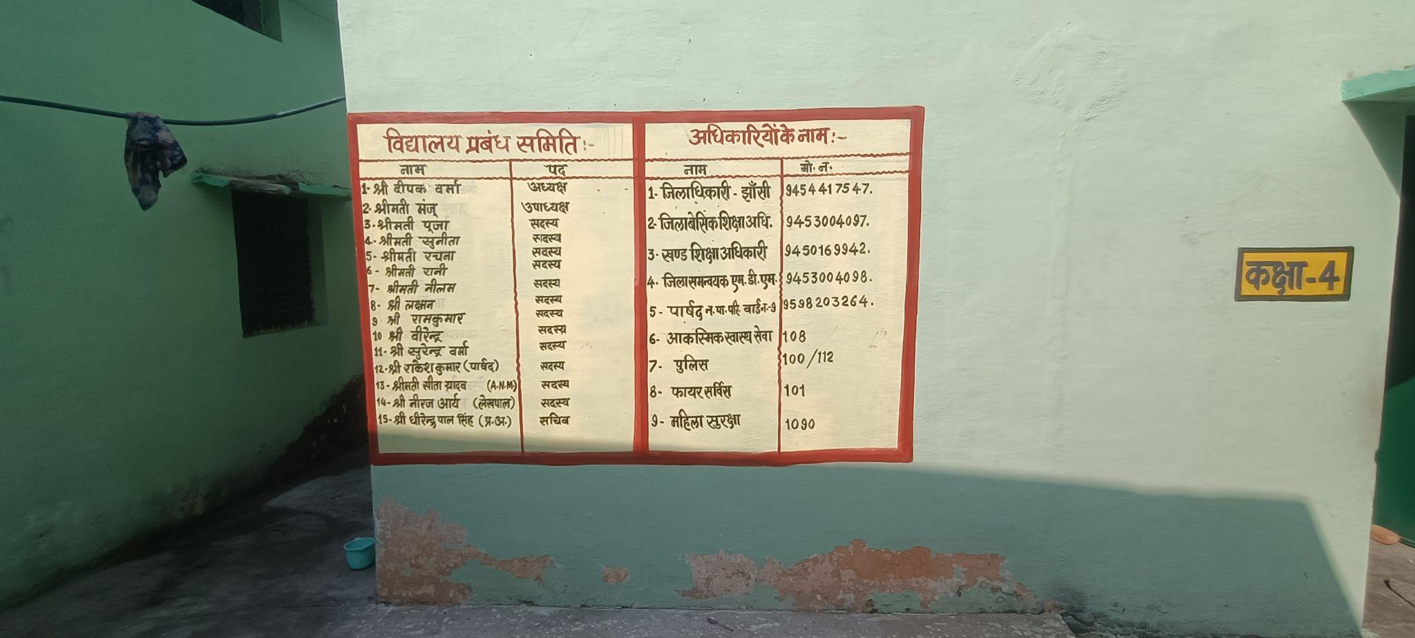
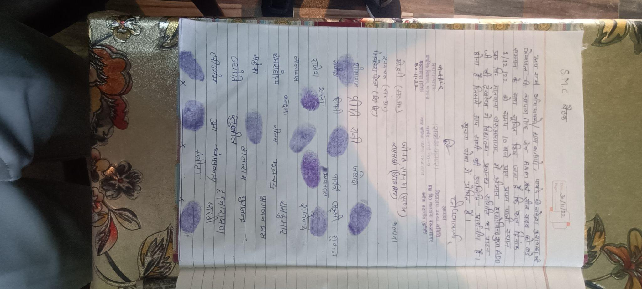
Other Facilities:
There are six classrooms for the teaching-learning process, and another one is for staff or teachers. There is a separate space and enough room for the midday meal. Drinking water, toilet facilities, electricity, etc., are available for students. There is no separate library room for study. Approximately 100 books are available and are in use. We saw a few TLMs that are displayed in the classroom. There are enough places for playing, a functioning separate toilet room for boys and girls, drinking water facilities, and other basic amenities and facilities available.
