**FIELDWORK SUMMARY**

**TEMPLATE**

**DIET NAME:** District Institute of Education & Training Shivrampur, Chitrakoot

**DIVISION:** Chitrakoot Division

**FIELD TEAM:** Paavana Barman (Research Assistant),Vaishnavi & Khushal

**DATES OF VISIT:** 12th - 16th December, 2022 **DURATION:** Five Days

*NOTE: Please add only your observations, do this as a group activity. You may add your reflections for your FA report; this document is only for observations. Please add Photos wherever relevant in the different sections.*

1. **OBSERVATIONS DIETS**
2. **DIET Infrastructure** (Staffroom, Classroom Labs, Library, Sports facilities, ICT Lab, SUPW Room)

The infrastructure within the Shivrampur DIET was in construction, the entire space or land was not that wide unlike Jhansi. There was a two storey seminar room under construction just behind the main building of the DIET. There was an old building located in premises which they had plans to renovate and turn into a training center. The main building was two storeys. It had a total of 3(for classes) classrooms,2 staff rooms,1 Principal’s Office, 1 room for registerar. Besides this there was only one Science lab which wasn’t very well -mainted and had apparatuses which were quite around 1980’s and it also lacked basic chemicals to conduct the experiments. The library was located further away from the main building at the backside. It was a new room but the space was small and didn't have any sufficient books. There was a shelf on psychology, some books on research and education, rather than that they mentioned that science and math books were really needed and also an upgrade on them was necessary. One ICT lab on the upper floor of the main building with five working computers. There was no physical space or playground observed within the DIET premises.

**Teaching Learning Resources** ( Books, posters, displays)-

New books have been in order for the lists in preparation for the proposal for the next Rs. 20 lakh in finance. TLMs are being used and promoted, according to a number of observations made in the classroom and conversations had with the kids and teachers. Learning by doing is encouraged via the tool kit (which is used to teach the majority of the courses; we observed geography, computer education, and home science being taught), chart papers, handmade crafts, online resources, and lecturers.

2. **D.El.Ed Class Observation** (Pedagogy, Interactions etc.) -Four Classroom observations were done on the 12th and 14th of December. These were done on both the batches of 2021 and 2022. The two classes which were observed on the 12th- one a language class and the other was a revision class. The interactions were mostly in the form of a Q and A session. The classes observed for geography and Hindi were mainly content based. At the beginning of the class there was an active engagement noted amongst both students and teachers, the teachers were asking questions to the students and simultaneously introducing the topic.But as the class progressed it was noted that it became more sort of traditional lecture session where the students were passively listening to the the teachers, a more one-way sort of interaction. One thing also noted was that the students at the back were hardly able to get proper view of the boards in the classroom.The process or the way by which this content based information would be transacted by the student teachers during the internship programmes in schools was barely observed in these classes.
4. **D.El Ed Student-teacher Interactions** ( Aspirations, goals, feedback on the programme etc.)

In class, there wasn't much discussion or question-asking from the students. It resembles a one-way class more. The majority of students enroll in the course because of familial pressure or because it will secure them employment with the government. Some students enjoy dealing with kids; thus, they want to be teachers. The curriculum was deemed outmoded by the lecturers. The majority of the curriculum is content-based, meaning it is less concerned with teaching and more with subject matter and theoretical understanding. How to teach is not taught to students. Teachers attempt to teach pedagogy-related concepts. That isn't necessarily the case for all teachers, and it varies from person to person.

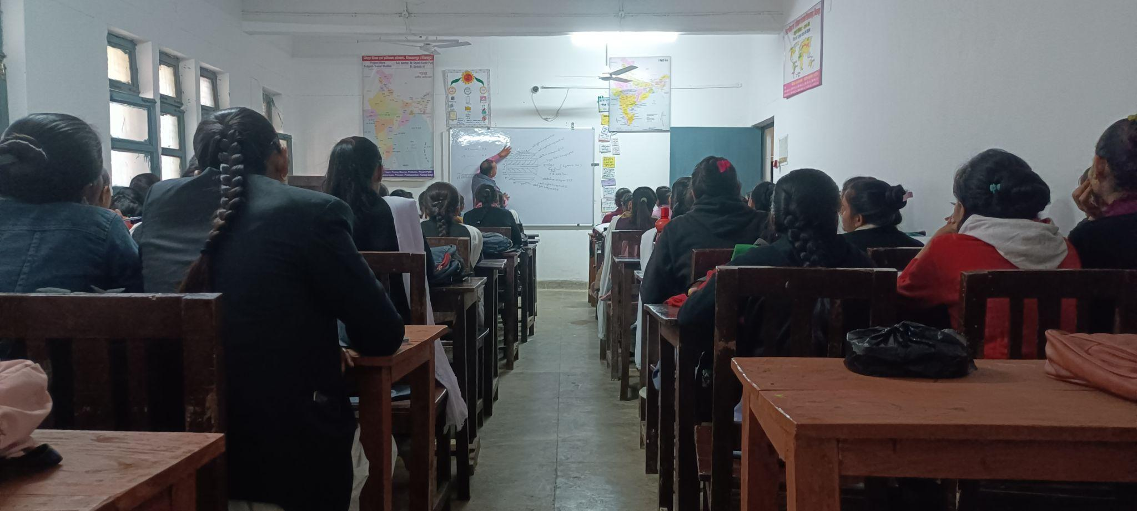

1. **Workshops / Inservice Training Observed -** On the first day of the arrival of the DIET in Shivrampur, the researchers were invited to observe the in-service teacher training session. This session was mainly led by the SAMPARK Foundation NGO and was mainly covering the Language part under Foundational Literacy Numeracy skills. Its objective was to align with the three critical guidelines of NIPUN Bharat. Some other aspects focused on were pre-existing knowledge,

Introduction to bi-lingual stories and simultaneously using english words. The framework was based on the LSRW(Listening, Speaking, Reading and Writing) Framework. Rhymes, theme-based approach. Code mixing and code switching(knowing of certain words of mother tongue in English), On-going assessment and gamified assessment. Besides this the researchers also observed that there were certain TLM’s that were used by them to teach the teachers creative English Kit with alphabets on coloured sponges.

1. **NGOs Presence**

**Sampark Foundation -** a rechargeable audio device—a voice mascot called "Sampark Didi." It is a listening and speaking catalyst for first-time English learners that uses LSRW (listening, speaking, reading, and writing), a "whole language" approach.

1. **Other Observations** (Co-curricular activities, Assembly etc.)- The morning assembly which goes on for about a whole 15 minutes was observed this includes- prayers, national anthem, saying of motivational quotes. This was followed by a biometric attendance of all the students before entering the building. It was noted that the biometric device wasn't able to read the handprint properly, this was also addressed as a concern by the person taking it. A bit of chaos, students coming in late was noted. Due to physical space being less there weren't any co-curricular activities like sports observed.

**B. INTERVIEW SUMMARY** ( Principal / Vice Principal / Sr Lecturer / Junior Lecturer)

1. **Interviewee -- Principal / Vice Principal / Sr Lecturer / Junior Lecturer**

The BSA is in charge of the Principal, but despite having ultimate authority, the BSA is unaware about how the DIET operates. BSA discusses his genuine issue on the field, as well as the limitations of the administration and academic support, as well as the system as a whole.

1. **Institutional Identity and Focus:** [Understand the DIETs identity through the focus areas of work, goals, objectives and its ability and capacity to function as an independent and autonomous institute leveraging state and national schemes]

The main objective of the DIET is to offer maximum capacity building in teaching as pre-service training to the student teachers. There must be focus more on Pre-Service rather than in-service or other administrative, supervisory roles.

In terms of in-service training the DIET’s try to provide them as much as upgraded training as possible. Next goal is to look into the proper implementation of these trainings at the school level. In regards to the NEP objectives aligned with the DIET it was mentioned there hasn't been much focus on the DIET’s, the B.ed professional course is more on focus, there can be implementation of B.Ed as an integrated course within the DIET’s.

**Systemic location and relation to other institutions:** [Understand the DIETs positioning vis-à-vis the state education system, including SCERT and BRCs-CRCs.]

A common concern which came up as from the DIET’s in regards to the support from SCERT was that they needed the posts of clerical staff, senior lecturers and subjects teachers to be filled soon. There is a lack of these people which thereby diverts their purpose from academics.

1. **Financial Aspects:** [Understanding the financial aspects such as provisioning of infrastructure, resources, staff and faculty positions and other facilities.]

Regarding the financial aspects a common point which came up and was put into focus was about their salary not being quite regular.The salary would come in after every 3 months and during the pandemic it went for about 5-6 months.Besides one faculty also mentioned that due to lack of physical space a proposal sent by SCERT which was within the budget of 5 crores for creation of Hostels within the DIET was not approved by them.

1. **Development of Faculty and Staff:** [Understand the current roles and responsibilities, staffing needs of DIETs, the recruitment processes, leadership roles, vacancies, capacity building of DIET heads, faculty and staff and nurturing a professional culture/community.]

The capacity building of the faculty and staff was observed to be scanty, there wasn't much scope for teacher educators to reflect on their teachings within their profession.However there was presence of some Formal Groups which was created by SCERT as well as some inner informal Faculty groups within DIET’s in Whatsapp towards creating some sort of development within the profession. They were mainly involved in a lot of administrative work due to lack of staff. In regards to the vacancies they mentioned that for some subjects the government is not filling up posts. Eg- Statistics teacher was teaching Math. This was mentioned in line with the recruitment process which needs to be filled in with subject teachers and similarly with the post of Senior Faculties, so that there is less work load.

1. **DIET functions and Activities:** [Understand the different functions and activities implemented by the DIETs by way of inputs, processes, outputs, and outcomes, including teacher development, both pre-service and in-service, DIETs as resource and teaching-learning centers and institutes for local curriculum and material development.]

**Functions and Activities of DIET:**

1. Training and orientation of elementary and secondary school teachers (both pre-service and in-service) on various school subjects.

2. Orientation of Heads of School Complexes on New Trends in Education.

3. Academic and resource assistance to the district's elementary and secondary education systems.

4. To undertake action research to deal with the specific academic problems of the district in achieving the objectives of education.

5. To familiarize the stakeholders in school education in the district with new trends and approaches in education.

6. To organize seminars and workshops on various educational topics to enhance the abilities of teachers and teacher-educators.

7. Extension activities and interaction with the field.

8. To act as a resource and learning center for teachers and trainees.

9. Development of locally relevant materials as teaching aids, evaluation tools, etc.

10. To serve as an evaluation center for elementary and secondary school programmes.

1. **Collaborations and Partnerships:** [To understand DIETs working with partners such as universities, DIETs within and across states, NGOs, and multilateral funding agencies towards gaining access to expertise, capacity building, networking and institution building.]

The SCERT has formed formal groups for specific subjects in which all DIET lecturers of that subject share their ideas, propose new methods, and innovate new ways to teach the subject. There are also some lecturers who, in their own capacity, interact with their fraternity to learn something new about their subject.

**SAMPARK Foundation NGO**

a rechargeable audio device—a voice mascot called "Sampark Didi." It is a listening and speaking catalyst for first-time English learners that uses LSRW (listening, speaking, reading, and writing), a "whole language" approach.

1. **COVID-19 Impact:** [ Overall impact of lockdown and pandemic-related issues]

Conducted Mohalla Classes during COVID,

Classes, Training, Monitoring Shift to Online Platforms.

**C. INTERVIEW SUMMARY STAKEHOLDERS** ( BSA | BEO/BRP | SRG |DCT |ARP)

1. **Interviewee -**  ( BSA | BEO| SRG|DCT|ARP)

Interviewed BSA, DCT, BEO, and 4 ARPs.

BSA, DCT, BEO, ARPs

1. **Job/Role as described by Interviewee**

**BSA-**

1. To consider and grant leave to all the employees under him.

2. To have administrative control over all primary and junior high school schools.

3. Keeping the account of Basic Education Fund.

4. To investigate and take appropriate action on conflicts between non-gazetted officers.

5. Inspecting the school and taking appropriate action on negligence.

To approve the distribution of salary of all the employees under him.

**DCT-**

Coordination between the different stakeholders like BSA, BEOs, SPGs, ARPs.

**BEO-**

The BEO works at the block(Taluka) level. Main function is to administer, supervise, inspect, guide and control education at the block level.

**ARPs-**

1. Supportive supervision of 30 schools with the uploading of the required information on the PRERNA portal.

2.Academic support & monitoring their respective subjects

1. **Opinions/issues expressed by the interviewee**

* Poverty in the region.
* Parents of students from these interiors are working mainly as laborers. Creating and impact on the need of foundational education gets tough,
* Migration of parents to other states for earning livelihood creates issues of out of school children and also contributes more towards learning gaps.
* There is a lot of network and connectivity issues which creates a huge issue in online learning throughout the region.
* Some ARP’s are not that motivated to teach the in-service trainees.
* Main focus should remain on learning outcomes , but it gets distracted with administrative work.
* During in-service training the arrangement of lunch must be repalced with simple refreshments as this kills a lot of time and there is huge expenses that needs to be covered.
* The teaching technique/ pedagogy needs to be focused a lot. Need to understand individual needs of each child understand their levels and accordingly reflect on their teaching.
* There should be atleast training for about a week or 15 days for the District Coordinators before going into the profession as it very hard at the beginning to understand and adjust to the functioning of the system at the ground level. It sometimes takes about two- three months just to understand the structure.
* There is good support coming in from the ARP’s but the teachers are not co-ordinating well with these ARP’s(Academic Resource Person). They mainly think them as just teachers or colleagues, there are some experienced as well as new teachers who don’t think that these ARP’s can teach them better or they know better.
* Teachers must be given freedom within their profession. A target or aim should be set towards the percentage of learning outcomes which needs to be achieved or else would be faced by legal consequences. Besides, this the all sorts of administrative work must be denounced by the teacher.

1. **Nature of Interactions with DIET /DIET Faculty**

There are monthly meetings which are held with the DIET Principal and Faculty where in issues relating to these primary schools are discussed when they go in for the supportive supervision.In some ways these DIET faculties sometimes suggest the ARP’s on TLM’s or how it can be improved. The sort of different aspects they need to inculcate more while at the field.

**D.OBSERVATIONS SCHOOLS**

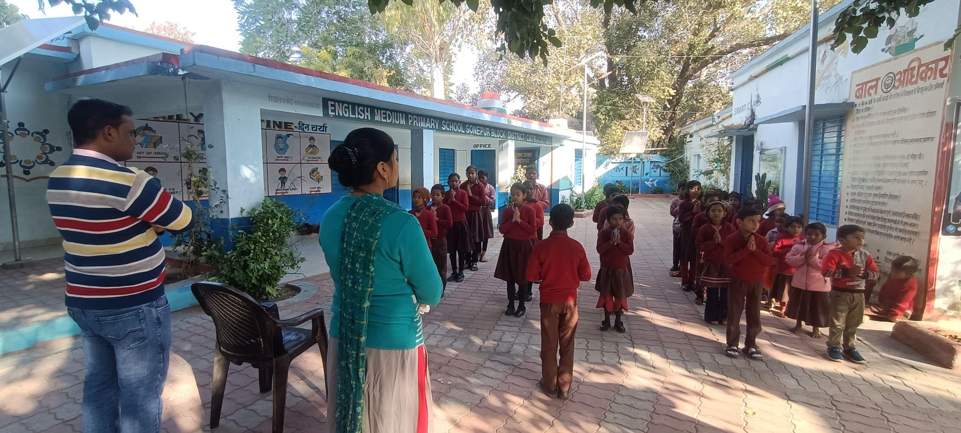

1. **School Type** (Primary, Upper Primary, Composite, KGBV)

#### 

#### **PV SONEPUR-**

#### This was a lower primary english medium school as soon as the team arrived there was Morning Assembly going on. The school had an enrollment rate— Boys:80 Girls-81 ratio was-. These students are enrolled by a yearly tracking process during the month of April under School Chalao Abhiyan.

**PMV School SARAIYAN Manikpur Block is located in a Rural Area.**

#### 

#### 

#### 

#### **K.G.B.V. SHIVRAMPUR-** The Kasturba Gandhi Awasi Balika Vidyalaya was located within the DIET. It was an Upper Primary Girls Schoo it was established in 2005 and it is managed by the Department of Education. Hindi is mainly the medium of instruction and it

1. School Location /Surroundings (Rural or Urban)

English Medium Primary School Sonepur is located in a Rural area.

1. **Infrastructure** (Staffroom, Classroom, Playground, Drinking Water, ICT Lab, Toilets, Facilities for special needs students/students with disabilities)

#### 

#### The Sonepur School had 5 classrooms in total, this also includes one smart class located at the very right of the entrance. There were no staff rooms observed, the playground space was also limited, drinking water facilities were more in basin form with running water facilities. Two toilets were present for both girls and boys on either side of the main gate. There weren't any working toilet facilities for the differently abled children.It was also noted that there weren't any sitting arrangements for the students, lack of chairs, students used to sit on mats, rugs and attend classes.

The School in the Manikpur block at Saraiyan village had a total 3 classrooms which were quite small in its structure, so it was observed that some students were attending classes outside. Two classrooms were equipped with ICT. There were three toilets present within the school premises which included a girls toilet with sanitary napkin facilities, one boys toilet and one toilet for the disabled. It also had RO drinking water facilities but here too there was a lack in the physical space with no playgrounds observed. The sitting arrangements within the classes also lacked chairs and students were attending classes sitting on rugs.

#### 

#### The Composite school at Agarhundam, Manikpur was under construction at the time we arrived. There were a total of 6 classrooms observed, with one Principal’s office. There weren't any rooms for the teachers. It had a science class which included a projector and a white board. Toilets were two in total. The physical space was observed to be more in this DIET. There was a fairly large playground to facilitate sports activities.Classrooms here too were observed to lack in sitting arrangements and students mainly sat on rugs/ mats and attended the classes.

#### 

The KGBV is a government building at the institution. For educational reasons, it has 3 classrooms. The classrooms are all in decent shape. It features two more rooms for uses other than teaching. For the Headmaster and Teachers, the school has a separate chamber. A Pucca boundary wall surrounds the school. The school is connected to electricity. Hand Pumps are the school's functional supply of drinking water. The school has one functional male restroom. and five females, and it is a working restroom. It contains a playground for students.

1. **Teaching Learning Resources** ( Books, posters, displays)

In all these schools visited in the Chitrakoot Division they were mainly following SCERT books. There were TLM’s, Math, science and english kits observed. In regards to its usage it was observed to be used in a class under the composite school. The school PMV saraiyan had one ICT room which included a lot of 3D innovative modules of human anatomy and story-telling methods of explaining concepts of heat. The posters and displays included foundational concepts on grammar-tense, negative, interrogative sentences,Global handwashing Day, pictures on cleanliness. Social messages like ‘Save Girl’, ‘Teach Girl’,TLM’s on identifying numbers, days in a week , names of India’s president , prime minister etc.

1. **Class Observation** (students, blackboard, Seating, Pedagogy, Interactions etc.)

The classroom observation in all these schools were mostly a combination of traditional lecture method, blackboard teaching, Question and Answer session to the latest use of 3D based ICT modules in understanding the structure of human anatomy. There were both blackboards and whiteboards noted. The sitting arrangements were mostly in rugs and mats there was lack of tables and chairs in the classrooms. The interactions would be mostly at the beginning of introduction to the topic or only when the teacher would ask them questions. Besides the students would tend to be passive listeners.

1. **Interaction with head teacher/teacher- The interactions with the teacher head teachers can be summarized under the following core points-**

* Basic need for all three schools- Classrooms, Science labs, Computer room, libraries, Clerical staff.
* BSA, BEO and other officers are not providing adequate support especially in infrastructure.
* Enrollment rate will increase to maximum , the target given every year will be achieved if they provide more classrooms.
* Training during In-service were management training, swachta training at scert level and Power Angel training for female teachers on self-defense empowerment.
* The online training provided to teachers with links have no contextual alignment with schools and are given to complete with certain targets creates burden, confusion and not at all useful.
* School Chalao Abhiyaan in the interiors has not been able to be very successful especially in the Composite School. After every 3 months there are dropouts noticed.
* Impact of administrative work is there for both teachers and students.
* More enrollment rate notedin the English medium schools.

* Teacher professionalism new ways of classroom management needs to be trained. This was pointed out as a major gap.

1. **NGOs Presence**

**Sampark Foundation -** Sampark Smartshala is offering free educational content for students and teachers in both Hindi and English languages. Pratham foundation will also be organising a training programme for classes 4-8.

1. **Other Observations** (Co-curricular activities, Assembly etc.)-. Besides the basic lack of infrastructure of desks and benches in the classes the Upper Primary School of Saraiyaan particularly it was sharply observed how there was a complete lack of space which drove the stakeholders of this school to conduct exams outside and also the students of these schools did’nt seem to have notebooks they were writing mainly in a piece of paper or on hardboards.