PERUNTHALAIVAR KAMARAJAR COLLEGE OF EDUCATION
[Recognized by NCTE & Affiliated to Pondicherry University]
NEHRU NAGAR, KARAIKAL – 609 605
FUNCTIONING UNDER THE AEGIS OF PONSHE, PUDUCHERRY

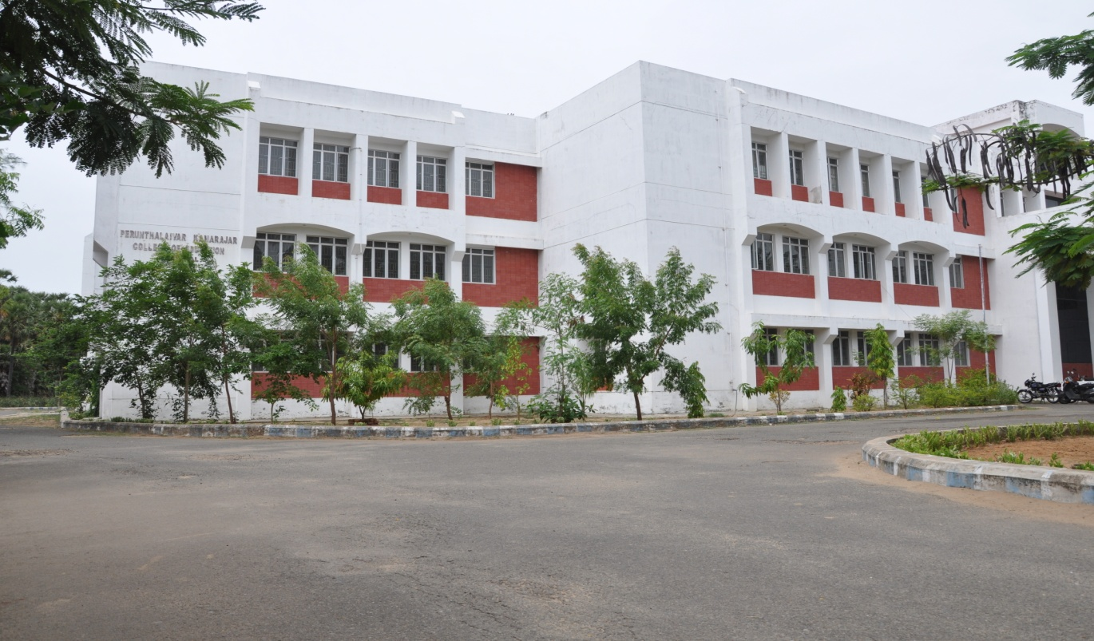

SELF APPRAISAL REPORT

SUBMITTED
TO

ACADEMIC & ADMINISTRATIVE AUDIT, PUDUCHERRY

AUGUST 2017

Phone: 04368 – 231 390 Fax: 04368 – 231 490

PART I

INSTITUTIONAL DATA
FOR AAA

- PROFILE / DETAILS OF THE INSTITUTION

- Name and address of the institution:
PERUNTHALAIVAR KAMARAJAR COLLEGE OF EDUCATION,
NEHRU NAGAR, KARAIKAL – 609 605,
UNION TERRITORY OF PUDUCHERRY.

1.2 Date of Establishment :
MM
YYYY
01
2001

  - Address for communication: Perunthalaivar Kamarajar College of Education
First Cross, Nehru Nagar, Karaikal 609 605

e-mail Address : pkce.kkl@gov.in & pkcekaraikal@yahoo.com
Name | Phone  Number with STD Code | Fax No | E-Mail Address
Dr. P. Banumathi  Principal – i/c | 04368 231390 | 231490 | pkcekaraikal@yahoo.com  pkce.kkl@gov.in
S.MOHAN KUMARAMANGALAM  Co-ordinator - IQAC | 04368 231390 | 231490 | rewamohan@gmail.com

Residence
Name | Telephone Number with STD Code | Mobile Number
Principal – i/c | 04368-231410 | 9442987076
Co-Ordinator - IQAC | --- | 9442630891

1.6 Website Address : www.pkcekkl.edu.in

1.7 Accreditation Details :
SL  NO | CYCLE | GRADE | CGPA | YEAR OF  ACCREDITATION | VALIDITY  PERIOD
01 | 1st Cycle | A | 3.38 | 2014 | 12 / 2019

1.8 Institutional Status :
√
Affiliated College : Yes NO

Affiliating University / Board to which the institution is affiliated:
PONDICHERRY UNIVERSITY (Central University), PUDUCHERRY.
√

-
1.9 Autonomous College of UGC : Yes NO

√

Type of Institution : Co-education Men Women

Location of the Institution :
Urban Semi-urban Rural Tribal Any other
√

Financial Status :
√

Govt. Grant-in-Aid UGC 12B UGC 2F

1.10 Type of Faculty / Programme :
Arts : Science : Commerce : Law : Education :
√

Polytechnic : Engineering : Health Sciences Management

  - Special Status conferred by Central / State Govt. – UGC/ CSIR/ DST/ DBT/CMS
STATE
Autonomy by State / Central Govt. / University

College with potential for Excellence :

Campus area in acres: - Own land
02.00.50 Ha [20050 Sq. m]
√
Is it a recognized minority institution? Yes No

Details of UGC recognition under sections 2(f) and 12(B) of the UGC Act.
Month & Year Month & Year
MM
YYYY
04
2009
MM
YYYY
04
2009
2(f) 12(B)

II IQAC Composition & Activities

2.1 No. of Teachers : | 10
2.2 No. of Administrative / Technical Staff : | 2
2.3 No. of Students : | 4
2.4 No. of Management representatives :
2.5 No. of Alumni | 4
2.6 No. of any other stakeholder & com. Representative
2.7 No. of Employers / Industrialists :
2.8 No. of Other External Experts :
2.9 No. of Members : | 20
2.10 No. of IQAC Meetings held : | 6
6
2.11 No. of meetings with various stake holders : No. Faculty

2.12 Has IQAC received any funding from UGC during the year :
√

Yes : No :

Does Not arise
If yes Please mention the amount :

2.13 Seminars & Conferences ( Only quality related )

No. of Seminars / Conferences / Workshops / symposia organized by IQAC

3
(i) Total Nos : International National State Institution Level
1

(ii) Themes

Gender Perspectives
Legal Rights
Career Development

2.15 Plan of Action by IQAC / Outcome

The plan of action chalked out by the IQAC in the beginning of the year towards quality enhancement and the outcome achieved by the end of the year.

PLAN OF ACTION | ACHIEVEMENTS
It has been decided to conduct awareness programme on legal right September 2016 | Awareness programme conducted for as many as 100 students of B.Ed & D.El.Ed about anti Ragging & legal rights of women.
It has decided to conduct career development / capacity building programe during January 017 | Career Development / Capacity building programme was organized to Both B.Ed & D.El.Ed students. A lecture was given by  …………….. Professor, Central University, Delhi on career prospects.
It has been slated to conduct National Seminar on Gender Perspectives under RUSA | A two days National Seminar “On Gender Perspectives was organized during 26 & 27th April 2017. Dr. Manimegalai & Dr. Sudha, Professors from Department of Women Studies, Bharathidasan University, Trichirapalli were special invitees. As many as 50 research papers have been submitted during the seminar.
* Attach the academic Calendar of the year as Annexure.

III - COURSE DETAILS

Sl.  NO | Courses  Offered | Year of starting | Sanctioned strength | Year of revision of syllabus
01 | B.Ed | 2001-02 | 100 * | 2015-16
02 | D.El.Ed | 2006-07 | 100 ** | --

* The B.Ed course has been converted into two year course from the academic year 2015-16 and the syllabus was changed according to two year’s duration. With two units of 50 each.

** The D.El.Ed Course was started during the academic year with an intake of 50 students ( one unit for each year) . Since it is established as a Teacher Education Institute, the following teacher education programmes are offered.

Details of Teacher Education programmes offered by the institution:
Sl. No. | Level | Programme/ Course | Entry Qualification | Nature of Award | Duration | Medium of instruction
i) | Pre-primary |  |  | Certificate
 |  |  |  | Diploma
 |  |  |  | Degree
ii) | Primary/  Elementary |  |  | Certificate
 |  | D.El.Ed. | H.Sc. (+2) | Diploma | Two yrs | Tamil
 |  |  |  | Degree
iii) | Secondary/  Sr. Secondary |  |  | Certificate
 |  |  |  | Diploma
 |  | B.Ed. | Graduation | Degree | One year | English
iv) | Post Graduate |  |  | Diploma
 |  |  |  | Degree
v) | Other  (specify) |  |  | Certificate
 |  |  |  | Diploma
 |  |  |  | Degree
Details of NCTE recognition (for each programme mentioned above)
 | Order No. & Date | Sanctioned Intake
Elementary  D.El.Ed. | F.SRO/D.Ed./2006-07/6802 dated 15.07.2006 | 50 | 50
Secondary  B.Ed. | F.PN/NEW/SEC/SRO-NCTE/2001-02/6778 dated 21.06.2001 | 60 | 100
 | F.N.PN/SE-AI/42/SRO-NCTE/2004-05/2689 dated 13.04.2004 | 40
Permanent Recognition vide
Order No. F.SRO-NCTE/2004-05/ 2698 dated 18.04.2004

4. Details of Students:
4.1. Mode of Admission : merit basis of the qualifying examination
02
18
11
50
4.2 Reservation in Admission in % General OBC MBC EBC
01
16
02
BCM SC BT
4.3 Details of students admitted:
Course | 2013-14 | 2014-15 | 2015-16 | 2016-17 | 2017-18
B.Ed  (Bachelor of Education) | 100 | 100 | 76 | 50 | Under progress
D.El.Ed  (Diploma in Elementary Education) | 38 | 35 | 30 | 36 | 50

Course | 2016-17 |  |  |  |  |  | 2017-18
 | Boys | Girls | OBC | SC | BT | Total | Boys | Girls | OBC | SC | BT | Total
B.Ed | 02 | 48 | 42 | 08 |  | 50
D.El.Ed | 02 | 34 | 30 | 06 |  | 50 | 06 | 44 | 42 | 07 | 01 | 50

4.4. Details of resultsFinal year results only)
Course | 2015 |  |  | 2016 |  |  | 2017
 | appeared | Passed | % Result | appeared | Passed | % result | appeared | Passed | % result
B.Ed | 100 | 93 | 93% | 76 | 71 | 93% | 76 | Result awaited
D.El.Ed | 29 | 7 | 24% | 28 | 6 | 21% | 28 | Result awaited

5. Details of Staff:
B.Ed & D.El.Ed
5.1 Teacher –Students ratio: 13 : 100
5.2 Details of Faculty
Department | No. of sanctioned Posts | No. of Staff  (filled) |  |  | No. of posts vacant | No. of faculty with Qualification |  |  | No. of papers Pub-lished | No. of seminars conducted
 |  | Regular | Temporary | Part-time |  | Ph.D | M.Phil | NET/ SLET
B.Ed | 17 | 10 | - | - | 7 | 6 | 7 | 10
D.El.Ed | 9 | 6 | - | - | 3 | 2 |  | 4

5.3 No. of Research Projects Completed ongoing

13 : 11
5.4 Teacher – Non-teaching staff ratio:

5.5 Details of Non-Teaching Staff:
Designation | No. of Posts
 | sanctioned | present | vacant | Out-sourcing
Principal | 1 | - | 1
Accounts Officer |  |  | -
Superintendent | 1 | 1
Assistants/UDC/LDC | 4 | 3 | 1
MTS-Security | - | - | - | 6
MTS- House Keeping | - | - | - | 4
MTS- General | 4 | 4 | -
College Librarian | 1 | 1 | -
Director of Physical Edn | 1 | 1 | -
Asst Librarian | 1 | 1 | -
6. Infrastructure Facilities:
6.1 Facilities in the Department:
Department | No. of Class Rooms | No. of Laboratories | No. of Computers | No. of Books | WiFi/Internet connection | Others
Physical Sciences | 01 | 01 | 01 |  | -- | E.T., ICT & Psychology lab common for all Depts.
Biological Science | 01 | 01 | 01 |  | --
Mathematics | 01 | 01 | 01 |  | --
English | 02 | Language lab | 10 + 7 +2 = 19 |  | --
Tamil | 02 |  | 02 |  | --
Social Sciences | 01 |  | 01 |  | --
Psychology |  | 01 | 01 |  | --
Commerce | 01 |  | 01 |  | --
For D.El.Ed
First Year | 01 | 01 | Common Science Lab
Second year | 01 | 01 | ICT lab with 50 computers

6.2 Library:
8193
No. of Books

40
No. of Journals subscribed:
No. of Magazines subscribed
√
Whether Computerised Yes Partially computerised

03
No. of Staff in the library
√
Reading room available: Yes No

6.3 Physical Education:
√

Whether Playground available Yes No
√

Indoor Stadium available Yes No
√

Whether Gym available Yes No

Details of Prizes/Medals won in the national/International level:

Does not arise

7. Students Support:

7.1 Canteen available Yes No
√

√

7.2 Girls Rest Room Available Yes No
√

7.3 Toilet facilities available Yes No

7.4 RO system/Drinking Water available Yes No
√

8. Extracurricular activities
√

8.1 NSS No. of Units No. of Volunteers

8.2 NCC No. of Cadets
Action has been initiated to adopt Thalatheru village
8.3 Village Adoption Name of the Village:
Activities undertaken in the village:
Does not arise

8.4 Other activities:
1) Red Ribbon Club
2) Weekly Shramdaan cleaning activities
3) Yoga classes. & Coaching classes for CTET
4) Self defense Karate classes.

