TISS Evaluation of the CSSTE, August-September 2017 |  | Tool 5 | Institution fact sheet for IASE, CTE, DIET and BITE
Instructions Please ill up the basic information about the institution, with the help of interview of the institution head. General (Data may available with CTE / DIET / BITE – In Annual work plan Document – 5 year trend)
State | MAHARASHTRA | District/Place | NANDURBAR
Name of institution | DIECPD, NANDURBAR
Researcher name | Shiva Thorat | Date of visit | 04 September 2017
Respondent name | DR.R.D.KAMBALE | Designation | PRINCIPAL

- When was the institution established? Was it upgraded from some earlier institution? What was its earlier form?
The institute was established in 2011. It was newly started after the declaration of Nandurbar as district.

- Organizational Structures (organogram) today.
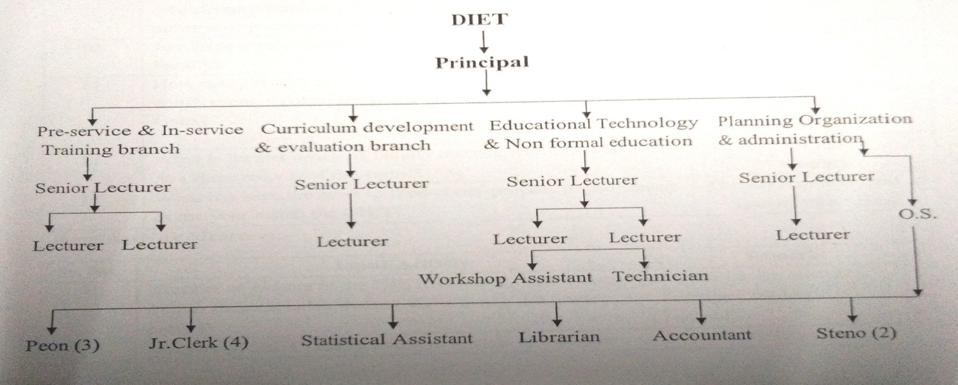
In addition to this we have 9 Subject Assistants to work for Pragat Shaikshanik Maharashtra.

- Academic posts vacancy (note vacancies and transfers over the last five years)

Year | Sanctioned | working | Transfered in the year
2012-13 | 11 | 05 | 01
2013-14 | 11 | 07 | 01
2014-15 | 11 | 08 | 02
2015-16 | 11 | 06 | 03
2016-17 | 11 | 08 | 02

- Non academic posts (note vacancies and transfers over the last five years)

Year | Sanctioned | working | Transfered in the year
2012-13 | 14 | 01 | 00
2013-14 | 14 | 00 | 00
2014-15 | 14 | 02 | 00
2015-16 | 14 | 04 | 00
2016-17 | 14 | 05 | 01

- What are the key duties which the institution is expected to perform and which are performed within the current constraints of resources? (note expected duties and actually performed duties)
- To monitor and empower pre-service training colleges in the district.
- To develop district academic plans and monitor the quality of schools and teaching.
- To design interventions for direct support to schools and work with special groups in the district.
- To be responsible for in-service training of both primary and secondary school teachers.

- Has there been any recent major revision of the duties and functions of the institute? After RTE? After CSSTE 12th plan?
There has been major revision of the duties and functions of the institute. The training policies have been changed. The approval from district Level Executive committee needs to be taken for smooth functioning. Since 2015 each stakeholder is trying for making children 100% learn through support.

- When did these take place? And why? ( who has occasioned them? For what reasons? Etc)
After the meeting of DIET Principals at Pune dated 11th December 2015 the meeting was held in DIET for smooth functioning and to channelize the new role of DIET.

- Was there any revisioning exercise based on which these changes were made?
Yes, there were two meetings held at DIET on 14.12.15 & 22.12.15 respectively.

- Have there been any major restructuring of the institution? Why? How does the present structure compare with the earlier structure? Better/ more problems etc.
As per the Government resolution dated 16 October 2017 there has been a major restructuring of the institute 9 Subject Assistants have been appointed for quality of education purpose throughout the district under Pragat Shaikshanik Maharashtra Programme. Now the Academic staff is almost complete. So it is helping hand to our institute.

6.Collection of related Documents –Syllabus of ongoing courses (Pre-service) and Annual work plan/budget (if any)

7. Which of the following activities of the DIET are currently taking place (as envisioned in the 2012 guidelines):
Role | Yes/No
1. Has the DIET been conducting ISTE programs? | Yes | No. of Master resource persons prepared, no.of courses designed, school follow up and documentation | Selection grade trainings, workshops etc, depending upon no.of trs. resources are prepared.
2. Has the DIET planned for direct school intervention and improvement? | Yes | How Many interventions planned and What kind of interventions? | The interventions are categorized under 3 heads-  - 100%enrolment  - 100%retention in class  - 100%expected achievement
3. Has the DIET developed as a resource centre? | No | What kind of resources? How many? Who uses the resource centre | --------
4. Has the DIET organized forums? | Yes | How many conducted? How many participants were there? On what were the forums conducted? | In each tahsil at least Quality Education forums were organized.
5. Has the DIET organized co-curricular activities? | Yes | How many? On what? And for whom were these conducted? | Competition on the occasion of Population Day related to Population Education
6. Has the DIET followed the staffing guidelines? | Yes |  | The staffing pattern is sanctioned by government .The posts are filled through competitive exams.
7. Does the DIET have a PAC? | Yes | If yes, is the composition as per suggested norms? How many times have they met? Are there any minutes of meetings? Collect if any? | The advisory committee is formed as per the norms given.
8. Are the infrastructure facilities at the DIET as per the guidelines? (use guidelines to expand and check against each) | Building  Under  Construction | - Classrooms  - Seminar rooms  - Special rooms  - Staff rooms  - Library  - Hostels  - Canteen / Dining Hall | The building for DIET is under construction.
9. Has the DIET established systemic linkages with other institutions? | Yes | Details of linkages/interactions with SSA, RMSA, CTE, SCERT, NGOs, Higher education institutions, others. What is the nature of / operational form of these linkages and meetings? | There is linkage of DIET with SSA/RMSA/NGos etc. There is a collaboration among these institutes to implement various schemes through different stakeholders to serve the purpose.
10. Does the DIET conduct any programs/ activities for faculty development and capacity building? | No | How many in the last five years, topics, number of participants? | The faculty development programmes are conducted by SCEART or NCERT as and when planned.
11. Is the DIET involved in research activities? | Yes | -Areas of research covered  -No. Of publications | School subjects,Self learning material .  13 action researches
12. Has the DIET prepared the perspective plan? | Yes | How is it prepared? | It was prepared after the state level meeting. The meeting of DIET faculty was called twice for perspective plan.
13. Has the DIET prepared its annual plans? | Yes | How are these prepared? | Each faculty member contributed for annual plan as per their departments.
14. Has the DIET introduced any innovation in the role it plays ? | Yes | Details of innovative programs? Who has funded them? | The dictionary named “Pravas Satpudyacha” and Activity book is prepared. Through SSA.

8. CTEs

Not Applicable for DIET

8.1. Role as envisaged under 2012 CSSTE Guidelines
Role | Yes/No | If yes, details | Remarks
1.Has the CTE played a role in development of excellence in secondary teacher education? |  | -Needs analysis surveys for trainings conducted  -Creation of context specific handbooks  -maintenance of detailed database on secondary schools and secondary school teachers  -other activities
2. Have new CTEs been set up wherever a need was identified?
3. Has the CTE developed collaboration with IASEs? |  | -Capacity development of CTEs  - Capacity development for handling research
4. Has the CTE developed collaborations with SCERT? |  | -Facilitating collaborations with other state agencies  - Support provided to the CTE’s PAC
5. Has the CTE used ICT effectively? |  | -Adherence to NCFTE 2009 norms  -Retention of institutional memory  -Institutional Development  -Development of institutional links  -Development of locally relevant teacher education modules  -Development of COPs
6. Has the PSTE programme been implemented? |  | How many students have completed the PSTE?
7. Has the mandated process of tracking and monitoring been followed?
8. Does professional development of TEs form a part of the CTEs activities? |  | In what way?
9. Has the ISTE program been implemented? |  | How many participants in 5 years?
10. Has the CTE provided extension and resource support to secondary schools? |  | How many schools? What kind of support has been provided?
11. Has the CTE provided resource support to DIETs? |  | How many? When? What support was provided?
12. Has the CTE established linkages with other education institutions?
13. Has the CTE undertaken research? |  | Number of research studies? What were the topics? How were these disseminated or used?
14. Has material development taken place? |  | What kind of material? How many resources were used? Where is this material available?
15. Is the organisational structure and personnel as per the given norms? |  |  | If these are not followed, why not?
16. Are the 1989 infrastructure guidelines followed? |  |  | If these are not followed, why not?
17. Is the annual work plan prepared? |  |  | If this is not prepared, why not?
18. Are there annual reports prepared? |  |  | If this is not prepared, why not?
19. Does the CTE have a perspective plan prepared? |  |  | If this is not prepared, why not?
20. What innovations have been introduced by the CTE in its role?

9Academic and non-academic posts vacant as of August/Sept 2017:

 | sanctioned | Post filled | Permanent / Contractual | Innovations/ Measures to deal with vacancies | Any Litigation for not filling up vacancies
Academic | 11 | 10 | Permanent | Extra workloads | Government Decisions
Non-academic | 14 | 04 | Permanent | Extra workloads | Government Decisions
Total | 25 | 14

- Faculty Information
1 | Is there an appointed head or acting head? | Appointed Head
2 | What is the total faculty senior | 03
3 | What is the total faculty-junior | 06
4 | How many faculty fulfil the NCTE qualificaitons> | 10
5 | Which subject specialisations do faculty have?  Science, maths, language (of the state/region), English, social sciences, work experience art, physical education, education foundations including psychology and history. | R.D.K.-Chemistry  A.S.Z.-.Marathi  S.N.A.-Hindi  R.G.C- Marathi,Edu.commu  G.E.B-Electronic  S.S.T-Psy.,Pol.Sci.  B.R.P-Marathi  C.A.P-Hindi,Histroy  P.S.J.-English  S.D.M.-Hindi

- How may inservice programmes were conducted under the CSSTE scheme?

 | For teachers | For MRPs/KRPs | For teacher educators/TEIs | School heads
2011-2012
2012-2013
2013-2014 | 05 | 01 | 02 | 00
2014-2015
2015-2016
2016-2017

- How many in service programmes were conducted under other schemes? (SSA/RMSA/other state funds)

 | For teachers | For MRPs/KRPs | For teacher educators/TEIs | School heads
2011-2012 | SSA-01 | SSA- | SSA- | SSA-
2012-2013 | SSA-01 | SSA- | SSA- | SSA-01
2013-2014 | SSA-  RMSA-01 | SSA-  RMSA- | SSA-  RMSA- | SSA-  RMSA-01
2014-2015 | SSA-  RMSA-06 | SSA-01  RMSA- | SSA-  RMSA- | SSA-  RMSA-
2015-2016 | SSA-  RMSA-04 | SSA-  RMSA- | SSA-  RMSA- | SSA-  RMSA-
2016-2017 | SSA-01  RMSA-04 | SSA-  RMSA- | SSA-  RMSA- | SSA-  RMSA-

11. Student Profile (2016-17)

Course Name | No. of Students | No. of Girls | No. of SC Students | No. of ST students | No. of students from under Rs. 1 lakh annual family income | Any other details
D.Ed.I year | ------- | ------- | ------- | ------- | ------- | -------
D.Ed.II Year | 12 | 12 | 02 | 02 | 11 | ----------
Correspondence Course | 75 | 06 | 01 | 66 | -- | ---

11. Funds received and utilized by DIET/CTE/BITE Under the CSSTE scheme

S.No. | Year | Fund proposed (in Lakhs) | Fund sanctioned (in Lakhs) | Fund received (in Lakhs) | Date on which funds received | Fund utilized (in Lakhs) | If there was any additional (apart from what was received from the Centre as per guidelines) source of funding please mention
1 | 2011-12
2 | 2012-13 |  | 21.57 | 21.57 | March | 21.57
3 | 2013-14 | 359.955 | 58.03 | 58.03 | March | 58.03
4 | 2014-15 | 388.46 | 97.33 | 97.33 | March | 97.33
5 | 2015-16 | 422.02 | 77.49 | 77.49 | March | 77.49
6 | 2016-17 | 432.32 | 127.21 | 127.21 | March | 127.21

12. What were the other sources from which funds were received? (please include also funds raised by the institution locally.

S.No. | Year | Source/  scheme | Amount (in lakhs) | purpose | Date on which funds received | Fund utilized (in Lakhs) | Achievements
1 | 2011-12
2 | 2012-13
3 | 2013-14 |  |  | NIL
4 | 2014-15
5 | 2015-16
6 | 2016-17

