**FIELDWORK SUMMARY**

**TEMPLATE**

**DIET NAME: DIET Bareilly (Faridpur) DIVISION:**

**FIELD TEAM: Anjali Kaushik, Shreya Ghosh, Tejal Ahuja**

**DATES OF VISIT: 5- 10 December 2022 DURATION:**

*NOTE: Please add only your observations, do this as a group activity. You may add your reflections for your FA report; this document is only for observations. Please add Photos wherever relevant in the different sections.*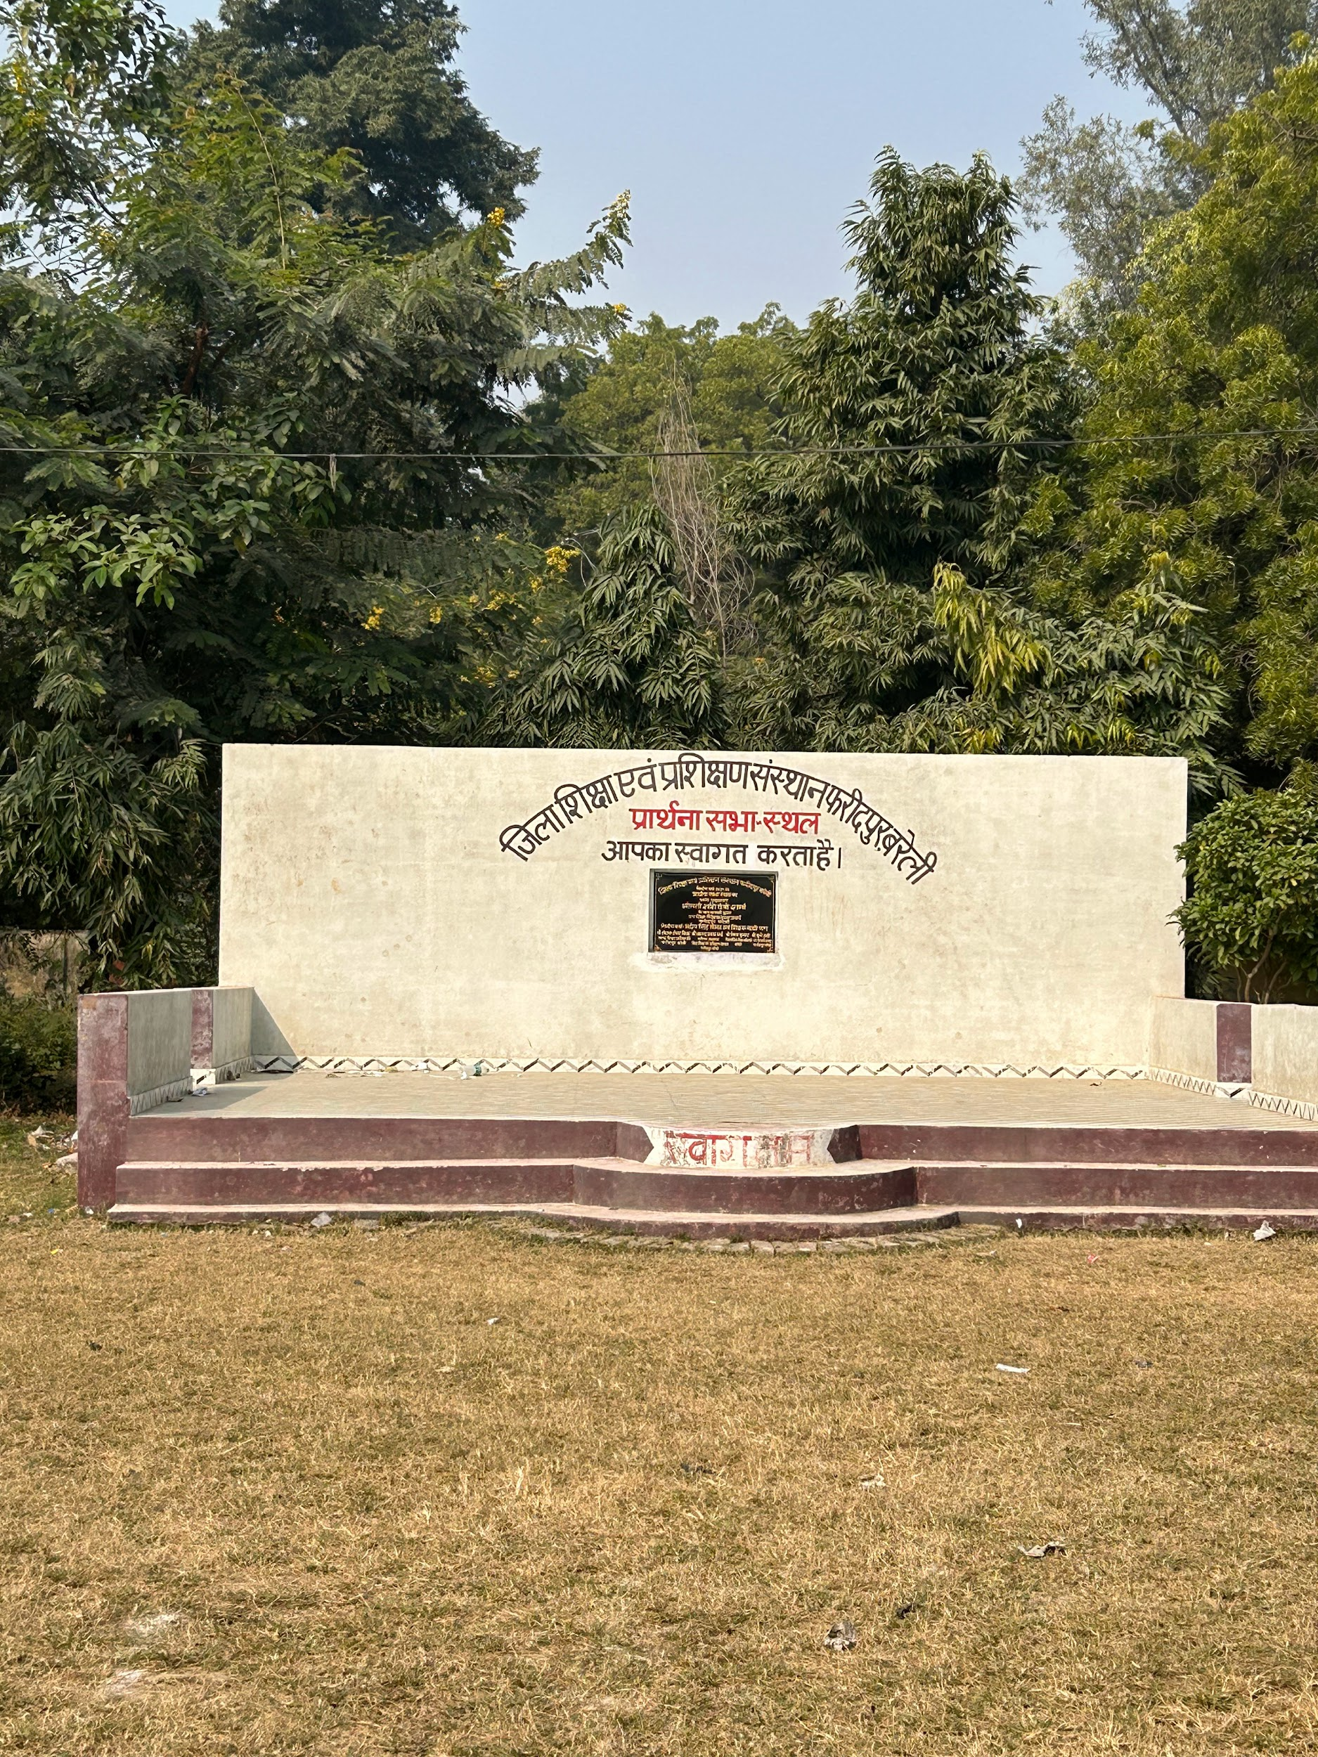

1. **OBSERVATIONS DIETS**
2. **DIET Infrastructure** (Staffroom, Classroom Labs, Library, Sports facilities, ICT Lab, SUPW Room)

There were 2 blocks in DIET. One block had a principal's office, separate room for each senior lecturer, a library and one room for administrative work; the other had classrooms and rooms for some lecturers. Most of them were given separate rooms, in some cases 2-3 shared the room. Apart from it, there was an auditorium which was also used to conduct classes. There were no labs - ICT, Maths, Science or SUPW.

1. **Teaching Learning Resources** ( Books, posters, displays)

There was a library. However, the books present are old and outdated. The teachers

1. **D.El.Ed Class Observation** (Pedagogy, Interactions etc.)

Approximately 80-100 students in one classroom. 4 class observations done(2 sections each for 2021-2022 batch). The classroom sizes were big but very dimly lit. The blackboard is barely visible. The teachers were not observed using any TLMs to teach. There was some interaction between teachers and students during class.

1. **D.El Ed Student-teacher Interactions** ( Aspirations, goals, feedback on the programme etc.)

We interacted with pre-service teachers in the classrooms as well as in groups when the faculty was not around. They came from diverse academic backgrounds - science, arts as well as commerce. Some were also in the army before. Regarding the course, they were satisfied with they way teachers teach. Most of them have joined the course for the guarantee of a Government job.

A day or two before our interaction, during our classroom observations, we were formally introduced as research assistants from TISS and student-teachers were asked to pose any questions that they wanted to ask. In two of the four classes, we were asked about TISS and the study.

1. **Workshops / Inservice Training Observed**

No workshops or training observed.

1. **NGOs Presence**

There was no constant association of any NGO. Some such organizations are involved in conducting workshops for in-service teachers like Sankalp Foundation in association with the DIET, will be conducting a training session for in-service teachers of English.

1. **Other Observations** (Co-curricular activities, Assembly etc.)

The DIET had organized an ICT competition in which In-service teachers of primary, middle and high school prepared presentations on innovative use of ICT in their classrooms. Out of 38 applications, only 10 participants participated. The programme was organised in the auditorium with pre-service teachers as the audience.

The same day, a yoga competition was also organized in which only 3 in-service teachers participated out of the 10 who applied. The competition was organized in the classroom when students were seated in the auditorium.

**B. INTERVIEW SUMMARY** ( Principal / Vice Principal / Sr Lecturer / Junior Lecturer)

1. **Interviewee -- Principal / Vice Principal / Sr Lecturer / Junior Lecturer**
2. **Institutional Identity and Focus:** [Understand the DIETs identity through the focus areas of work, goals, objectives and its ability and capacity to function as an independent and autonomous institute leveraging state and national schemes]
3. **Systemic location and relation to other institutions:** [Understand the DIETs positioning vis-à-vis the state education system, including SCERT and BRCs-CRCs.]
4. **Financial Aspects:** [Understanding the financial aspects such as provisioning of infrastructure, resources, staff and faculty positions and other facilities.]

As reported, the principal takes in views of the faculty members regarding their needs to make the budget. Budget is then sent to the SCERT. Apart from this, SCERT also provides funds for the trainings. The frequency and the rationale of these trainings varies. There is often a delay in the arrival of funds. Funds to be received will be used to maintain washrooms, get lab equipment.

1. **Development of Faculty and Staff:** [Understand the current roles and responsibilities, staffing needs of DIETs, the recruitment processes, leadership roles, vacancies, capacity building of DIET heads, faculty and staff and nurturing a professional culture/community.]
2. **DIET functions and Activities:** [Understand the different functions and activities implemented by the DIETs by way of inputs, processes, outputs, and outcomes, including teacher development, both pre-service and in-service, DIETs as resource and teaching-learning centres and institutes for local curriculum and material development.]
3. **Collaborations and Partnerships:** [To understand DIETs working with partners such as universities, DIETs within and across states, NGOs, and multilateral funding agencies towards gaining access to expertise, capacity building, networking and institution building.]

The DIET as required collaborates with some NGOs to conduct certain workshops for in-service and pre-service teachers as directed by SCERT. For example - the Sampark Foundation. Due to paucity of space and infrastructure, some workshops are conducted in Future college, a private college nearby.

1. **COVID-19 Impact:** [ Overall impact of lockdown and pandemic-related issues]

No significant impact on current admissions and pedagogy because of the pandemic. WhatsApp is still used to share readings. Meetings conducted by SCERT, BEOs are conducted on Google Meet and Zoom, as feasible. During the pandemic, mohalla classes were organised in association with shiksha mitra. As reported, classes had 70-80 percent turnout. The lecturers were also required to come to DIET during the the first wave, during which all got infected and one died.

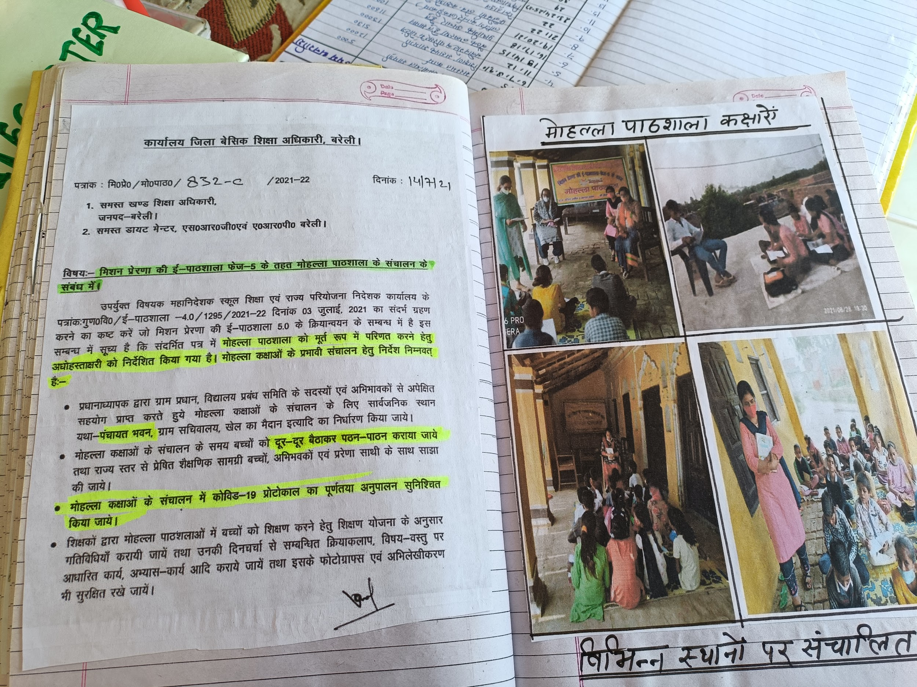

A letter regarding Mohalla classes - at an Upper Primary School in Bareilly.

**C. INTERVIEW SUMMARY STAKEHOLDERS** ( BSA | BEO/BRP | SRG |DCT |ARP)

1. **Interviewee -**  ( BSA | BEO| SRG|DCT|ARP)
2. **Job/Role as described by Interviewee**
3. **Opinions/issues expressed by the interviewee**
4. **Nature of Interactions with DIET /DIET Faculty**

**D.OBSERVATIONS SCHOOLS**

<Please add Photos wherever relevant >

1. **School Type** (Primary, Upper Primary, Composite, KGBV)

Observed primary, upper primary, composite and KGBV schools.

1. **School Location /Surroundings** (Rural or Urban)

Rural and urban setting.

1. **Infrastructure** (Staffroom, Classroom, Playground, Drinking Water, ICT Lab, Toilets, Facilities for special needs students/students with disabilities)

Schools have rooms for the headmaster/headmistress, a library, drinking water facilities, toilets. Most schools did not have facilities for students with disabilities and ICT Lab. The KGBV schools also had facilities for student accommodation with 15 beds in one room. 2 students share one bed.

1. **Teaching Learning Resources** ( Books, posters, displays)

The KGBV schools had no books for the students. Teachers have a few textbooks they use. Some classes have too many students. There was no library.

The other schools were print rich with walls painted by teachers.

1. **Class Observation** (students, blackboard, Seating, Pedagogy, Interactions etc.)

Not enough classrooms for the students, many students sit on the floors due to lack of desks and benches. Some schools had two classes in one room. Shortage of teachers is a consistent issue. The teachers have election duty that adds to the burden already created by less number of teachers in schools. Students were seen interacting with the teacher when asked questions. Some students also did a small performance when we visited. This was done during a cultural event.

1. **Interaction with headteacher/teacher**

Lack of infrastructure, shortage of teachers is a persisting issue. Cleaning staff paid from their own salary.

1. **NGOs Presence**

No NGO presence was mentioned.

1. **Other Observations** (Co-curricular activities, Assembly etc.)

Schools have assembly and PT in the mornings. Sports facilities were present. Was mentioned that students have sports period as well.