|  |  |  |  |  |  |
| --- | --- | --- | --- | --- | --- |
| TISS Evaluation of the CSSTE, August-September 2017 | | | Tool 5 | | Institution fact sheet for IASE, CTE, DIET and BITE |
| Instructions Please ill up the basic information about the institution, with the help of interview of the institution head. General (Data may available with CTE / DIET / BITE – In Annual work plan Document – 5 year trend) | | | | | |
| State | Chhattisgarh | District/Place | | Raipur | |
| Name of institution | DIET |  | |  | |
| Researcher name | Vikram Chourey, Dipankar Roy | Date of visit | | 28 August 2017 | |
| Respondent name | R.K. Verma | Designation | | Principal | |

1. When was the institution established? Was it upgraded from some earlier institution? What was its earlier form?

1988, yes, BTI

1. Organizational Structures (organogram) today.

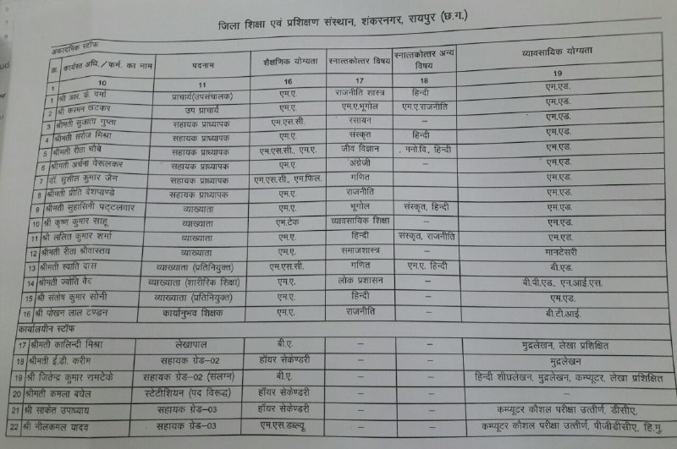

1. Academic posts vacancy (note vacancies and transfers over the last five years)

1 to 6 post are academic

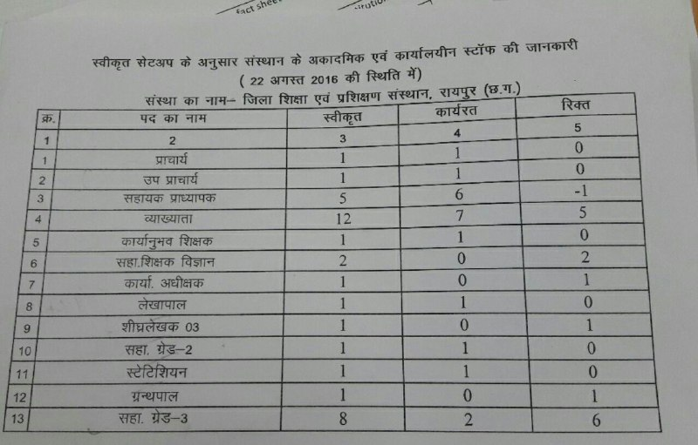

1. Non academic posts (note vacancies and transfers over the last five years)

7 to13 post are non academic



1. What are the key duties which the institution is expected to perform and which are performed within the current constraints of resources? (note expected duties and actually performed duties)

Key duties

regular teaching (done this year)

trainning/workshop (done this year)

awp plan (done this year)

textbook/module writting (done this year)

national survey/monitorying on education/dropout children

research (done this year)

1. Has there been any recent major revision of the duties and functions of the institute? After RtE? After CSSTE 12th plan?

Dropout, 1986 quality education, CCE involvement, ICT based trainning increase, Survey.

1. When did these take place? And why? ( who has occasioned them? For what reasons? Etc)

after 1986, (ICT In schools with the help of Alok shukla)

1. Was there any revisioning exercise based on which these changes were made?

Reviewed duties after orientation of RTE.

1. Have there been any major restructuring of the institution? Why? How does the present structure compare with the earlier structure? Better/ more problems etc.

Encrease responsibilities, beter then older. And always need to chang according to need and pregress.

6. Collection of related Documents –Syllabus of ongoing courses (Pre-service) and Annual work plan/budget (if any)

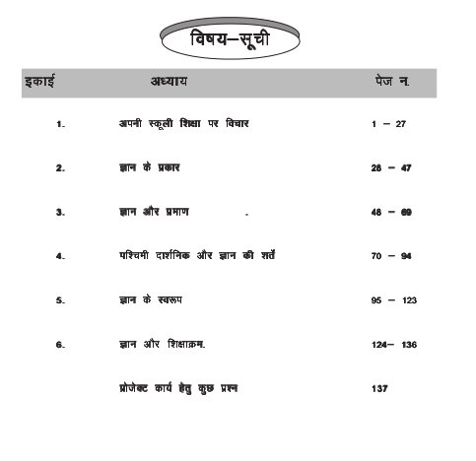

7. Which of the following activities of the DIET are currently taking place (as envisioned in the 2012 guidelines):

|  |  |  |  |
| --- | --- | --- | --- |
| Role | Yes/No |  |  |
| 1. Has the DIET been conducting ISTE programs? | no | No. of Master resource persons prepared, no.of courses designed, school follow up and documentation |  |
| 2. Has the DIET planned for direct school intervention and improvement? | yes | How Many interventions planned and What kind of interventions? | 3 to 4 times. SMC, School, Meetings, Classroom Observations, RTE Act awarness Programmes. |
| 3. Has the DIET developed as a resource centre? | no | What kind of resources? How many? Who uses the resource centre | Libreary, Computer Lab, Art & Craft, Science Lab, Teacher and Students. |
| 4. Has the DIET organized forums? | yes | How many conducted? How many participants were there? On what were the forums conducted? | Watsup Groups. |
| 5. Has the DIET organized co-curricular activities? | yes | How many? On what? And for whom were these conducted? | Sports, Cultural activities. For students |
| 6. Has the DIET followed the staffing guidelines? | yes |  |  |
| 7. Does the DIET have a PAC (Programme Advisory Committee) | yes | If yes, is the composition as per suggested norms? How many times have they met? Are there any minutes of meetings? Collect if any? | Yes, Two times in a year, yes. |
| 8. Are the infrastructure facilities at the DIET as per the guidelines? (use guidelines to expand and check against each) | yes | * Classrooms * Seminar rooms * Special rooms * Staff rooms * Library * Hostels * Canteen / Dining Hall | All yes. |
| 9. Has the DIET established systemic linkages with other institutions? | yes | Details of linkages/interactions with SSA, RMSA, CTE, SCERT, NGOs, Higher education institutions, others. What is the nature of / operational form of these linkages and meetings? | Linkages with all. Academic nature. |
| 10. Does the DIET conduct any programs/ activities for faculty development and capacity building? | yes | How many in the last five years, topics, number of participants? | State level workshop on action research. About 60 participants. |
| 11. Is the DIET involved in research activities? | yes | -Areas of research covered  -No. Of publications | ?, Published. |
| 12. Has the DIET prepared the perspective plan? | yes | How is it prepared? | Prepared with the help of BEO, DEO,BRC, DIET. |
| 13. Has the DIET prepared its annual plans? | yes | How are these prepared? | Yes. |
| 14. Has the DIET introduced any innovation in the role it plays ? | yes | Details of innovative programs? Who has funded them? | SCERT funded for research |

8. CTEs

8.1. Role as envisaged under 2012 CSSTE Guidelines

|  |  |  |  |
| --- | --- | --- | --- |
| Role | Yes/No | If yes, details | Remarks |
| 1.Has the CTE played a role in development of excellence in secondary teacher education? |  | -Needs analysis surveys for trainings conducted  -Creation of context specific handbooks  -maintenance of detailed database on secondary schools and secondary school teachers  -other activities |  |
| 2. Have new CTEs been set up wherever a need was identified? |  |  |  |
| 3. Has the CTE developed collaboration with IASEs? |  | -Capacity development of CTEs  - Capacity development for handling research |  |
| 4. Has the CTE developed collaborations with SCERT? |  | -Facilitating collaborations with other state agencies  - Support provided to the CTE’s PAC |  |
| 5. Has the CTE used ICT effectively? |  | -Adherence to NCFTE 2009 norms  -Retention of institutional memory  -Institutional Development  -Development of institutional links  -Development of locally relevant teacher education modules  -Development of COPs |  |
| 6. Has the PSTE programme been implemented? |  | How many students have completed the PSTE? |  |
| 7. Has the mandated process of tracking and monitoring been followed? |  |  |  |
| 8. Does professional development of TEs form a part of the CTEs activities? |  | In what way? |  |
| 9. Has the ISTE program been implemented? |  | How many participants in 5 years? |  |
| 10. Has the CTE provided extension and resource support to secondary schools? |  | How many schools? What kind of support has been provided? |  |
| 11. Has the CTE provided resource support to DIETs? |  | How many? When? What support was provided? |  |
| 12. Has the CTE established linkages with other education institutions? |  |  |  |
| 13. Has the CTE undertaken research? |  | Number of research studies? What were the topics? How were these disseminated or used? |  |
| 14. Has material development taken place? |  | What kind of material? How many resources were used? Where is this material available? |  |
| 15. Is the organisational structure and personnel as per the given norms? |  |  | If these are not followed, why not? |
| 16. Are the 1989 infrastructure guidelines followed? |  |  | If these are not followed, why not? |
| 17. Is the annual work plan prepared? |  |  | If this is not prepared, why not? |
| 18. Are there annual reports prepared? |  |  | If this is not prepared, why not? |
| 19. Does the CTE have a perspective plan prepared? |  |  | If this is not prepared, why not? |
| 20. What innovations have been introduced by the CTE in its role? |  |  |  |

9 Academic and non-academic posts vacant as of August/Sept 2017:

|  |  |  |  |  |  |
| --- | --- | --- | --- | --- | --- |
|  | sanctioned | Post filled | Permanent / Contractual | Innovations/ Measures to deal with vacancies | Any Litigation for not filling up vacancies |
| Academic | 25 | 20 | Permanent |  |  |
| Non-academic | 14 | 5 |  |  |  |
| Total | 39 | 25 |  |  |  |

1. Faculty Information

|  |  |  |
| --- | --- | --- |
| 1 | Is there an appointed head or acting head? | Appointed head |
| 2 | What is the total faculty senior | 8 |
| 3 | What is the total faculty-junior | 0 |
| 4 | How many faculty fulfil the NCTE qualificaitons> | 8 |
| 5 | Which subject specialisations do faculty have?  Science, maths, language (of the state/region), English, social sciences, work experience art, physical education, education foundations including psychology and history. | Not have psychology and history. Rest of subject faculties have. |

1. How may in service programmes were conducted under the CSSTE scheme?

|  |  |  |  |  |
| --- | --- | --- | --- | --- |
|  | For teachers | For MRPs/KRPs | For teacher educators/TEIs | School heads |
| 2011-2012 |  |  |  |  |
| 2012-2013 |  |  |  |  |
| 2013-2014 |  |  |  |  |
| 2014-2015 |  |  |  |  |
| 2015-2016 | 7 |  | 0 | 1 |
| 2016-2017 | 9 |  | 0 | 1 |

1. How many inservice programmes were conducted under other schemes? (SSA/RMSA/other state funds)

|  |  |  |  |  |
| --- | --- | --- | --- | --- |
|  | For teachers | For MRPs/KRPs | For teacher educators/TEIs | School heads |
| 2011-2012 |  |  |  |  |
| 2012-2013 |  |  |  |  |
| 2013-2014 |  |  |  |  |
| 2014-2015 |  |  |  |  |
| 2015-2016 | NA |  | NA | NA |
| 2016-2017 | NA |  | NA | NA |

11. Student Profile

|  |  |  |  |  |  |  |
| --- | --- | --- | --- | --- | --- | --- |
| Course Name | No. of Students | No. of Girls | No. of SC Students | No. of ST students | No. of students from under Rs. 1 lakh annual family income | Any other details |
| D.Ed Ist year | 93 | 51 | 35 | 17 | 0 | 37 (OBC) |
| D.Ed 2nd year | 100 | 48 | 22 | 23 | 0 | 55 (OBC) |
|  |  |  |  |  |  |  |

11. Funds received and utilized by DIET/CTE/BITE Under the CSSTE scheme

|  |  |  |  |  |  |  |  |
| --- | --- | --- | --- | --- | --- | --- | --- |
| S.No. | Year | Fund proposed (in Lakhs) | Fund sanctioned (in Lakhs) | Fund received (in Lakhs) | Date on which funds received | Fund utilized (in Lakhs) | If there was any additional (apart from what was received from the Centre as per guidelines) source of funding please mention |
| 1 | 2011-12 |  |  | 158.36 |  | 158.36 |  |
| 2 | 2012-13 |  |  | 134.96 |  | 134.96 |  |
| 3 | 2013-14 |  |  | 162.49 |  | 162.49 |  |
| 4 | 2014-15 |  |  | 192.02 |  | 192.02 |  |
| 5 | 2015-16 |  |  | 228.95 |  | 228.95 |  |
| 6 | 2016-17 |  |  | 215.52 |  | 215.52 |  |

12. What were the other sources from which funds were received? (please include also funds raised by the institution locally.

|  |  |  |  |  |  |  |  |
| --- | --- | --- | --- | --- | --- | --- | --- |
| S.No. | Year | Source/  scheme | Amount (in lakhs) | purpose | Date on which funds received | Fund utilized (in Lakhs) | achievements |
| 1 | 2011-12 | Europion Commission | 2.44 |  |  | 2.44 |  |
| 2 | 2012-13 | Europion Commission | 17.22 |  |  | 17.22 |  |
| 3 | 2013-14 | Europion Commission | 0.00 |  |  | 0.00 |  |
| 4 | 2014-15 | Europion Commission | 1.26 |  |  | 1.26 |  |
| 5 | 2015-16 | Europion Commission | 17.93 |  |  | 17.93 |  |
| 6 | 2016-17 | Europion Commission | 0.00 |  |  | 0.00 |  |