|  |  |  |  |
| --- | --- | --- | --- |
| TISS Evaluation of the CSSTE, August-September 2017 | | Tool 5 | Institution fact sheet for IASE, CTE, DIET and BITE |
| Instructions Please ill up the basic information about the institution, with the help of interview of the institution head. General (Data may available with CTE / DIET / BITE – In Annual work plan Document – 5 year trend) | | | |
| State | Chhattisgarh | District/Place | Mahrajpur Kabirdham |
| Name of institution | DIET |  |  |
| Researcher name | Hari Mishra, Saurav Mohanty | Date of visit | 26Th August 2017 |
| Respondent name | Mr PK Adhikari | Designation | Principal |

1. When was the institution established? Was it upgraded from some earlier institution? What was its earlier form?

Ans: 2006-07. New building. Funding started from 2007-08

1. Organizational Structures (organogram) today.
2. Academic posts vacancy (note vacancies and transfers over the last five years)

Ans: 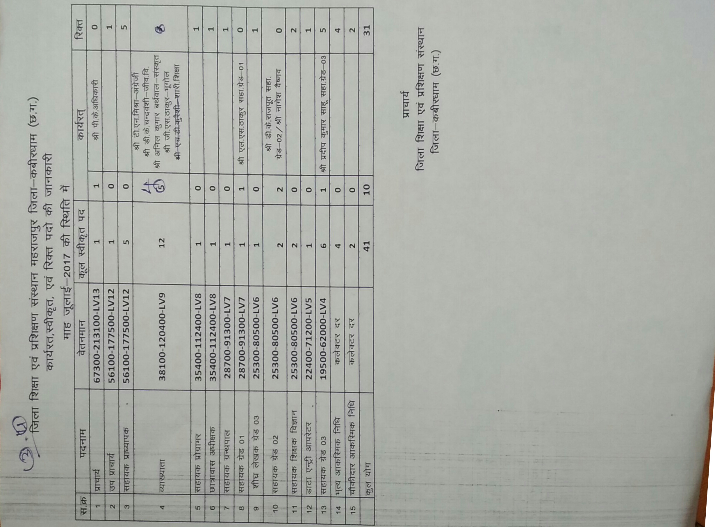

1. Non academic posts (note vacancies and transfers over the last five years)

1. What are the key duties which the institution is expected to perform and which are performed within the current constraints of resources? (note expected duties and actually performed duties)

Ans: 1. Universalizetion of elementary education 2. Capacity building of teachers. 3. Ennovation/ Research. 4. Community involvement for enhancement of quality education. We are doing PST & INST Training, workshop (For TLM), Educational Awareness programs, professional skill development programs.

1. Has there been any recent major revision of the duties and functions of the institute? After RtE? After CSSTE 12th plan?

Ans: We are developing an environment for quality education in deference with RTE & CSSTE with the help of decentralizing work.

1. When did these take place? And why? ( who has occasioned them? For what reasons? Etc)

Ans: From 15th June to February every year. Faculty members are doing all these work for professional development.

1. Was there any revisioning exercise based on which these changes were made?

Ans: Yes. With the help of faculty member and program advisory committee we revise CSSTE programme and inserted our needs of grassroot level.

1. Have there been any major restructuring of the institution? Why? How does the present structure compare with the earlier structure? Better/ more problems etc.

Ans: Boundary wall for safety majors. After construction of boundary wall our institute is free from all the encumbrance.

6. Collection of related Documents –Syllabus of ongoing courses (Pre-service) and Annual work plan/budget (if any)

7. Which of the following activities of the DIET are currently taking place (as envisioned in the 2012 guidelines):

|  |  |  |  |
| --- | --- | --- | --- |
| Role | Yes/No |  |  |
| 1. Has the DIET been conducting ISTE programs? | Yes | No. of Master resource persons prepared, no.of courses designed, school follow up and documentation |  |
| 2. Has the DIET planned for direct school intervention and improvement? | Yes | How Many interventions planned and What kind of interventions? | Language |
| 3. Has the DIET developed as a resource centre? | Yes | What kind of resources? How many? Who uses the resource centre | Museum (social science), Language, village history dictionary. Story telling |
| 4. Has the DIET organized forums? | No | How many conducted? How many participants were there? On what were the forums conducted? |  |
| 5. Has the DIET organized co-curricular activities? | Yes | How many? On what? And for whom were these conducted? | Pre-service teachers ( Student teachers) |
| 6. Has the DIET followed the staffing guidelines? | No |  |  |
| 7. Does the DIET have a PAC (Programme Advisory Committee) | NO | If yes, is the composition as per suggested norms? How many times have they met? Are there any minutes of meetings? Collect if any? |  |
| 8. Are the infrastructure facilities at the DIET as per the guidelines? (use guidelines to expand and check against each) | Yes | * Classrooms -2 * Seminar rooms-No * Special rooms- No * Staff rooms-Yes * Library-Yes * Hostels-Yes * Canteen / Dining Hall- No |  |
| 9. Has the DIET established systemic linkages with other institutions? | Yes | Details of linkages/interactions with SSA, RMSA, CTE, SCERT, NGOs, Higher education institutions, others. What is the nature of / operational form of these linkages and meetings? | SCERT, Eklavya, APF, Pratham |
| 10. Does the DIET conduct any programs/ activities for faculty development and capacity building? | Not Really | How many in the last five years, topics, number of participants? | -NA- |
| 11. Is the DIET involved in research activities? | Yes | -Areas of research covered  -No. Of publications |  |
| 12. Has the DIET prepared the perspective plan? | Yes | How is it prepared? | Discussion on role and function |
| 13. Has the DIET prepared its annual plans? | Yes | How are these prepared? |  |
| 14. Has the DIET introduced any innovation in the role it plays ? | Yes | Details of innovative programs? Who has funded them? | ICICI Foundation, CCSTE |

8. CTEs

8.1. Role as envisaged under 2012 CSSTE Guidelines

|  |  |  |  |
| --- | --- | --- | --- |
| Role | Yes/No | If yes, details | Remarks |
| 1.Has the CTE played a role in development of excellence in secondary teacher education? |  | -Needs analysis surveys for trainings conducted  -Creation of context specific handbooks  -maintenance of detailed database on secondary schools and secondary school teachers  -other activities |  |
| 2. Have new CTEs been set up wherever a need was identified? |  |  |  |
| 3. Has the CTE developed collaboration with IASEs? |  | -Capacity development of CTEs  - Capacity development for handling research |  |
| 4. Has the CTE developed collaborations with SCERT? |  | -Facilitating collaborations with other state agencies  - Support provided to the CTE’s PAC |  |
| 5. Has the CTE used ICT effectively? |  | -Adherence to NCFTE 2009 norms  -Retention of institutional memory  -Institutional Development  -Development of institutional links  -Development of locally relevant teacher education modules  -Development of COPs |  |
| 6. Has the PSTE programme been implemented? |  | How many students have completed the PSTE? |  |
| 7. Has the mandated process of tracking and monitoring been followed? |  |  |  |
| 8. Does professional development of TEs form a part of the CTEs activities? |  | In what way? |  |
| 9. Has the ISTE program been implemented? |  | How many participants in 5 years? |  |
| 10. Has the CTE provided extension and resource support to secondary schools? |  | How many schools? What kind of support has been provided? |  |
| 11. Has the CTE provided resource support to DIETs? |  | How many? When? What support was provided? |  |
| 12. Has the CTE established linkages with other education institutions? |  |  |  |
| 13. Has the CTE undertaken research? |  | Number of research studies? What were the topics? How were these disseminated or used? |  |
| 14. Has material development taken place? |  | What kind of material? How many resources were used? Where is this material available? |  |
| 15. Is the organisational structure and personnel as per the given norms? |  |  | If these are not followed, why not? |
| 16. Are the 1989 infrastructure guidelines followed? |  |  | If these are not followed, why not? |
| 17. Is the annual work plan prepared? |  |  | If this is not prepared, why not? |
| 18. Are there annual reports prepared? |  |  | If this is not prepared, why not? |
| 19. Does the CTE have a perspective plan prepared? |  |  | If this is not prepared, why not? |
| 20. What innovations have been introduced by the CTE in its role? |  |  |  |

9 Academic and non-academic posts vacant as of August/Sept 2017:

|  |  |  |  |  |  |
| --- | --- | --- | --- | --- | --- |
|  | sanctioned | Post filled | Permanent / Contractual | Innovations/ Measures to deal with vacancies | Any Litigation for not filling up vacancies |
| Academic | 19 | 5 | Permanent |  |  |
| Non-academic | 22 | 4 | permanent |  |  |
| Total | 41 | 9 |  |  |  |

1. Faculty Information

|  |  |  |
| --- | --- | --- |
| 1 | Is there an appointed head or acting head? | Yes |
| 2 | What is the total faculty senior | 4 |
| 3 | What is the total faculty-junior | 0 |
| 04 | How many faculty fulfil the NCTE qualificaitons> | Only 1. |
| 5 | Which subject specialisations do faculty have?  Science, maths, language (of the state/region), English, social sciences, work experience art, physical education, education foundations including psychology and history. | English, Maths, sanskrit,Art, Hindi |

1. How may in service programmes were conducted under the CSSTE scheme?

|  |  |  |  |  |
| --- | --- | --- | --- | --- |
|  | For teachers | For MRPs/KRPs | For teacher educators/TEIs | School heads |
| 2011-2012 |  |  |  |  |
| 2012-2013 |  |  |  |  |
| 2013-2014 |  |  |  |  |
| 2014-2015 |  |  |  |  |
| 2015-2016 |  |  |  |  |
| 2016-2017 |  |  |  |  |

1. How many inservice programmes were conducted under other schemes? (SSA/RMSA/other state funds)

|  |  |  |  |  |
| --- | --- | --- | --- | --- |
|  | For teachers | For MRPs/KRPs | For teacher educators/TEIs | School heads |
| 2011-2012 |  |  |  |  |
| 2012-2013 | 790(SSA) 485(RMSA) |  |  |  |
| 2013-2014 |  |  |  |  |
| 2014-2015 |  |  |  |  |
| 2015-2016 |  |  |  |  |
| 2016-2017 |  |  |  |  |

11. Student Profile

|  |  |  |  |  |  |  |
| --- | --- | --- | --- | --- | --- | --- |
| Course Name | No. of Students | No. of Girls | No. of SC Students | No. of ST students | No. of students from under Rs. 1 lakh annual family income | Any other details |
|  |  |  |  |  |  |  |
|  |  |  |  |  |  |  |
|  |  |  |  |  |  |  |

11. Funds received and utilized by DIET/CTE/BITE Under the CSSTE scheme

|  |  |  |  |  |  |  |  |
| --- | --- | --- | --- | --- | --- | --- | --- |
| S.No. | Year | Fund proposed (in Lakhs) | Fund sanctioned (in Lakhs) | Fund received (in Lakhs) | Date on which funds received | Fund utilized (in Lakhs) | If there was any additional (apart from what was received from the Centre as per guidelines) source of funding please mention |
| 1 | 2011-12 |  | 1700000 | 1700000 |  | 1699561 |  |
| 2 | 2012-13 |  | 1800000 | 1800000 |  | 347688 |  |
| 3 | 2013-14 |  | 2120000 | 2120000 |  | 929802 |  |
| 4 | 2014-15 |  | 3300000 | 3300000 |  | 801603 |  |
| 5 | 2015-16 |  | 2600000 | 2600000 |  | 610222 |  |
| 6 | 2016-17 |  | 2200000 | 2200000 |  | 788352 |  |

12. What were the other sources from which funds were received? (please include also funds raised by the institution locally.

|  |  |  |  |  |  |  |  |
| --- | --- | --- | --- | --- | --- | --- | --- |
| S.No. | Year | Source/  scheme | Amount (in lakhs) | purpose | Date on which funds received | Fund utilized (in Lakhs) | achievements |
| 1 | 2011-12 | European Commission | 297000 |  |  | 176213 |  |
| 2 | 2012-13 | European Commission | 1988819 |  |  | 1525875 |  |
| 3 | 2013-14 |  |  |  |  |  |  |
| 4 | 2014-15 | European Commission | 2991650 |  |  | 2492901 |  |
| 5 | 2015-16 | European Commission | 5200000 |  |  | 5084891 |  |
| 6 | 2016-17 |  |  |  |  |  |  |

**\* Please Also see the Budget allocation file in the drive**