**Quantitate Analysis about the fund utilization and its uses**

N = BRC = 254, N = CRC = 302, N = 45

The total number of responses we received from Block Resource Person is 254, out of which 119 of them said we didn’t received any kind of traning or oritentation regarding fund utilization and 74 of them said yes orientationis been conducted through circulars and notifications,and only 1 SMC member responses for this question said Yes, in a meeting the orientation is conducted, Hence very poor responses we received from BEO/BEO only 45 of them answer this question and if see the data on CRC 154 said there no orientation been conducted , you can also see the similar responses from HM responses below:

As you can see majority of HM never received any orientation or training regarding libraries fund and their use, very few of them responded they attended a training and few of other HM and DEO also helped them in the program. N = 5309 this question only for HM’s

Received few responses from BO, DEO only 7 of them said we received fund on time and 4 BO & DEO said fund are disbursed at the end of the financial year, 20 of them said fund are disbursed irregular intervals. 14 BO & DEO said it impacted by Covid-19, but on time for other years

N = 45

Total numbers of responses received from HM is 5309 in which majority of them said Funding is not available and only 116 HM said most years fund we get fund on time but it affected due to Cvoid-19.

N= 5309

Received few responses from BO & DEO about return of funds to Samagra Siksha only 33 BO & DEO said they never returned the fund and two of them said most times they return the fund in last five years.

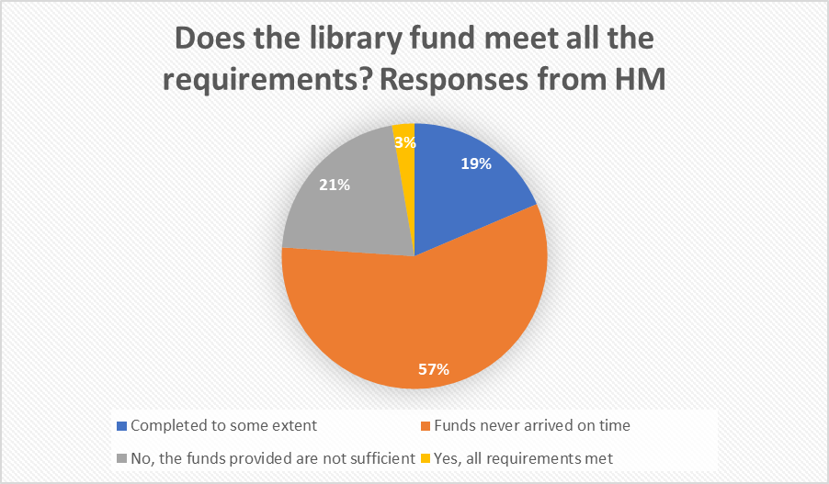

N = 5309

The majority of HM Said the funds never arrived on time and 21% said the funds provided are not sufficient, very few responses were in favor of meeting all the requirements.