**FIELDWORK SUMMARY**

**TEMPLATE**

**DIET NAME: ALIGARH DIVISION: FIELD TEAM: Dr. LETHA RAMMOHAN, ACHLA YADAV, KARAN KUMAR**

**DATES OF VISIT:** 12/12/2022- 17/12/2022

**DURATION: 6 days**

**A. OBSERVATIONS DIETS**

**1. DIET Infrastructure** (Staffroom, Classroom Labs, Library, Sports facilities, ICT Lab, SUPW Room)

The DIET is located on the outskirts of the main city in Madrak. The main building of the DIET had two storeys and had two classroom on the ground floor and two classrooms on the first floor. There was one Principals room, one vice principals room and one room of the senior lecturer. It had one common staff room where all the meetings were held. There were separate rooms for the lecturers, one room was used by either two or three lecturers. There was one library, one smart class, one science lab and no ET lab. There was one administrative office on the ground floor. The classes generally happened on the ground floor but during the in-service training sessions the classes were shifted to classroom on the first floor. A new building has been constructed along with an auditorium on the other end of the campus where the classes will start after the inaugural function is done. There is a huge open space in between the new and the old building where morning assembly takes place, and is also used by student- teachers for playing various sports.

INFRASTRUCTURAL GAPS

The washrooms are not properly maintained because of no permanent housekeeping staff. Student teachers said that there were separate washrooms for lecturers which were kept locked and not for the use of students.

● We could not see the science lab as the lecturer in-charge had gone for the training in Lucknow.

The collection in the library was very limited, some general and some syllabus related books were there, along with a few competitive magazines. The books were issued for 15 days. There was no sitting infrastructure in the library.

● There was no separate SUPW room but everything was randomly kept in the library. ● Lack of sitting infrastructure in the classrooms.

● All the rooms were not lit properly. The campus also faced frequent power cuts. ● There are high tension live wires running through the campus at a very low height. ● Some staff quarters which were built initially are now deserted.

● One of the staff quarters (not in a good condition) is now being used as a hostel by some student-teachers.

● Most of the windows were broken.

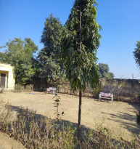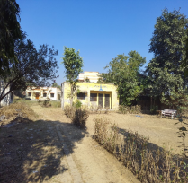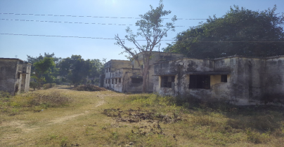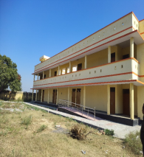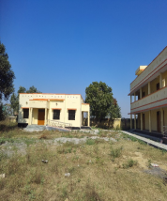

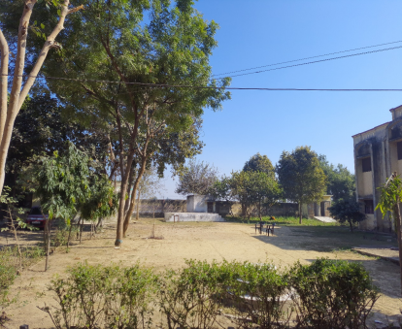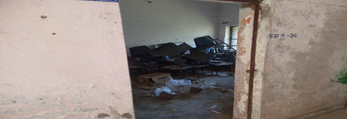

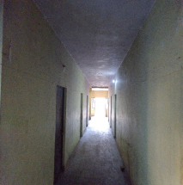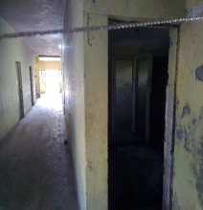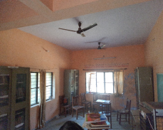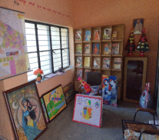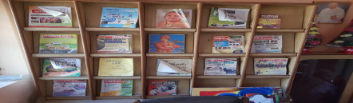

**2. Teaching Learning Resources** ( Books, posters, displays)

Students were accessing E-books of all the papers made available by SCERT. Students were heavily dependent on guides. In the library some very limited books are available. students showed more inclination to crack competitive examinations for which some magazines are available in the library.

**3. D.El.Ed Class Observation** (Pedagogy, Interactions etc.)

Classroom observation could not be conducted as all the faculty were attending training sessions organised by NCERT .However we did observe one class conducted by a sr. faculty on the topic current affairs. the topic covered was ‘ . The faculty was knowledgeable and confident. He was citing accurate facts. though he was writing all data on the blackboard ,, the management of the BB was not systematic. The teaching Learning Process was more teacher centric . Students were found very attentive and vere curious to understand the topic. Other than BB no TLN was used.

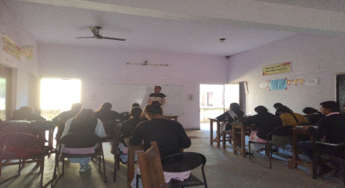

**4. D.El.Ed Student-teacher Interactions** ( Aspirations, goals, feedback on the programme etc.) The total strength of the students was **72** out of which **38** students were in the second year and **34** in the first year. Seats are not getting filled completely from the past few years. The total seats in the DIET are 100(50 for each batch).

**● Students were skeptical about the future of D.El.Ed degree. Now that individuals with a B.Ed degree are also eligible to apply for elementary.**

● The main aim/aspiration of the students is to get a govt. job.

● Some of them liked interacting with children hence they pursued this course. **●** The medium of instruction was mainly hindi.

**●** The main challenge the student faced was in writing 3 exams back to back in a day with no break in between.

**●** The campus is located on the outskirts of Aligarh hence the students face a lot of problem in travelling/ commuting.

**●** The students want hostel and canteen facilities in the campus along with transportation facilities.

**●** They all want to prepare for competitive exams and want guidance regarding the same. 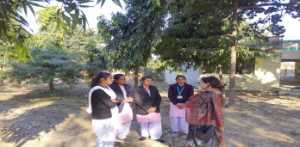

**5. Workshops / Inservice Training Observed**

ENGLISH LANGUAGE TEACHERS TRAINING OBSERVED: - The training was organised for all the English medium schools (215 schools)

● Was conducted by SAMPARK foundation

● Use of FLN guidelines.

● Activity based learning.

● Use of rhymes/ TLM kit/ flash cards.

**6. NGOs Presence**

SAMPARK

PRATHAM

**7. Other Observations** (Co-curricular activities, Assembly etc.)

Regular morning assembly was conducted in the campus sharp at 10 am.

**B. INTERVIEW SUMMARY** ( Principal / Vice Principal / Sr Lecturer / Junior Lecturer)

1. **Interviewee -- Principal**

2. **Institutional Identity and Focus**

The DIET Principal is the head of all the schools in the district Aligarh he is responsible for regulating the functioning of these schools and also to make sure that all schools run smoothly. He is responsible to keep a check on the progress of the schools affiliated to the DIET and also to address the issues that any school is facing in the district. The implementation of various schemes launched by the SCERT rests upon the shoulders of the DIET Principal. He also looks after the trainings of all the pre service and in service teachers.

3. **Systemic location and relation to other institutions:**

The DIET principal conducts a monthly meeting in which everyone including the BEO, BSA, SRG, ARP, DIET faculty are present. The meeting is conducted so that the problems faced by all the stakeholders can be put forward and a viable solution could be provided to the problems, the DIET principal is also the point of contact between the DIET and the SCERT. He is also directly connected to the BRC.

4. **Financial Aspects:** [Understanding the financial aspects such as provisioning of infrastructure, resources, staff and faculty positions and other facilities.]

The funds received are less according to the size of the campus, regular maintenance of the buildings can not be carried out in less funds.

5. **Development of Faculty and Staff:**

There were no subject specific lecturers for ICT and languages . The senior lecturer also takes up classes of general studies when ever needed to keep the students engaged. apart from the academic staff the DIET there are no housekeeping staff in the campus and also there are no security guards

6. **DIET functions and Activities:**

The DIET is primarily responsible for conducting the trainings of the pre service i.e the D.El.Ed batch and also conduct the trainings for the in service teachers in various disciplines. The DIET is responsible for monitoring the functioning of all the schools affiliated to the DIET the DIET lecturers are responsible for visiting the schools and keep a check on their progress through the DIET mentorship program. The DIET also conducts the various seminars and trainings for the respective teachers which are forwarded by the SCERT.

7. **Collaborations and Partnerships:** [To understand DIETs working with partners such as universities, DIETs within and across states, NGOs, and multilateral funding agencies towards gaining access to expertise, capacity building, networking and institution building.] At present there are no such collaborations, but they are actively looking for such collaboration with various other institutes like inter colleges, other DIETS not only for the students but also for the DIET lecturers. The DIET is collaborating with NGOs like PRATHAM and SAMPARK for conducting In service trainings as and when required in various disciplines.

8. **COVID-19 Impact:** [ Overall impact of lockdown and pandemic-related issues]

The digital presence increased during the pandemic phase, all the interactions happened online. The school teachers actively participated in the mohalla classes with a thought that students should not loose touch with studies.

1. **Interviewee -- Junior Lecturer**

2. **Institutional Identity and Focus**

The junior lecturers are responsible for conducting regular D.El.Ed classes in the DIET also many in service trainings are conducted by the DIET lecturers. the DIET lecturers are also responsible for visiting assigned schools under the mentorship program and keep a track of the progress of the schools and also support the school teachers in the academic domain.

3. **Systemic location and relation to other institutions:**

The DIET mainly interact with the ARPs AND the SRGs. The DIET lecturers provided an academic support to the ARPs and the SRGs. The DIET lecturers interact with the SCERT only in the form of trainings that are conducted by the SCERT at the state level.

4. **Financial Aspects:** [Understanding the financial aspects such as provisioning of infrastructure, resources, staff and faculty positions and other facilities.]

The important aspect highlighted that there are was less sitting infrastructure in the campus and also only one smart class. There were no computer systems in the campus that the students can access i.e there was no ICT lab in the campus apart from some systems in the admin block.

NOTE:- The lecturers do not receive their salaries on time.

5. **Development of Faculty and Staff:**

There is a healthy working environment in the DIET but the lecturers are not satisfied with the designation of lecturers though their nature of work corresponds to that of assistant professor. The lecturers highlighted that they got very less time to conduct action research i.e only 3 months and that it is a very short period of time to conduct any research. They highlighted that they require subject specific lecturers for ICT and languages and also there was no support staff in the campus.

6. **DIET functions and Activities:**

The DIET is primarily responsible for conducting the trainings of the pre service i.e the D.El.Ed batch and also conduct the trainings for the in service teachers in various disciplines. The DIET is responsible for monitoring the functioning of all the schools affiliated to the DIET the DIET lecturers are responsible for visiting the schools and keep a check on their progress through the DIET mentorship program. The DIET also conducts the various seminars and trainings for the respective teachers which are forwarded by the SCERT.

7. **Collaborations and Partnerships:** [To understand DIETs working with partners such as universities, DIETs within and across states, NGOs, and multilateral funding agencies towards gaining access to expertise, capacity building, networking and institution building.] At present there are no such collaborations, The DIET lecturers want to actively engage for academic development and capacity building with other inter colleges and DIETS so that they can share their own practices and also get to know about the good practices of other organizations. The DIET is collaborating with NGOs like PRATHAM and SAMPARK for conducting In service trainings as and when required in various disciplines.

8. **COVID-19 Impact:** [ Overall impact of lockdown and pandemic-related issues]

The digital presence increased during the pandemic phase, all the interactions happened online. The school teachers actively participated in the mohalla classes with a thought that students should not loose touch with studies

**C. INTERVIEW SUMMARY STAKEHOLDERS** BSA

**1. Interviewee -** BSA

**2. Job/Role as described by Interviewee**

The BSA looks after the primary education in the government schools. He was appointed after clearing the state PCS examination. His work is mainly related to monitoring and supervision of the primary education in the district. He also looks after the implementation of various schemes. He has to visit a minimum of 20 schools every month. The BEOs work under him at the block level. The district coordinators of the 7 aspects of samagra also work under him.

**3. Opinions/issues expressed by the interviewee**

Issues highlighted by him: -

There are many vacancies that need to be filled in the DIET and in the schools as well.

There is a need to do strengthening of DIET staff.

He suggested that master trainers can be brought in who will dedicatedly work for conducting the trainings.

**4. Nature of Interactions with DIET /DIET Faculty**

He directly interacts with the DIET Principal. There is a meeting in the DIET at the end of every month. the interaction is mainly related to administrative work and regarding trainings.

**C. INTERVIEW SUMMARY STAKEHOLDERS** BEO

**1. Interviewee - BEO**

**2. Job/Role as described by Interviewee**

The main responsibility of the BEO is related to administration, supervision, inspection and looking after the schools at the block level.

**3. Opinions/issues expressed by the interviewee**

During the interview the BEO highlighted that:-

He said that the trainings has become superficial now a days. The seriousness with which trainings happened earlier is not there anymore.

The DBT is not very effective. It is not beings properly used by the parents. Also, it has added to the workload of the teachers.

He said that the enrollment of the students and their attendance in govt. schools has increased after covid.

Because of the increasing use of technology monitoring has improved.

Student teacher ratio is poor in most of the schools.

The salaries of shiksha mitras and contractual teachers should be raised and disbursed in a timely manner.

Teachers should be given a token of appreciation and recognition for motivating them.

**4. Nature of Interactions with DIET /DIET Faculty**

There is a meeting in the DIET at the end of every month. The DIET principal, BSA, BEOs and SRGs all participate in it. Interaction is mainly related to academics and training purposes. There is frequent interaction with the DIET mentor of the block.

**C. INTERVIEW SUMMARY STAKEHOLDERS**

**5. Interviewee -** Assistant Teacher

**6. Job/Role as described by Interviewee**

The teacher was a science teacher. Her main responsibilities were academic i.e. involved teaching. But there were other responsibilities such as that of BLO (booth level officer)

**7. Opinions/issues expressed by the interviewee**

Issues highlighted by the teacher :-

● The science equipments that come to the school are not up to the mark, rarely functional.

● The teacher said that the training should be limited in number. Multiple guidelines from above and trainings, that are conducted in both online and offline mode, often get very confusing.

● The non teaching activities take up a lot of time of the teachers. And this has a negative impact on the academics of students.

**8. Nature of Interactions with DIET /DIET Faculty**

The teacher said that majority of the interactions happen with the DIET mentor of the block. The teachers are required to visit the DIET centre at the time of trainings and when there are some competitions. The DIET principal also visits the school for monitoring occasionally.

**D.OBSERVATIONS SCHOOLS**

**1. School Type**

KGBV MADRAK

**2. School Location /Surroundings (**Rural)

The school was located on the outskirts of Aligarh just behind the DIET campus. The surroundings are that of a rural setup.

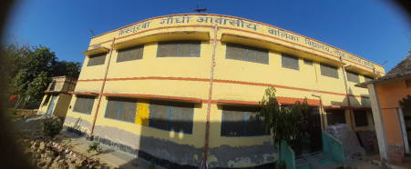

**3. Infrastructure** (Staffroom, Classroom, Playground, Drinking Water, ICT Lab, Toilets, Facilities for special needs students/students with disabilities)

There were 3 classrooms on the ground floor, 1 warden's office and 1 kitchen with some open area inside the building and there were two rooms on the first floor that were being used as dormitories. There is a small open space outside the building but because of some construction work it was unusable but in normal times it was used as a small playground. The classrooms had computers which the students can access anytime. There are 2 full time teachers and 3 part time teachers. There were no students with disabilities hence there were no facilities for students with special needs. The classrooms had a computer and also a projector which could be accessed by the students in presence of a teacher.

**4. Teaching Learning Resources** ( Books, posters, displays)

**5. Class Observation** (students, blackboard, Seating, Pedagogy, Interactions etc.) The students were well dressed in their uniforms, the classrooms were equipped with good benches, the students were highly responsive and were answering to questions with confidence, the classroom had a working computer system and the students were allowed to

access it in presence of a teacher.



**6. Interaction with headteacher/teacher**

The staff highlighted some issues:-

lack of staff in the school. No subject specific teachers for Hindi, science and maths. Most of the staff Is highly underpaid.

The teachers feel a pressure for enrolling a certain amount of students in the school. The kitchen staff were highly underpaid according to the job they are supposed to do.

**7. NGOs Presence**

There was as such no presence of any NGOs.

**8. Other Observations** (Co-curricular activities, Assembly etc.)

**D.OBSERVATIONS SCHOOLS**

**1. School Type** Junior High School Pilona



**2. School Location /Surroundings** (Rural)

The School was located in a rural area. It was located approximately 30 km away from the DIET campus.

**3. Infrastructure** (Staffroom, Classroom, Playground, Drinking Water, ICT Lab, Toilets, Facilities for special needs students/students with disabilities)

In terms of infrastructure the school was well equipped with good benches, black boards, clean toilets etc. There was no ICT lab and small space was there in front of the school which was used by the students to sit and have their mid day meal, there was no playground as such, there was a small reading corner in the principals room and also the science equipment’s were kept in the same room. The room also had posters which were made by the teachers as well as the students which depicted science diagrams.

**4. Teaching Learning Resources** ( Books, posters, displays)

There were a lot of posters that were displayed which showed different scientific diagrams, there were specimens of various animals which were displayed in the room, there were working microscopes in the school which the students were allowed to access in presence of a teacher, there were a lot of science specific resources available that could aid in the learning of the students.









**5. Class Observation** (students, blackboard, Seating, Pedagogy, Interactions etc.)

**6. Interaction with headteacher/teacher**

While interacting with the teachers of the school they highlighted following issues

● The science equipment or tools that come to the school are not up to the marks, barely functional.

● Not enough grants for sports equipment’s, not enough space for sports. ● Multiple trainings are conducted in both online and offline mode which often gets very confusing and also is very time confusing.

● Trainings should be limited in number.

● Non-academic roles of the teachers affect the academics of students.

● Multiple guidelines, rules and regulation are often very confusing.

**7. NGOs Presence**

**There** is no involvement of any NGO at the school

**8. Other Observations** (Co-curricular activities, Assembly etc.)

**D.OBSERVATIONS SCHOOLS**

**1. School Type**

Primary school Pilona

**2. School Location /Surroundings** (Rural)

The was located in a Pilona, which was a rural area.

**3. Infrastructure** (Staffroom, Classroom, Playground, Drinking Water, ICT Lab, Toilets, Facilities for special needs students/students with disabilities)

The school had no proper benches for the students, the students had to sit on the floor in the winters, the school had no play ground and no proper drinking water facility, there was no ICT labs the teachers used their own laptops and mobiles to show videos to the students. There was a common staff room in the campus.

**4. Teaching Learning Resources** ( Books, posters, displays)

**5. Class Observation** (students, blackboard, Seating, Pedagogy, Interactions etc.) The class was equipped with black boards but there were no benches in any of the classrooms. The students were very responsive and answered well in the class, it was evident from the responses that the students showed progress beyond the nipun lakshya.



**6. Interaction with headteacher/teacher**

While interacting with the teachers of the school highlighted following issues The teachers were over burdened with the non academic roles

No sitting infrastructure in the school.

Teacher salaries not on time.

The Nipun Assessment Test happened on the 12th of December and the students were supposed to fill OMR sheet for that. The teachers felt that the students are not old enough to carefully fill the OMR sheets on their own and this process of examination was beyond the age bracket of students.

**7. NGOs Presence**

**There** is no involvement of any NGO at the school

**8. Other Observations** (Co-curricular activities, Assembly etc.

**RASAL GANJ SCHOOL COMPOUND**

Apart from these schools we visited some schools in the urban area, it was very disturbing to see that there were almost 5 schools that were running in a single campus, 1 school was running in a single room which was run by a single teacher, there was constraint of space for all the schools, no proper toilets and no proper facility for drinking water. The mid meal was prepared in a very unhygienic place inside the campus. The campus had no proper playground, no ICT lab , no library and also two or more classes are merged as one and a single teacher is responsible for conducting the classroom. There was a huge dumping ground in front of the school. These schools were located in rusel ganj in the urban setup.





We also visited another school campus in which there were 4 schools running and was in more or less in the same condition as of the above mentioned schools. These schools were located in the urban setup the region was called as refugee quarters





