FIELDWORK SUMMARY

DIET NAME: जिला शिक्षा एवं प्रशिक्षण संस्थान, मेरठ DIVISION: CHHOTA MAWANA, MEERUT

FIELD TEAM: TEJAL AHUJA (Research Assistant),
ANJALI KAUSHIK (Research Scholar), and SHREYA GHOSH (Research Scholar)

DATES OF VISIT: 11th December- 17th December, 2022 DURATION: A week

- OBSERVATIONS DIETS

- DIET Infrastructure
There were two staff rooms in total, one was for the senior lecturers and faculty members, whilst the other was for the Humana People to People, NGO. Other rooms include the Principal's office, the Vice-Principals office and an office space for the Sr lecturers. There was a newly constructed computer lab, which was not yet functional because of the network connectivity (no wifi as well). A library was present but was outdated and the space was very cramped. Some of the lecturers stay at the library with broken chairs and an unclean environment. There was as such no sports facility provided, but the students did have enough space to play around leisurely. They do not yet have a science lab, but they do have a few equipment for it. They have the materials and the teaching resources, but space is a problem. There are no projectors in any class yet, however there is one in the newly established computer lab, but the teachers do complain about how it is extremely taxing to use it. The washrooms are mostly unclean with dim lighting and not enough water supply. There seems to be space present in the DIET for construction of classrooms and other necessary resources.

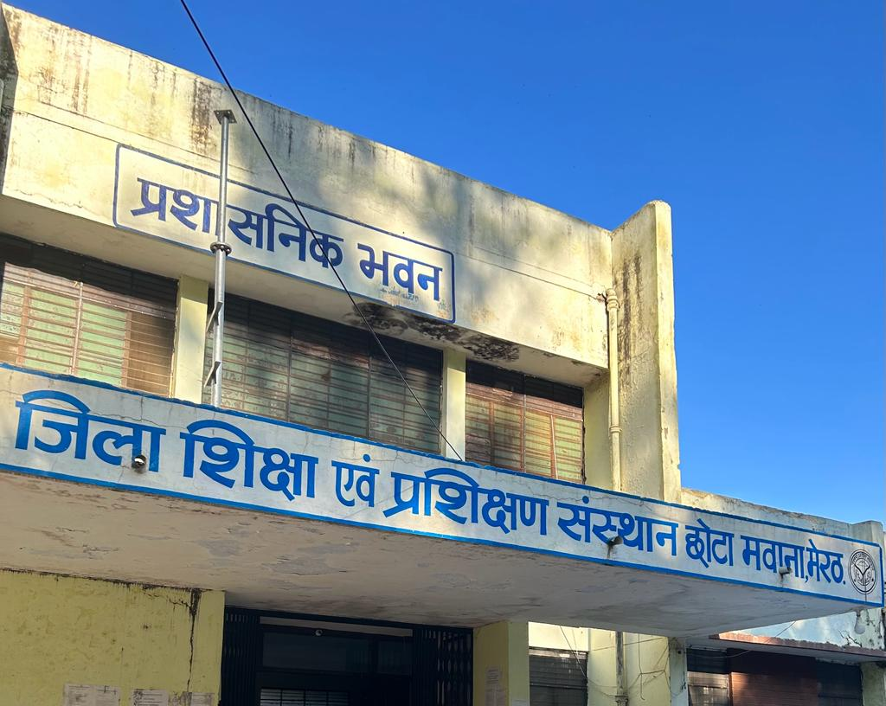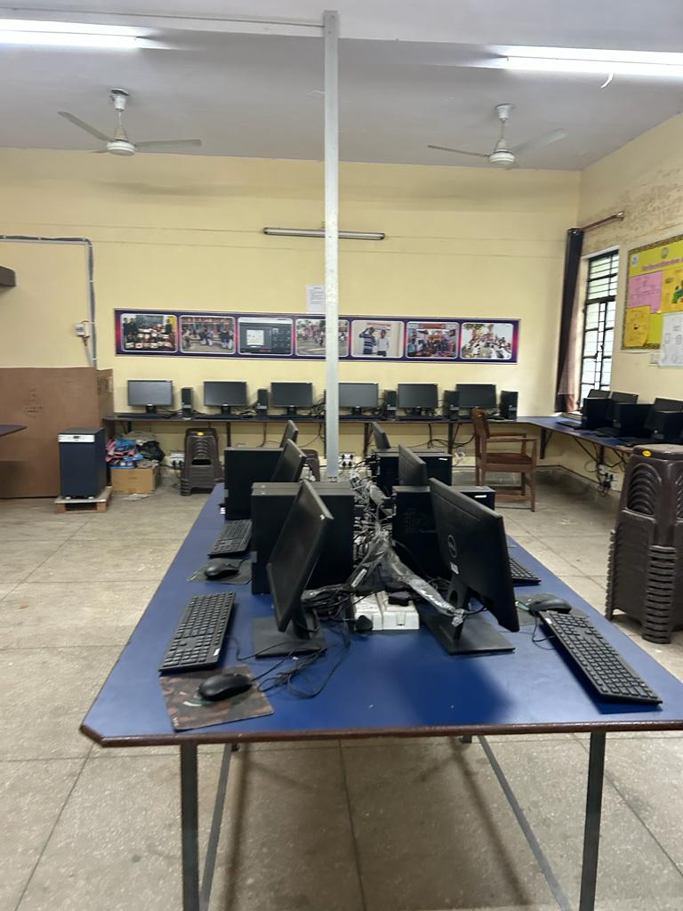

- Teaching Learning Resources
Lists have been given numerous times for getting new books, but no action has been taken. At the library there are two types of books- general and curriculum based. The lecturers did complain about feeling unheard. There are 8-10 outdated books still kept in the library. After numerous classroom observations, interaction with the students and the faculty members, an inference was drawn that TLM’s are being used and promoted. Mathematics tool kit (for teaching most subjects- we observed science), chart papers, online resources and articles are shared and lecturers do promote learning by doing.

- D.El.Ed Class Observation
Observed 2021 batch classes as 2022 batch was on leave to prepare for exams starting from the 19th. One teacher was teaching with the child in class. It was extremely distracting for the students, after she came to class late. The teachers get good external support from the NGO, as when the teachers are absent or they have election duty, or any training that they need to take, then the teachers connected with the NGO, help them manage their classes and cover up the syllabus. The class we observed was Social science and Science. In SST, the class was disrupted and was stopped several times to cater to the child, as the child was disrupting the class. However, the teacher continued teaching and students seemed very keen to learn and very very attentive. The classroom was print rich with charts on the walls.

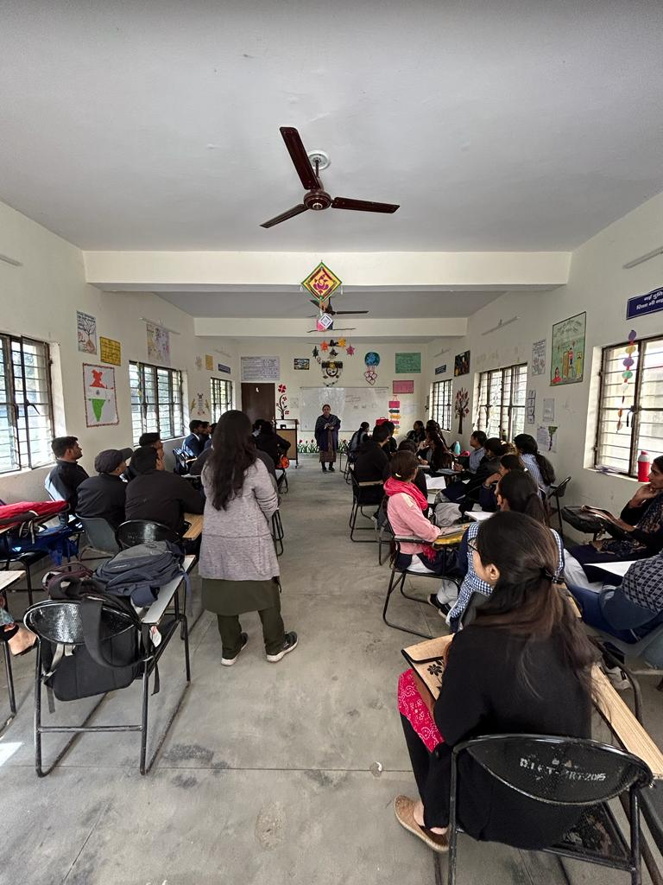

- D.El Ed Student-teacher Interactions
Students were interacting and asking questions in class. Most students are a part of the course because it would guarantee a government job. It also guarantees a job sooner than a B.Ed college. A few students aspire to be teachers since they enjoy interacting with children and recognise the impact their teacher had on them. They hope to do the same for them.
Teachers viewed the curriculum as outdated. Most parts of the curriculum have to deal with subject and theoretical knowledge as opposed to pedagogy. Students are not taught how to teach and therefore, interest in the class seems low. Teachers try to teach aspects of pedagogy. However, that is not true for all teachers and depends from person to person.

- Workshops / Inservice Training Observed
SCERT conducts workshops on education and teacher training. Only two units were functional- pre-service and in-service. Teachers in the schools receive training mostly from the ARPs who are trained in the DIETs. Direct interaction with the DIET is limited.

- NGOs Presence
Humana People to People- NeTT teaching practice, they also created a digital platform on doctrine modern methods, and different themes are present- eg— another kind of school, teacher etc. They make a monthly plan and try to execute it. In an interaction with the NGO team leader it was mentioned that in 2013, when the team came, the board still had a date of 2011. They have a portfolio of every student and provide any assistance that they might require. Mentioned they DIET is otherwise cooperative but sometimes depends on teachers interest- how much they want to learn
Hostel existed and functioned for 1-1.5 years. The NGO took responsibility to clean the quarters. But had to vacate after students started drinking, etc in the hostel

- Other Observations
A new concept of focus groups was seen, here each teacher used to mentor 6 students. A progress report is made quarterly, yearly, monthly for their own good (NGO). they didn't face any problem during the time of COVID-19, as everything was mostly online so they were able to manage. Less ARPs- should be 65, currently 42-43 ARPs only. In Mawana, only 2 ARPs.Humana team leaders mentioned there are loopholes in the system too. Age gap between teachers and students creates a gap between them where teachers cannot really build a connection with the students. Humana is mostly involved in pre service and in service not the other departments unless help is required and specifically asked for.
Almost 150 B.Ed and Btc colleges hence wanting to do a D.El.Ed has reduced comparatively.
Meerut is one of the DIETs selected as one out of 5 to make into an excellent/Model DIET. Reason for selection could be to select one from each Mandal. No other information is available currently.
There are 2 types of admission- direct and merit based. Level of students is lower because of direct admissions.
Prerna supportive supervision app that is used to supervise schools, only has 3-4 words worth of suggestion box.

B. .OBSERVATIONS SCHOOLS

- School Type
Primary, upper primary and composite schools.

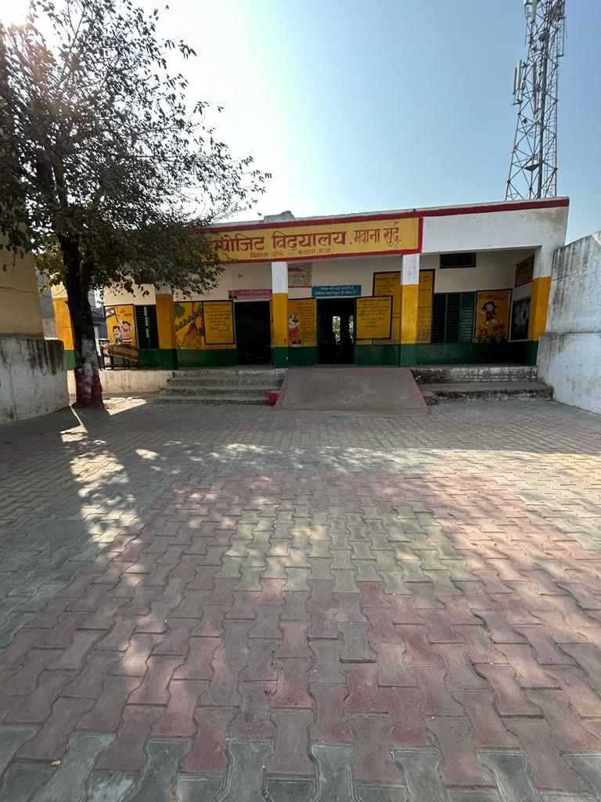

- School Location /Surroundings
Rural and urban. Some schools are in the interiors and connectivity is a problem.

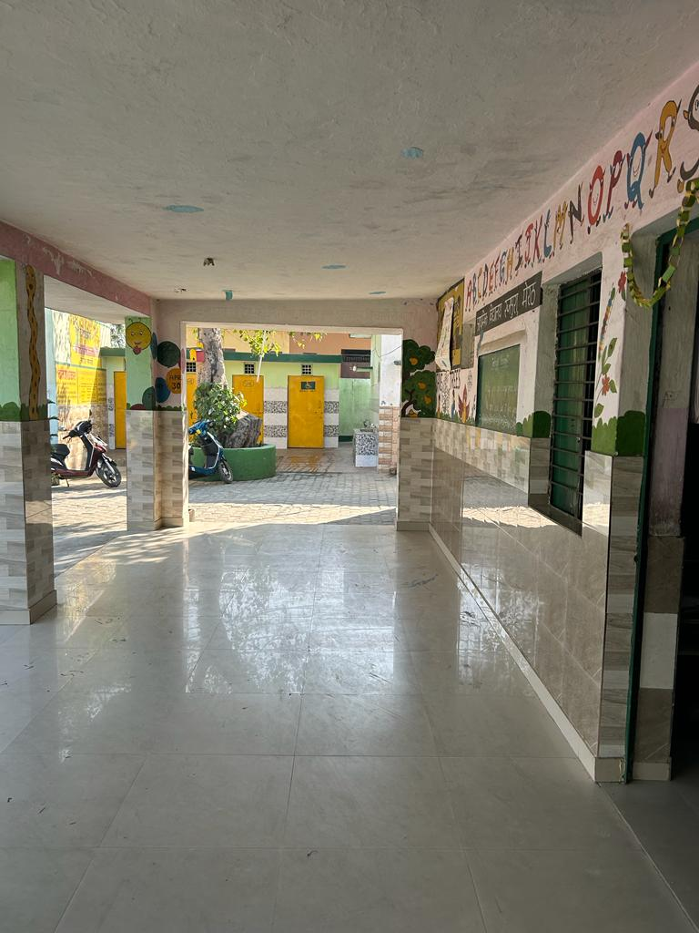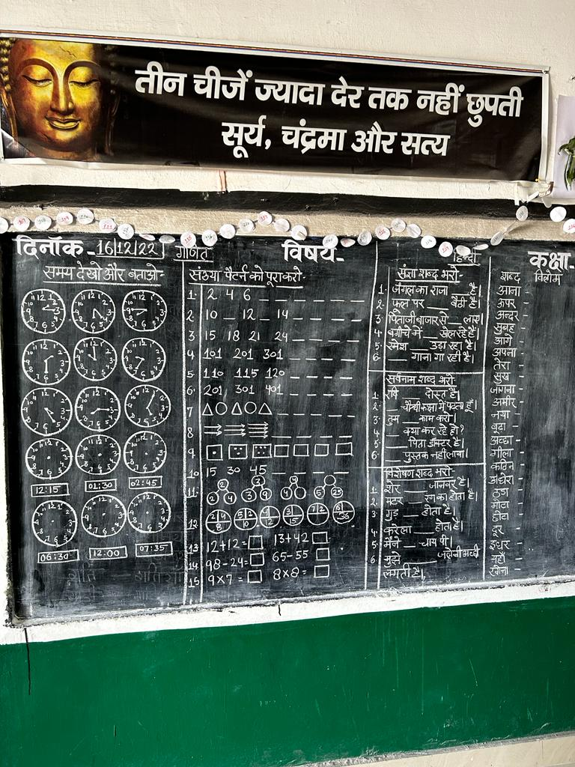

- Infrastructure (Staffroom, Classroom, Playground, Drinking Water, ICT Lab, Toilets, Facilities for special needs students/students with disabilities)

The schools had a room for the headmaster/headmistress, classrooms for students, washrooms and some facilities for students with disabilities. Some schools had a library, a science lab, and a computer lab. One school had a separate washroom for menstruating girls that is usually locked and not to be used by anyone else. The teacher mentioned it is locked so that boys in the school don't use them and ask questions about the same.

- Teaching Learning Resources ( Books, posters, displays)

Most schools had libraries- either a separate room or a corner in the classroom. We were told students also issue books and in some places only read in the library period. Most schools were print rich with the walls often hand painted by the teachers in the school.

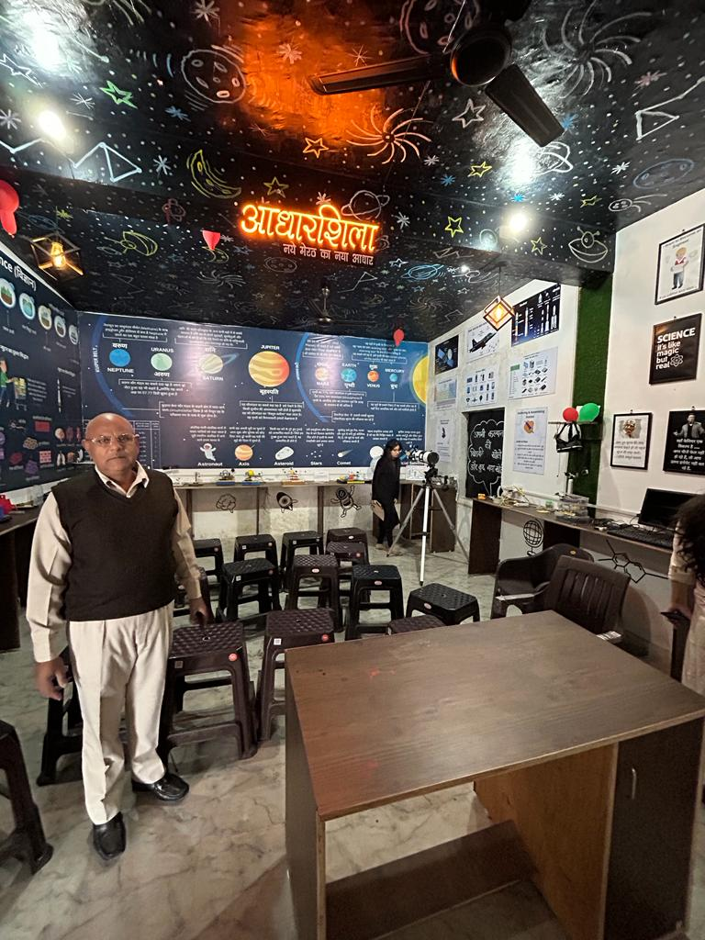

- Class Observation (students, blackboard, Seating, Pedagogy, Interactions etc.)

Students were mostly seated facing the blackboard as opposed to sitting in groups. Most schools had a space crunch with 2 classes in one classeo. Often 1 teacher manages 2 classrooms. The interactions with the teachers showed the space crunch was a big issue. They also have to do election duty which leads to a lesser number of teachers. Shortage of teachers is also a big problem. Teachers were observed using some TLMs in class.

- Interaction with headteacher/teacher

Teacher shortage and space crunch were two things that were big issues. For the teachers in grades 1-3, there were issues of less flexibility in what they were teaching and how they were teaching because of the lesson plans they needed to follow to attain the NIPUN LAKSHYA. Often the cleaning staff is paid from their own salary.

- NGOs Presence

Humana NGO had 10 schools under them in one block. Visited one of them- the composite school. BGO had provided KADAM books to cater to students who need more help and aligned with NIPUN Lakshya. Like the DIET mentors, the NGO members also visit schools to provide support and mentoring to the teachers in the school.

- Other Observations (Co-curricular activities, Assembly etc.)

Schools have morning assembly with PT. One school has a summer camp they organize for students during summer. Most schools have cultural festivals and sports that students can participate in.

