**FIELDWORK SUMMARY**

**TEMPLATE**

**DIET NAME:** Lucknow **DIVISION:** Lucknow

**FIELD TEAM:** Prof. Bindu, Palak, Preet, and Ramnivas

**DATES OF VISIT:** 5/12/2022 - 9/12/2022 **DURATION:** 5 days

*NOTE: Please add only your observations, do this as a group activity. You may add your reflections for your FA report; this document is only for observations. Please add Photos wherever relevant in the different sections.*

1. **OBSERVATIONS DIETS**
2. **DIET Infrastructure** (Staffroom, Classroom, Labs, Library, Sports facilities, ICT Lab, SUPW Room)

There are two separate staffrooms for male and female professors.

There were 2 classrooms for D.El.Ed students of both the batches, an auditorium where classes are held when there are no training sessions or events.

There is a science lab which is functional, and computer lab, which has computers but none of them are in a working condition.

There is a library, with books divided according to different subjects. A large section is reserved for D.El.Ed books which students use for preparing for competitive exams. It can accommodate around 15 students at a given time.

There is a badminton net at the back of the main building, which the students often use to play badminton.

There is no SUPW room.

There is a room developed by Room to Read organization, which the D.El.Ed students use for especially when preparing TLMs.

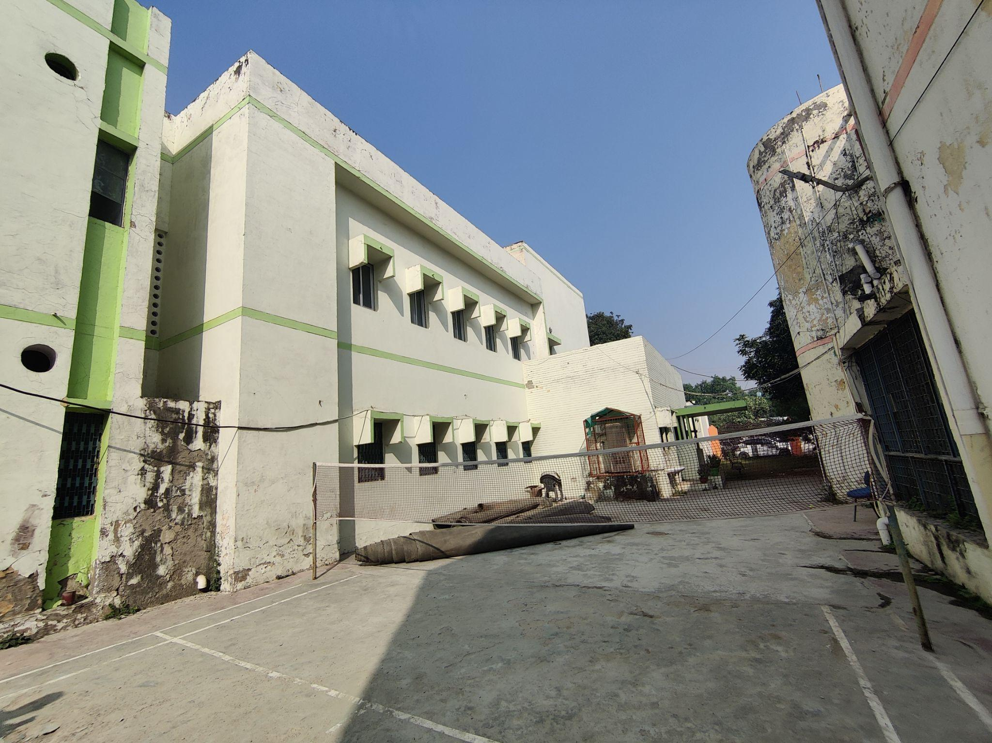

1. **Teaching Learning Resources** ( Books, posters, displays)

The classroom walls were filled with TLMs which were amde by the D.El.Ed trainees. Nipun Laksh posters were hung in the school corridor. A poster of National Disability Day was also there, given they had celebrated it on the 3rd of December. The library had books related to the subjects that were taught to the students, both in Hindi and English.

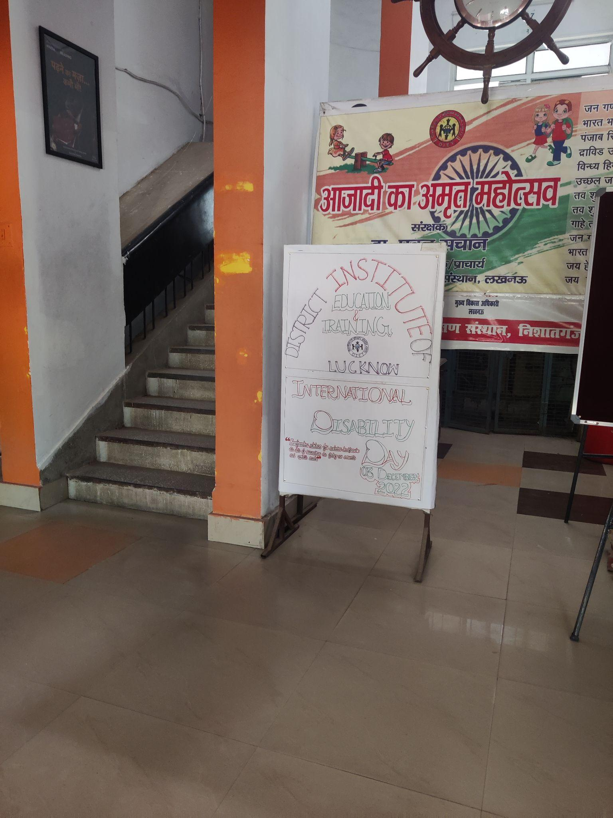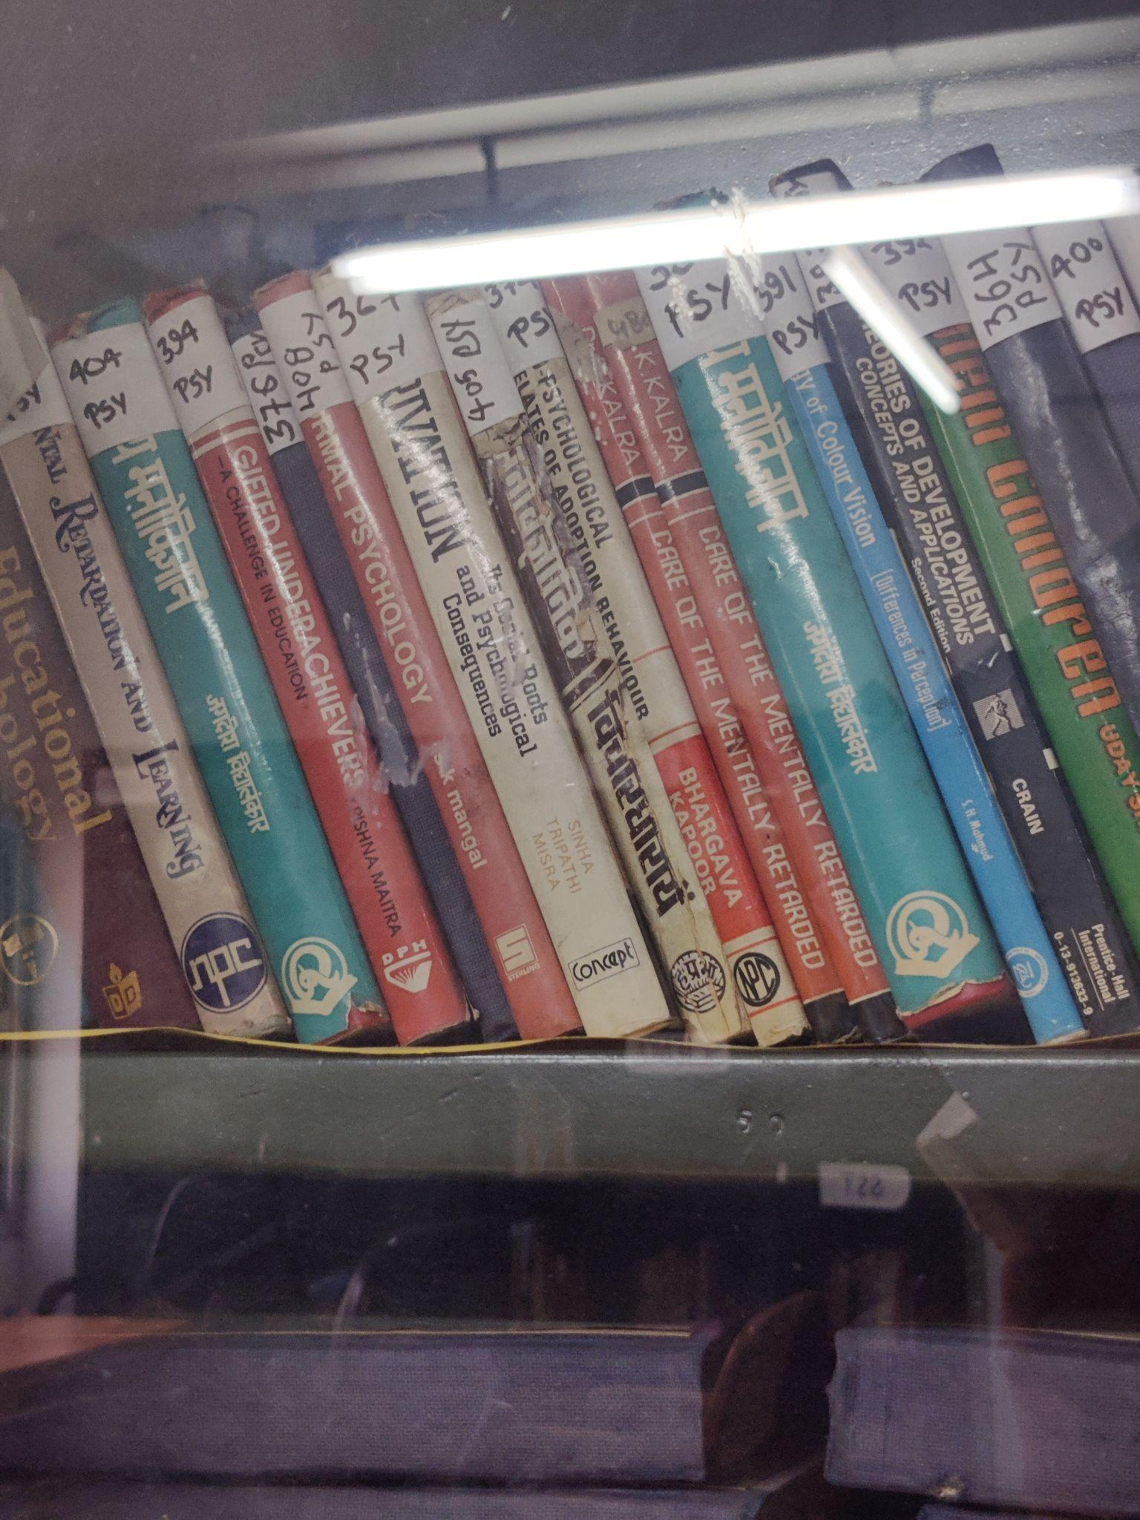

1. **D.El.Ed Class Observation** (Pedagogy, Interactions etc.)

We observed one class. The subject Mathematics was being taught to the year 1 students. The topic was HCF & LCM. The teacher was using the blackboard as a tool during the lecture. Given the size of the class, the students sitting at the back found it difficult to hear the lecture, as there was no mic, which the students also complained of. The class began with solving doubts from the topic taught in the previous lecture. For teaching that day’s topic, the teacher explained finding HCF through the common factor method. The medium of instruction was Hindi, though English was also used when explaining the terms like HCF & LCM. During the two hour lecture, the teacher asked students for doubts only twice, where one student had asked for a query. He was dictating the definitions of HCF & LCM which the students were expected to note down. In the lecture, mention was made of the questions that were important for the competitive exams.

The class was divided in two clear groups, and boys and girls sat separately. There were insufficient tables and chairs for the students. Only the front three rows in both sides had big tables. Students sitting at the back were keeping notebooks on their laps. The classroom floor was not clean. While the class was from 10:30, students, mostly boys, kept walking in, especially till 11:45. Towards the end of the class, the teacher introduced the next topic pie-chart and explained what data is.

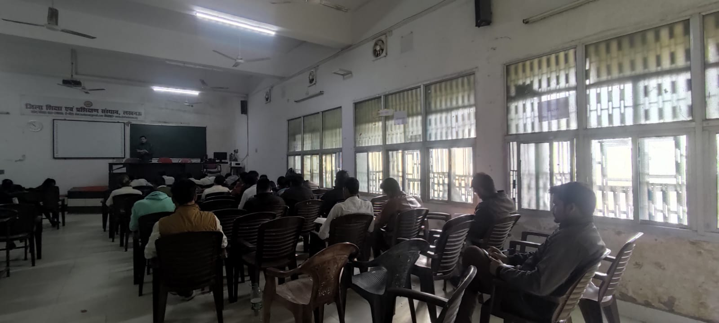

1. **D.El Ed Student-teacher Interactions** ( Aspirations, goals, feedback on the programme etc.)

For all the students that we interacted with, this course and teaching as a profession was a back-up plan for them . They all were preparing for some competitive exam, like UPSC, UPPSC, etc. Along with their course, they were preparing for government exams related to teaching, like TET. Students found classes in Hindi to be difficult for them as many had done their higher education and bachelors degree in English. They wanted hostel and canteen facilities. As per the interaction with the students, they did all the repairs (related to electrical, gardening, fixing broken chairs, etc).

1. **Workshops / Inservice Training Observed** A story telling competetion was organized, called “kahani sunao partiyogta” for the Primary school teachers. The teachers narrated a moral story, they used various methods to do so. Experts in the fied were invited to judge the competition. the DIET faculties, D.El.Ed students, and M.Ed students who had come as interns were spectators of this competition.

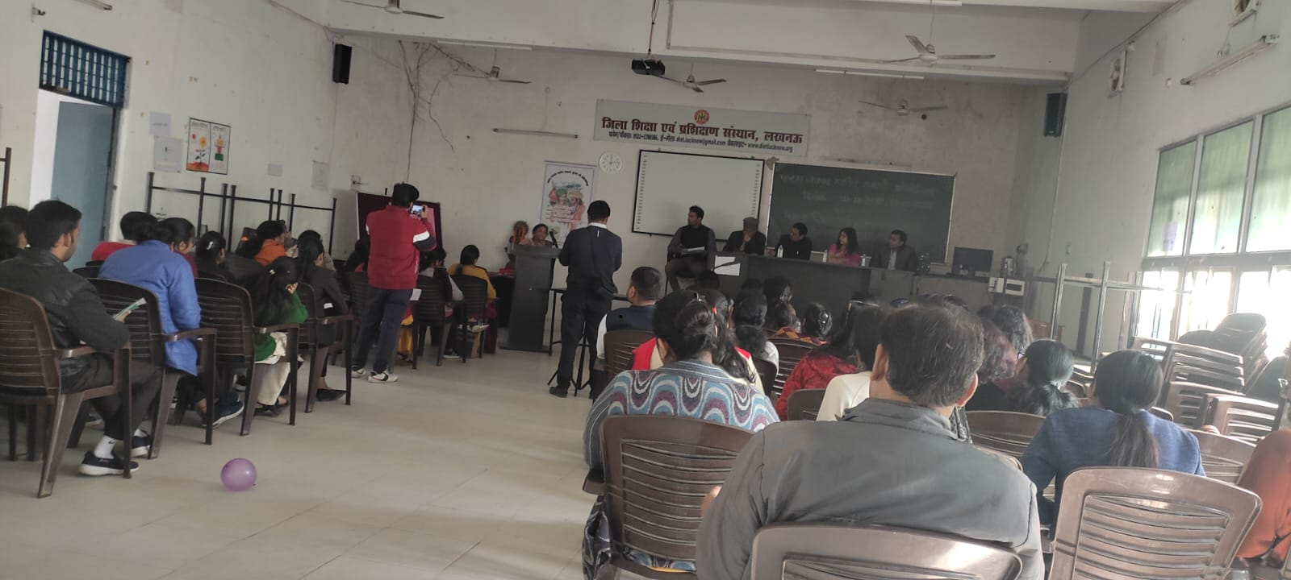

1. **NGOs Presence**  Room-to-Read has set up its library in the DIET.
2. **Other Observations** (Co-curricular activities, Assembly etc.) We observed the assembly, where the girls and boys stood in different rows. There was a prayer, followed by pledge and an Inspirational thought. Post this, news (sports, political, UPSC, local news). Next, one of the junior lecturers asked a few questions to the students, which students standing at the back could not hear given it was held in a open ground, without any mic. This was followed by physical exercises led by a few students, for which they also used a drum. The assembly came to an end with singing the National Anthem and saying “Bharat Mata ki Jai”.

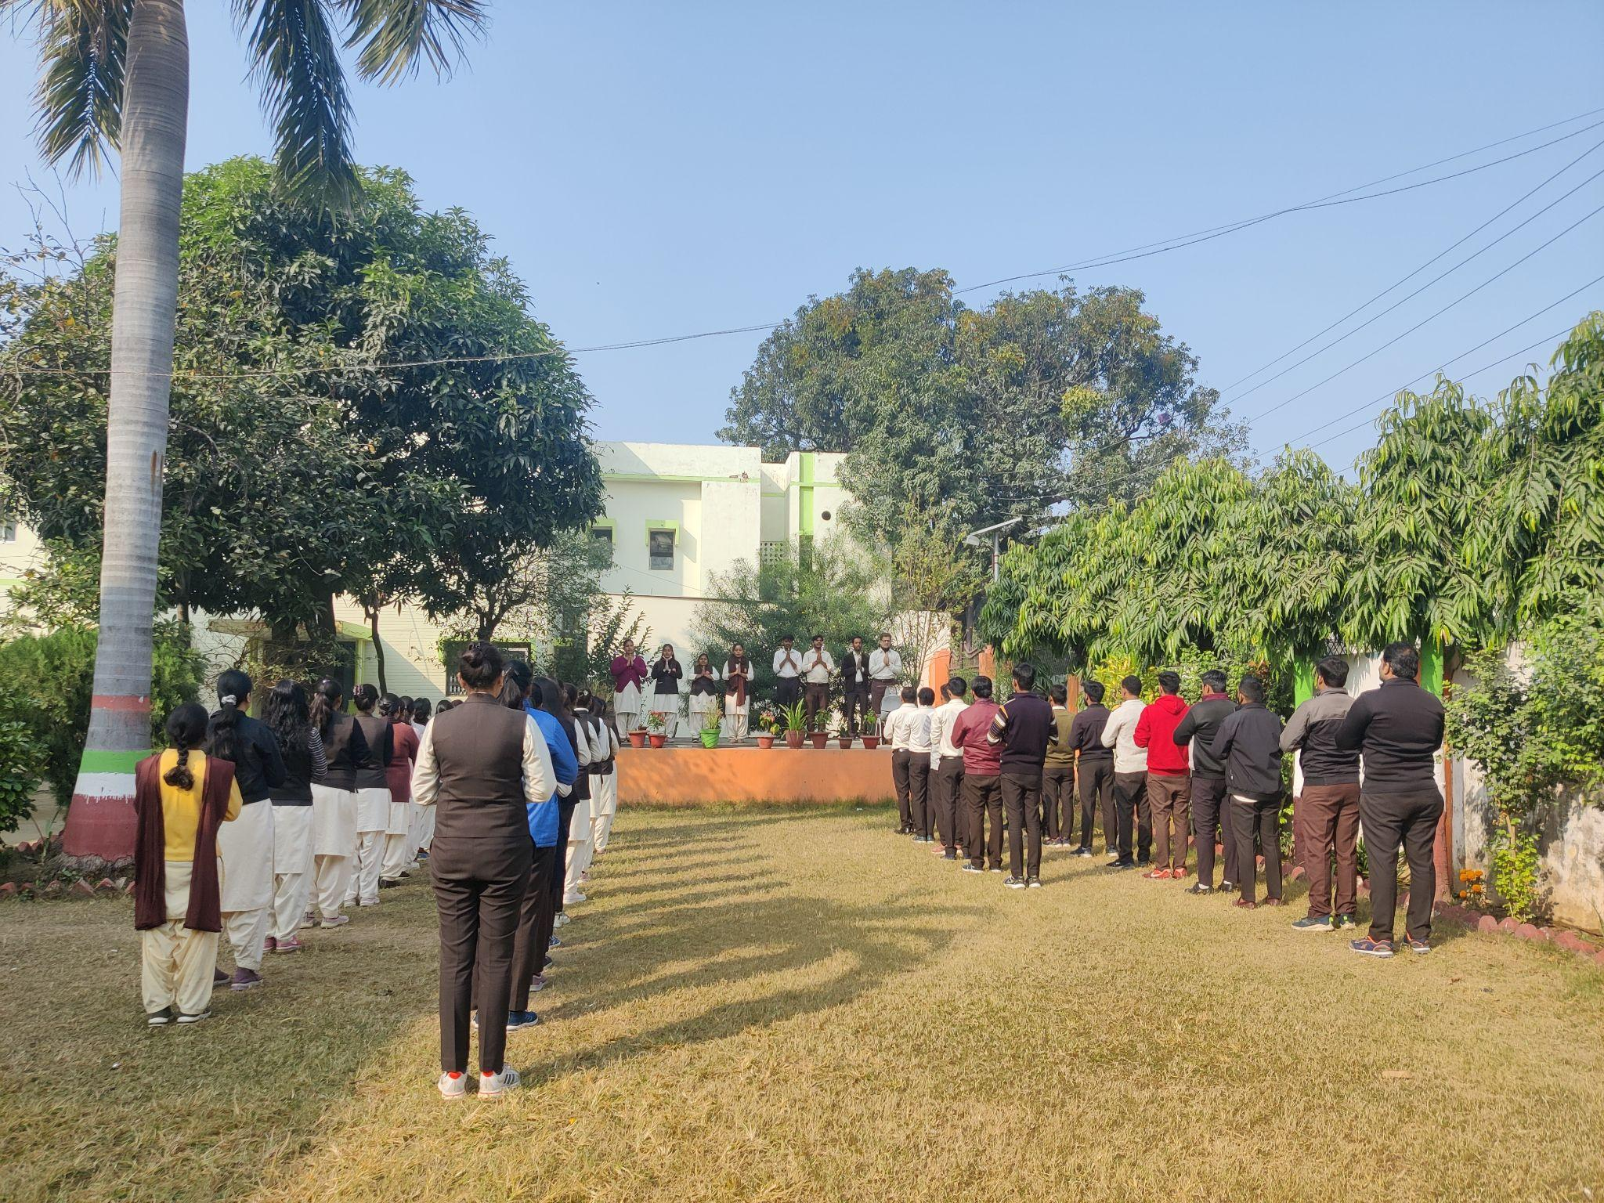

**B. INTERVIEW SUMMARY** ( Principal / Vice Principal / Sr Lecturer / Junior Lecturer)

1. **Interviewee -- Principal / Vice Principal / Sr Lecturer / Junior Lecturer**

We interviewed 1 senior lecturer and 2 junior lecturers.

1. **Institutional Identity and Focus:** [Understand the DIETs identity through the focus areas of work, goals, objectives and its ability and capacity to function as an independent and autonomous institute leveraging state and national schemes]
2. **Systemic location and relation to other institutions:** [Understand the DIETs positioning vis-à-vis the state education system, including SCERT and BRCs-CRCs.]
3. **Financial Aspects:** [Understanding the financial aspects such as provisioning of infrastructure, resources, staff and faculty positions and other facilities.]
4. **Development of Faculty and Staff:** [Understand the current roles and responsibilities, staffing needs of DIETs, the recruitment processes, leadership roles, vacancies, capacity building of DIET heads, faculty and staff and nurturing a professional culture/community.]
5. **DIET functions and Activities:** [Understand the different functions and activities implemented by the DIETs by way of inputs, processes, outputs, and outcomes, including teacher development, both pre-service and in-service, DIETs as resource and teaching-learning centres and institutes for local curriculum and material development.]
6. **Collaborations and Partnerships:** [To understand DIETs working with partners such as universities, DIETs within and across states, NGOs, and multilateral funding agencies towards gaining access to expertise, capacity building, networking and institution building.]
7. **COVID-19 Impact:** [ Overall impact of lockdown and pandemic-related issues]

Lecturers - Teach D.El.Ed students, prepare master trainers who further train in-service teachers in the BRCs. Main motive of DIET is to improve in-service and pre-service teachers. DIET should work independent for teacher training, as it will improve its quality. This is so because DIET lectures come from all different fields, hencethey are the most suitable for academic development in training. Instead of just monitoring schools, that they do now, the lecturers feel that they should be given entire academic control of every block. For in-service training, often master trainers are created by the DIET who further train in the BRCs, but in their opinion, it shouldbe the DIET lecturers who should give this training. NIPUN laksh has come into place taking in the recommendations of NEP 2020.

All 7 departments in a DIET should be created clearly, which should be managed by the lectures itself and not the senior lecturers, who have little knowledge of academic subjects and needs. Seniority should not be the factor. DIETs should be made to run independently, given set goals and objectives and thus they will become centres of excellence. D.El.Ed students needs to be updated, more practical approach should be added rather than a lot of focus on theory.

There is almost no interaction with BSA and BEO, which acts as a gap.

DIET lecturers are mentors in schools, who do supportive supervision in 10 schools every month and give feedback to school principals and teachers. Focus is given on the NIPUN laksh recently.

During COVID all communications were happening online, even supportive supervision process was made online. Schools ran moholla classes. SCERT gave directions on how to run things online and it happened timely, including trainings for teachers.

All funds are allocated by the SCERT. If lecturers have requirements, it goes to the SCERT through the DIET principal. Lack of sufficient peons to communicate things to the SCERT, like writing and sending letters. Better infrastructure and staffs could make the everyday duty of lecturers easier.

Salary is not regular, get it at a gap of 4-5 months, which affects the motivation of lecturers.

No career growth, as promotion happens according to the seniority list. For professional development, workshops are held but they are not allocated as per the qualification or area of interest of the lecturers.

**C. INTERVIEW SUMMARY STAKEHOLDERS** ( BSA | BEO/BRP | SRG |DCT |ARP)

1. **Interviewee -**  ( BSA | BEO| SRG|DCT|ARP)

We took an interview with the BEO of Gosaiganj, along with whom two ARP’s were also present.

Later, we also interviewed the BSA and an SRG.

1. **Job/Role as described by Interviewee -** The BEO said that he administers, and is in charge of the education at the block level. The ARPs described their position as of supervisors but also teachers who are in deputation. Thus, for three years, they do supervisory work, post which they will go back to teaching. They have to supervise 30 schools every month, hold atleast 1 workshop related to their subject of expertise. They also have to be present in the monthly meetings with the DIET, DEOs and Sankul meetings.
2. **Opinions/issues expressed by the interviewee -** The ARPs expressed the issue that they are often put to duties in other departments, like BLO, ration, which affects their designed work, i.e. monitoring schools. They also said that their schools needed facilities like smart TVs. Admissions till very late after the beginning of the academic year was yet another problems as then students would receive their books late.
3. **Nature of Interactions with DIET /DIET Faculty**

The BEO, SRG, ARPs, and DCT have a monthly meeting in the DIET, with its Principal, Senior Lecturers and Junior Lecturers who also monitor schools of the district. In this meeting, the achieved goals of all members, as well as the goals and objectives for the upcoming month are discussed in detail.

Often DIET prepares master trainers and send them to the BRCs, where school teachers are trained. DIET faculty and ARPs are also in contact as they both are in charge of monitoring schools.

**D.OBSERVATIONS SCHOOLS**

<Please add Photos wherever relevant >

1. **School Type** (Primary, Upper Primary, Composite, KGBV)

We visited 3 schools, one Primary, one Upper Primary and One Composite.

1. **School Location /Surroundings** (Rural or Urban)

All the schools were Rural in setting

1. **Infrastructure** (Staffroom, Classroom, Playground, Drinking Water, ICT Lab, Toilets, Facilities for special needs students/students with disabilities)

In the Primary school, there was no staffroom, but there was a room designated for the Principal. Earlier, there were 5 classrooms, one for each class, but as Balvatika has been introduced now, they had to give up one room for the anganwadi children. Thus, one grade has their classes either in the library or in the shed in the campus, where otherwise students eat their MDMs. In the four classrooms, there were sufficient tables and chairs for the students. There is a small playground in the school with a few swings for the children to play on. There is a handpump in the playground which serves as a drinking water facility for the children. There are no ICT facilities in the school. Their is a library, which is now managed by the Room To Read organization. They have coloured the library, provided racks for books to be kept on, jute bags which have 5 colour divisions, marking books from simpler to complex in terms of reading level. There were separate toilets for boys and girls, but there was no washroom for students with disabilities.

In the Upper Primary School, there was a no staffroom for the teachers, thus a big table with chairs were set up in the corridor, which the teachers used as a staffroom. There was a separate room for the principal, which was used by the Principal in-charge. The classrooms were did not have sufficient desks for all students and hence some had to sit on the floor. It was also seen that there was insufficient lighting in the classrooms. There were no ICT facilities in the school. There were separate toilets for boys and girls.

In the composite school, there was again no staffroom for the teachers. The in-charge principal sat in the room designated for the principal. The classrooms for classes 4-8 did not have sufficient desks for all the students, hence those who came late had to sit on the floor. The classes for classes 1-3 had bala paintings. There was no science or ICT lab in the school.

1. **Teaching Learning Resources** ( Books, posters, displays) In the Primary school, Room To Read has set up a library room, with cupboards, jute bags, and have painted the room. The library is managed by the organisation. The classrooms and school walls have BALA paintings. NIPUN Laksh posters have been put up in various places in the school. The menu of MDM is also printed on the wall

In the Upper Primary School, there is a library room, with story books as well as academic books for the students. The library also stores musical instruments, games that the students use for assembly and games period. The school has many paintings on its walls, including the MDM menu.

In the Composite School, Room to Read, has set up a jute bag library up in the primary classes. The rooms too are painted and maintained by the organization. For the rest of the students, a cupboard in the Principal’s office has books, which is the library for the students. Students can borrow books from the library according to their need.

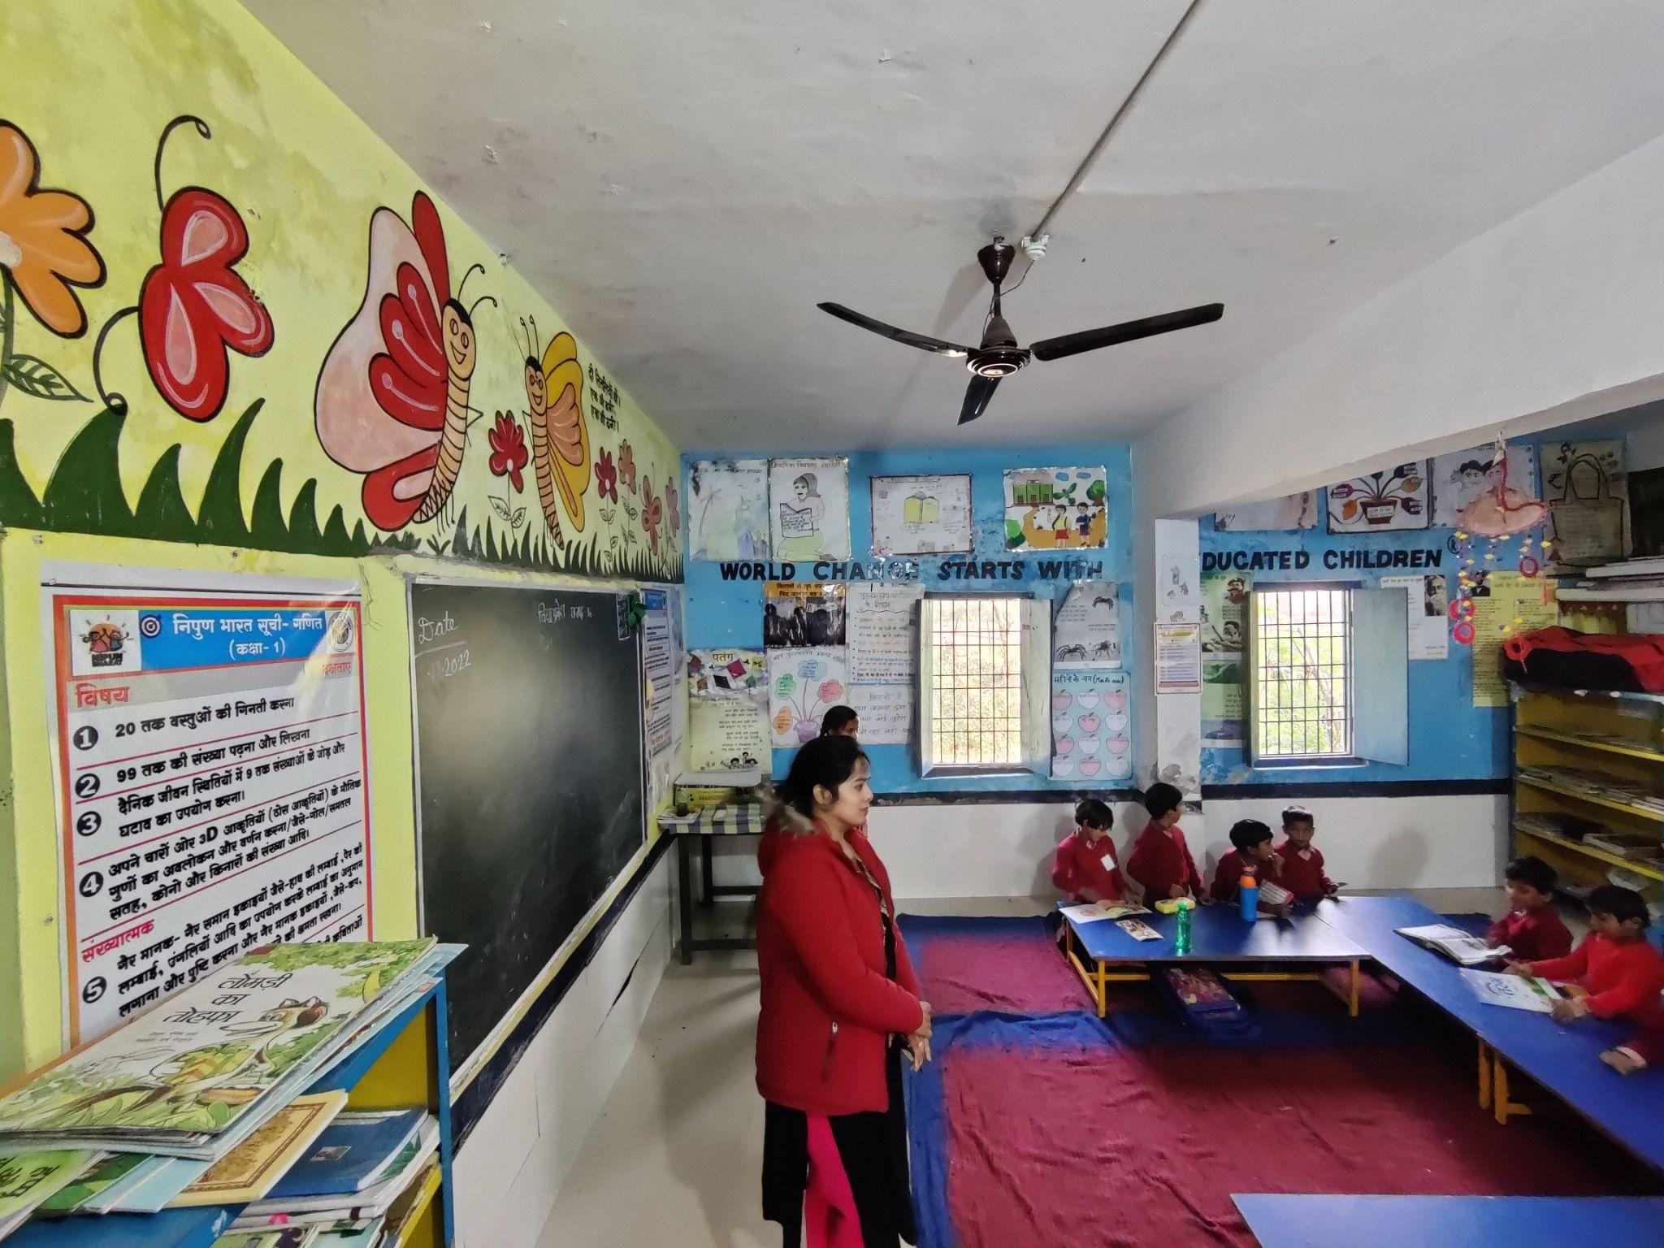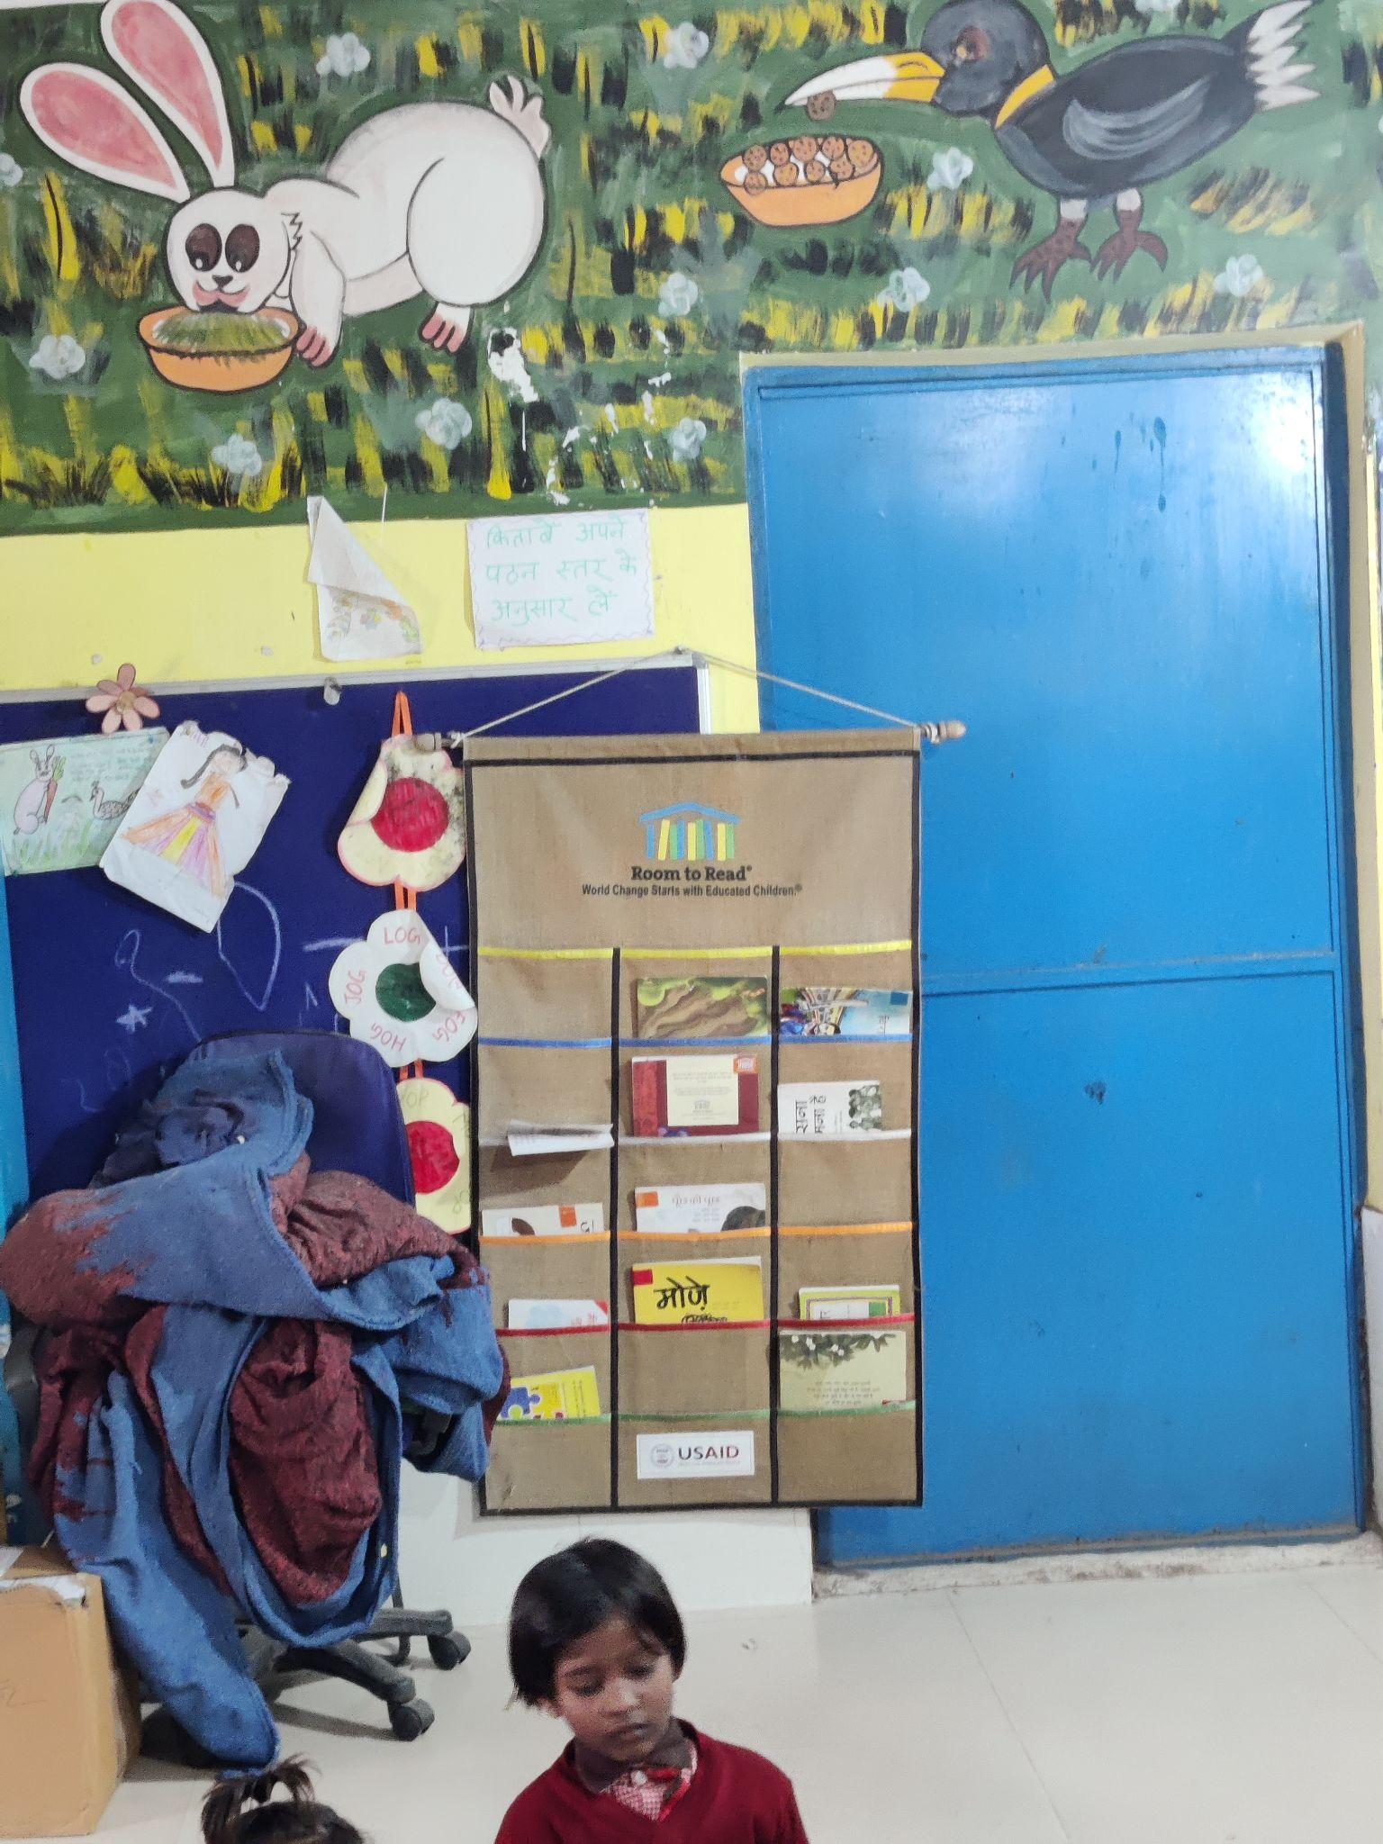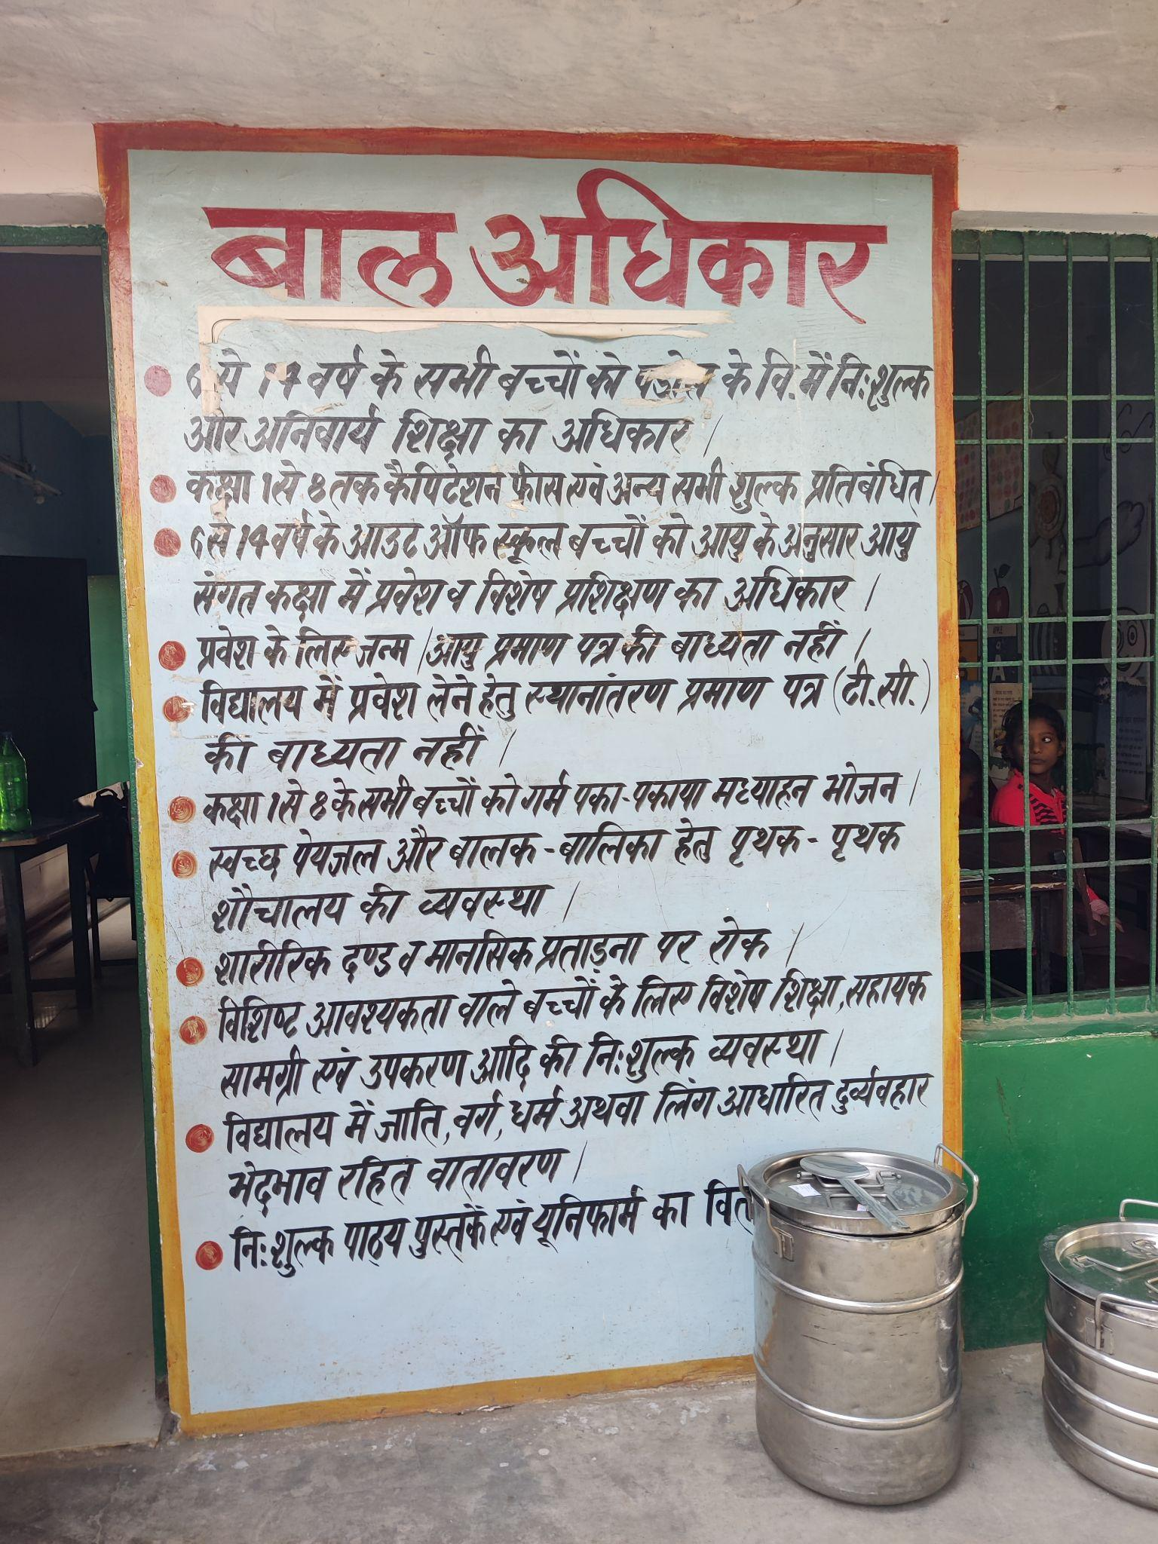

1. **Class Observation** (students, blackboard, Seating, Pedagogy, Interactions etc.)

In the Primary school, all classes had sufficient number of tables and chairs in the classroom. The children do not separately according to their gender. The classes have balckboard, BALA paintings. There is a shortage of one classroom as one classroom has been allotted to the Bal Vatika, hence, one class sits in the school compound or in the library.

In the Upper Primary School, there was a shortage of desks in the class and hence some children sit on the floor.

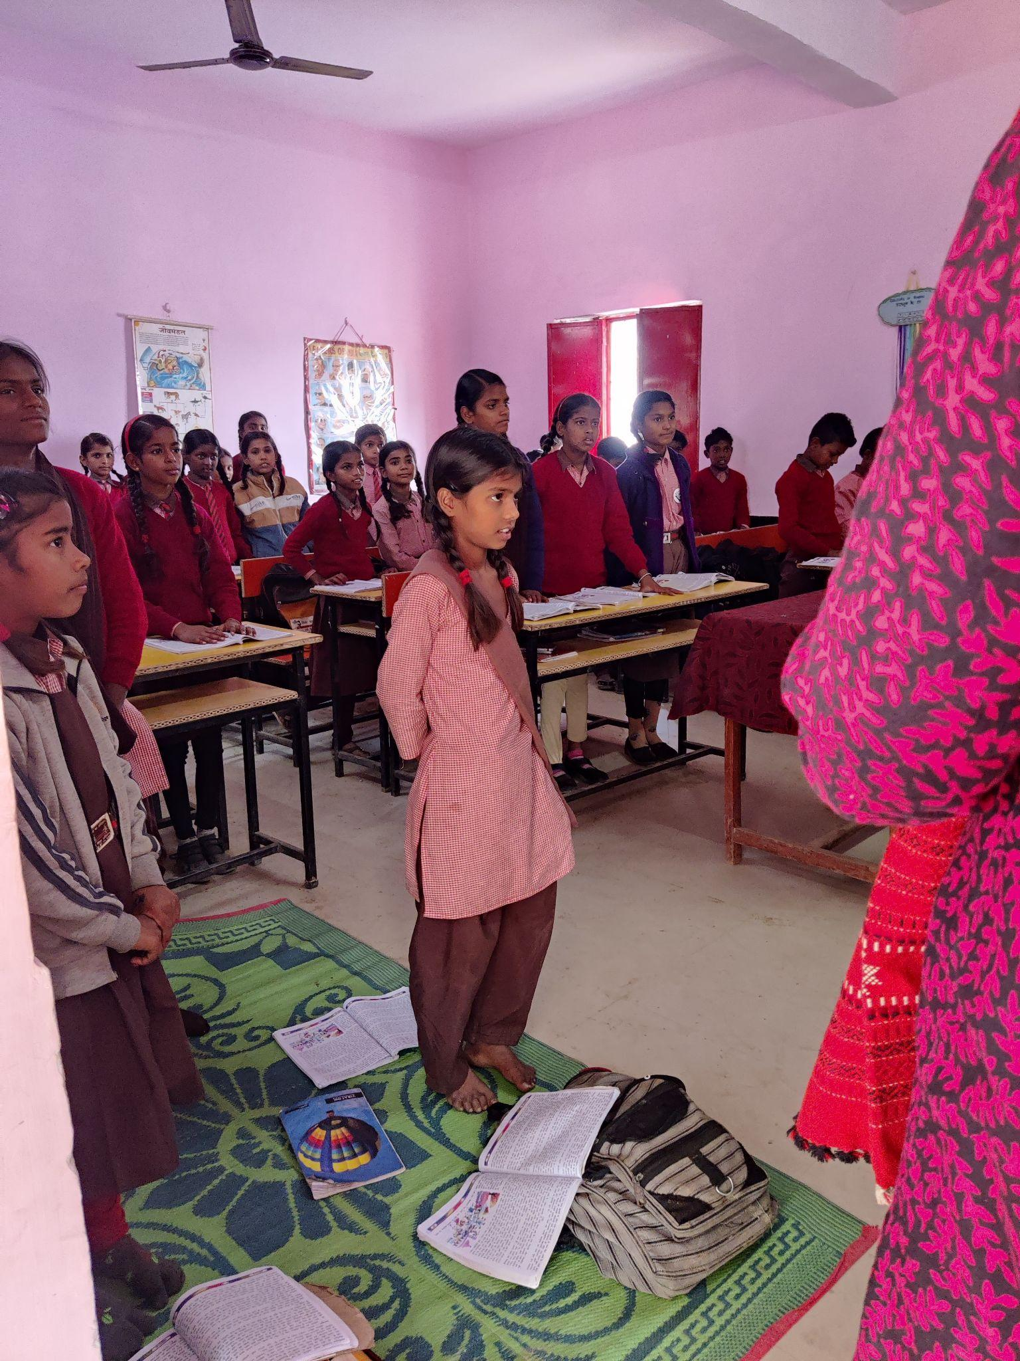

1. **Interaction with headteacher/teacher** The headteachers and teachers mentioned of the lack of technological facilities in their school, like smart classes, computer facilities

They mentioned of the supportive supervision which has been very helpful for them, especially with regards to achieving the NIPUN laksh

1. **NGOs Presence** Room to Read was present in the Primary and Composite school. UNICEF organises events for students in the Upper Primary School. Akshaya Patra - provides MDM in all the three schools.
2. **Other Observations** (Co-curricular activities, Assembly etc.)

We observed the morning assembly in the Primary school. Apart from the prayer, all children from grades 1-5, led by their class monitors revise general knowledge like the name of all the continents, oceans, India’s all State and their Capitals, all districts of Uttar Pradesh. They also revise all numerical tables.

