**FIELDWORK SUMMARY**

**DIET NAME:** Diet Sarnath **DIVISION:** Varanasi

**FIELD TEAM:** Arindam Bose, Rajnish Raj, Anand kumar, Abhijeet kumar

**DATES OF VISIT:** 5th Dec. to 10th Dec. **DURATION:** 6 days

1. **OBSERVATIONS DIETS**
2. **DIET Infrastructure**

DIET Sarnath is located in the most isolated part of Varanasi city. And being the most isolated part, they have enough land. Which is the first requirement for any institute. If we talk about their infrastructure, their infrastructure remains very old. We also got to see the remains of some houses built during the British rule. Talking about the total building, here the number of total building is 3 and one building is being constructed. Apart from having a playground, there is also a building in this complex, one of which is very old and another is in a good condition. Trees and plants in Diet Sarnath and a beautiful garden, which is in front of the main building, adds to its beauty. If we talk about the Staffroom, Classroom Labs, Library, Sports facilities, ICT Lab, SUPW Room then there are three staffroom and these are for Females staffs, one is Common room and another for Senior Lecturers. There are two class room in which class is taking now. We were shown different things about the lab in different rooms, but it seemed as if it was not in use, it was very dusty and the room was also very dusty. In the Library, it only had seating for max 5 studentsto 10 students at a time. 85% books are of publication before 2005, 15% after 2005 publication. There was a clerk who works as a librarian and doesn't have essential qualifications to become librarian. For the Sports facility, During the ground visit, when we reached the ground, the volleyball net was being installed, the children suddenly seemed to have come to the ground, it seemed as if an attempt was being made to show us that children play. there was a badminton court (the rackets were new). There was a volleyball court (but not functioning, with no net). There was no any ICT lab but we saw ICT presentation Competition at district level. For the SUPW room, Arts room was there, but the events happen as a yearly assignment.

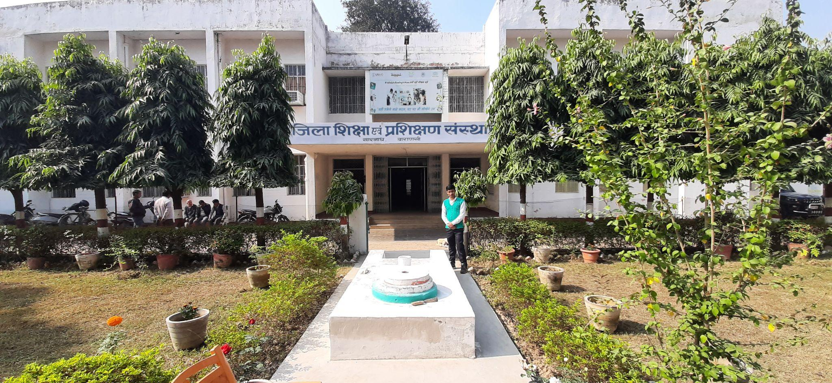

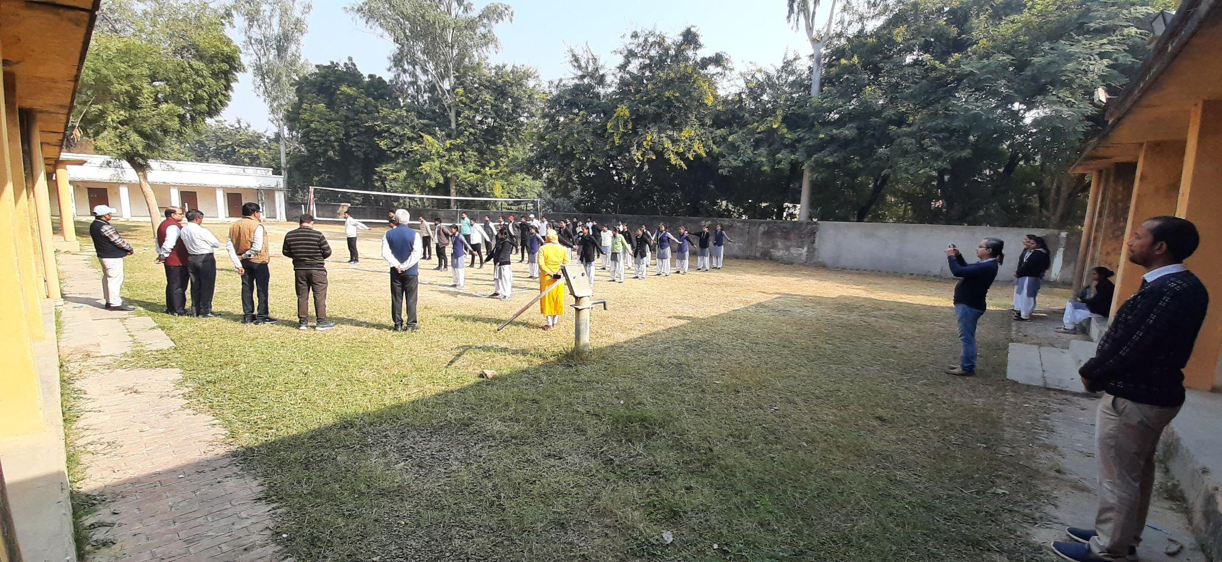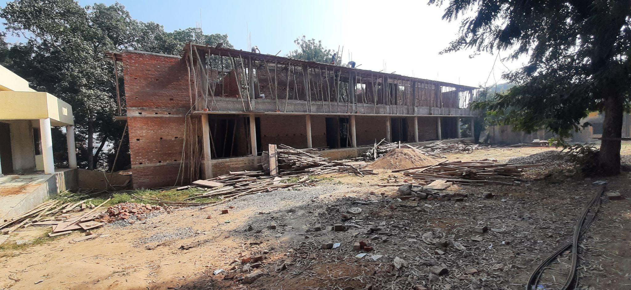

PHOTOS BY evening 27th dcember

1. **Teaching Learning Resources**

During our visit to Diet, we came across a lot of books, poster and display. There are so many old books there. And no any relevant to present D.el.ed Course. NCERT books were there.USAID books were also there. Books from rooms to read were also available. For the poster we saw of many different types Nipun lakshya poster, based on types of intelligence, Environmental education (given by MPS traders), Child psychology (Hand made), all were in Supw Lab. and for the Displays, In the entrance of the Diet administration building there were two statues of Goddess Mata Sarswati and Lord Ganesha respectively. Supw some arts and crafts work shown on the left side of the entrance of diet.

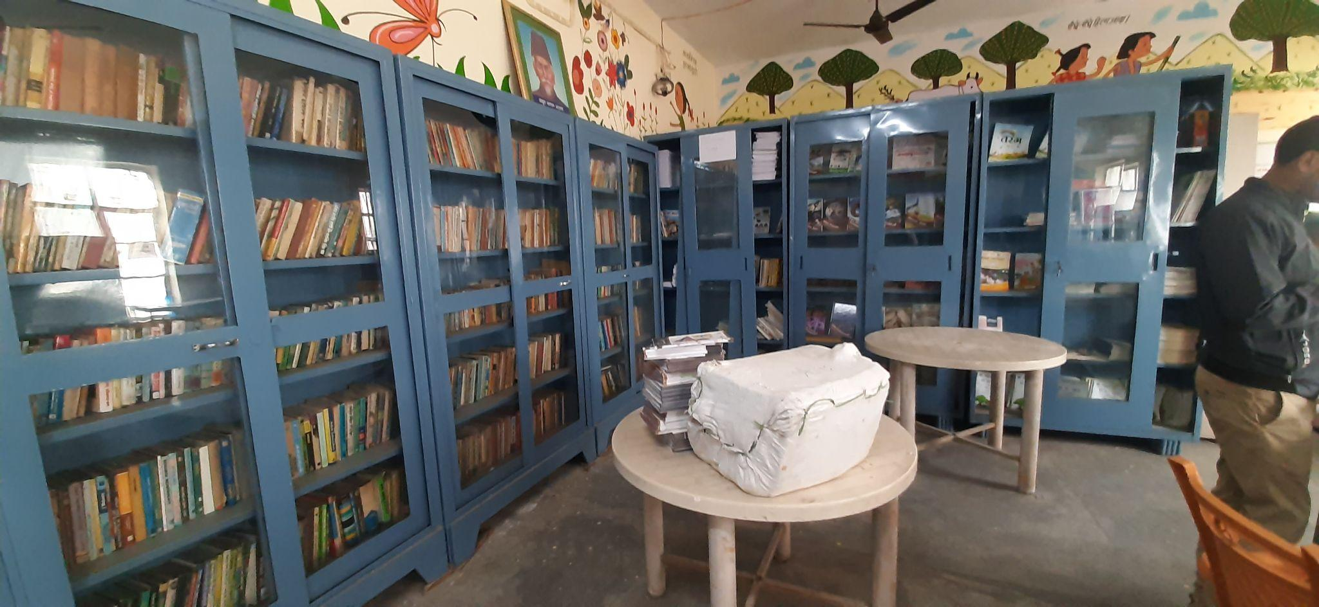

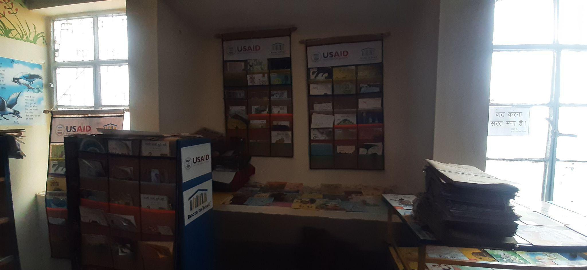

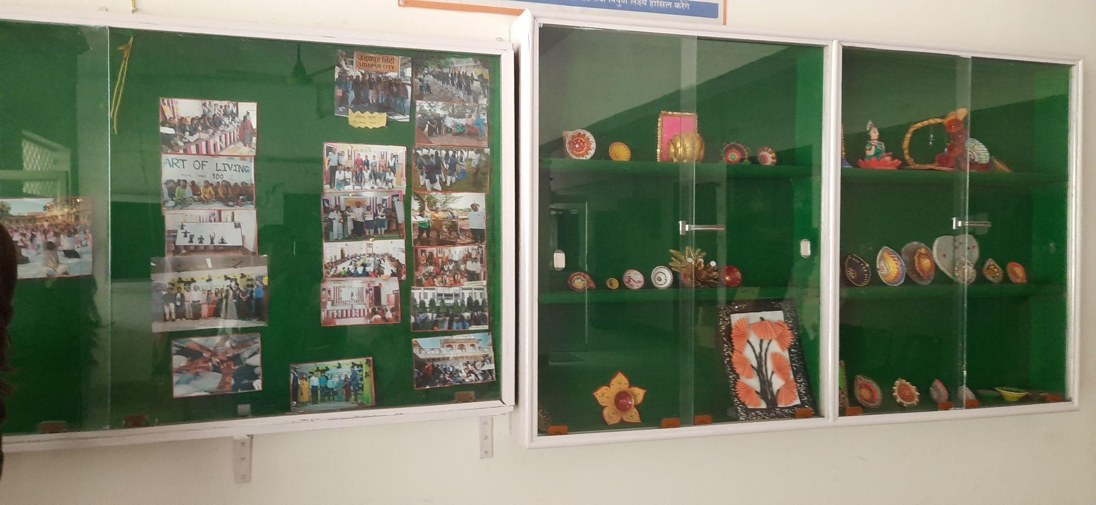

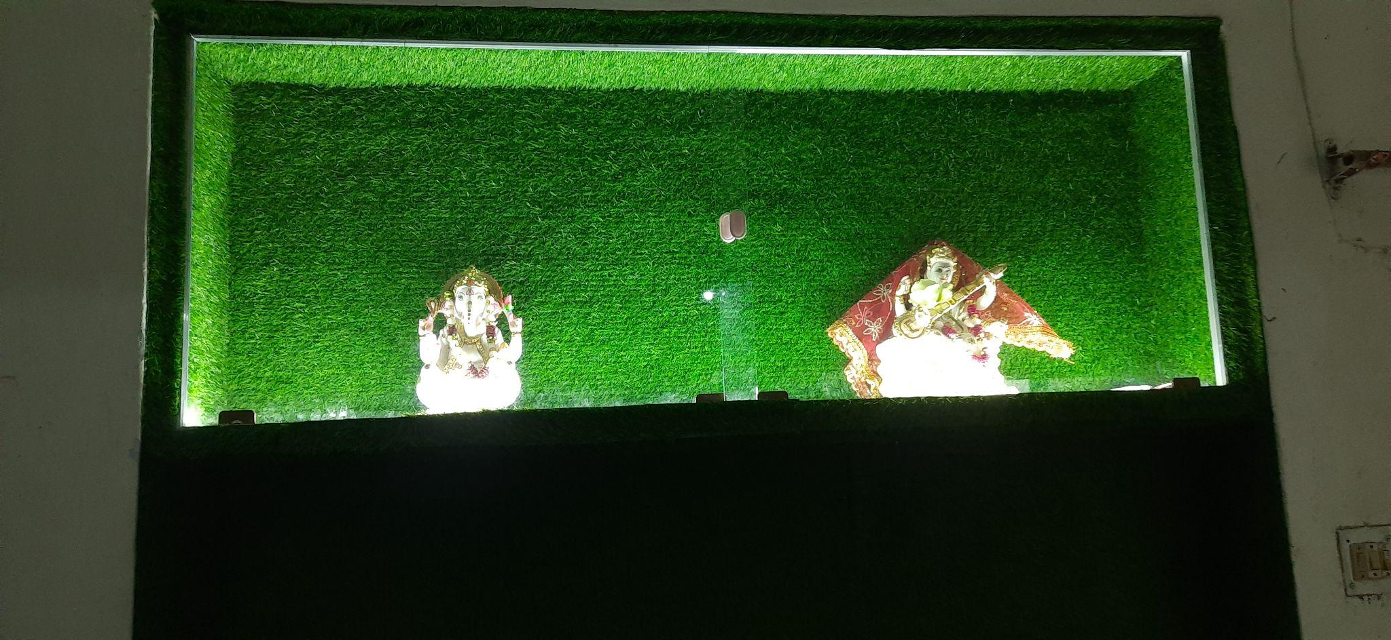

PHOTOS BY evening 27th dcember

1. **D.El.Ed Class Observation**

We also got a chance to do class observation during this diet visit. In the class where a ma'am was teaching Bhakti movement and we sat at the back, from here we could not see the board properly. 45/60 students were present that day. The questions asked by mam during teaching were not being answered by the students. Too big classroom for 60 students, No mic facility for teachers. The language of instruction was Hindi and mam was telling by writing on the board and the students were writing it on the copy. The questions asked by Mam were being answered by only a few students (5/45). We observed that no prior readings were provided to them before the class and even after the class for reference. Student free to read from any source which they have. There were not enough lights in the entire class. in the room with only ⅜ fans were working, 2/8 tube lights were working. Untidy wooden Benches and chairs were provided for sitting. And Mam's class ended at 11:45, after that we started waiting for another teacher to come but no teacher came to take the class, due to which we got a chance to talk to the children and during talking we got to know many things. At first they raised the point of exam, they told us that three exam are taken in a day. Which is very tough for us. We are not given time in between all the three exams. Due to lack of updated books in the library, we are not able to use the library properly. After the corona period, for most of the things, we had to take help from online resources, which was very helpful, but after coming to offline mode, the need for online resources has increased even more and accordingly we are not given facilities like digital type Classes, WiFi connection, information about online resources etc. they told us about sanitation problem, water tank problem, no prior guidance for competitive exams and also the canteen and hostel facility for girls and boys.DIET Sarnath has hostel facilities for boys whose fee is ₹ 500 but boys have to cook their own food, they have been given the facility of bus stay. He also raise the problem of delay of result, due to which their 1 year is wasted.

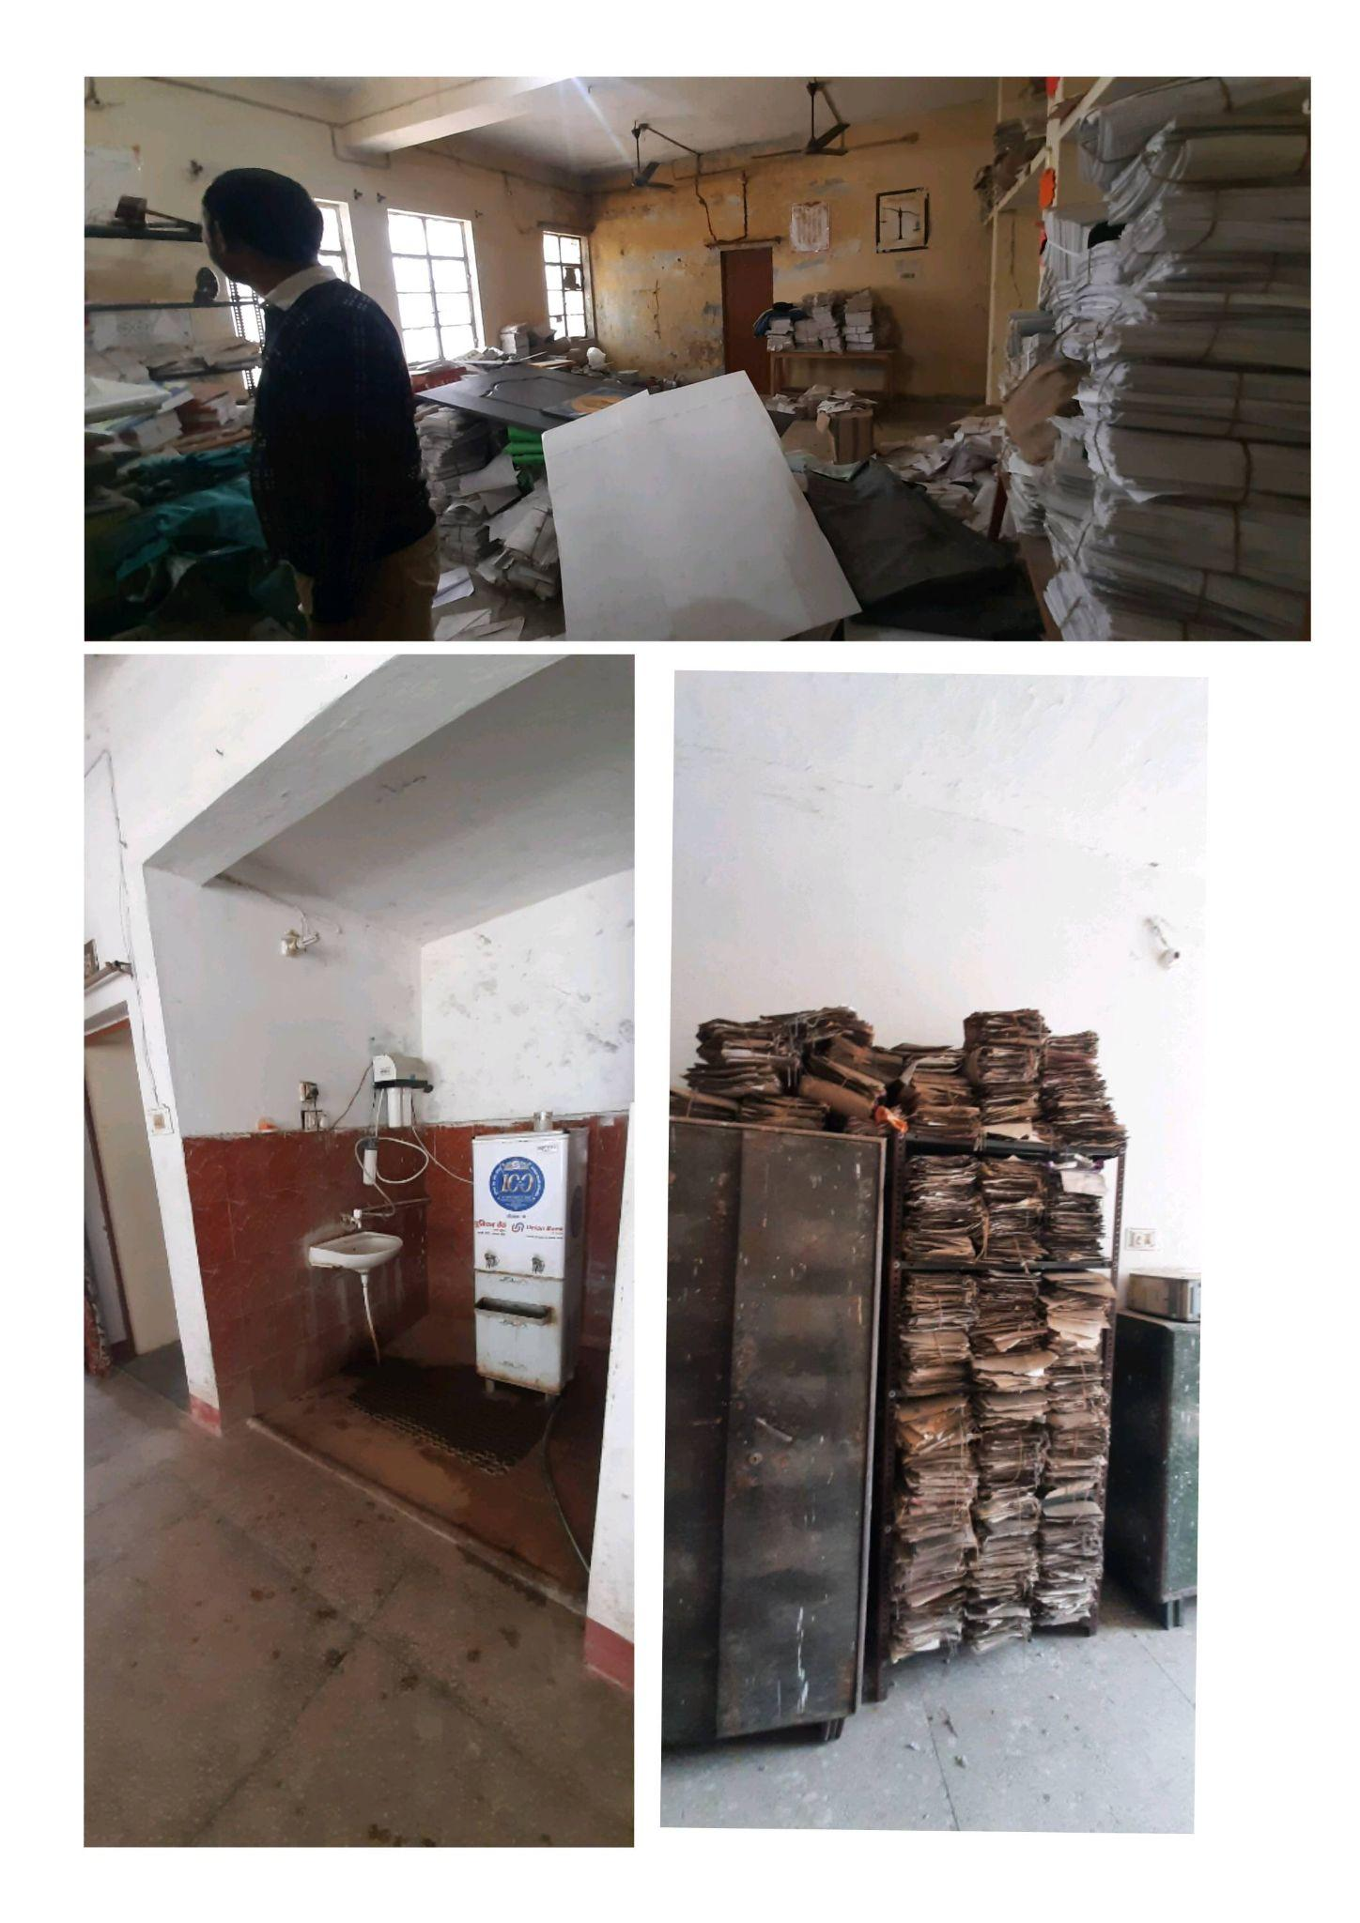

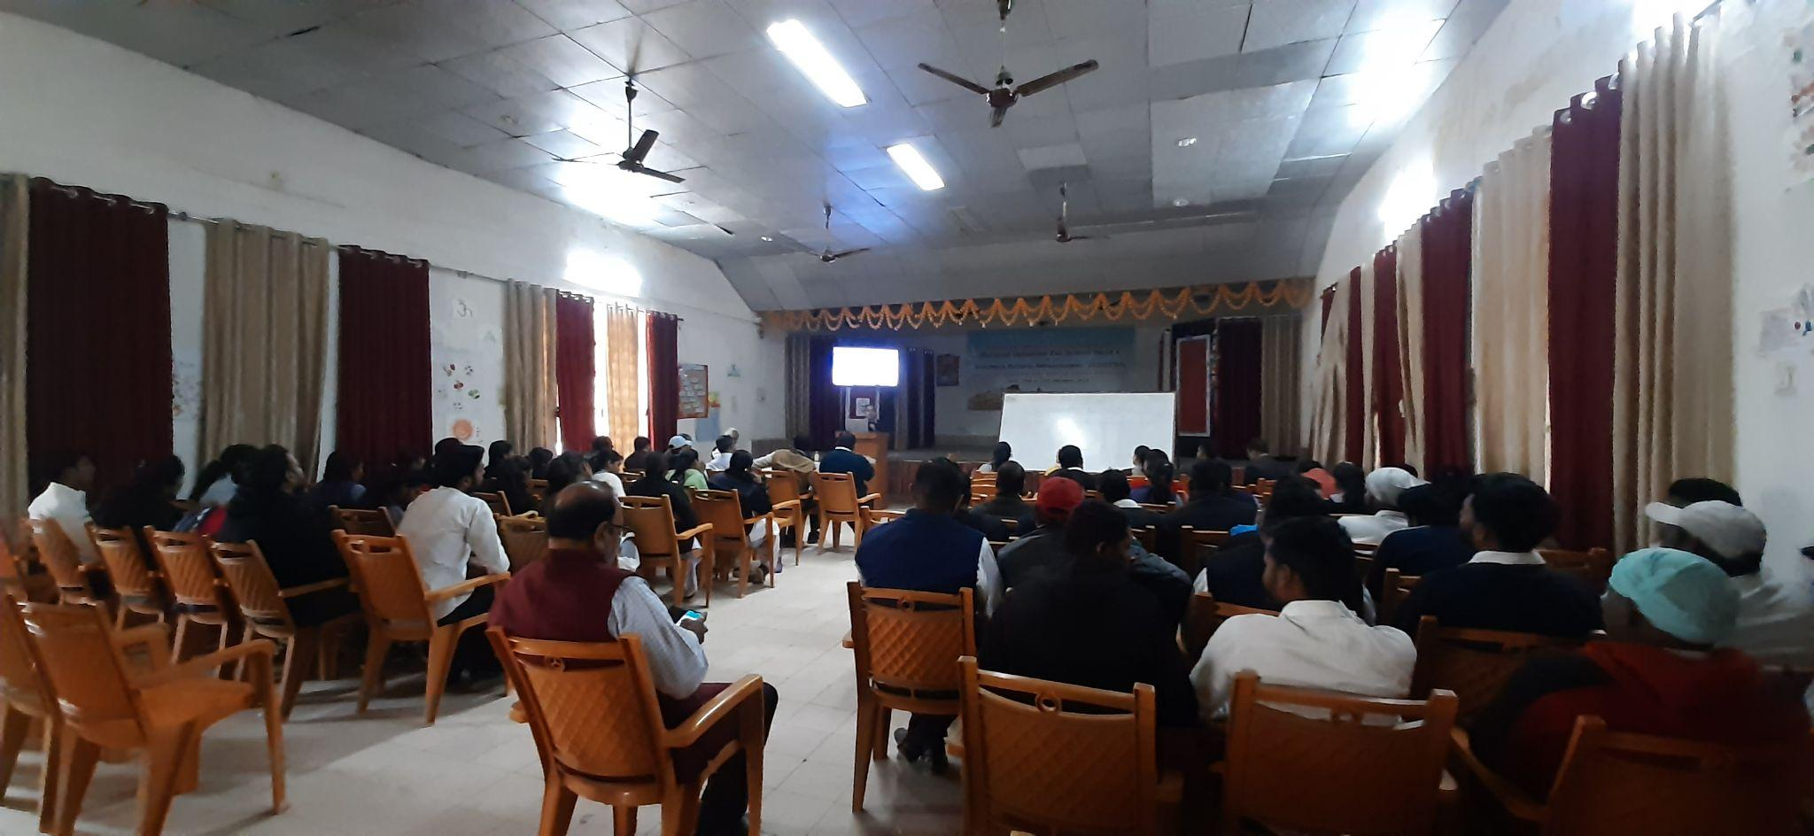

PHOTOS BY evening 27th dcember

1. **D.El Ed Student-teacher Interactions**

Aspiration for the students is to get a job as a government teacher and for the teacher, their inspiration was, There should be no problem in understanding the children while teaching, timely diagnose all their problems and move forward step by step with the children.for the goal of students, to earn a livelihood and for the teachers is to promote inclusive education and Appropriate usage of an ICT. the feedback which is given by the students, they get less marks over private d.el ed college, as they informed us that in UP allotment of teachers is done on merit basis, so anything below 90% will leave them unemployed. They want results on time, they want prior training and guidance for competitive exams relevant to the field. No source provided to students to read before or after class. And we got from teacher also which are promotion problem, salary is not delivered on time, more than 50% of diets are working on interim principal basis, commute expenses regarding field visit is an issue here.

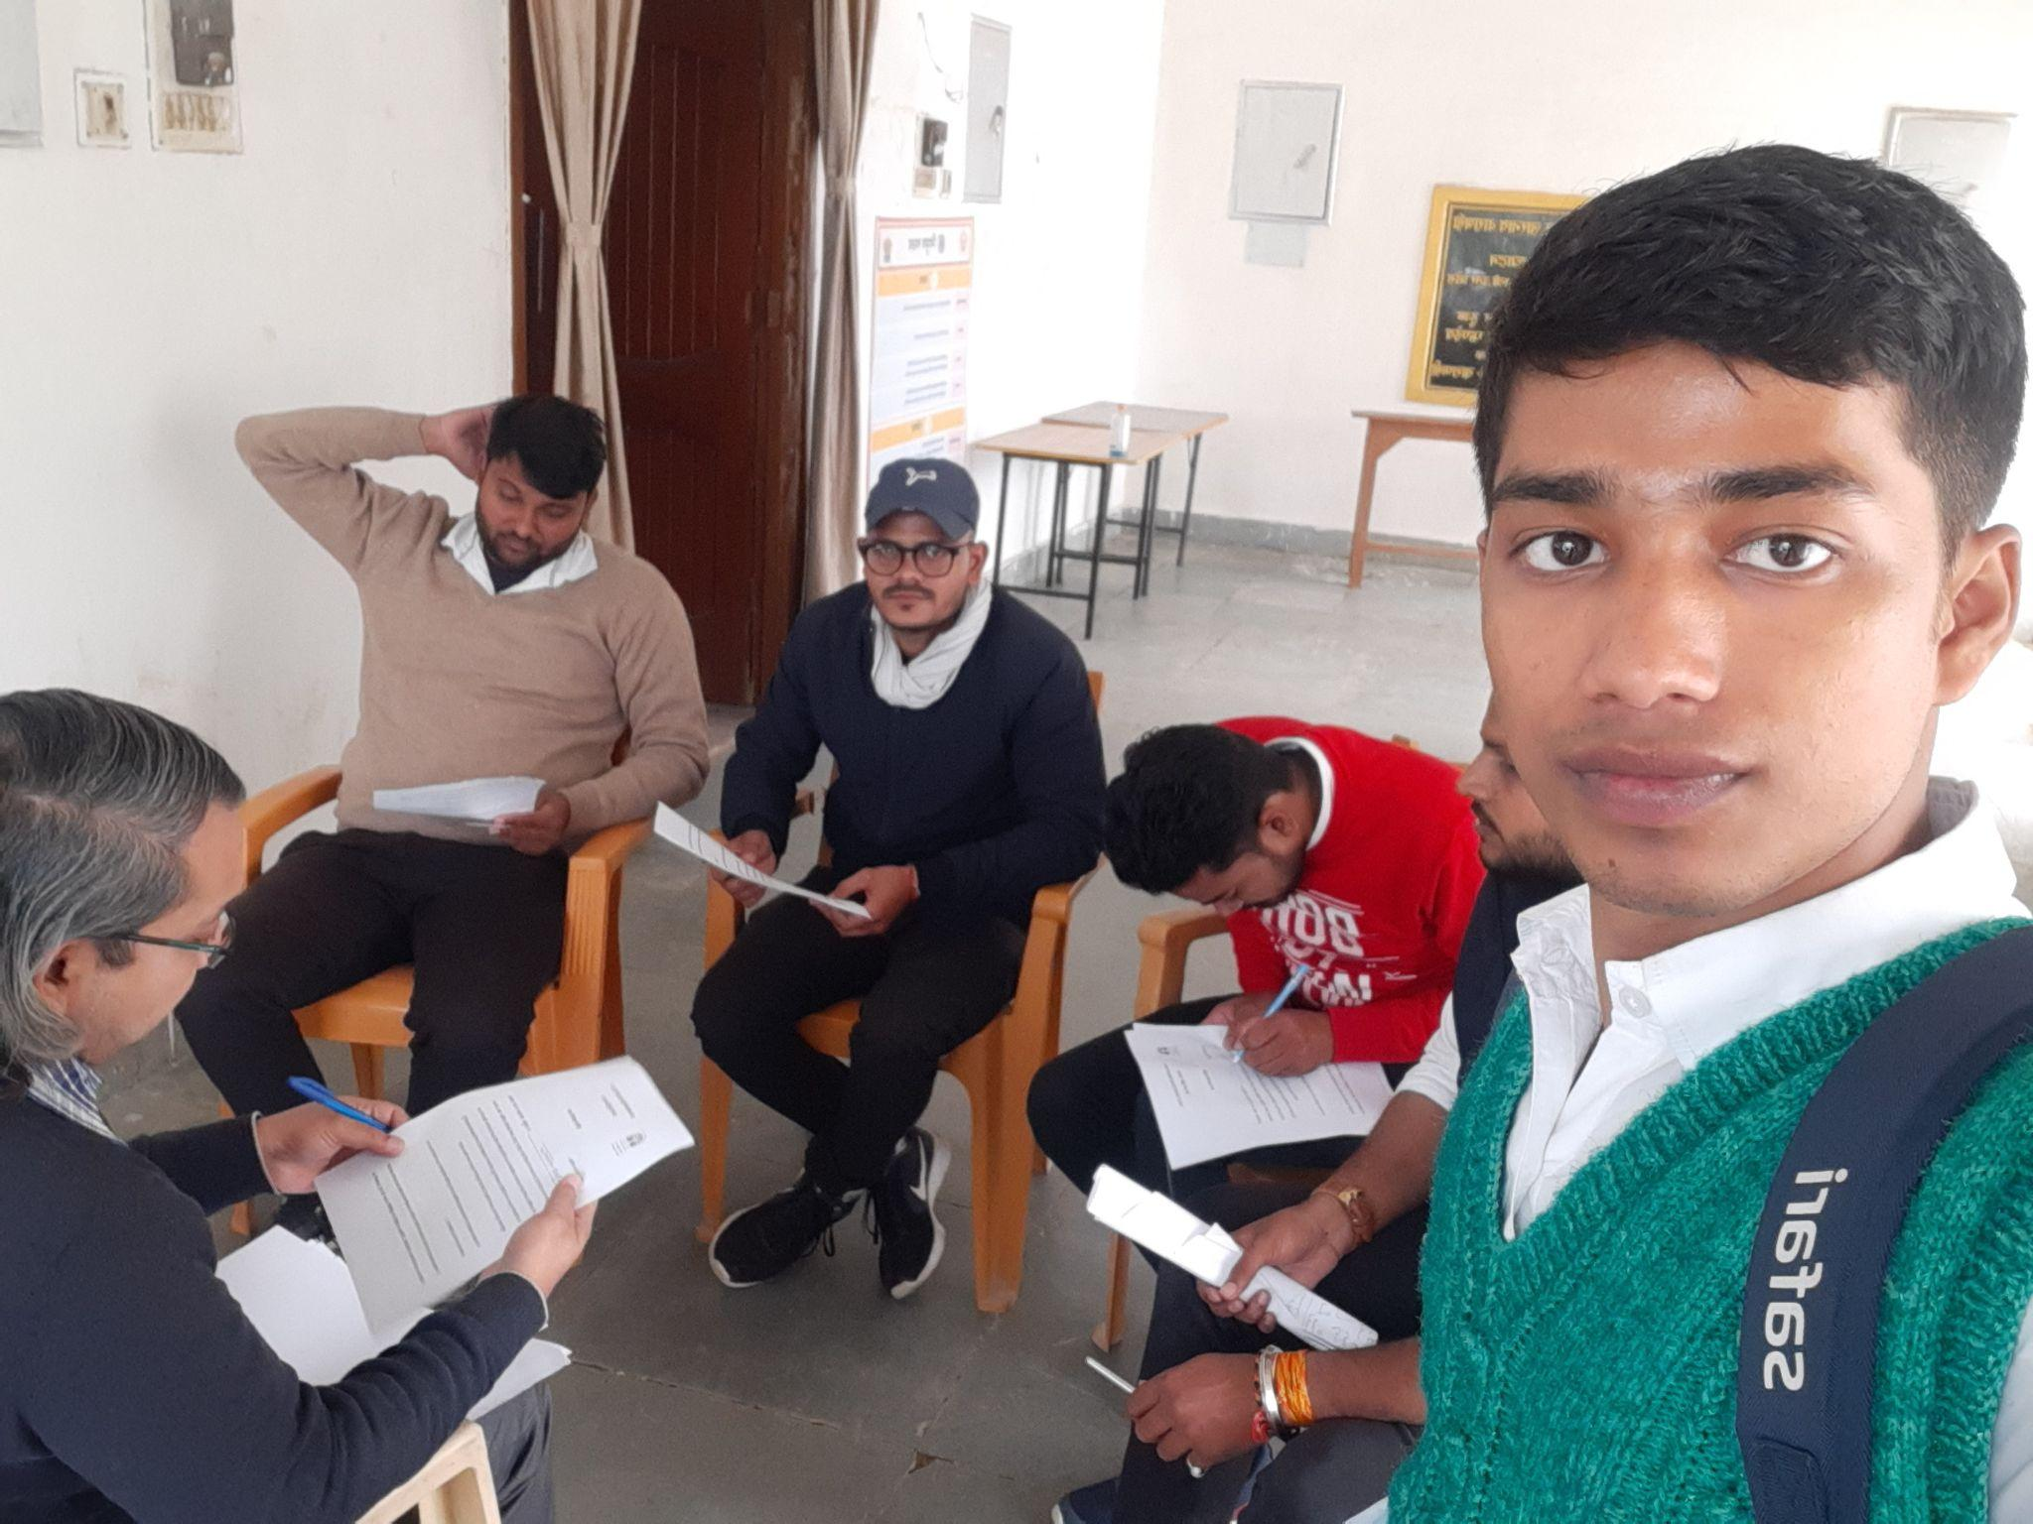

1. **Workshops / Inservice Training Observed**

There was no any workshop happening there.when we were on visit, unfortunately we didn't saw any of the above in diet varanasi. We heard about a wellbeing workshop by the principal and few more like, similar things also for the in service. During observation of class, we observe thst they focus more on Emotional maturity for TEacher, Stress management for students and Yoga Initiative in DIET

1. **NGOs Presence**

No NGO is functioning in diet but the principal want NGO to pitch in and works on computer lab.

1. **Other Observations**

Regarding the class activity, where we have already told you, but here we got a chance to see the Antrashri of poems as an activity and the participation of the children was also very high, the children were playing Antarashree eagerly. And finally the antrashree is won by girls. It was just like poem competition. And there was a activity based on words. Everyone was given some words by random by the sir and children had to make a story from all those worlds and then share it as a presentation in the class. For the assembly it happened Only one day on time, second day it was not that well organized on time. It also includes Physical exercise, thought for the day, quiz related to subject, quiz related to current affairs & static gk, News for the day.

**B.OBSERVATIONS SCHOOLS**

<Please add Photos wherever relevant >

1. **School Type** (Primary, Upper Primary, Composite, KGBV)

* **Modern primary english school, Sagunahan, Badagaon (UDISE Number - 09670203201)**

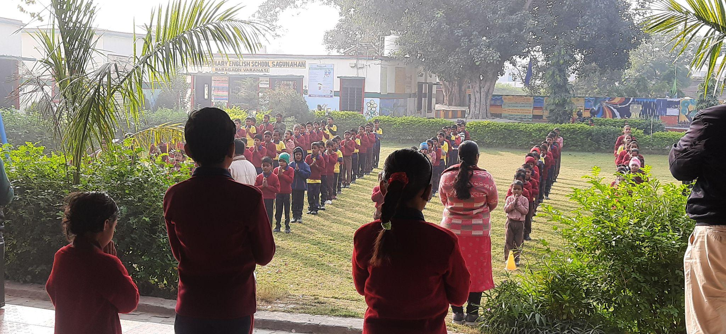

* **Composite school, Sherwanipur (UDISE code- 09670209701)**

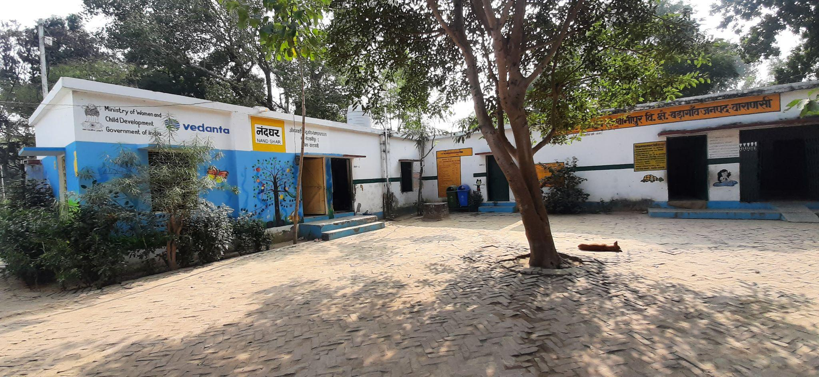

* **Composite school, Badagaon (UDISE code– 09670209301)**

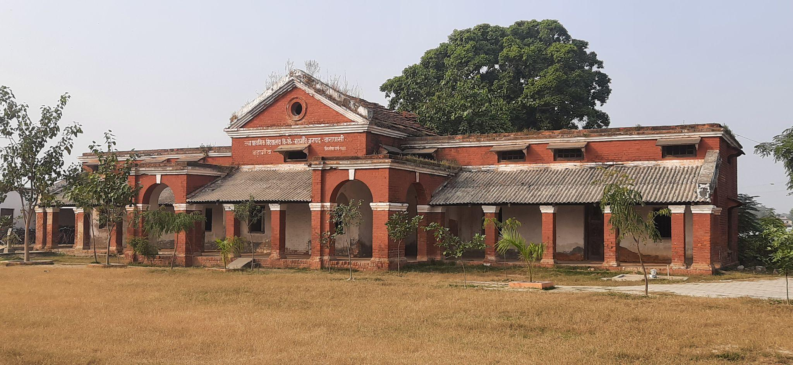

* **Primary School, Bhimchandi (Udise code- 09670508401)**

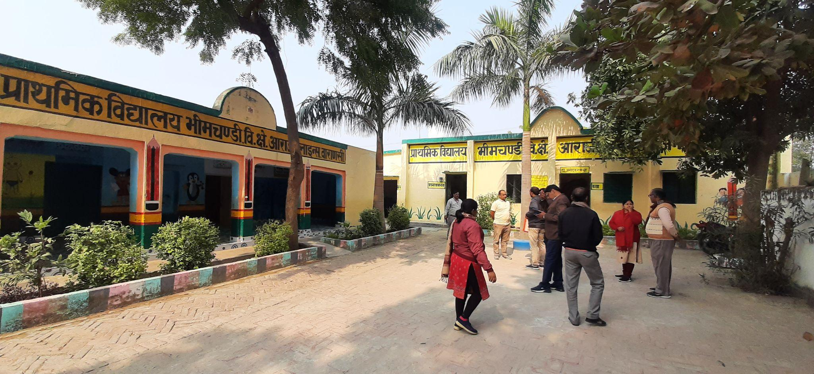

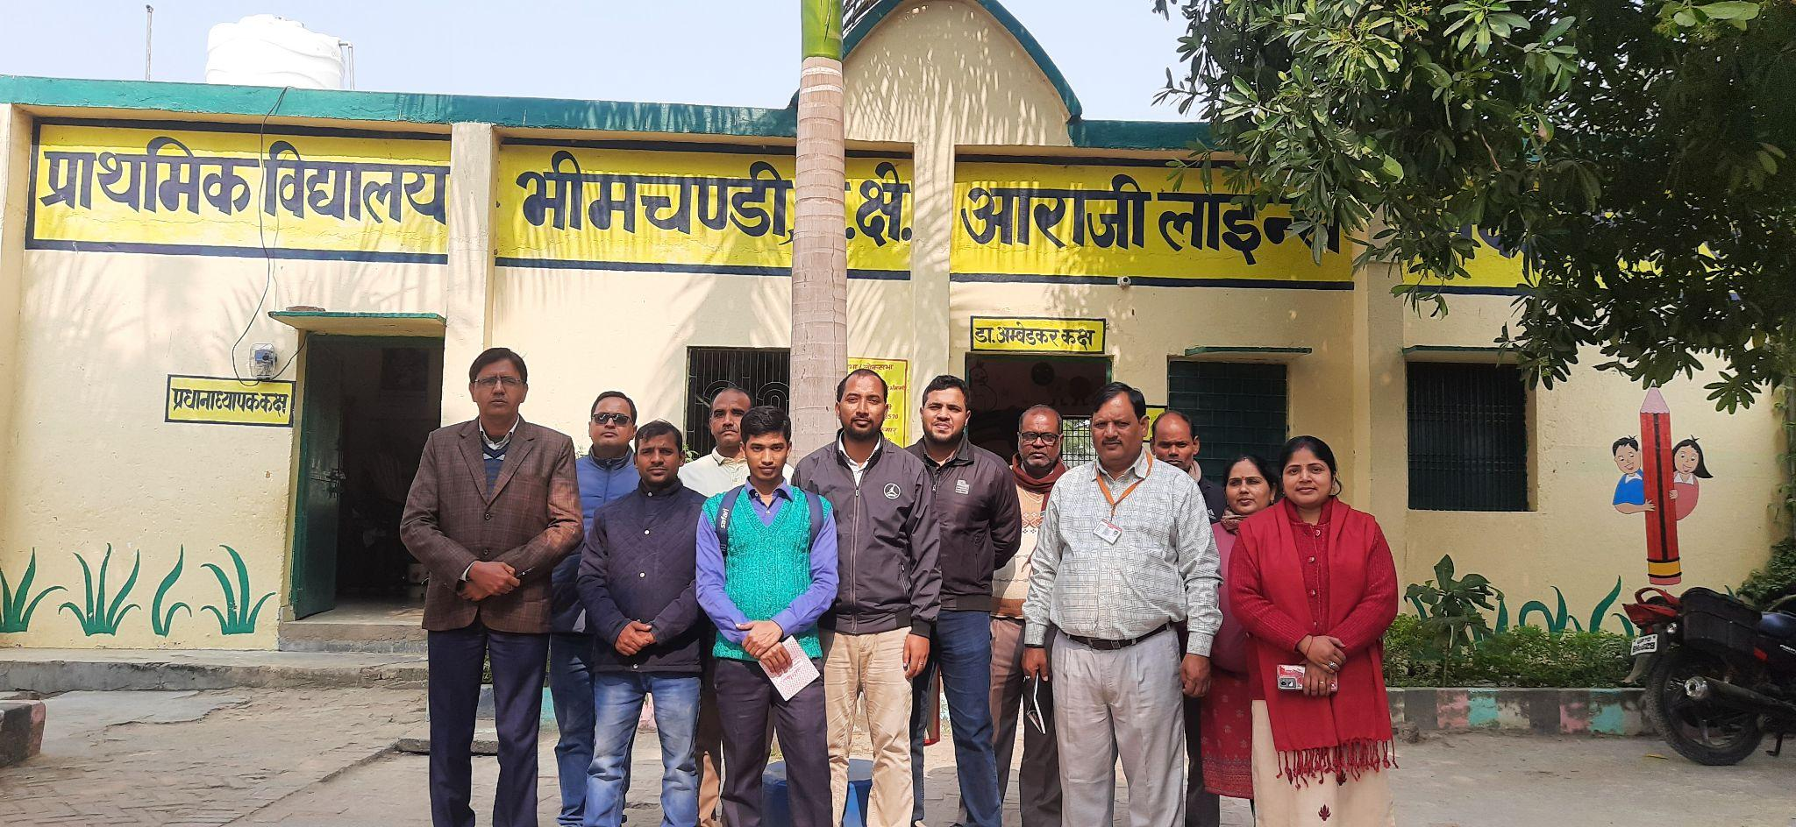

* **Composite school, Dhadhorpur (anganwadi code- 09197018952)**

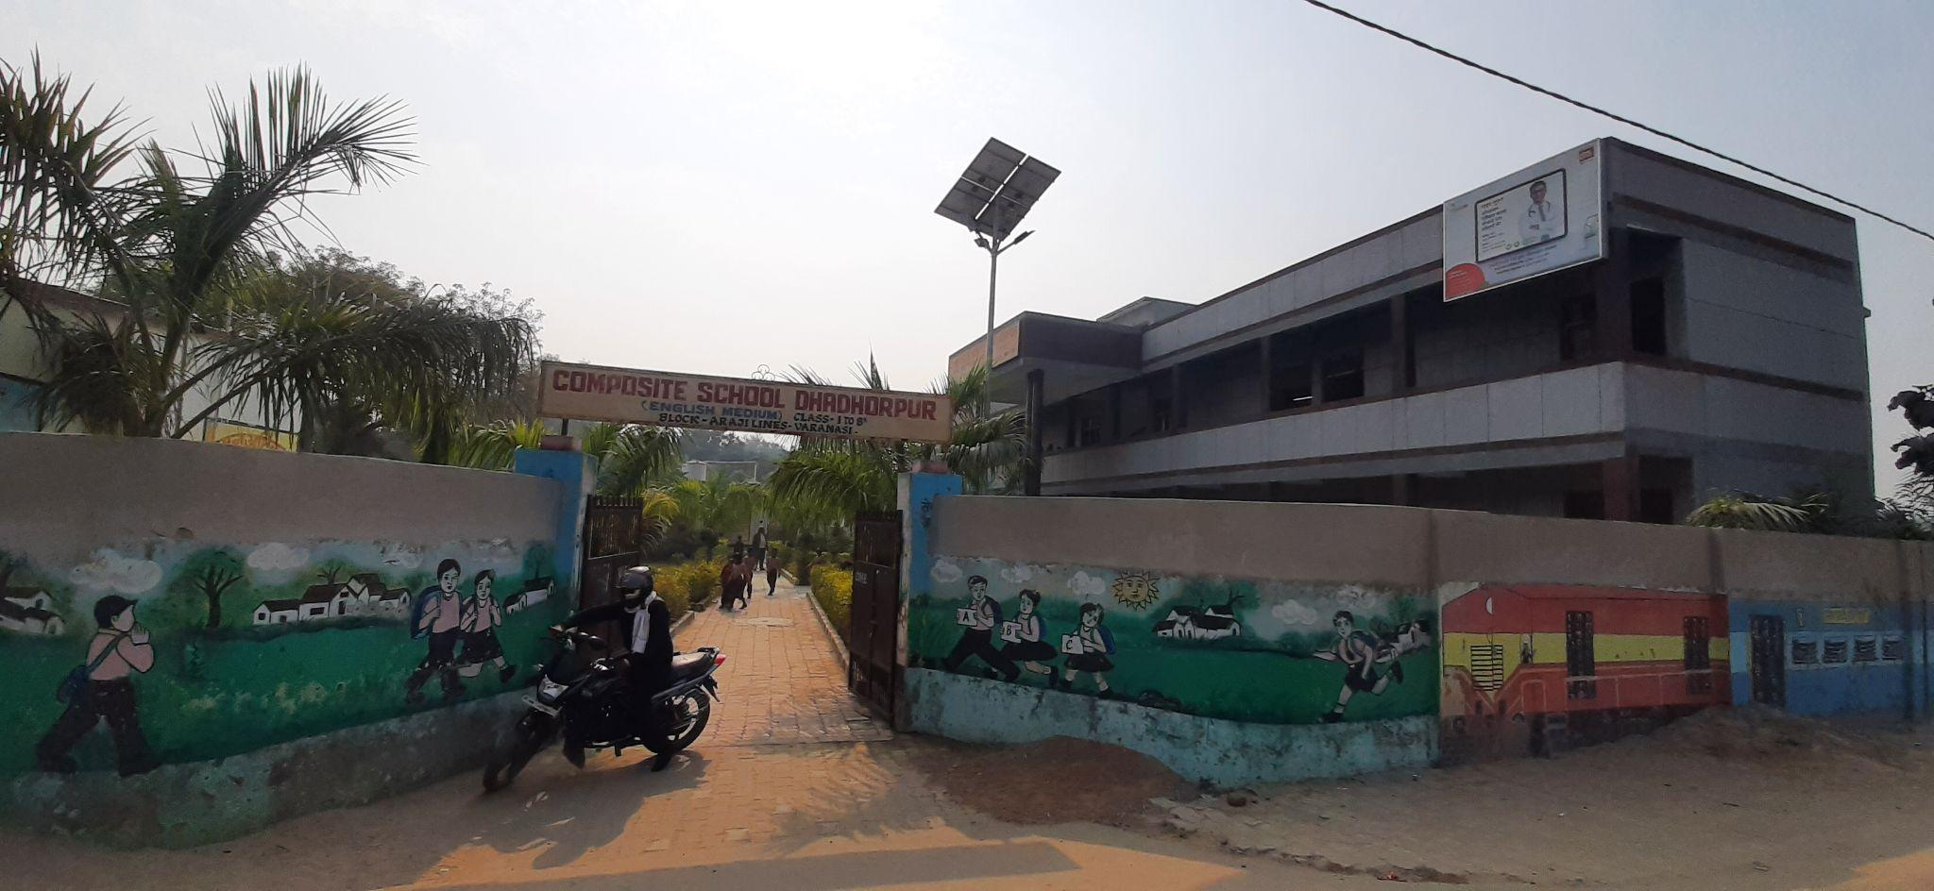

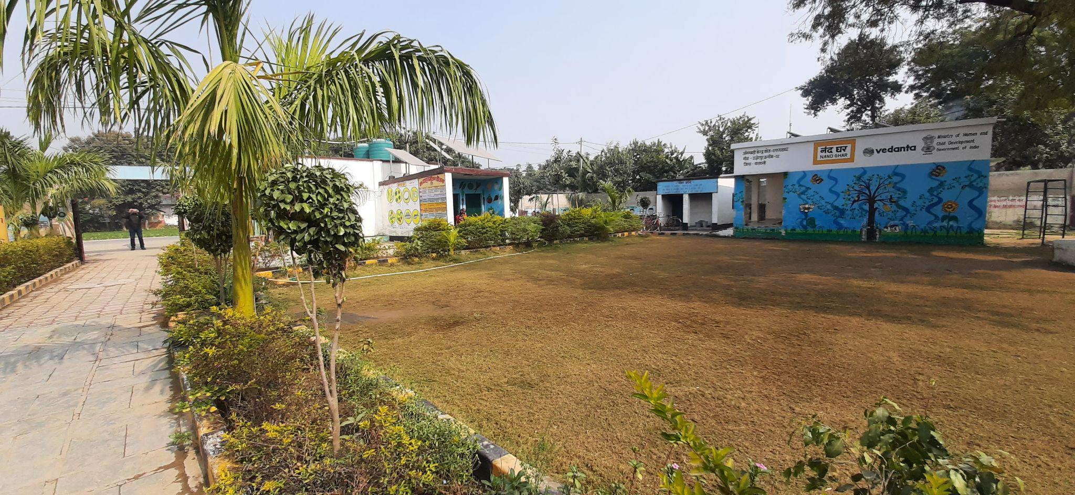

**NGO works in this School**

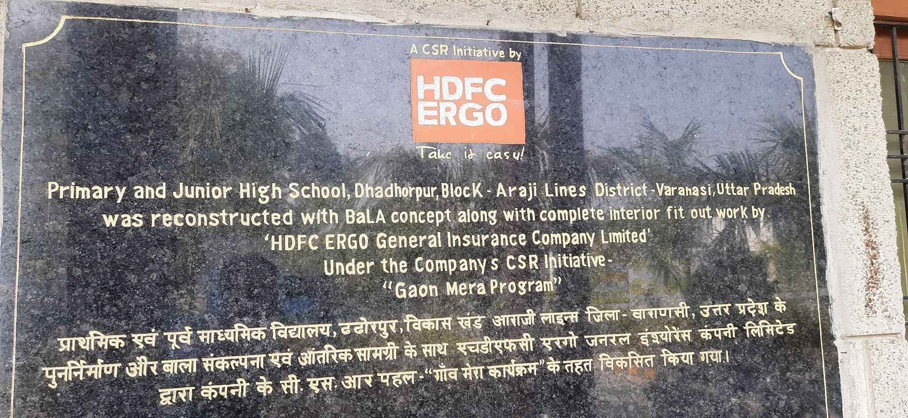

PHOTOS BY evening 27th dcember

1. **School Location /Surroundings**

All the school which we went were of rural setup

* Those were somewhat 5 to 15km away from the city
* Most of schools were surrounded by farmland

1. **Infrastructure**

During visit school, every school have enough land and infrastructure. But there is need of something there also likes

* 2/5 schools had staff rooms, no school had separate staff rooms
* Classrooms of Badagaon were equipped with quality furnitures with standard height for children
* Drinking water facility was there in every school but no RO facilities in any one of them
* 1/5 School had a washroom for disabled students/teachers.
* No ICT labs in any schools, only projector in a school (BADAGAON composite)
* 1/5 school had science lab (Funded by HDFC) (Badagaon, composite)
* 1/5 school building is funded by HDFC ERGO (Dadhorpur)
* ⅕ school had Library for students.
* After talking to teachers they said they provided different resources to physically challenged students, separate contractual teachers come on a weekly basis to guide them, Lamps to read,etc are provided to them.

PHOTOS BY evening 27th dcember

1. **Teaching Learning Resources**

There are so many different types of books, posters, or displays available there, also there is available Teacher Learning Materials there. This school's teacher were good. The teacher's extra work for non-active students. State government books are used there. And all teacher was focused on NIPUN BHARAT. As long as we stayed there, we saw some of the classes being studied and conducted under Nipun Bharat. And also in some class, they were teaching as a syllabus.

PHOTOS BY evening 27th dcember

1. **Class Observation**

The class which i observed was of hindi class 2, separate rows for girls and boys (2 boys and 1 girls), the teacher believed in reciting poems with body movement, was interacting with every student present in the class. The other class which I observed was of geography, class 8, he was teaching types of season & along with it a different subject for girls in the same class as home science. 3/5 schools were not having enough teachers to accommodate each class at a time, so we got an opportunity to check numeracy and literacy of students.

PHOTOS BY evening 27th dcember

1. **Interaction with headteacher/teacher**

During visit of school, we interact with four primary Teacher and two Secondary Teacher. They told us their problem likes

* They are managing with less human resource
* They are passionate about teaching but there major concern of interference by NGO in curriculum
* They suggested the curriculum framework designed by SCERT (Aadharshila, Dhyaanakarshan & Sikshan Sangrah) ( is way better than LLF modules)

1. **NGOs Presence**

In diet sarnath, only LLF NGO was working. This ngo provided a small library in this diet. Due to adoption a block by NITI ayog and the constitution area of the respected prime minister, so many NGO were working independently. They do not contact with diet sarnath. So i have no any exact data regarding it. At diet level, When we were on visit we didn't find any NGO directly involved in interaction with students. And also all the Teachers were not happy with NGO presence for training as they said there is a lack of teaching staff in every school, now we should focus more on teaching students rather than skipping classes and going for training and involve with NGO.

1. **Other Observations**

We got an opportunity to attend an assembly in one school. The school conducted an assembly starting with prayer followed by the National anthem, followed by PT, Followed by Poem recitation. We observed that students of the government schools were good with numeracy and reading as well. During teaching by our mentor sir related to reasoning type question in grade 5, some students of that class find the logic of the answer so we can say that they were good in numeracy.