Shala Granthalaya chi Ghosti:
The Story of School Libraries in Maharashtra, India

A Summary Report of Status of School Libraries in Maharashtra
2023
Centre of Excellence in Teacher Education (CETE), Tata Institute of Social Sciences (TISS)
&
UNICEF

A Policy Implementation Analysis Report Summary

A UNICEF-TISS Collaboration

Shala Granthalaya chi Ghosti: The Story of School Libraries in Maharashtra, India – A Summary Report of Status of School Libraries in Maharashtra.

Citation: CETE and UNICEF. (2023). Shala Granthalaya chi Ghosti: The Story of School Libraries in Maharashtra – A Summary Report of the Status of School Libraries in Maharashtra. CETE, TISS and UNICEF.
Summary Report Authoring Team
Maithili Gupte (UNICEF)
Supported by Anusha Ramanathan (CETE, TISS)
Report Authoring Team at CETE, TISS
Anusha Ramanathan (Assistant Professor)
Sheetal Kamble (Postdoctoral Fellow)
Shreyasi Mitra (Research Associate)
Ravi Chalwadi (Research Assistant)
Arpitha Jayaram K (Research Manager)

Overall Research Team at CETE, TISS
Anusha Ramanathan (Assistant Professor)
Sheetal Kamble (Postdoctoral Fellow)
Dinesh Chand (Postdoctoral Research Associate)
Ravi Chalwadi (Research Assistant)
Shreyasi Mitra (Research Associate)
Nishevita Jayendran (Assistant Professor)

Student Interns Team for Data Collection, Compilation and Analysis
Aaishwarya Anilkumar Jadhav
Agasti Chaskar
Ameya Sanjay Jadhav
Bhavna Shahare
Dipalee Kamble
Kajal Gupta
Kushali Arote
Madhuri Bhale
Maitrayee Pan
Prapti Shamkuwar
Riya Wasnik
Saurabh Bhusari
Soumya Chahande

Graphic Design
Ramesh Khade

Acknowledgement

We would like to express our sincere gratitude to the team at UNICEF, Ms Reshma Agarwal and Ms Maithili Gupte, who have been the stalwarts behind this research study from conception to execution to now its reception. They have facilitated the process and given many insights through every step of the way.
We would especially thank Ms. Saroj Jagtap at Samagra Shiksha who coordinated all our visits and facilitated the Google Survey form to be circulated through WhatsApp groups and circulars. She not only gave inputs but also held late-night debriefs with this research team on the status of data collection and the way forward. Without her support, this research could not have had the reach it did.

We further thank the team at SCERT, Pune who met us and were gracious enough to spare us time for interviews and follow-up calls.
Research in the field of libraries and the use of libraries needs the voices of practitioners to inform the study and the design of the tools. We were lucky enough to have on our advisory panel Ms Parul Bajaj from Parag, Tata Trusts; Ms. Purvi Shah, Pratham Books, StoryWeaver; Mr. Saktirbata Sen, Room to Read and Ms. Sujata Noronha, Bookworm Goa all representing library spaces and Ms. Shveta Lall, Language and Learning Foundation coming in as the advisory expert for language and literacy development. Their inputs have helped refine our tools for the research and we wish we could have done more of the open-ended questions such as ‘What books do you read, ‘describe your vision of a library’ in the survey as well. These questions in the interviews revealed a lot of insights and Saktibrata Sen’s idea of looking at community habits and attitudes regarding libraries deserves research themselves. The feeble forays we made as offshoots to our research visits tell us this question deserves historical research to understand the changes over time from oral cultures of storytelling to script-based consumption of stories and the impact on literacy and not just script-literacy, but also communicative, critical and cultural literacies.
Thanks are also owed to Prof Padma Sarangapani, our Centre’s Chair for supporting us through and through and Ms Gayathri Moily for her constant support through the many financial aspects we had to manoeuvre. Mr Tushar Vaity who oriented student-interns through travels and claims and Mr Vijay Jathore for handling the personnel.
Last, but not least, we cannot forget the 13 student interns we were privileged to work with: Aaishwarya Anilkumar Jadhav, Agasti Chaskar, Ameya Sanjay Jadhav, Bhavna Shahare, Dipalee Kamble, Kajal Gupta, Kushali Arote, Madhuri Bhale; Maitrayee Pan, Prapti Shamkuwar, Riya Wasnik, Saurabh Bhusari and Soumya Chahande They were on the field for weeks and went beyond their brief in their quest to trace how libraries/books were used in schools and the processes of the policy implementation. They grappled with frustration many times and have anecdotes that can (and should) fill a book. This research is based on the work they did. We are proud of them all and thankful to each one of them.

STATUS OF SCHOOL LIBRARIES IN MAHARASHTRA

SUMMARY REPORT

Shala Granthalaya chi Ghosti
(The Story of School Libraries in Maharashtra)

Context

Learning to read in the first years of primary school is critical for success in later grades and for retention of students in schools. This is why, school readiness programmes and early grade curriculum, focus on helping children learn to read as a part of their foundational literacy development efforts. Exposing new readers to diverse print material, including good quality age-appropriate- literature, is essential in the development and strengthening of reading among children. School and classroom libraries are therefore important, especially for children who may come from families, where access to print material is limited. Findings of the National Achievement Survey 2017 had clearly indicated that school children who have access to a school library and who ready story books have higher levels of learning.

The need for libraries in every school is recognized by the National Curriculum Framework, 2005, the Right of Children to Free and Compulsory Education Act, 2009, and the National Education Policy, 2020. Every year, under Samagra Shiksha Abhiyan, government schools receive a library grant to procure books for their libraries, in tandem with the activities under Padhe Bharat Badhe Bharat. The guidelines for the utilization of the grant were revised in 2020, in alignment with the NEP, which emphasizes on the importance of libraries and books. These guidelines detail the processes for selection of books, printing and procuring of library books, and ways of setting and managing libraries, towards building of a culture of reading. As per the guidelines, primary schools (grade 1-5), receive an annual library grant of Rs. 5000/- and upper-primary schools (grades 6-8), receive Rs. 13,000/-.

Further, under the Samagra component of ‘strengthening of existing schools,’ provision has been made to provide library rooms in school where library rooms are not available. The guidelines also provide for the creation of classroom libraries and e-libraries/ digital libraries under which story books, visuals, audio and videos can be stored on the school computers. Provisions are also to be made for children with special needs to ensure that libraries promote inclusiveness. The guidelines also include setting up of the book selection committee at the state level and management committees for making libraries functional at the school level with teacher and student participation.

As per the UDISE data of 2019-2020, 83% government elementary schools in Maharashtra have a library for their students, which includes story books provided through Samagra Shiksha, or donated at the school level by individuals/ NGOs. Although the data on the number of schools with libraries is collected and analysed every year through UDISE, data across schools on the quality and types of books, status of library rooms, and library/ reading programmes, is absent. With the increase in the focus on foundational literacy and numeracy under the NEP 2020, and the existing data on learning levels, which indicates low learning achievement, it is now more important than ever to strengthen school/ classroom libraries and ensure access to good quality books and effective use of libraries at the school level.

In order to better support schools to promote the use of libraries, it is critical to understand the current status of libraries and library usage, along with the existing models of library settings in schools across Maharashtra. Towards this end, UNICEF commissioned the Centre of Excellence in Teacher Education, TISS to conduct a study on the status of libraries in elementary government schools in the state in the 2022.

The following were the major findings from this study-
- Teacher awareness and training- Teachers acknowledge the importance of libraries for children but lack adequate training to effectively utilise libraries and storybooks in the classrooms.
- Inadequate library resources for children, including those with special needs support-adequate age appropriate and graded books (as per reading levels) are absent in most schools and books/ resources are not available for children with special needs. Further, the available books do not reflect the linguistic diversity in the schools in the state.
- Underutilised library periods- despite policy recommendations for two dedicated library periods per week, most schools have not integrated library periods into their schedules.
- Funding challenges- insufficient funding at the school level for establishing and maintaining libraries, couples with delays in fund disbursement, is a recurring issue.
- NGO contributions- external organizations such as NGOs, play a significant role in enhancing school libraries by providing high-quality children’s literature and supporting library maintenance.
- Local innovations- there are several good practices and innovations at the school level that are tailored to the diverse needs of schools and children across different regions of the state.

At every stage of the study design and execution, senior officials from the Samagra office in Mumbai and the State Council for Educational Research and Training (SCERT) were consulted. A core team of members from five leading organizations that work in the area of libraries was also formed to inform the design of the study and taken into consideration their experience of working on school libraries in the state.

Introduction to the Study

2.1 Study objectives
The overall objective of the study was to recommend to the state, practice and policy-level changes to promote effective use of libraries to promote reading and literacy in government schools in the state. More specifically, the study aimed to-
- Understand the various policies and provisions on libraries in the state;
- Study the status of libraries vis-à-vis the above policies and provisions at the school level;
- Understand the status of libraries from the perspective of number books available, the types of books, their quality and appropriateness for all children, the functioning of the libraries, and usage among students;
- Study the type of trainings given to teachers to promote the use of libraries for students in school;
- Identify best models in the context of libraries and library use in the state.

2.2 Methodology
This research used a mixed study methodology that included secondary data analysis, in-depth desk review of relevant and credible data sets, interviews with key state and district stakeholders, focus group discussions with district and sub-district functionaries, teacher survey and field visits.
The primary respondents of the study were district officials (DIET and EO’s office), block and cluster officials, school HMs, teachers, children, and community representatives. To the extent possible, diversity in terms of age, gender, social group and geography, were ensured when selecting respondents.
Data was collected in two phases- in the first phase of data collection, a rapid survey was used to cover all the 36 districts of Maharashtra. In the second phase, data was collected through field visits across 15 districts selected based on purposive sampling to ensure representation across rural, urban and tribal sites, guided by suggestions from the state and the trends indicated by the rapid survey. In each district, an attempt was made to visit at least two representative school, in addition to the interviews conducted with the district representatives.
Profile of the survey respondents:
Total respondents- 9917 (69% male and 31% female)
Teachers- 3980
Head Teachers- 5308
BRC- 253
CRC- 302
BEO- 31
DEO 13
SMC members- 30
List of districts that were selected for field visits
Satara
Kolhapur
Pune
Aurangabad
Beed
Osmanabad
Ratnagiri
Palghar
Gadchiroli
Gondia
Nandurbar
Ahmednagar
Akola
Amravati
Wardha
The following research questions were framed for the study-
- What are the current policies and provisions with regards to libraries in the state, including the financial provisions, and the actual utilization of the same in the last 5 years? (Including the basis of fund allocation, procurement, and use)
- How are these being implemented at the school level?
- What are some of the gap areas in terms of provisions and their implementation, and gaps in the policies/ provisions themselves, vis-à-vis the NEP/ FLN?
- What trainings have been offered to teachers, to help them support library use in their schools?
- What are some of the best practices and models in the context of libraries in the state?

2.3 Pilot
The Nashik district was selected in consultation with the Samagra office for Maharashtra as a pilot site to test the study tools. Meetings were conducted with the DIET lecturers, BEOs, teachers, HMs, and representatives from NGOs such as Room to Read and Pratham Foundation. The online survey tool was also administered to assess the efficacy of the tools. A major finding from the pilot study was the presence of a separate library room and reading activities in schools that had the support of external/ non-governmental organizations such as Room to Read.

Findings- Secondary Desk Review & Field

3.1 Guidelines and Policies on libraries- secondary desk review

The needle has recently moved in India concerning policies highlighting the need for libraries and encouraging schools to invest in them. Be it the National Curriculum Framework of 2005, the Right of Children to Free and Compulsory Education Act of 2009, or the National Education Policy of 2020, the thrust on libraries as a core learning space has been highlighted repeatedly.

With the increase in the focus on foundational literacy and numeracy under the NEP 2020 and the records of learning loss and poor reading levels, the importance of libraries that can be spaces for joyful learning and developing literacies cannot be emphasized enough. The NEP highlights the need to strengthen libraries and emphasizes providing access to 'enjoyable' and relevant books for children to ensure a school reading culture. To better support schools in promoting the use of libraries, it is critical to understand the current status of libraries and library usage, along with the existing models of library settings in schools across Maharashtra.

The revised Samagra Shiksha guidelines for ‘Library Grant and Promoting Reading in Schools’ (28 October 2021) states that libraries may be of different kinds-
- A standard physical library with reading area, display shelves, stock room, issue/receipt counter.
- Classroom library inside a classroom where books can be accessed during class period or during breaks.
- Rotating library where books are interchanged between classes/ sections and students.
- An e-library system or Digital Library system under which digital reading/learning material such as story books, visuals, videos, audios, etc. may be stored in the computers of the libraries.
This provision for the library grant was first introduced as a response to the findings from the National Achievement Survey (NAS) 2017. The findings indicated that in the high achieving states, 91% of the schools had a library, whereas in low achieving states only 62% of the schools had a library. In view of this finding, the Samagra Shiksha Abhiyan was revised in 2018 to include the provision of a library grant to all government schools (grades 1- 12). The library grant ranges from INR 5000 for primary schools to INR 20,000 in composite senior secondary schools. The table below details the funds as per the school category:
S.No | Category of School | Library Grant (in INR)
1 | Primary School (grades 1-5) | 5000
2 | Upper Primary School (grades 6-8) | 13,000
3 | Secondary School (grades 9 & 10) | 15,000
4 | Senior Secondary School (grades 11 & 12) | 20,000

With regard to the selection of library books, the Samagra guidelines recommend the constitution of a Selection Committee at the state level. Priority during selection needs to be given to story books, magazines and comics published by the National Council of Educational Research and Training (NCERT), national Book Trust (NBT), Central Institute of Indian languages, the State Council of Educational Research and Training and other central and state government agencies. The type of books selected for school libraries may include-
- Story books;
- Reputed children’s magazines and comics;
- Referral books for secondary and senior secondary students;
- Other books that are considered essential for the holistic development of the child, such as, books on mental health and well-being, sports, arts music, design thinking, etc.
Under the Samagra provisions, state governments, including Maharashtra, began to utilise the grants at the state level, providing the books directly to the schools. This limited the agency of the schools in procuring local and more contextualised story books for their children.
In addition to the provisions regarding available funds and procurement of books, the Samagra guidelines on libraries issued in 2021 emphasises on the promotion of libraries and their role in language development and the achievement of foundational literacy.
Further, under the component of ‘strengthening of existing schools’, Samagra has also made a provision to provide a library room in schools where an independent library room is not available. This includes cost for civil work, furniture, racks, cupboards, and fitting.
In 2020 with the introduction of the National Education Policy (NEP) and the NIPUN Bharat Abhiyan, the need for libraries and promotion of reading was once again highlighted. Several provisions under the NEP make a strong case for strengthening school libraries and emphasise the need to provide access to ‘enjoyable’ and relevant books to all children to ensure a culture of reading in schools. The NEP (para 6.2) also makes reference to reading corners that is also a part of the Padhe Bharat Badhe Bharat Abhiyan. A reading corner is made available in classrooms where books are easily accessible to children, allowing them to read independently and engage in group activities. The Padhe Bharat Badhe Bharat guidelines recommend two weekly library periods in a week to promote a culture of reading in the school.
To promote the use of libraries, training modules were introduced as part of the National Initiative for School Heads’ and teachers’ Holistic Advancement (NISHTHA). These trainings included Block Resource coordinators, Cluster Resource Coordinators and teachers.
The 2021 library guidelines recommend states to ensure that regular monitoring be done through CRCs and BRCs on the utilization of the library grant at the school level and the record of library books to be uploaded on the UDSE + and PRABANDH portal.
Maharashtra’s procurement and funding provisions are as per the Samagra guidelines. The following table includes the details of Maharashtra’s budget allocation and utilization in the last five years with regard to the library grant.
Academic Year | Budget (in lakhs) | Utilization (in lakhs)
2018-19 | 20.40 | 15.50
2019-20 | 183.93 | 441.33
2020-21 | 383.02 | 383.02
2021-22 | 649.08 | 0
2022-23 | 649.76 | 126.068

The lack of utilization in the academic year 2021-22 can be attributed to the extended school closures during the COVID 19 pandemic. An analysis of funds allocated to Library use and utilised by the State Government reveal an increase in expenditure, both planned and expended, overall. However, the fact that the Samagra Shiksha, Maharashtra prints books at the state level and distributes books to schools leads to two major concerns: (1) contextualisation of books such as local language/s inclusion, catering to specific disabilities in book choice, inclusion of local folk lore etc as recommended by Samagra Guidelines for Library Use and (2) the per school utilisation and the discrepancy in need for number of books in schools with high enrolments (above 100 or even 250) versus schools with lower enrolments leads to lower access among students in schools with higher concentration.

3.2 Field research findings

3.2.1 Reflections on School Libraries
The interviews and focus group discussions with the over 500 different stakeholders at the district, sub-district and school level, including teachers, shed light on the importance of libraries in education as perceived by them, the challenges they currently face and the potential solutions to improve their effectiveness of library use.
The following were the key themes that emerged from the interviews-
- Libraries as knowledge hubs- although some of the respondents did mention the need to promote the joy of reading, majority of the responses see libraries as vital centres of knowledge for children.
- Insufficient library resources- respondents highlighted the need for well-stocked libraries with age-appropriate books especially for the younger children, reading based activities in schools and community libraries. Teachers and head teachers also shared that schools did not have good infrastructure to support an independent library room.
- Funding challenges- challenges related to inadequate funding for maintaining libraries and procurement of books were frequently mentioned.
- Training gap- as per the respondents, the absence of dedicated school librarians, especially for schools with high enrolment underscores the need for regular training in library management.
- Parental engagement- there was a strong emphasis on engaging parents more actively in promoting reading at home.

3.2.2 Availability and types of libraries in schools

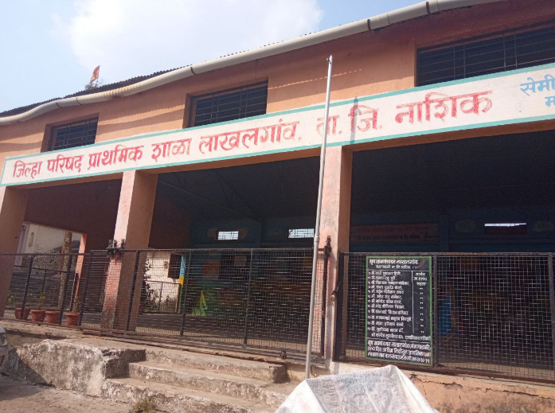
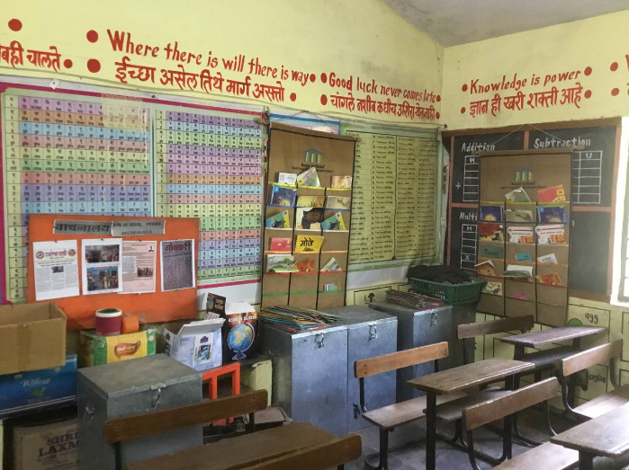
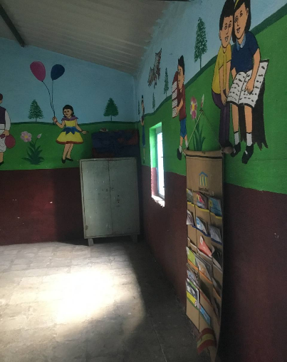
Data from this study indicates that a significant number of schools across all districts have established reading corners with the aim of creating dedicated spaces to promote reading. However, infrastructure-wise, many lack separate library rooms for children.
As depicted in the below figure (Figure 1), which represents the responses from teachers, it is noteworthy that 64% of participants reported having reading corners in their schools but no dedicated libraries. Additionally, 17% indicated the presence of both reading corners and libraries in their schools, 14% mentioned having a separate library room, and 5% states that their schools had neither libraries nor reading corners. This observation gains significance when we consider the data from UDISE for the year 2020-21, which reports the existence of schools in the state with libraries. This contrast between the study’s findings and the UDISE data highlights the need for a closer examination of the actual functioning and existence of library spaces in schools. Further, as per teacher reports, the data on libraries would have changed during the COVID pandemic, which saw many classrooms and libraries falling in disrepair during the closures.

Figure 1: Availability and types of libraries in schools
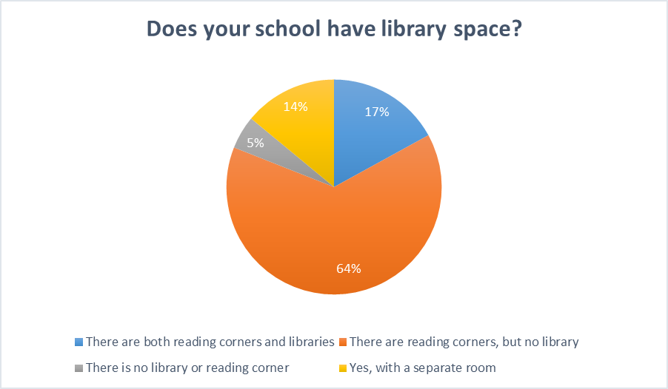
An interesting observation on the availability of libraries was made when analysing SMC meeting records during the school visits made in the 15 selected districts. All the records record lack of a library as an agenda point of discussion. This is also a positive finding as it indicates the importance of libraries in the minds of the SMC members.

3.2.3 Access

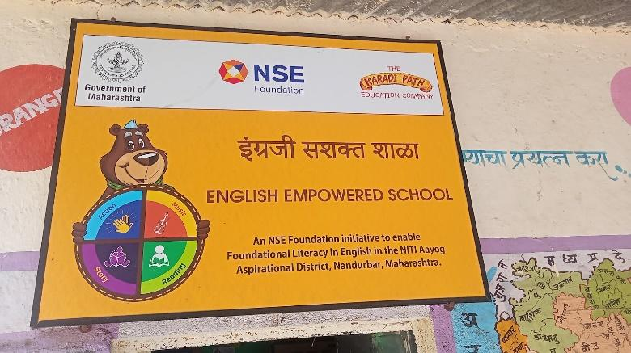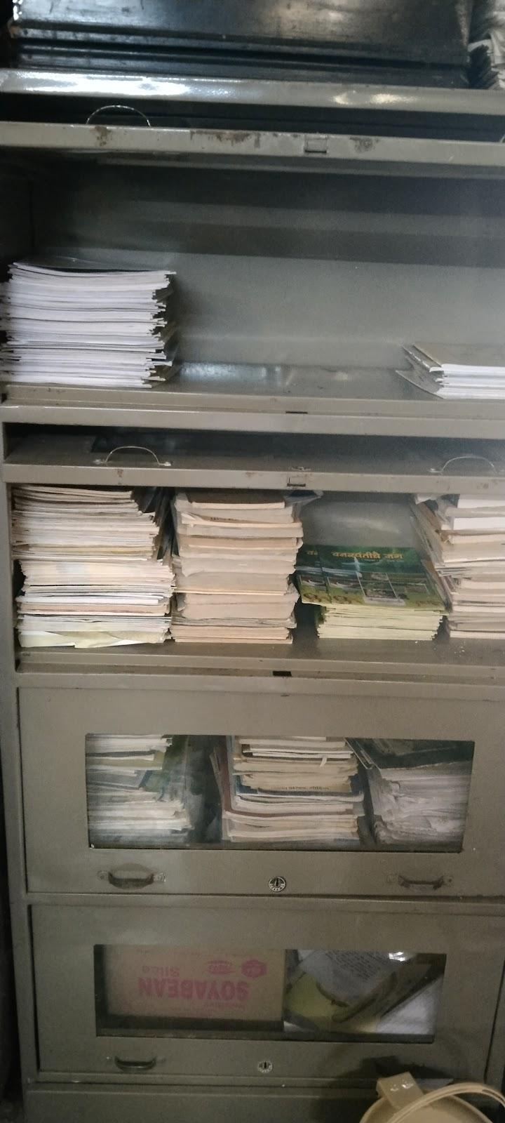

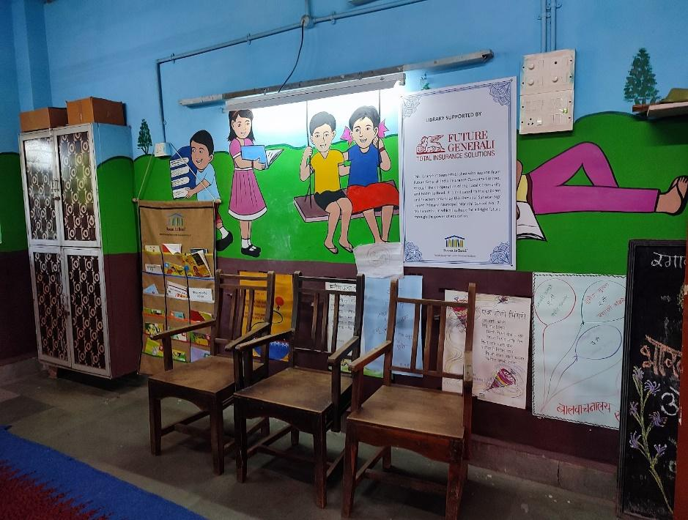

Fig. 6: Comparison: Schools without NGO Intervention where books are under in cupboards, mostly under lock and key (image on left) and a separate, welcoming room and well-maintained registers in schools with ongoing NGO interventions (images on right).

Despite policy recommendations advocating for two dedicated library period per week, a significant number of schools have not fully integrated these library periods into their weekly schedules. Surprisingly, 52.8% teachers said there is no specific Library Period though 67% also stated that library related activities are conducted weekly.

Wirth regard to accessibility, 51% of the total teacher respondents reported that their libraries are accessible to children only during school hours. An additional 31% of teachers mentioned that children have the opportunity to collect books during school vacation, while 18% responded that the library was accessible after school hours and also during vacation. visit the library after school hours and during recess.

Interestingly, during the interviews, teachers expressed concerns about lending books to children to take home. Their apprehension seems to stem form a fear that the books may be damaged in the process. However, this apprehension may inadvertently discourage students from utilizing the library resources to their fullest potential.
Of the 556 BRCs and CRCs who were interviewed on whether school libraries were open to children not formally enrolled into school, such as Out of School Children, 14% stated that libraries were for enrolled students only, whereas 25% shared that the library was open to all students, irrespective of their enrolment status. The other BRCs and CRCs also reported that the schools may use their discretion to invite OoSC to the libraries.

3.2.3 Availability of books
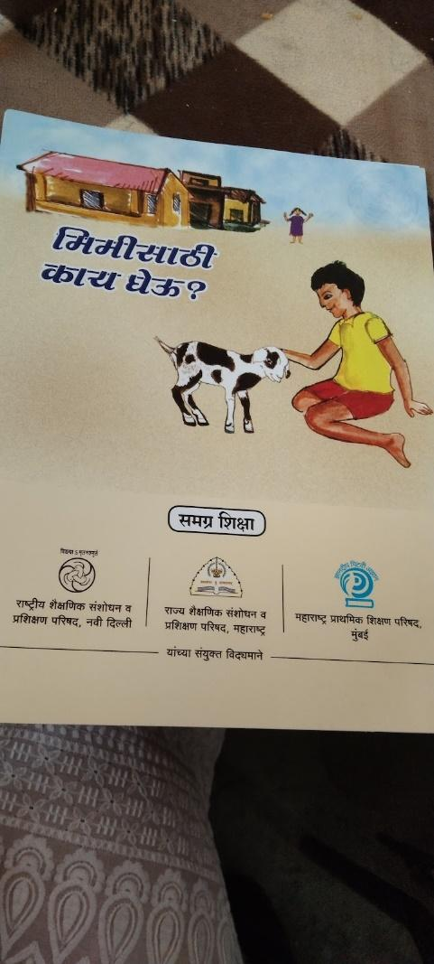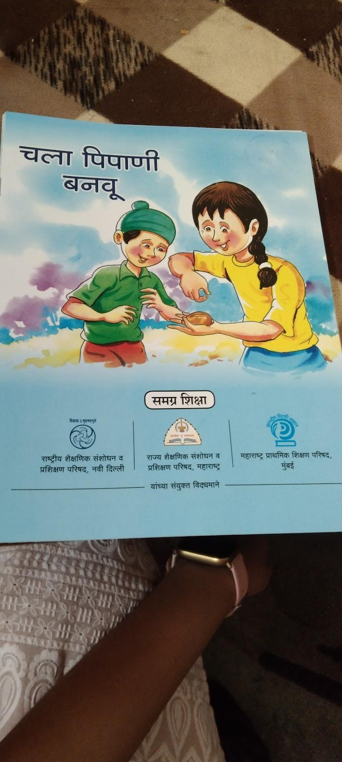
Under the Library Grant scheme of the Samagra Shiksha, the state government started providing books directly to the schools utilizing the grants directly at the state level. The onus of utilizing the funds hence fell on the State government itself. Since the books are printed and provided at a state level, the schools are denied their agency to procure the kind of books that they deem fit for their children with local dialects being used and such. The benefit of this large-scale supply of books to schools resulted in every school reporting their possession of 100 books and the presence of a library (in whatever form) on U-DISE. However, this process standardizes the languages and the types of books provided. Books are not contextual to children and the struggle to be inclusive still remains with limited to no resources for Children with Special Needs.
With regard to the data on languages of the books available, 97% school teachers with the additional charge of the library reported having Marathi books in their libraries. Whereas 41% reported having English books, 23% reported having Hindi books and 4.1% reported having Urdu books. Only 3.2% reported having other local language books. Mapping this data to the fact that 44.9% of the teachers shared that that their schools have books available in just one language, 43% reported two languages and 11.9% stated that they have 3-5 languages and none reported more than 6 languages showcases a glaring need to enhance language diversity in books available in the school libraries, especially given NEP 2020's focus on the three-language formula.
The aspect of school/teacher agency and ownership was also raised during the interviews and the focus group discussions conducted for this study. However, many did identify that purchasing was also a concern given the number of guidelines limiting book selection to those provided by the National Book Trust and other such agencies. Further, teachers, HMs, CRCs and DIET Faculty were not sure that disbursement of funds would be timely for them to procure and shared that selection of books needed more robust teacher training.

3.2.4 Fund availability and utilization
The findings of the study underscore the challenges related to the availability, regularity and sufficiency of funds for school libraries. Addressing these issues is essential to ensuring that school libraries can function optimally and serve their intended purpose in facilitating learning and promoting reading among the students.
The following figure represents the regularity of funds for school libraries, as reported by headmasters (HMs). Out of the 5,309 responses from the HMs across the state, approximately 83% indicated that funding for libraries was not made available every year at the state level which was reflected in the absence of books provided to schools.

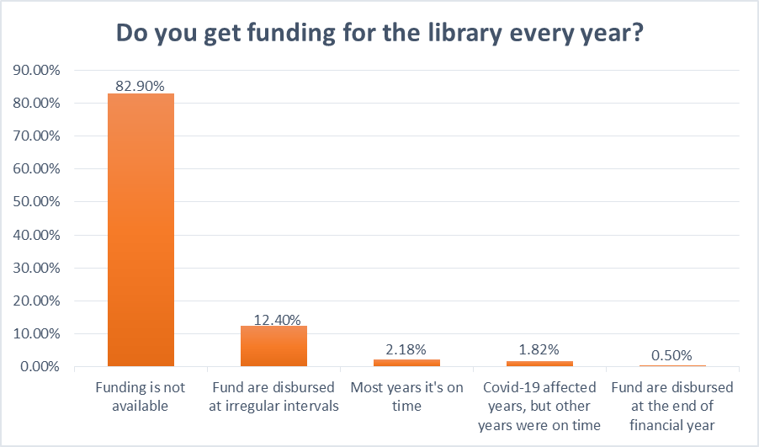

When the same question was posed to the district and sub-district officials, of the 44 EOs and BEOs only 15% reported that they had received the funds on time. 6% of the BEOs stated that funds are disbursed only at the end of the year, while 45% of them reported irregular intervals for fund disbursement. Further, 31% of the EOs and BEOs mentioned that fund disbursement was adversely impacts by the COVID-19 school closures.
The respondents were also asked their views on whether they considered the funds made available to schools as sufficient to effectively run a library. Among the 5,309 HMS who responded, 57% did not comment on the adequacy stating that funds were never on time. Another 21% states that the current grant needs to be increased and only a small fraction of respondents (3%) expressed satisfaction with the current funds, deeming them adequate.

3.2.5 Capacity building on library management and use

The study findings highlight a critical need for structured training and awareness programmes to equip teachers and other officials with the knowledge and skills necessary to effectively utilize library funds, ensure the efficient management of school libraries and the use of library story books for language development and other skills such as critical thinking, self- expression, etc.
Despite the inclusion of a module on library management in the Nishtha trainings, almost 79% of HMs and teachers reported never having received any orientation of training in this regard. From among the pool of district and sub-district officials, out of the 254 responses, almost 47% respondents mentioned that they did not have any training on library fund usage, which indicates that they may be poorly equipped to support schools in effective implementation of the library guidelines.

3.2.6 NGO participation
Several non-governmental organizations and CSRs are playing a role in the setting-up and management of libraries in the state. Among these are two notable organizations, Room to Read and Pratham, that stood out during the interactions with field functionaries. The organizations are actively involved in setting up and maintaining library spaces within schools. They also provide essential training to teachers to effectively engage children through books and make available age appropriate, graded books for children.
91% of the teachers reported that there is no external intervention in their schools. Only 6% of schools mentioned having some form of intervention from external organizations, while 2% indicated that a representative from such organizations occasionally visits to guide them on library use.

3.2.7 Select Best Practices
The field visits provided an insight into some of the practices that schools with limited resources have creatively to inculcate reading habits among children. The following section provides 5 such examples of best practices that were recorded during the visits.

- The Window Library:
of the initiatives taken in the school in Palghar is that the books are hung on the window. This way books are accessible to children throughout the day. They read books during lunch breaks and whenever they get time. Children from 5th to 8th grade take responsibility for these books. At the end of the school day the books are kept back in the same place.
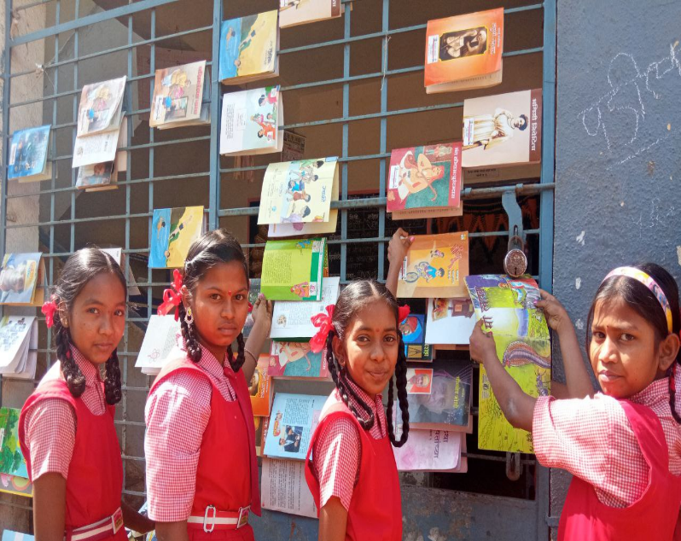
- Book Clinic at the school library
“As we fall sick, we need medicine, just as a book needs a clinic’’: A teacher in Palghar has started an activity called “Book Clinic”. This is an activity related to the school library. Students do not bring school bags on Saturdays. Instead, they come and read books in the library. Due to constant use, some books get torn and damaged. In this activity, the teacher says children are taught how to put tape on a torn book, put on a cover, and glue the book. This activity increases the enthusiasm of children. They learn how to repair books and understand how to take care of books.
(c ) Reading Circle for Community Books
In Ratnagiri, the teacher has started an APJ Abdul Kalam Reading Circle called Firta Vachan Katta(फिरता वाचन कट्टा). It consists of a mobile cart that has around 400 books which many people have donated. In this district, people live in Wadi settlements, with less contact with others. In such a situation, this Reading Practice comes in handy. People come to the cart to read. Books are given to people in the community through "Book Messengers" (''पुस्तक दूत ‘’), who are primarily children. Therefore, children's interaction with their parents also increases. Some of the interior villages have no access to newspapers. People are not familiar with any medium of reading. Therefore, this reading circle helps the community people to familiarize themselves with books.
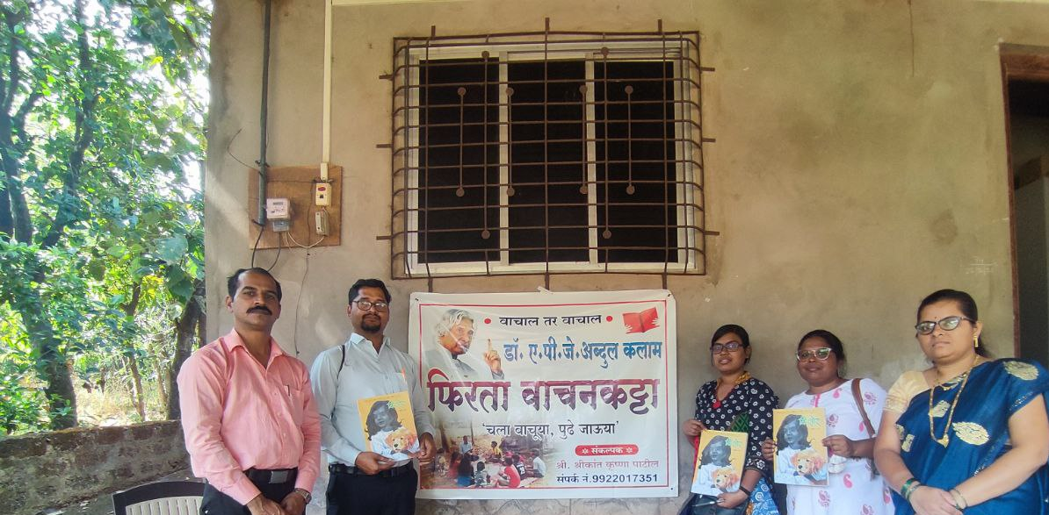

- Book Writing
Writing a book is a unique activity conducted at the Palghar school. Through this activity, the teacher makes the children (aged 5 to 8 years) identify books within ten days. Within these ten days, children have to note the names of the books, book covers, authors, book references, book prices, publisher names, etc. The teacher gives specific themes for the children to write a 10-page book. For example, children wrote books on monsoons, schools, agriculture, etc. Some children have caricatured the cover of their “Pustak”. The teacher also shares his experience of writing the book with the children.
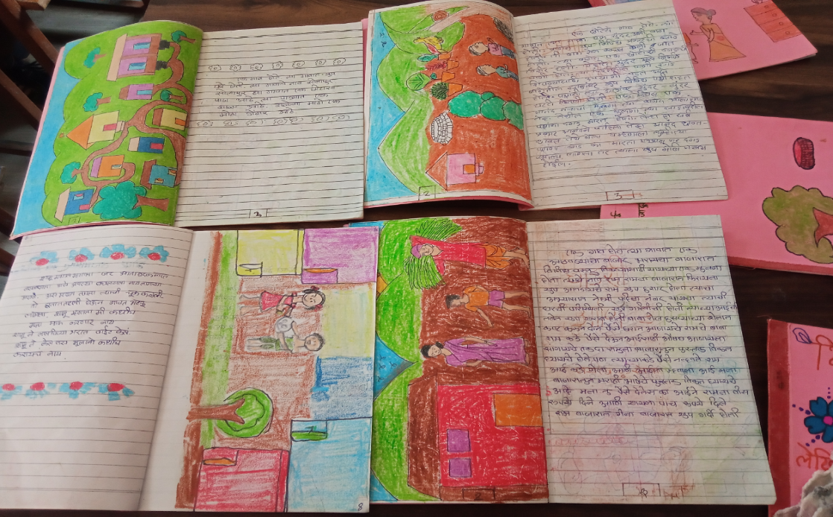

(e ) Limited resource-based library

This is a picture of a ZP school library developed by a self-motivated teacher with limited resources. Earlier, there were reading corners for children of 1st to 5th grade. But there is no place for children to sit in school. In such a school, a teacher in Aurangabad has created a library in the available space. This library has been designed so that children can easily access books.
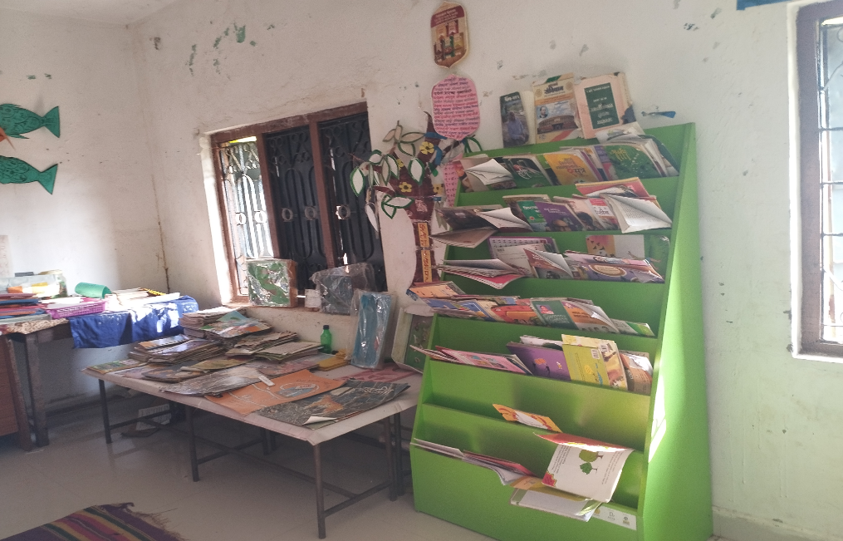

These select best practices also highlight the self-motivation of the teachers as their love for books is expressed through the practices they have implemented at their schools and in their community.

Recommendations

4.1 System-level recommendations

At the system level, it is imperative to address critical aspects of school library development. Firstly, comprehensive teacher training programs should be established to equip educators with the necessary skills to effectively use libraries and integrate them into the curriculum. This training should emphasize the pivotal role that libraries play in fostering students' literacy skills. Additionally, policy measures should ensure that schools have access to well-stocked libraries with age-appropriate and diverse books, catering to the linguistic and learning needs of all students, including those with special needs. Policies should encourage autonomy for schools in selecting books to match local preferences and languages. Adequate and timely funding provisions should also be made to guarantee the sustainability and functionality of school libraries, with a focus on resource allocation tailored to school sizes and requirements.
Furthermore, policies should underscore the importance of language inclusivity, ensuring that libraries offer books in local languages and dialects to accommodate the diverse linguistic landscape of Maharashtra.

4.2 Implementation-level recommendations

To effectively translate policy objectives into practice, it is vital to address various implementation strategies. Firstly, schools should be encouraged to integrate dedicated library periods into their weekly schedules, aligning with policy recommendations. Regular monitoring and enforcement should be in place to ensure the successful execution of these periods, fostering a culture of reading among students. Additionally, parental engagement is crucial for reinforcing the impact of libraries. Schools should be empowered to organize awareness campaigns and workshops, promoting active parental involvement in supporting reading at home.

External support, particularly from non-governmental organizations (NGOs) and experienced external organizations, should be leveraged to enhance library resources and activities. These organizations can provide age-appropriate, graded readers and offer training to teachers to effectively engage children through books. Moreover, establishing a robust system for regular monitoring and evaluation is essential to track the utilization of library grants at the school level. State-level bodies like the State Councils for Educational Research and Training (SCERT) and Block Resource Coordinators (BRCs) should oversee the effective use of grants, ensuring that resources are allocated appropriately. Keeping updated records of library books and resources through digital platforms like UDISE+ and PRABANDH portal can aid in this process. Furthermore, sharing best practices and innovative approaches across schools and regions can foster a collaborative environment for improving library implementation.

4.3 Monitoring-level recommendations

At the monitoring level, the focus should be on specific actions and initiatives to ensure that libraries are accessible beyond enrolled students. Promoting the use of libraries for children not formally enrolled in school, such as Out of School Children (OoSC), is crucial for expanding the reach and impact of these resources. By opening libraries to all students, irrespective of their enrolment status, a broader spectrum of learners can benefit from these valuable educational assets. Monitoring initiatives should emphasize inclusivity and equal access, aligning with the overarching goal of promoting literacy and fostering a culture of reading among children in Maharashtra.
**************************************************************************

Revised Guidelines for Promoting Libraries, MoE, 2020
UDISE 2019-20
DIET- District Institute of Education and Training; EO- (district) Education Officer
Two additional districts of Mumbai and Nashik were also visited when designing the study. However, data from the 15 selected districts was analysed for the report.
National Initiative for Proficiency in Reading with Understanding and Numeracy
Padhe Bharat Badhe Bharat was introduced as a su649.08b-programme under the Sarva Shiksha Abhiyan in 2014 and is now also a part of Samagra Shiksha
Project Appraisal, Budgeting, Achievements and Data Handling System

