**TISS-UNICEF Maharashtra Library Study**

**Introduction:**

*Shala Granthalaya chi Goshti (The Story of School Libraries in Maharashtra)* is a study that responds to UNICEF’s Call for Proposals to assess the status of school libraries in government elementary schools in Maharashtra.

The importance of books and libraries in the formation of individuals, society, and nations is unique. The usefulness of books as a great tool for information, knowledge, entertainment, and curiosity is well known. Hence, libraries are urgently needed as powerhouses for intellectual development and social development. The library has existed since ancient times. Taksh Sheela and Nalanda universities in ancient India were famous for their libraries. The academic and intellectual development of students was done through the library at that time. Libraries have been an integral part of academic and social life from ancient times to modern times. In terms of education, the foundation of the study teaching and assessment method depends on the curriculum, syllabus, and textbook.

Singh (2003) lamented the lack of a library to support a reading culture for the ‘neo-literates’ in India. The deemphasize on reading and the focus on performing arts is often seen in societies with oral traditions and low literacy rates (Tötemeyer, 1994). In low-resource contexts, schools are often the only place students have access to learning materials other than textbooks. Unlike textbooks that offer students little agency in the selection process, libraries afford them a space to explore and exercise their agency in choosing materials that cater to their interests. Thus, the space is transformative enabling skills such as critical literacy.

The needle has moved in India in recent times concerning policies that highlight the need for libraries and encourage schools to invest in them. Be it the National Curriculum Framework, 2005, the Right of Children to Free and Compulsory Education Act, 2009, or the National Education Policy, 2020, the thrust on libraries as a core space for learning has been highlighted over and over again.

In the case of Maharashtra, the UDISE data showcases heartening statistics such as the fact that 99% of schools report that they have libraries. However, although Samagra Shiksha Abhiyaan accords primary schools (grade 1-5), an annual library grant of Rs. 5000/- and upper-primary schools (grades 6-8), Rs. 13,000/-49% of schools have 100 books, and only 6% report having more than 300 books. Furthermore, only 48% of head teachers (a number similar to the schools with 100 books) report satisfaction with the library resources they have.

With the increase in the focus on foundational literacy and numeracy under the NEP 2020 and the records of learning loss and poor reading levels, the importance of libraries that can be spaces for joyful learning and developing literacies cannot be emphasized enough. The NEP highlights the need to strengthen libraries and emphasizes providing access to ‘enjoyable’ and relevant books for children to ensure a culture of reading in schools.

To better support schools to promote the use of libraries, it is critical to understand the current status of libraries and library usage, along with the existing models of library settings in schools across Maharashtra.

**We understand from the call the need to**

* use secondary research to establish the importance of libraries as physical spaces to improve literacies ranging from foundational to critical to cultural,
* present an analysis of various policies and frameworks related to libraries, especially in the context of Maharashtra,
* survey to understand
  + the nuances of the libraries that exist in government elementary schools in Maharashtra concerning availability, quality, access, and use of library resources,
  + teacher preparedness in identifying, selecting, and facilitating the use of resources,
  + stakeholders' perceptions regarding the use of libraries.
* gather first-hand information with regards to the availability of, access to, and use of resources in the library,
* identify gaps between policy and practice and similarities and differences in stakeholder perceptions.
* identify and document best practices adopted by government school libraries.

**The objective of the study:**

The overall objective of the study is to recommend the state, practices, and policy-level changes for ensuring the effective use of libraries to promote literacy and reading in government schools in Maharashtra.

**In particular, the study will aim to-**

1. Compile the various policies and provisions on libraries issued by GoI and in the state chronologically;
2. Assess the status of libraries vis-à-vis the above policies and provisions at the school level;
3. Understand the status of libraries from the perspective of several books available, the types of books, their quality and appropriateness for all children, the functioning of the libraries, and usage among students;
4. Study the type of training given to teachers to promote the use of libraries for students in school;
5. Identify the gaps in current policies/ implementation and expectations from children and schools;

Document good practices and innovations in the context of libraries and library use in the state.

**The timelines for the study are tight and we aim to**

* Finalize a survey to be released to HMs, BRC/CRC, Teachers, Librarians, SMC members, and DEOs by end-September 2022. This tool will then be translated into Marathi and shared district-wide.
* Identify districts (and therein schools) in Maharashtra to conduct field visits and in-person interviews with key stakeholders and such by the first week of October.
* Conduct Field visits in October and November.
* Preliminary analysis of data from Survey and Field visits by end-December 2022.
* Detailed analysis by January 2023.
* A policy brief by February 2023.

All public-facing collaterals will also be translated into and made available in Marathi.

**Recommendation for the Selection of Districts**

The study will be conducted in select government (education department) elementary (grades 1-8) schools that have received books in the last 5 years and/ or funds for infrastructure to set up school libraries. The same will include different types of schools based on the enrollment size of the 36 districts in the state.

The **first phase of data collection** will use **rapid survey** tools and cover **all 36 districts of Maharashtra**. The survey form would require facilitation at the MPSP or SCERT as applicable and DEOs, BRC/CRC and School level (Headmaster, Teachers, Appointed/Nominated Librarian, SMC Member) to be sent out as formal orders. This process needs to be supported by UNICEF.

The **second phase of data collection will include field visits. The field visits will cover 10-12 districts.** This selection would be based on purposive sampling to representatively cover rural, urban, minority, and tribal sites and border areas guided by suggestions solicited from the stakeholders, the trends indicated by the rapid survey, and the suggestions by UNICEF. The primary respondents will be school HM, teachers, students, and those working in the schools in the library space, including community leaders (SMC members), NGO members, and such. The tools used would be interviews and focus group discussions primarily. There will also be a session observation of students using library resources. In each district, attempts will be made to visit at least two representative schools. There will also be key informant interviews conducted with district officials (DEOs, BRC/CRCs), SCERT officials, and leadership of other private bodies or NGOs working in the library space in government elementary schools in Maharashtra.

In Phase 1, we will send out the **survey tool to all 36 districts** through the State mechanism. We will also **conduct regional online meetings** to orient the participants to the tools and aid doubt solving. This meeting will also act as an FGD to solicit more detailed examples that the survey may not be able to capture.

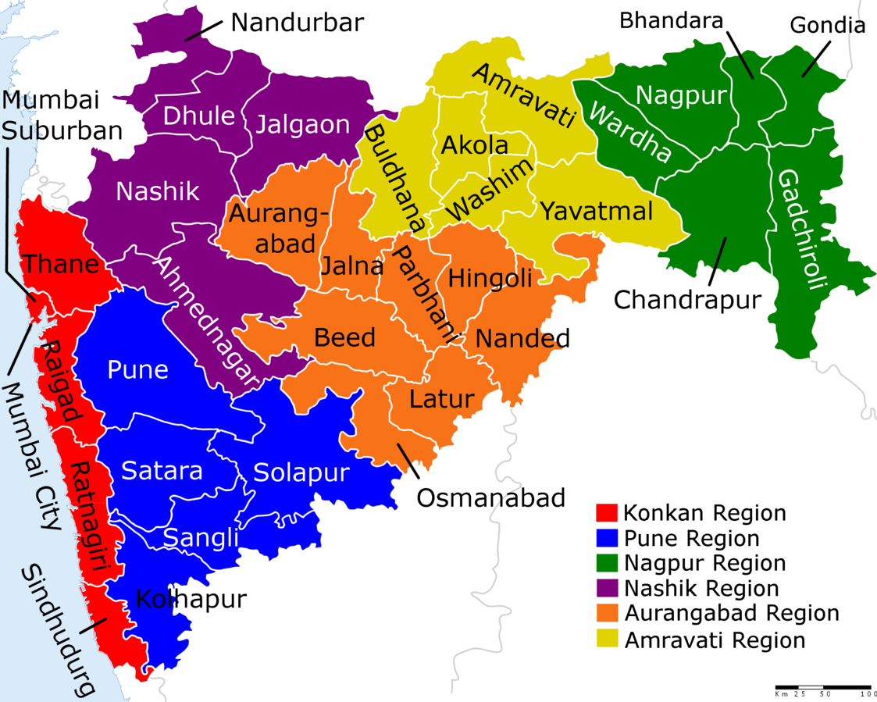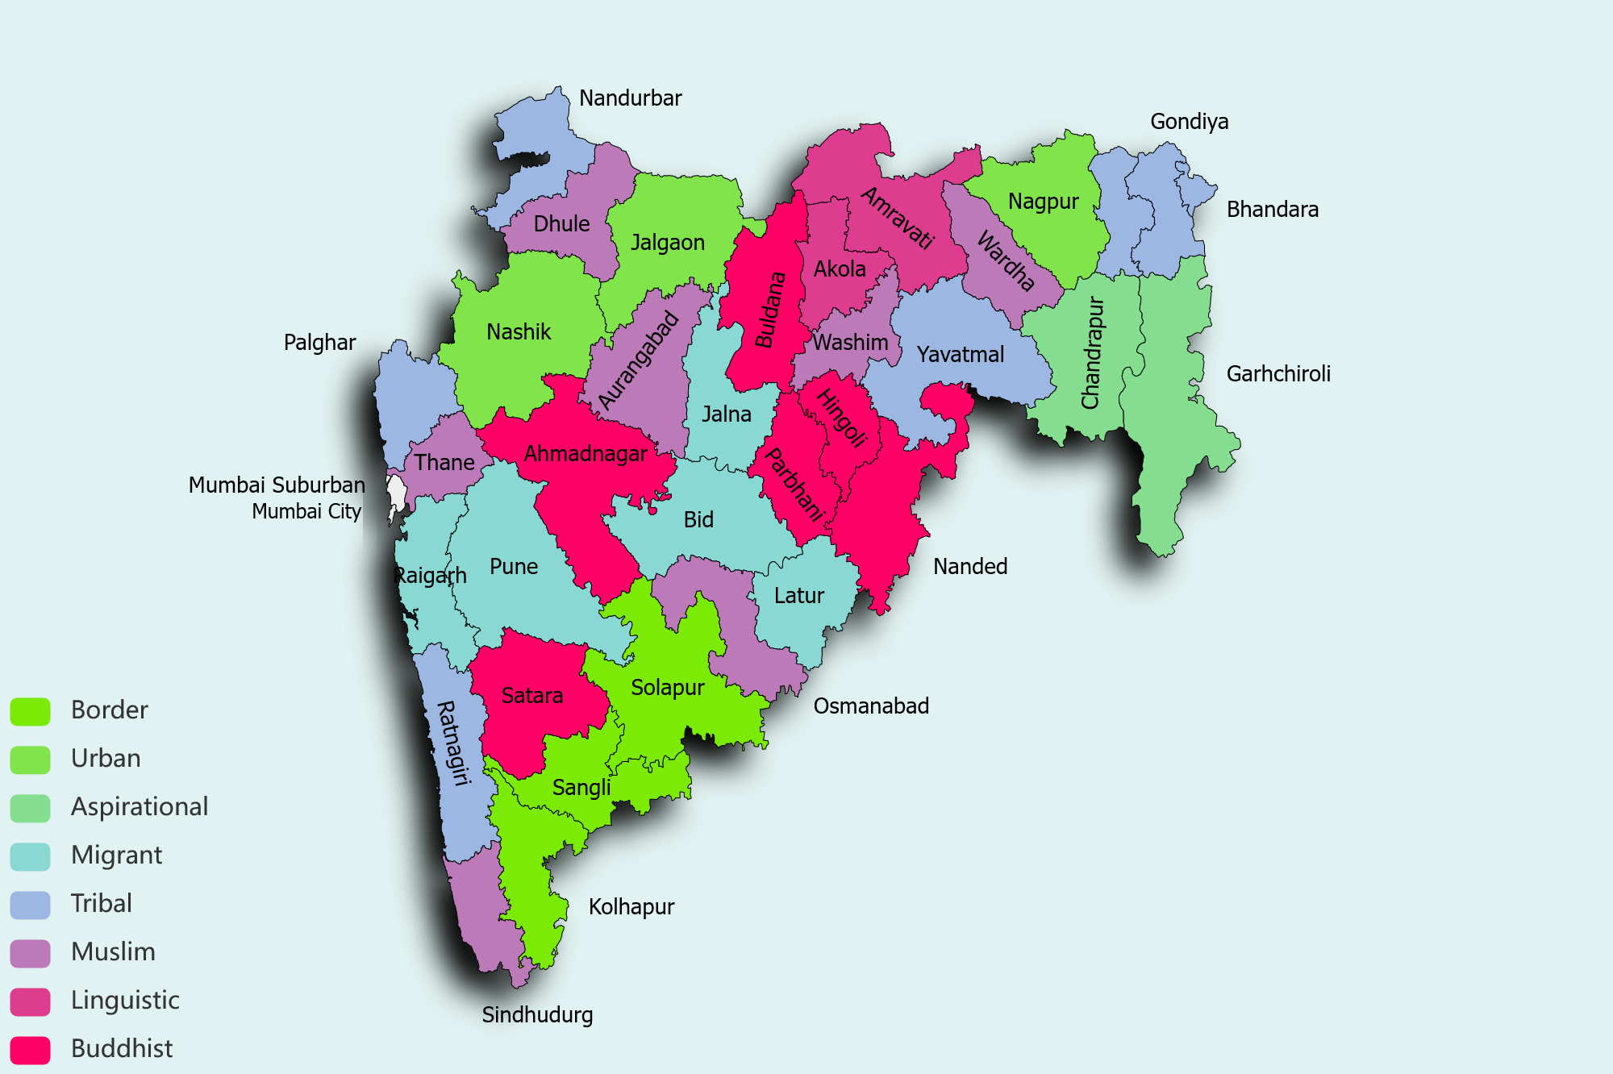

Fig. 1: Maharashtra Districts Fig. 2: TISS Profiling of Districts

For phase 2, the selection of the districts for **field visits** will be based on four major criteria:

1. Regional Representation
2. Geographical aspects (sharing borders with other states, water scarcity, etc.)
3. Demographics - (Tribal, Religious minorities, etc), the economic landscape (rural/urban/migrant, BPL, etc), and linguistic representation and disability
4. Aspirational districts

The table below highlights the salient aspects of the districts based on a desk review undertaken.

| **Region** | **Districts** | **Criteria** |
| --- | --- | --- |
| Western Maharashtra | 1. **Satara** 2. Sangali 3. Solapur 4. **Kolhapur** 5. **Pune** | 1. Buddhist Population | Rural | History | 2. Border | Conflict 3. Border | Conflict | Disability 4. Urban-Rural | Border | Conflict | Linguistic 5. Urban | Migrant | Disability |
| Marathwada | 1. **Aurangabad** 2. ***Latur*** 3. **Beed** 4. Nanded 5. Hingoli 6. Jalna 7. **Osmanabad** 8. Parbhani | 1. Urban-Rural | Muslim | Linguistic | Disability 2. Rural | Muslim | Migrant population 3. Rural | Migrant | Buddhist population 4. Buddhist population 5. Tribal 6. Muslim 7. Rural **Aspirational** | Muslim 8. Buddhist |
| Konkan | 1. **Ratnagiri** 2. Sindhudurg 3. **Thane** 4. Raigad 5. Palghar 6. ***Mumbai City*** 7. ***Mum -Suburban*** | 1. Tribal | Sex Ratio 1122 | Disability 2. Muslim population | Sex Ratio 1036 3. Urban-Rural | Muslim | Tribal | Migrant | Disability 4. Migrant 5. Tribal 6. Urban | Migrant | Linguistic | 7. *Clubbed with Mumbai-City |* Disability |
| Vidharbha | 1. **Gadchiroli** 2. Chandrapur 3. **Gondiya** 4. ***Nagpur*** 5. Yavatmal | 1. Border | **Naxalism** | Rural | **Aspirational |** 2. Tribal 3. **Tribal | Rural** 4. Urban-Rural | High density of schools 5. Rural |
| North Maharashtra | 1. **Nandurbar** 2. ***Nashik*** 3. Jalgaon 4. Dhule 5. **Ahmednagar** | 1. Tribal | **Aspirational District | Disability** 2. Urban | Buddhist Populations 3. Muslim Population 4. Buddhist Population 5. Buddhist | **Conflict | High Dropout** |
| Vardha | 1. Buldhana 2. Washim 3. **Akola** 4. **Amravati** 5. ***Bhandara*** 6. Wardha | 1. Buddhist Population 2. Muslim Population 3. **Linguistic** 4. **Urban-Rural | Linguistic** 5. Tribal 6. Muslim | Disability |

Table 1: Region-wise District Profile of Maharashtra

The 14 districts bolded in blue indicate first preference and the 05 other districts italicized indicate possibilities for field visits. We have purposely kept Mumbai out of the first cut of districts since we think we can cover the district during the piloting of field visit tools and later in December if we need additional data.

**Region Wise District Profiles:**

**An Overview :**

**Western Maharashtra: (Pune, Satara, Sangli, Kolhapur, and Solapur)**

Western Maharashtra has a rich history of primary education reformers. Maharshi Karve from Pune advocated empowerment through education. (1]Rajarshi Chhatrapati Shahu Maharaj was the great king (1894-1922) of the state of Kolhapur in Maharashtra. Shahu Maharaj proposed providing free education to the marginalized sections of Maharashtra. Sangli, Solapur, and Kolhapur share the Karnataka border. Therefore, interstate migration is a concerning issue. This deviation faced inter-state conflict during covid.

**Marathwada:**

**Beed, Jalna, and Latur districts**

Latur, Jalna, and Beed are drought-prone areas of Maharashtra which have faced climatic crises and water scarcity, which is a concerning issue, and no land ownership for Buddhist and Muslim communities.

[2]Beed, an administrative district in the Aurangabad division of Maharashtra, is located in the Marathwada region, bordering Karnataka and Telangana. On 31 October 2018, the Government of Maharashtra declared Beed as the most severely drought-affected district in the country. Hence the extremely internally Migrated and backward district of Marathwada.

According to the 2011 Census of India, Beed has a population of 2,585,049 in 2011 of which 1,349,106 are males, and 1,235,943 are females. Out of 987,185 literate people, 1,718,507 are males and 731,322 are females. Nanded district has a 10% Buddhist and 14% Muslim population

**Aurangabad:**

[3]In 2011, Aurangabad had a population of 3,701,282 males and females 1,924,469 and 1,776,813 respectively. In the 2001 census, Aurangabad had a population of 2,897,013 of which males were 1,505,363 and the remaining 1,391,650 were females. Aurangabad District population constituted 3.29 percent of the total Maharashtra population. In the 2001 census, this figure for Aurangabad District was 2.99 percent of Maharashtra's population. Aurangabad has a large Muslim population. Hence Urdu language books are available in schools.

**Mumbai (City and Suburban):**

Mumbai has a long history of migration, which has played a major role in the city's economic and social transformation. There is intrastate and interstate migration. The city presents an interesting contrast of economic housing, one of the world’s most expensive homes (Antila), and one of the world’s largest slums (Dharavi). It also has high linguistic diversity and is home to the maximum number of Parsis in India. Furthermore, it is convenient for piloting tools, conducting field visits, and plugging gaps in school-based research, if any.

**Konkan: (Raigad, Ratnagiri, Sindhudurg, Palghar and Thane)**

Compared to Sindhudurg, Raigad and Thane districts have a lower literacy rate among tribals and a lower population of the Muslim community. [4]The Konkan Education Society (K.E.S.) is the pioneering educational institution engaged in delivering knowledge to the rural population in the Konkan Region of Maharashtra State. The Government of Maharashtra has appropriately recognized this society as a model/ideal educational institute. It would be interesting to see if the effects on literacy and library use have been considered in this area.

**Vidarbha:**

**Chandrapur and Gadchiroli district :**

[5]The total population of the district is 10,72,942. Male and female population is 5,41,328 and 5,31,614 respectively (As per Census 2011). SC and ST population in the district is 1,20,754 and 4,15,306 (As per 2011 Census). The literacy rate of the district is 74.4 %(as per census 2011). The percentage of Scheduled Castes and Scheduled Tribes community population that resides in the district is 11.25% and 38.7% respectively ( As per Census 2011). Gadchiroli district was formed on 26 August 1982 by bifurcating the erstwhile Chandrapur district. The Maharashtra government has declared both the districts as Naxal-affected border regions.

**Gondiya district:**

[6] The total population of the district is 1322635. The male and female population is 662656 and 659964 respectively. The SC and ST population in the district is 355484 and 309822**.**

Gondia district shares a border with Madhya Pradesh. The male and female population is 662656 and 659964 respectively. The population of Scheduled Castes and Tribes in the district is 355484 and 309822 respectively. The district has a very high literacy rate of 84.95%. Tribal people speak the Gondi language.

**Nagpur district: (Urban Rural School):**

Nagpur is a major hub of central India sharing a border with Madhya Pradesh. Nagpur has significantly developed community engagement and heritage contributions around the district. It. also has a rich culture of higher education.[7]As of the 2011 census, Nagpur District comprising 14 tahsils had a population of 46,53, 171. Nagpur had a population of 24,05,421 and the urban agglomeration had a population of 25,23,911. The average literacy rate was 89.52% compared to 84.03 in 2001; male literacy was 93.76% and female literacy was 85.07%.

**North Maharashtra: (Nashik, Dhule Jalgoan, Nadurbar, Ahmednagar)**

[8] According to Dr. Nilesh Gaikwad Nandurbar boasts of Zilla Parishad schools, ashram schools, government-aided private schools, technical institutes, and colleges offering professional courses with a literacy rate of just 64.38%, one of the lowest in Maharashtra. It also has a linguistic variety with Marathi, Various Bhili languages, Gujarati, and Hindi being spoken in the region. The educational dropout rate is very high in this area perhaps because the tribals face many problems concerning livelihood, education, health, employment, addiction, etc. tribal people mainly engage in agriculture work and land labor work, daily wages. Due to these problems, these tribal people are not fully aware of the importance of education. Zilla Parishad schools and Ashram schools provide free education, but the role of the library in ensuring literacy standards and as an active hub of learning in the school is largely unexplored.

In Nashik, in the same region, in contrast, the male literacy rate is 93.40% and the female literacy stands at 85.92%. We would also like to select Ahmednagar known to be one of the most ‘atrocity-prone’ areas in Maharashtra.

**Wardha (Wasim, Amravati, Akola, Bhandara and Yavatmal )**

The average literacy rate of Amravati in 2011 was 87.38 compared to 82.54 in 2001. If things are looked out at gender-wise, male and female literacy were 91.46 and 83.10 respectively. It ranks among the 250 most backward districts of India. Despite having fertile soil and good positioning on the Mumbai-Kolkata highway, this rural and largely agrarian district needs a lot of development, and with MIDC focus on textiles, metal, and the sugar industry, it would be interesting to see the playout of economics on school education, particularly concerning libraries and an input rich environment.

Furthermore, Amravati and Akola are Varadi-speaking districts, and most of the material in this language is available in the school curriculum.

Washim district is known for the cotton industry. The economy is dependent on agricultural activities. Buldhana (place of the Bhillas, a tribal group). Muslims are a minority in Buldana state forming 13.70% of the total population. In 2011, Yavatmal had a population of 2,772,348 of which male and female were 1,419,965 and 1,352,383 respectively. In the 2001 census, Yavatmal had a population of 2,458,271 of which males were 1,265,681 and the remaining 1,192,590 were females.

Bhandara is another district worth examining in this region with its mix of agriculture, manufacturing, and mining industries and a fairly high literacy rate of 83.76% with several higher education institutions also in this district.

**Overview:**

Overall, we have also looked at disability as an inclusion factor and while Mumbai-Suburban, Thane, and Pune do rank as the ones housing the highest number of differently-abled people, Nandurbar and Aurangabad have been selected for the high incidence of disability among the 0-19 age group (Sivanandan et al, 2016).

The selection of the districts in this first draft is indicative and not final and we hope to receive feedback from UNICEF, the State, and the Advisory Group on the same.

**Methodology:**

This study used a mixed study methodology will be used that includes secondary data analysis, in-depth literature review, desk review of relevant and credible data sets, interviews with key stakeholders, FGDs, and field visits as follows:

Desk research: this will include compilation and analysis of available research studies by universities/ reputed NGOs/ other agencies on the status of libraries in the last five years. Data from reliable data sets such as the UDISE and reports published by the state on the utilization of library funds will also be considered.

Field Survey: data collection for the study will use both qualitative and quantitative methodologies of data collection, including focus group discussions, interviews, and field surveys with relevant stakeholders.

To the extent possible, we will ensure diversity in respondents concerning age, gender, social groups, and geographies.

Subsequently, data compilation and analysis will be conducted to provide a final report, including best practices and recommendations. Inputs provided by UNICEF will be incorporated into the report before finalization.

We will aim to have a reference group of experts and practitioners from the library space reaching out to those from Room to Read, Pratham Books, Bookworm Goa, etc to get guidance on tools development and the overall research.

***4.2 Target Group***

The primary respondents of the study will be district officials (DIET and EO office), block and cluster officials, school HMs, teachers, children, and other relevant stakeholders working in the schools (including community representatives).

***5.3 Geographical Coverage***

The study will be conducted in selected government (education department) elementary (grades 1-8) schools that have received books in the last 5 years and/ or funds for infrastructure to set up school libraries. The same will include different types of schools based on the enrollment size in the 36 districts in the state.

The first phase of data collection will use rapid survey tools and cover all 36 districts of Maharashtra. The survey form would require facilitation at the MPSP or SCERT as applicable and DEOs level to be sent out as formal orders. This process needs to be supported by UNICEF.

The second phase of data collection will include field visits. The field visits will cover 10-12 districts. This selection would be based on purposive sampling to represent rural, urban, and minority communities, tribal sites, and border areas guided by suggestions from stakeholders, the trends indicated by the rapid survey, and the suggestions by UNICEF. The primary respondents will be school HM, teachers, students, and those working in the schools in the library space, including community leaders, NGO members, and such. The tools used would be interviews and focus group discussions primarily. There will also be the observation of a session of students using library resources. In each district, an attempt will be made to visit about 02 representative schools.

There will also be key informant interviews conducted with district officials, SCERT officials, and the leadership of other private bodies or NGOs working in the library space in government elementary schools in Maharashtra.

***4.4 Research Questions and Information Scope***

The list below provides the main research questions. Note that these will be finalized by the agency during the inception phase, along with the analysis framework, subject to UNICEF approval.

i.What are the current policies and provisions with regards to libraries in the state in the last 5 years (central and state)? This will include the following-

a. The basis of fund allocation and the different grants for setting up libraries in the school;

b. Selection criteria of books to be procured for schools (types of books defined);

c. Process of procurement;

d. Roles and responsibilities of different state bodies/ departments within Education with regards to libraries;

e. Policies around the capacity building of teachers with regards to the use of libraries;

f. Guidelines for the effective use of libraries, including the library set-up/ practices of maintaining books in the libraries.

ii.How are the above policies being implemented at the school level?

. What is the process of selection and procurement of books for the school library?

a. How are libraries being used in schools for children?

b. What are the different types of books available in the library for children?

c. Are there books available for teachers in the schools?

d. What are some of the challenges in the implementation of the above policies?

e. What are the barriers to timely procurement and disbursement of funds for books?

iii. How are the existing policies/ guidelines regarding libraries and library use, aligned with provisions needed for the effective implementation of NEP/ NIPUN Bharat?

iv. Are the schools/ school staff equipped with the necessary skills to ensure the effective utilization of libraries? What training has been offered to teachers, to help them support the library used in their schools?

v.What are some of the best practices and different models (reflecting the diversity of schools) in the context of libraries in the state?

vi. What are some of the effective school library models outside of government schools?

vii. From the perspective of children, what are some of the elements that need to be incorporated to make libraries more child-centric?

**Research Methods:**

***Survey Tools***

This survey is part of Phase 1 of the study. It will be sent out to ALL government elementary schools (and composite as applicable) in Maharashtra.

The study has applied survey tools to collect data from the identified key stakeholder involved in the function of the library starting from the librarian or designated teacher librarian to, the teacher, headteacher, CRC, BRC, and District Education Officer. The survey tools will cover various aspects of library functions, monitoring, library space as a room or reading corner, library infrastructure, collection of books & resources, librarian/designated teacher librarian, community participation through the SMC members, and NGO Interventions. These tools also examine the practice of orientation and training, fund and utilization and importance of library and reading culture., the function of Library,

These aspects are very significant to understand in the process of library functioning. Studies have also focused on their role and responsibilities to make the library more functional. Fund utilization is another significant aspect of the function of libraries and library policies. The survey tool has tried to touch on all fund utilization aspects with all the stakeholders. Apart from that study also trying to understand library timings, access to books post-school hours, and also the availability of the library during vacation time. Library and children have a deep relationship not only in subject matter but also in learning their day-to-day aspects, language, learning about behavior, and also getting introduced to various other contexts. The study has taken into consideration this aspect, especially for children.

=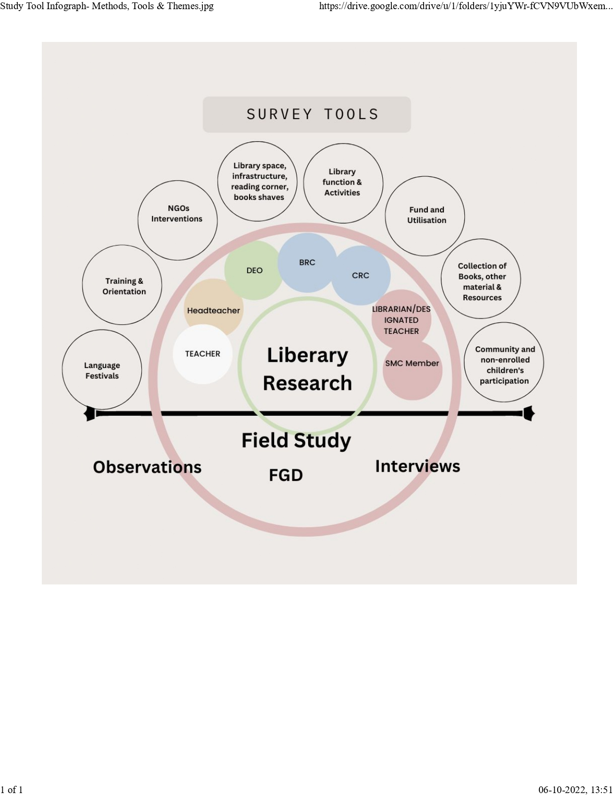

­

This image explains the involved research participants as well as various theme which has been covered in the study. A tentative timeline for the data collection process has also been inserted in the image.

***Interview:***

The interview has been included in the study to understand the stakeholder’s in-depth understanding of the function of the library, their experiences, their challenges, and stakeholders’ contribution to the function of the library. Interviews will be conducted in at least two selected schools within the selected 10-12 districts for observation and in-depth understanding.

An interview guide/schedule will be prepared for the interviews with the key stakeholder. The research team will visit the school and will conduct a face-to-face interview with the stakeholders.

***Focus Group Discussion:***

Focus group discussion will be conducted in the second phase of data collection with the DEOs, BRC and CRCs. Focus group discussion will focus more on the policy aspect along with the library function, it will also include the training and orientation, appointments of librarians, and assessment of the function of the library.

***Observations:***

The research team will be asked to note down all the observations while visiting schools and libraries. These observations will help to understand the function of the library practically and also the existence of the library. It will also observe the participation of children in the library, available infrastructure, and resources in the library.

**Sampling Process and estimated Samples**

As per UDISE 2020-21 Report, Maharashtra has a total of 65734 schools of which 43126 (Std 1-5) 20639 (Std 1-8) 9 (Std 6-8) and 962 (Std 1-10) are the target of this study. Similarly of the 249657 teachers 102114 (Std 1-5) 124505 (Std 1-8) 34 (Std 6-8) and 11191 (Std 1-10) comprise the teacher population to be surveyed in this study.

|  | Maharashtra  **Total** | The target of this Study | | | | Total Target | Proportion aimed at |
| --- | --- | --- | --- | --- | --- | --- | --- |
|  | **Std 1-5** | **Std 1-8** | **Std 6-8** | ***Std 1-10*** |
| Schools | 65,734 | 43126 | 20639 | 9 | *962* | 64,466 | 8%  **5157** |
| Schools with Library Facility | 65099 | To be determined | | | |  |  |
| Schools with Computer Facility | 43835 | To be determined | | | |  |  |
| DEOs | 36 Regions |  | | | |  | 1 per region |
| BRC/CRC | Need to verify Data | *Data as of now indicate 408 blocks with as many as 33 clusters in some blocks.* | | | |  |  |
| HM  (based on Schools) | 65,734 | 43126 | 20639 | 9 | *962* | 64,466 | 8%  **5157i** |
| Librarian / Nominated Teacher | Need Data | *Many schools may not have a dedicated Librarian and a nominated teacher might fill this tool.* | | | |  |  |
| Teachers | 2,49,657 | 102114 | 124505 | 34 | *11191* | 2,37,844 | 6%  **14,270** |
| SMC Member  (based on Schools) | 65,734 | 43126 | 20639 | 9 | *962* | 64,466 | 3%  **1934** |

TISS-UNICEF Maharashtra Library Study

l