**Key observations of the field visit and focus group discussion:**

**This is a picture of a ZP school library developed by a self-motivated teacher with limited resources.**

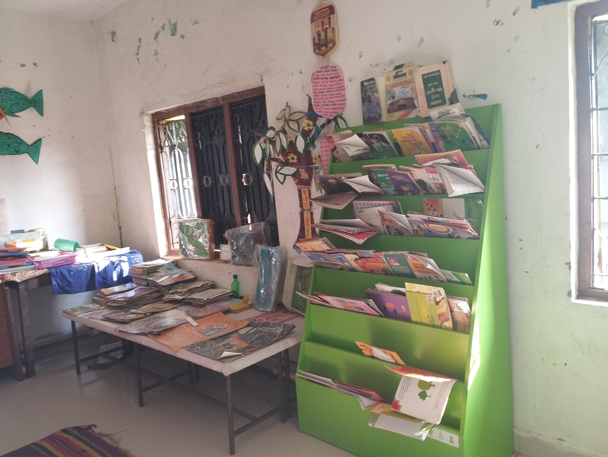

**We visited 15 districts of Maharashtra and conducted FGDs with CRC/BRC with the help of DIET faculty and BEO in Maharashtra. Personal interviews were also conducted with teachers and HMs. These are the most significant observations of the study which help to analyze the education policy.**

1. Self-motivation among teachers is seen as the biggest driver in schools with functional libraries. They are taking the initiative to run the school library.
2. Funding for the school library has not been available for the last several years. Therefore, most of the teachers are not aware of the special provisions of the school library fund.
3. One of the schools visited had a special educator who emphasized the lack of books for the CWSN students. The lack of books that caters to disabilities ( Such as Braille or Audiobooks, tactile books, etc. ) further dis -a privilege the disabled as the library is not inclusive of them.
4. Schools with more than 250 and 6th to 8th-grade students require special books. They want books on various subjects such as science, mathematics, atlas, and general knowledge, such as books that will inspire them in the future. Lack of training among teachers and lack of sensitivity to the need to read for pleasure is reflected in repeated comments in districts that they need to purchase books that cater to the subject discipline. Teachers express this need, especially for higher grades like 6-8. This shows that they do not know much about the scheme and for what purpose and how the funds can be used, but more importantly, they have lost the essence and enjoyment of reading.
5. There are NGO Rooms to read, and Pratham and D-mart are working on ZP School Library. Read to Room which imparts library management training to teachers. But they have time limits to work on the school library projects. Therefore, the teachers are sure that the government will be able to sustain the school library.
6. All teachers were asking for library training. According to them, school library management training will help them in running the library. Some feel that DIET professors are willing to conduct half-day workshops or training for teachers on library management. According to DEIT faculty, appropriate library management training materials should be developed.