Field Stories of School Library

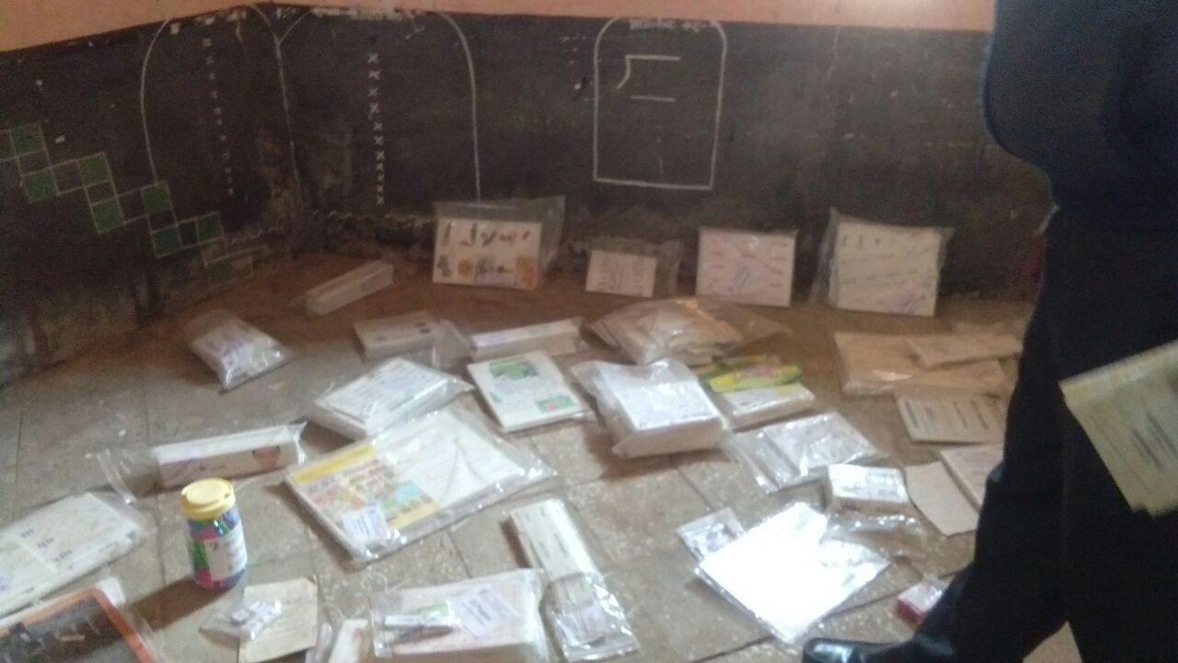
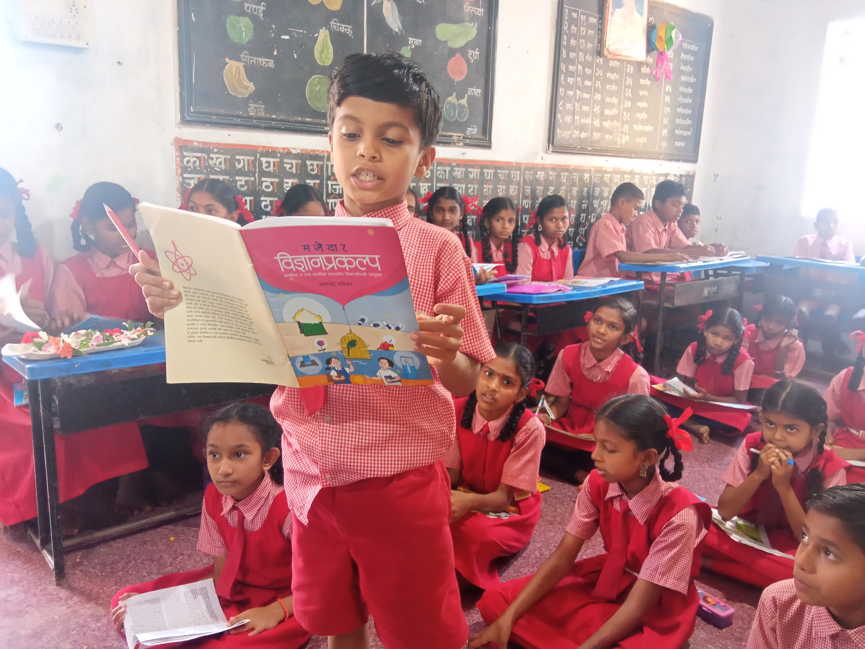

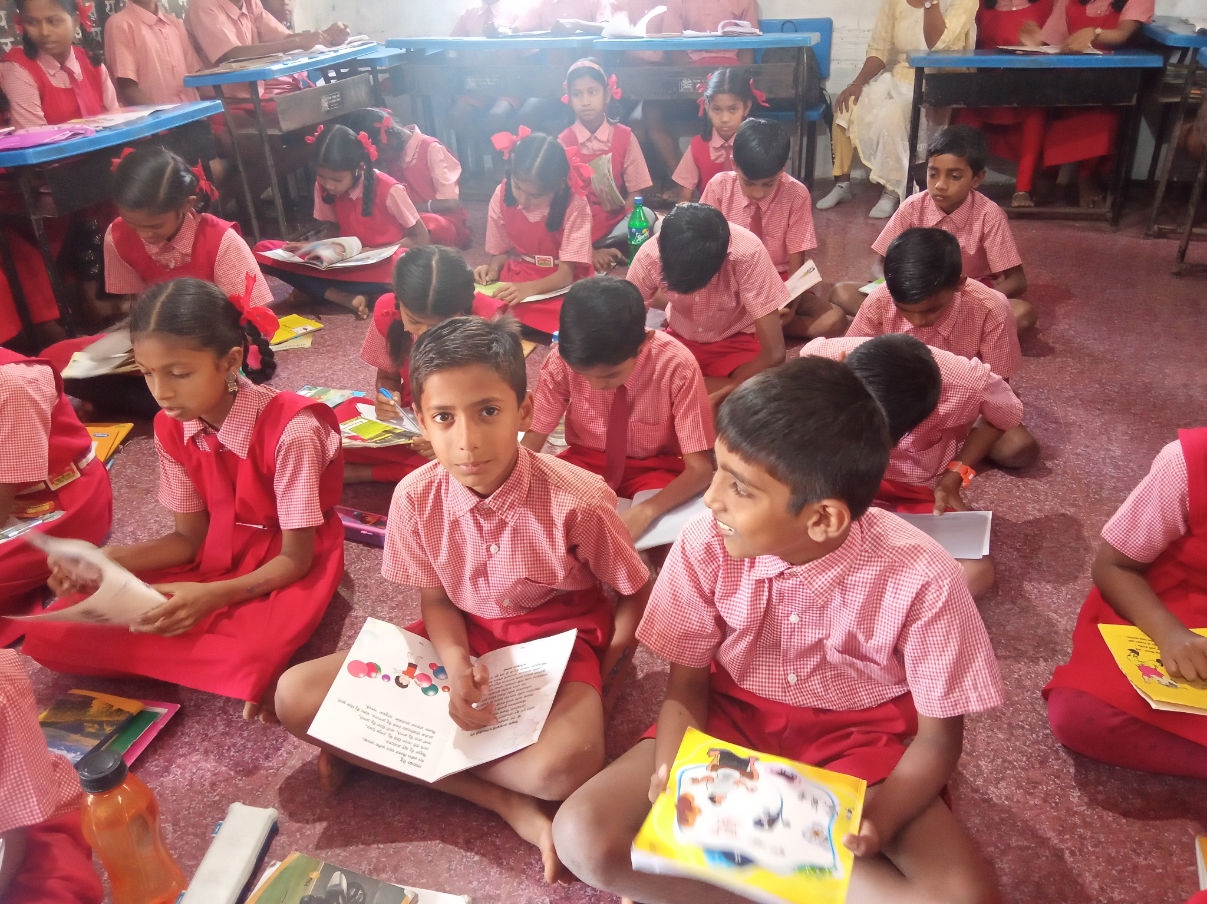
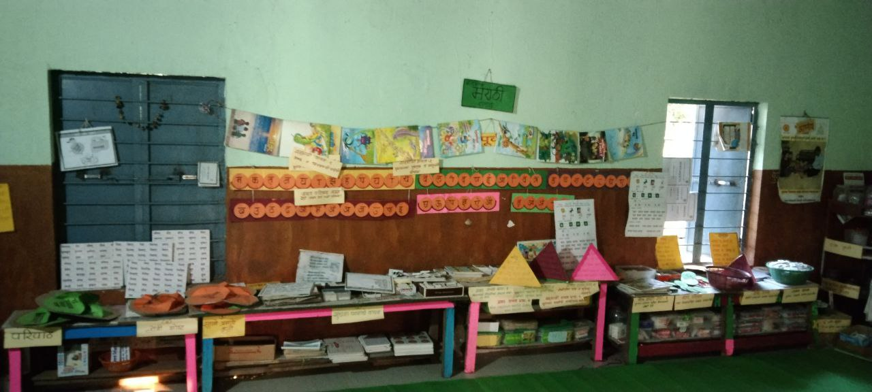

Dr. Dinesh Chand and Dr.Sheetal Kamble
Center for Excellence in Teacher Education
Tata Institute of Social Sciences Mumbai
Introduction :

Schools and libraries have been very correlated and connected to the teaching and learning process. Students and teachers are very significant stakeholders in the four entities of school, library, teaching, and learning. In the context of teaching and learning, teachers play a significant role in leading this process. Students are the recipients of this entire process. However, the library is a component that needs both the teacher and students. The main objective of the library is to provide a space for everyone including teachers and students for gaining knowledge, a place to enjoy and learn. Reading, which is a joyful activity for the children, makes more sense to the students. In this process, joys come from learning new things and learning about the world.

In the case of the younger children who are under the age of 15 and just starting to read letters, words, and sentences, it is a pleasure for them to understand it and make sense. This process brings a new world for the children to enter. Children learn a lot by reading these processes. Children also enjoy it by engaging in it. However, this process makes different meanings for the different children based on their social context, geographical location, social conditions, and their parent's economic reality.

This process may not please the children who come from marginalized backgrounds or the interior tribal reality as they are the first generational learning where they may not find meaning even in the reading as their reality and their experience has been very different from what has been mentioned in the books. There are many more aspects that one has to understand such as access to reading material and space where they can engage with these processes. In such matters and with such children, the reality is different, meaning library and reading may not provide them joy. For such children who come from difficult realities, the meaning of reading and joying differ from the others who have access to various materials.

Another aspect of reading, learning, and feeling joy in the process, is that the state is a very significant institution and monitoring body that looks after this process by various tools and instruments. The state has a lot of control to promote and reduce the interest in these processes through regulation and policy. Bringing new policies and investing in these processes are probably improving the conditions and making children engage in reading, by ensuring the children are getting access to the resources and materials.

In India, there is a labor education policy. Under the policy, there is a provision for a library in the school. Samagra Shiksha is an overarching program for the school education sector under the Department of School Education and Literacy, a program by the Ministry of Education. It also extends its support to the learning of children from preschool to class 12 h. Its goals are to improve school effectiveness measured in terms of equal opportunities for schooling and equitable learning outcomes. According to the policy aspect, this program is an amalgamation of three education schools. 1) Sarva Shiksha Abhiyan (SSA), 2)Rashtriya Madhyamik Shiksha Abhiyan (RMSA), and 3) Teacher Education (TE).
Taking inspiration from the library component under the Samagra Shiksha. A joint study was planned by Tata Institute of Social Sciences, Mumbai in association with UNICEF and the Government of Maharashtra in 17 Maharashtra districts to understand the library's condition under the title, “ Shala Granthalaya chi Gostha’. Another significant aspect of the library. The need for libraries in every school is recognized by the National Curriculum Framework, 2005, the Right of Children to Free and Compulsory Education Act, 2009, and the National Education Policy, 2020. Every year, under Samagra Shiksha Abhiyan, government schools receive a library grant to procure books for their libraries, in tandem with the activities under Padhe Bharat Badhe Bharat. The guidelines for the utilization of the grant were revised in 2020, in alignment with the NEP, which emphasizes the importance of libraries and books. These guidelines detail the processes for the selection of books, printing and procuring of library books, and ways of setting and managing libraries, towards building a culture of reading. As per the guidelines, primary schools (grades 1-5), receive an annual library grant of Rs. 5000/- and upper-primary schools (grades 6-8), receive Rs. 13,000/-.

The overall objective of the study is to recommend the state, practices, and policy-level changes for ensuring the effective use of libraries to promote literacy and reading in the government elementary (Grade 1-8) schools in Maharashtra.
The overall objective of the study is to recommend the state, practices, and policy-level changes for ensuring the effective use of libraries to promote literacy and reading in the government elementary (Grade 1-8) schools in Maharashtra.

In particular, the study will aim to explore the existing policies and provisions on libraries issued by the Government of India and in the state of Maharashtra chronologically; it also includes to assess of the status of libraries vis-à-vis the above policies and provisions at the school level and understand the status of libraries from the perspective of the number of books available, the types of books, their quality and appropriateness for all children, the functioning of the libraries, and usage among students; and barriers in beliefs/ perception of teachers/ students/ KPs/ EO/ DIETs on how the library be used that prevent effective use, to also understand the selection and procurement process followed for books at different levels such as regional/ language differences and/or disabilities.
The study has also tried to understand the type of training given to teachers to promote the use of libraries for students in school and the use of books for “reading for joy” and for language development. The study has identified some of the gaps in current policies/ implementation and expectations from children and schools and documented good practices and innovations in the context of libraries and library use in the state.

This study proceeded with the selection of the districts within the district, based on the criteria two schools were selected from two different locations in each district. The criteria for the selection of districts are mentioned below- For phase 2, the selection of the districts for field visits will be based on four major criteria:
- Regional Representation
- Geographical aspects (sharing borders with other states, water scarcity, etc.)
- Demographics - (Tribal, Religious minorities, etc), the economic landscape (rural/urban/migrant, BPL, etc), and linguistic representation and disability
- Aspirational districts
These criteria help to select 17 districts out of 36 districts in Maharashtra. The interesting part of this process is that field investigators visited each of these schools in the 17 districts, and interacted with the school teacher, headteacher, community people, children, and location authorities. Their experience is very rich in schooling, children’s access to libraries and learning, the practice of teaching, the status of the infrastructure and the state support, monitoring systems, teacher’s training, and also the participation of the community.
Based on their experiences and their stories, this booklet was planted to document and share the experiences of the researchers who gained it firsthand by engaging empirically in the process. These cases are very significant in sharing their reflection and empirical experience. The major stories that have emerged from the fieldwork are mentioned below.-
- Elementary School Library and Community Learning (Sheetal Kamble)
- Learning Materials and Things in the School Library (Aishwarya Jadhav )
- Reading Culture and Digital Learning: Exploration of Children (Agasthi Chaskar )
- School Libraries and Multiligastic Approach (Riya Wasnik )
- Inclusion: Tribal children's experience with the library (Prapti and Bhavana )
- BMC: Urban Settlement of School Library (Maitrayee Pan )
- school Liabrary and gender focus approch (Kushali Arote )

Learning Materials and Things in Library

Aishwarya Jadhav
1.1 The Idea of Library as Books
Whenever we think of the library, the very first image is a space filled with physical books. The Marathi word “Granthalay,” which means library, includes “Granth,” which stands for books-physical hardcopy books. Inspecting the image further, the type of books would almost always be non-fiction biographies, academic material, historical texts, advanced linguistic fiction, and a few storybooks. So, the variety of books is also pre-constructed in this image to denote those books with high language skills and complex cognitive content. Will a tiny box filled with basic storybooks and a few learning blocks be considered a library?
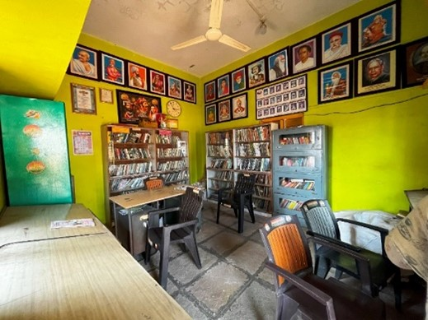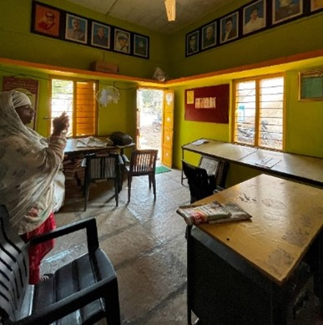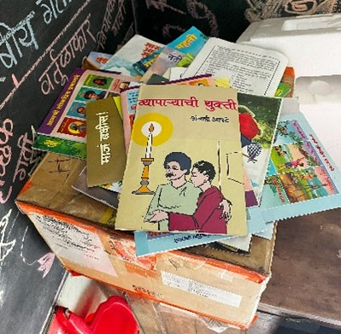
Library space is envisioned as having books as learning resources and tables with chairs as other things necessary to call it a library. Adding quotes and photos of leaders and influential figures makes it an ideal place. Nevertheless, when it comes to learning materials and things in the library, the understanding has widened much more, especially with the inclusion of technology in education. Reliance on books for meeting learning outcomes has become outdated, and engaging students through activities is a crucial part of their educational experience. Especially with inclusive education, reliance on one form of learning material is considered discriminatory. It keeps students with learning or other disabilities, atypical students, or neurodivergent children out of the learning process. In this respect, broadening our concepts and understanding of learning material in library space is also essential. While many teachers, educators, and administrators in the education sector still consider the traditional concept of the library as the defining concept, learning materials can still be non-traditional and occupy space in a traditional library.
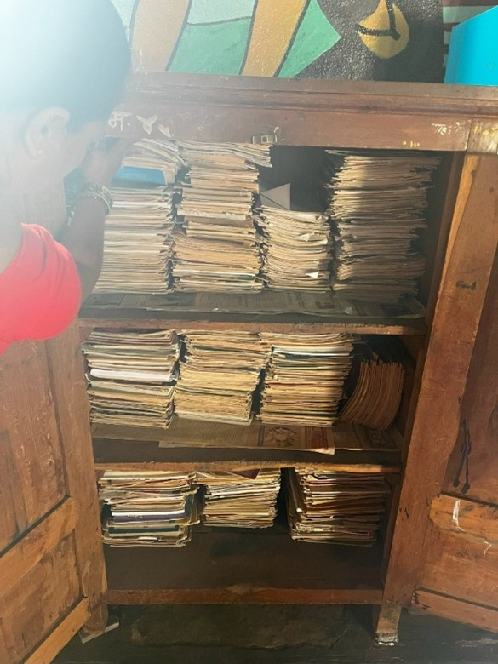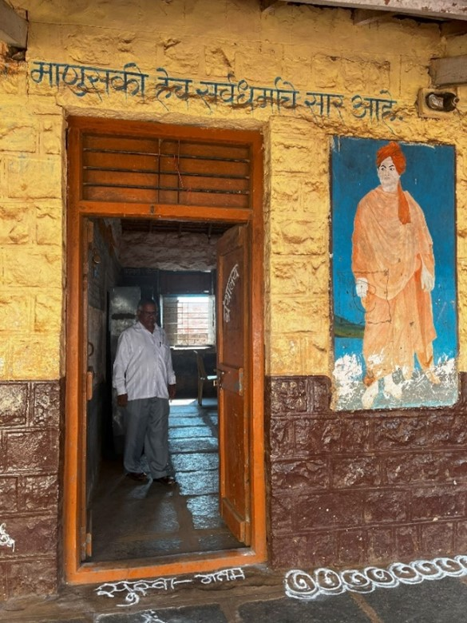
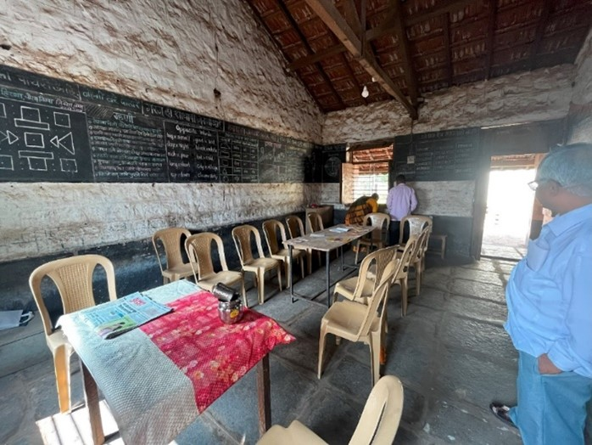
The library space in government primary schools is full of paradoxes. We wanted to know whether a library in the school was just a book full of cupboards or if there was a dedicated room allotted for the library. We wanted to judge the school's enthusiasm towards library utilization through this question.
But how does one judge a school with a dedicated library room, but the books are locked inside the cupboards? The room would be barely utilized, there would not be a particular day allotted for the students to use the library, there would be no activities conducted in the library room, and the students would not even read the books in the library. The way the library would function, the students would be asked to take the books home for reading, even with a dedicated library space in the school itself.
1.2 The types of learning material essential for students
A crucial point highlighted by everyone from the DIET to the school teachers was that books in the library should be age-appropriate The books given currently turn out to be too difficult for the reading skills of the lower grades, which makes it difficult to inculcate a reading culture in the students from an early age. If books could engage students from a younger age, it would be easier to sustain the habit as they age instead of introducing it directly in their teen years when it would be challenging to develop. An interesting observation that could be noted was that even though everyone from the DIET, Samagrah District Coordinator, the BRC, DEO, Principal, and even teachers knew the importance of age-appropriate books and even stressed it, however on a policy level, this opinion has failed to reflect. It makes one contemplate how participatory the policy formulation truly is when it comes to a crucial aspect like education.
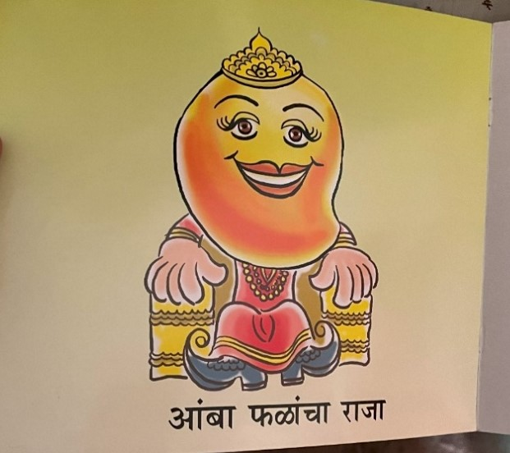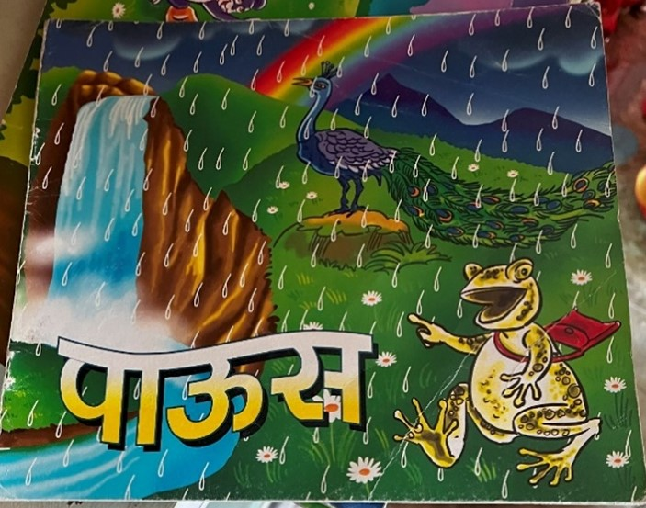
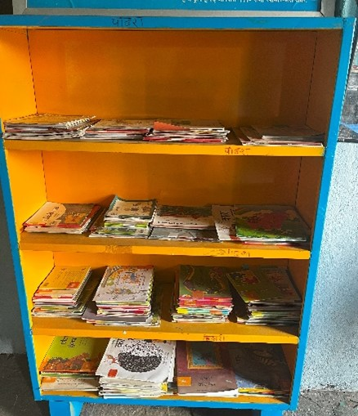
The types of learning material in the school are insufficient to complement students’ learning outcomes. To be genuinely inclusionary, reading materials should be diverse, not only according to age but also language, region, and learning capacities. As mentioned above, a common suggestion regarding materials was the age-appropriateness of the material. Unless the material is age-appropriate, it cannot facilitate reading habits or complement classroom study. However, there are NGO interventions like Room to Read, where books are segregated according to age groups and assigned specific colors. They are arranged according to this classification as well, and teachers are trained about this classification and activities that can be done, which are again age-specific.
Another vital suggestion in conjunction with this was the ability of the library resources to facilitate classroom learning. Books in the library should help students visualize and understand their classroom subjects better. This will increase their understanding and the student's capability to research a particular topic of her/his interest in their capacity. Knowing which book to read is a skill in itself, and hence, the capacity to choose a particular source of learning material can be built through a rich and diverse stock of learning materials.
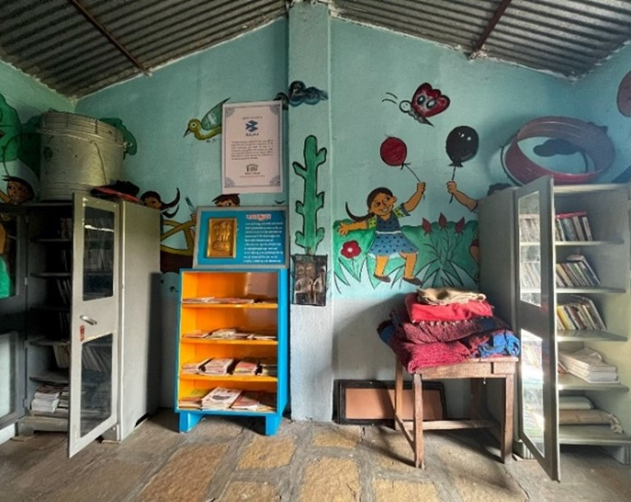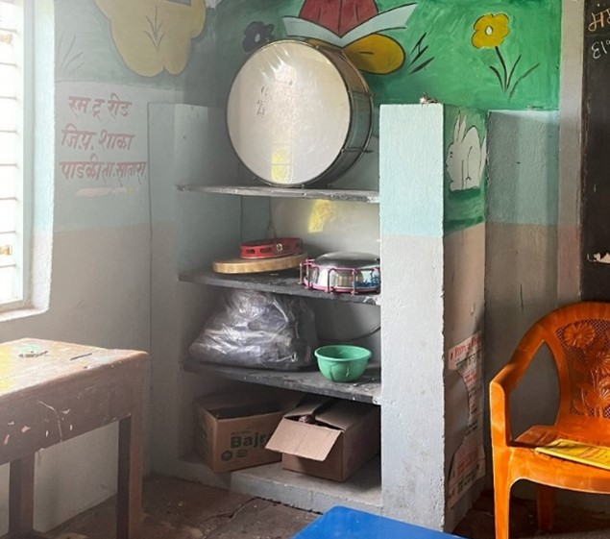
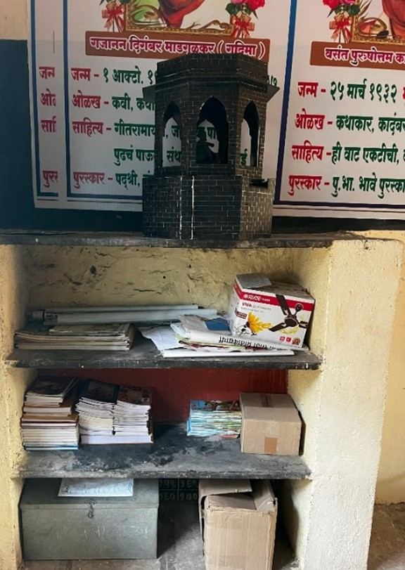
The things in the library are not necessarily books or related to the traditional concept ( Aishawrya Can you expain the menaining of traditional libarary ? Which help to undetsnad the diffirence between school libarary and tradational liabrary ) of a library. In most cases, libraries become storage rooms for activities that have lost importance and have also failed to have their dedicated school spaces. One might find drums and musical instruments not being a part of the library and an “other” element. But does this equipment have the potential to make library resources more diverse and unorthodox, especially for atypical, neurodivergent, and students with learning disabilities?
With that purpose in mind, these elements signify how libraries are constantly overlooked in the school scenario. The students pick up these clues from what they witness every day, and then it does not matter how much campaigning one does around the importance of the library; the student can only be convinced if behavioral practices change from an administrative level. Learning materials and things in the library should be more comprehensive than a particular pedagogy. Resources that stimulate visual learning, like the model of a fort in the picture above, help students relate to their regional discourses. Wanting to know more about their culture can help generate interest in the library books and develop reading, researching, and knowledge-building skills in students, which they can then extrapolate to other subjects.
Furthermore, things in the library could also be motivational material that can highlight the importance of reading itself. Innovative structures can make library spaces attractive, inviting students into a space they can explore independently. Bringing students to the library space and making it comfortable and attractive for them is also an essential factor that often needs to be addressed. Libraries for students should be designed with student-centric approaches.
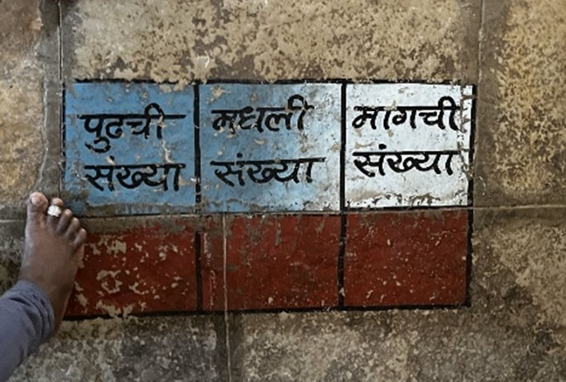
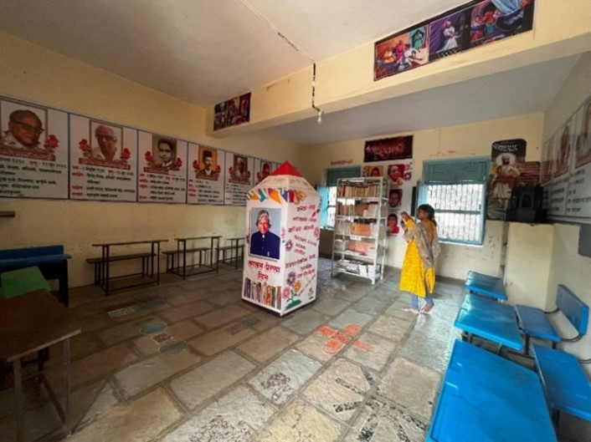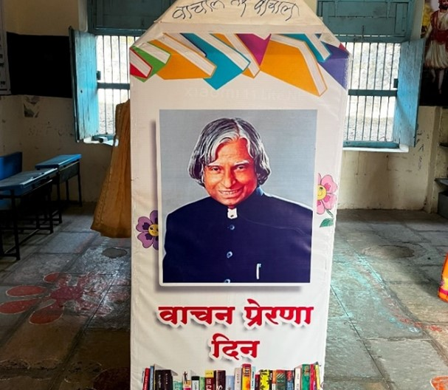
Learning resources in the library should supplement and complement classroom learning. The difference between this activity conducted in a classroom and a library is the student's diverse engagement and self-learning skills in a library scenario. Peer learning across age groups which engages students in activities like these can develop a child on a holistic level, building not just academic engagement but improving communication, socialization, group learning, and soft skills of the student.
.3 Access to learning materials
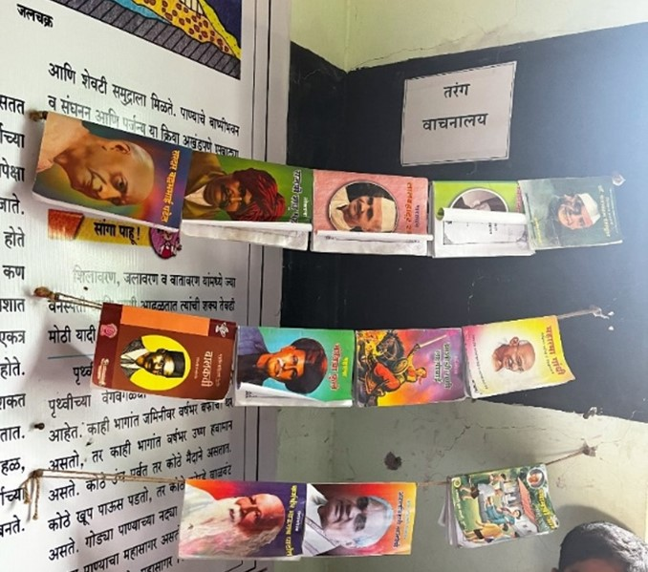
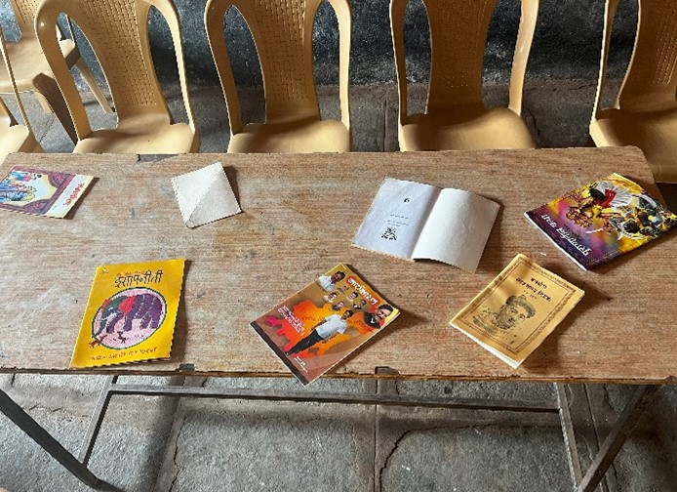
Also, library resources can extend beyond the space in the library. Many teachers and educators believe that if library resources are kept or stored in areas where students can look at them daily, there is an increase in engagement with these materials. Instead of putting energy into bringing students to the library, the library is brought to the students, making it a familiar and accessible entity in their spaces. Initially, the students might not use the books as they intended, but keeping these books in their spaces ensures that the student will one day or another engage with them, even on an amateur level. Once the books pique their interest, they can start by reading one sentence or paragraph and eventually take up reading as a hobby. This type of “Tarang Vachnalay” or Hanging Library also makes access to books inclusive for everyone in the classroom.
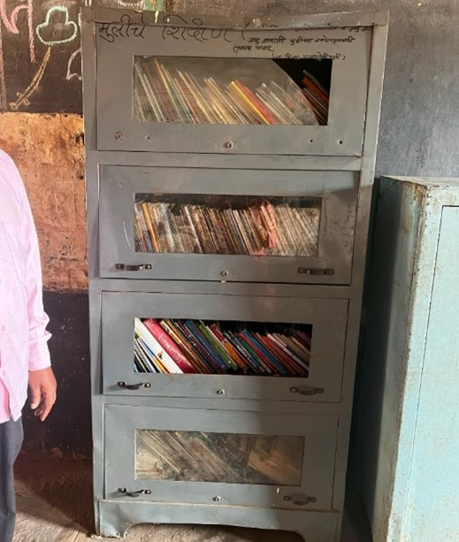
This Tarang Vachnalay contradicts the concept of placing the books on the table for the students to read. Although the concept is similar, the place where this is implemented affects the impact it has on students and their interest in reading as an activity. These books have been kept on the reading table in the library room of the school. However, this school did not have a particular period assigned, especially for the library. Nor were any activities conducted in this library space. This arrangement was made simply for a school visit. If the space is not utilized by the students daily, it is improbable that the materials in the space will impact the student’s learning. The space is unknown to the child, and the activity is uninteresting. Libraries by themselves connote an image of higher learning and a space for intellectuals. This creates a barrier in the students' minds who wish to explore but are awed by the concept. In such cases, interventions like Tarang Vachnalay can prove to be helpful. This concept takes into consideration the spatial aspect of library and library materials and how spatial familiarity can drastically affect the impact of learning materials.
I found this particular cupboard interesting because of the signifier. If you read the top left corner of the cupboard, it reads, “Girl Education” in Marathi. The fact that the books are locked away behind doors is just a comment on the accessibility of education to girls. Similarly, the resources in the library are not accessible to everyone, particularly to the differently abled and special children. Almost every school we visited lacked resources to help these students make the most of the library education. Furthermore, this example can be used as an analogy for how learning resources in the library, even if present physically, stay locked away from all the potential they can serve in improving the educational outcomes of students.
Regarding access, it is critical to think from the student's point of view. Interventions like the newspaper stand in the corridors bring the resources to the students in spaces that students feel comfortable. Such strategies are better suited to engage students with content they traditionally would not prefer utilizing. Furthermore, the design of shelves is also crucial in ensuring accessibility. Strategies like ensuring that grade books are placed on the lowershelves and higher grades books on slightly higher ones look simple but are crucial in considering libraries are student-centric and hence, accessible.
Another crucial factor is the inclusion of Teacher’s Books which ensure that the library in school is not only for the children but the teachers as well. This can help teachers lead by example by making use of the library. Also, including books that can guide teachers on how to supplement student learning, especially for differently abled and students with learning disabilities, can reduce the burden on special educators. This will also ensure that these students are not limited in their access to the library due to reliance on special teachers.
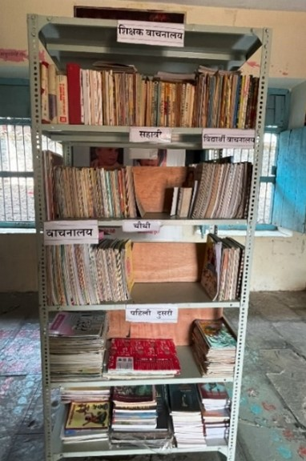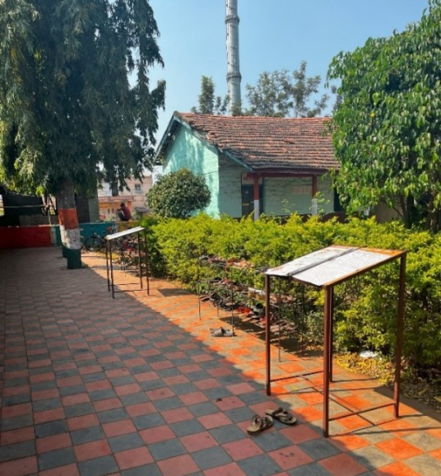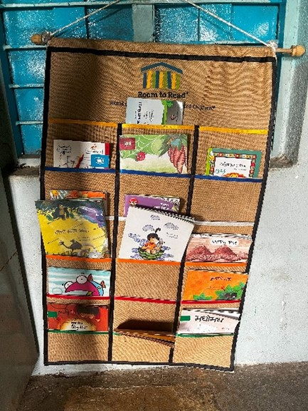
Attractive designs and interventions like those of Room to Read, where books are segregated based on learning levels into different color groups, ensure the age-specific provision of learning material. Making libraries disabled-friendly is important, and almost none of the schools we visited had any particular provisions for these students. The availability of Braille books and audiobooks depends on the government's distribution of such resources. Physical infrastructure still limits their access, which keeps the resources out of reach for these children too.
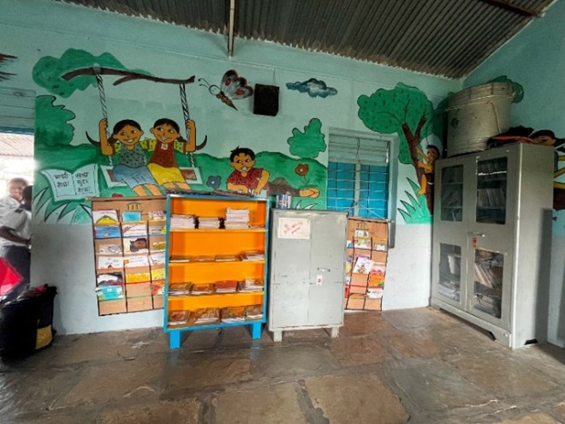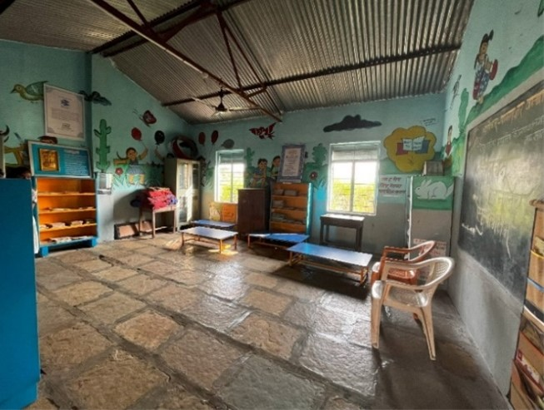

1.4 Teacher training and assessments for better utilization of learning materials
Crucial to ensuring the proper utilization of learning materials is training. For true accessibility, it is not sufficient that the material is available in the library; students should also be able to make the most of it.
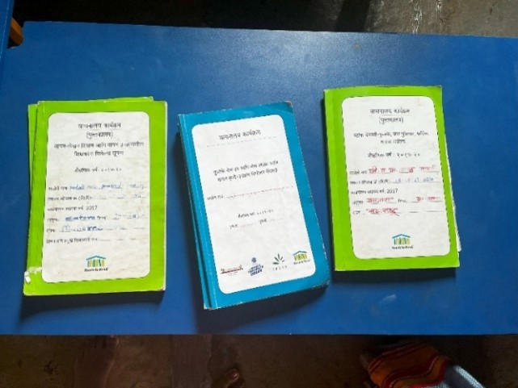
Training and assessment are two important aspects that often need to be addressed when it comes to library learning resources. Providing learning material does not mean the work is done. Training teachers about how these resources can be adequately used is also quintessential. Similar to the way teachers are trained to utilize textbooks in classes, the optimum utilization of library resources also needs to be taught.
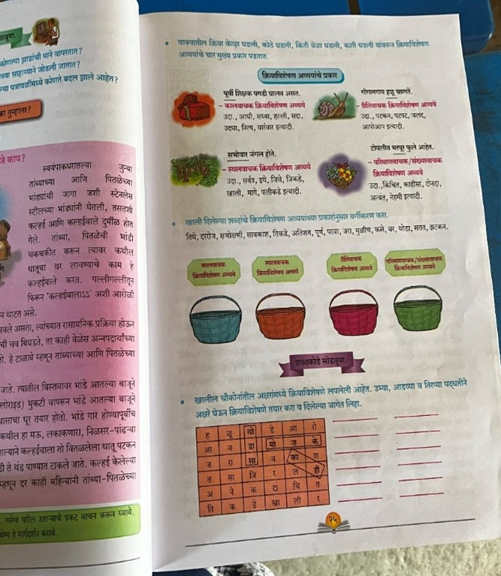
Furthermore, the lack of assessment is not limited to students. While it is crucial to assess students on how they are using the library material, more important is how these assessments are carried out. Few schools used the morning prayers to check whether students read the library books they carry home. Students are asked to narrate stories they learned or explain the moral of a story and give their analogies on a similar moral. This process helps students engage with content and extrapolate information from the library books. Some schools ask students to write their own stories based on the books they read or summarise books, depending on the level of their learning ability. While these strategies are innovative, they fail
to include material other than books in students’ assessments.
Additionally, assessments and audits are also crucial for teachers. NGOs that work in library interventions on the primary school level often conduct these in their programs. However, once the NGOs extract themselves from the field, the practices of assessments are rarely continued. This issue with sustainability of assessments and hence, engaging use of libraries arises due to over-reliance on external agents instead of capacity building of teachers.
For this purpose, teachers need to be trained in handling the learning material, be it book or non-book, to ensure students can develop better reading, surfing, and motor skills from the library material, which can complement their learning process and capabilities. This is even more crucial regarding differently abled or students with learning disabilities. Throughout the conversations, it was evident that the special teachers appointed for these children in government schools hardly engage with the students on library usage. Nor do the school teachers or other students. The visits of these teachers are only on paper. Even if they visit the schools, they are inefficient as facilitators between the school curriculum and the needs of the differently abled.
Furthermore, the material available for differently abled students must be more effective and proficient in aiding their inclusivity in the library space. Simply providing books with larger prints or using books of lower grades for slow learners are make-shift strategies the teachers use due to the unavailability of training and funds. The reason these practices prevail from policy to ground is that the schools usually consider the case of highly handicapped students as ‘goners’ who have no value to extract from libraries.
1.5 The role of BRC/CRC in making learning materials diverse
An essential role in ensuring the diversification of learning materials is that of the BRC/CRC members. We must ensure proper facilitation when discussing how to include diverse learning sources and activities in the library space and ensure teachers can utilize them in students' learning outcomes. Moreover, the BRC and CRC play a quintessential role in this purpose. The BRC and CRC link the administration and the academic system. They are envisioned as agents who connect every teacher and school to the administration in their own space rather than in the government's administrative setup. In this respect, they hold immense potential to carry out various reforms in the learning system and facilitate the implementation of innovative projects in the school environment. However, the CRC and BRC are usually invisible in the setup, even though their workload seems unnaturally high. By including the facilitation of an inclusive library system in primary school, it might seem that this is another burden to their workload. However, CRC and BRC, by focusing on the facilitation of inclusive books, teacher training for learning activities in the library space, or even conducting audits of library learnings and activities, can ensure the proper utilization of library space for students. Assessments form an essential part of library learning. Thus, the BRC and CRC can take up the responsibility of ensuring accountability, whether materials are appropriate and utilized productively, and assessments, especially for teachers. Special Educators can be involved and held more accountable for their role in making materials inclusive for disabled and atypical students. Conducting training for teachers, making frequent visits, and working towards school improvement are some of the critical responsibilities of BRC and CRC, which can be utilized for developing learning materials and their utilization in a library.
1.6 Conclusion:
Today's education system is being modified and re-envisioned to meet the changing understanding of holistic education. Children are unique, and so are their learning capabilities. This understanding has been a center point of the newly released New Education Policy, 2020. In this regard, including libraries in ensuring learning outcomes has been recommended. While the idea itself broadens the concept of school education, we need to focus on how this library concept can genuinely aid in meeting the changing understanding of learning outcomes. The traditional concept of library and learning materials needs to be revised for an education system that seeks to mold contemporary definitions of learning and schooling. Thus, a library cannot be limited to simply books, it cannot be limited to a particular gender, it cannot be limited to a particular physical ability, and it certainly cannot be limited only to students.
Furthermore, making the content relevant for the students is one step towards inclusivity. Proper assessments and training are crucial to ensure its effectiveness, especially for teachers. Learning is an active process, and no specific structure limits one’s access to knowledge. However, active learning from diverse and unorthodox sources requires one to develop a mindset. Students’ minds need to be trained to extract learning from non-traditional and unorthodox sources. For that, developing the capacity of teachers is preliminary. The teachers must know how to guide students to use puzzles, sensory activity tools, and other instruments like drums to extrapolate their learning. In this regard, the BRCs and CRCs are quintessential in their roles and can use this opportunity to make their work visible and effective.

Reading culture and digital library
Agasti Chaskar
The history and significance of reading culture in the Indian context are rich and diverse, reflecting the country's ancient heritage and its dynamic literary traditions. For centuries, India has been a land of storytelling, where oral traditions and written texts have played a pivotal role in transmitting knowledge, preserving cultural values, and fostering intellectual growth.
The origins of reading in India can be traced back to ancient times, with the advent of the script and the development of written languages such as Sanskrit, Prakrit, and Tamil. The scriptures of Hinduism, Buddhism, and Jainism, including the Vedas, Upanishads, Puranas, and epics like the Mahabharata and the Ramayana, were written down and disseminated through the art of reading. These texts served as religious and philosophical guides and laid the foundation for a literary tradition that continues to flourish.
During the medieval period, India witnessed a remarkable growth in literary works, with the emergence of various regional languages and the development of vernacular literature. Prominent poets and scholars composed work in languages such as Hindi, Bengali, Telugu, Tamil, and Urdu, addressing themes ranging from love and spirituality to social issues and political commentary. These literary works were primarily read and appreciated by a scholarly elite and the educated classes.
With the arrival of the British in the 18th century, India witnessed a significant transformation in its reading culture. The establishment of English-medium schools and the introduction of printing presses led to a proliferation of books and newspapers, making reading more accessible to a wider audience. Western literature and ideas began to influence Indian intellectuals, and a new wave of literary and social reform movements emerged.
The late 19th and early 20th centuries witnessed the rise of Indian nationalism and the struggle for independence from colonial rule. Reading played a crucial role in shaping the national consciousness and mobilizing public opinion. Nationalist leaders like Mahatma Gandhi and Rabindranath Tagore emphasized the importance of reading and education in empowering the masses and building a free and enlightened society.
After gaining independence in 1947, India focused on promoting literacy and education as key priorities. The establishment of public libraries, educational institutions, and publishing houses further contributed to the growth of the reading culture. The government's efforts to promote literacy, especially among marginalized communities, have played a significant role in expanding access to books and fostering a reading habit across the country.
Today, India has a vibrant literary scene with a diverse range of authors, genres, and languages. The country is home to numerous literary festivals, book fairs, and publishing houses that celebrate the written word. Reading continues to be valued as a means of personal growth, knowledge acquisition, and cultural enrichment. It serves as a medium for exploring diverse perspectives, fostering empathy, and nurturing a critical and informed citizenry.
The significance of reading culture in the Indian context lies in its power to shape minds, bridge cultural divides, and foster a sense of collective identity. It promotes intellectual curiosity, creativity, and empathy, enabling individuals to engage with ideas, challenge prejudices, and broaden their horizons. Reading also catalyzes social change, as it exposes people to different perspectives, encourages dialogue, and inspires action.
Reading culture is very important in India as well as in the whole world. Ever since the script was developed, ever since literature began to be produced in written form, the culture of reading has started. This is a tradition that has been going on since time immemorial. In conclusion, the history and significance of reading culture in the Indian context are deeply rooted in the country's ancient traditions, its struggle for independence, and its commitment to education and enlightenment. From ancient scriptures to modern literature, reading continues to be a vital medium for knowledge transmission, cultural preservation, and personal growth in India. We have seen various types of materials produced. Writers and writers produce many types of readable literature like biographies, autobiographies, collections of stories, novels, poetry collections, children's literature, and books on science and technology. Vinoba Bhave said that "If you read, you will read". Dr. Babasaheb Ambedkar, who contributed a lot to the constitution of our country, used to read and study for 18-18 hours, while reading, he would forget his hunger. Many great personalities have contributed to the development and cultivation of reading culture. Reading has a unique importance in primary education. Reading in school gives direction to the whole life. Textbooks are given great importance in the Indian culture and education system. Most of the teachers teach only from serial books. Subjects are taught through textbooks, but the practical knowledge, judgment, and attitude required for survival are formed through extensive reading. Students must develop a taste for reading at school age. The role of teachers, parents, and society is also essential in this. Young children imitate adults. They are learning from it. So if parents read at home, children behave like that. But children studying in most government schools need to have such an environment at home. Therefore, the role of school becomes important in inculcating reading culture in them. Students like exciting things, like books that arouse their curiosity. Picture books are preferred by students of classes 1st and 2nd. During the internship, when I interacted with the children and the teachers, I understood what the children like to read. Students look at books; they skim the cover, they look at the last page. If the book has pictures in between, they like such books even more. Students must get to handle books. From that, they gradually start to enjoy reading. For this, it is very important to have books available in schools.
UNICEF's 'Study of School Libraries' project was implemented in Maharashtra with the help of 'Samagra Shiksha'. It mainly reviewed the current condition of libraries and books in Zilla Parishad schools. Under that, I visited two schools in Ahmednagar and Nandurbar districts and explained the situation there. Many dialects are spoken in the Nandurbar district, for example, in Navapur, near the Gujarat border, many different dialects, like Bhillori, Mawchi, etc., are spoken. Therefore, the mother tongue of students coming to school here is not Marathi. When I went to the Zilla Parishad school in Amaln, the local teachers were talking to the students in their mother tongue because the first and second-grade students came to school and started learning Marathi. For them, Marathi is a foreign language which we also call a foreign language. But teachers were struggling to teach English subjects well. Teachers were saying that books in their dialect were not available for these students to read. In fact, no such literature has been produced in that language. So the guide students can be taught the Marathi language first, and then they can be made to develop an interest in reading. But the number of books was very few. Not even more copies of a book were available. It was pointed out that the necessary funds for purchasing books are not available from the government and even the books provided through Samagar are not sufficient. Zilla Parishad school in Budhaval had IFP, but it was closed due to technical difficulties. When teachers were asked about its use, they said that students also operate the IFP.
They use apps like V School and watch documentaries on YouTube. Teachers are also enthusiastic about it and teach using it. But for that, they connect mobile hotspots. Good quality internet facility is not available here. Also, the government does not provide help regarding essential things like electricity supply and electricity bills. Currently, we are living in a digital world, digital library is dominating to a large extent. But if we do not provide the infrastructure for it, then this dream is not possible to be realized even remotely. Later some parts about digital libraries come in the article. Ahmednagar has better conditions as compared to Nandurbar. The schools we visited here have built a library in a separate room. Books are being supplied to schools by raising funds through the public participation campaign 'Mission Apulki' under the Education Department of Ahmednagar Zilla Parishad. Also, many other works are being done. Also, teachers approach NGOs themselves and take their help. They are also helping from their own pockets. Books received under Samagra Shiksha are in this library. Another innovative initiative is that teachers, center heads, and extension officers after retirement, gift books to schools. Almost many of these people have gifted books worth Rs 10,000 each to the schools.
There are also great children's books from many different quality publications. But the number of books per student is less compared to that. So many students cannot read at the same time. The number of books should be proportional to the number of students. In many Zilla Parishad schools, there is no room available to set up a separate library. No special funds are provided for it. There is no such plan. In the schools we visited, separate shelters were created because there was room left. A book exchange register was also maintained there. Books were neatly arranged on shelves and shelves. It was designed to be easily handled by children.
In Usthala Dumala School of Nevase, the library was very well decorated. Felt very happy after entering there. There were good thoughts written on the wall. Information about local literary figures of the district was posted on the wall. An Indian meeting was held to sit and read. On one wall, a picture of a tree was taken, and books were hung in place of its leaves. There were section-wise books such as science, sports, things, poetry, and biography. As we looked at the library, the children eagerly peeked inside. They will also be curious as to what exactly people have come to do. In a school in Nevase, teachers were using smart TVs and projectors for teaching but there was no internet facility. Teachers were connecting to mobile internet. Some apps were used. A group reads a text on TV, or teachers show students more information about lessons and poems in textbooks. We can't immediately call this a use of a digital library because digital library is a broad concept. But in this 21st century, we also have to accept these changes. We cannot live without technology. We have to learn to live with it. It has to be properly combined with traditional education.
==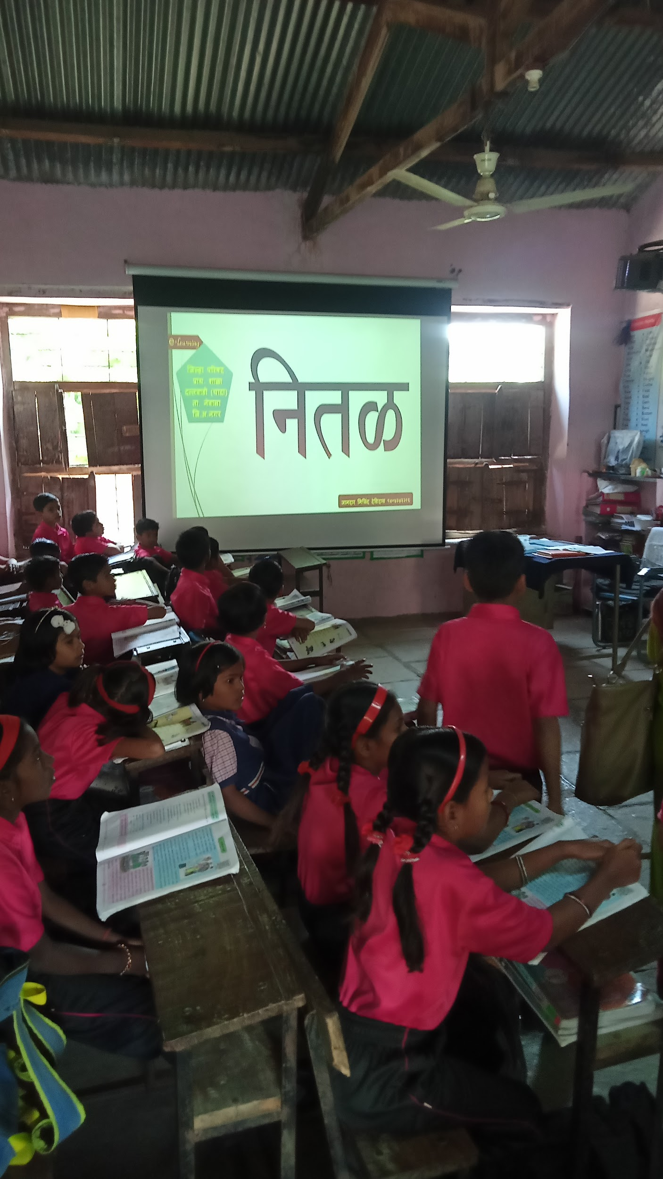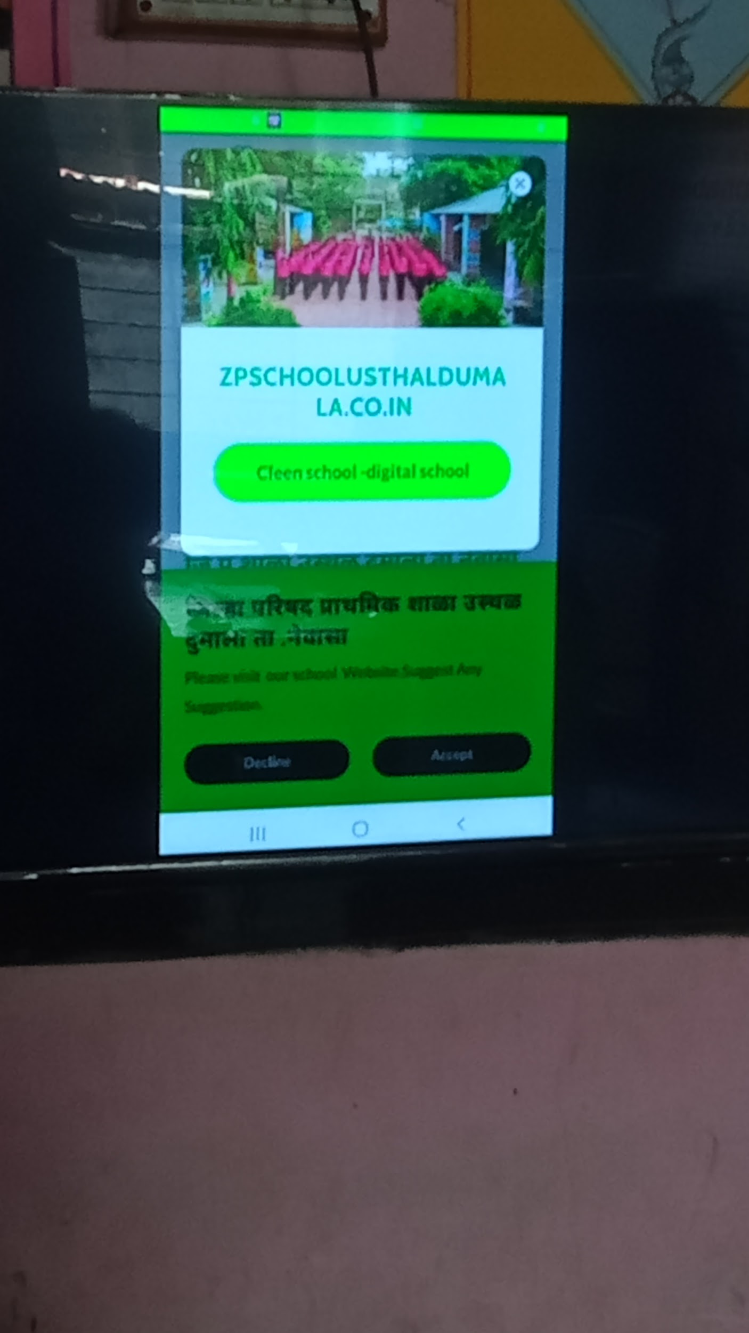
Children love to read with a book in hand. Children are observing the books. Children love books with attractive pictures and funny stories or information. Most importantly, the fun of actually holding the book and reading it is different. When the children read the book, they continue to read it; then they form a relationship with the book. The feeling of handling the actual book, the feeling of reading, the experience is not so much available on mobile or tab. There are two or three more important points that if we want to give tabs to all the students, the government will have to provide huge funds for it, which is not possible at least shortly. Children think very differently from adults. But this matter is completely ignored by us. We decide what children will like. When attempts were made to create digital libraries for children (aged eight to 14) in Europe and America, they did an innovative experiment. In it, he understood the words of the children. Children were involved in the design process. And the children enthusiastically participated and suggested many things. How should that platform be designed? How to search for books? How should the collection be displayed? How should the user interface be? On this, the children gave suggestions according to their choice. From this, it is clear that children love to work with a partner. This has not yet happened in our country. We still have the basics to work on. If we are thinking of building a great digital library, it will require a lot of front-line work.
Quality books and content have to be digitized. While doing that, you have to consider the preferences of the children. Making e-books, making audiobooks can be done but then the question arises of how to give access to the students. For that, all students should have a device tab and an iPad. At least the school should have a good internet facility. Teachers and students have to be trained in the proper use of that equipment.
Teachers need to teach students how to navigate those digital platforms. Finally, teachers need to be prepared to accept these changes that will accelerate in the coming future. But it is important to think of it as relevant. A lot depends on how much funds the government can provide for books and libraries. Although creating a digital library is not possible immediately, good books can certainly be provided in sufficient quantity. It is necessary to have consistency. Many times schools do not get books at all. Often a fixed set is sent, with the same book of things repeated over and over again. The teacher's advice should be taken into account. What books are currently available in the school? Which ones are needed? They know this very well.
There are a few things to consider regarding electronic devices. If we are going to ask them to read through such a medium, we have to pay attention to their screen time. Because it can also have bad consequences for young children and mobile or tab media can also distract students. Can reduce their concentration, and make them restless. Teachers and parents need to be aware of it. More work needs to be done on digital literacy. Then there is a need for better training of teachers on ICT. How to effectively use ICT in education and reading? Diet can implement training programs in this regard. These are very important factors for effective technology integration and adaptation.
Another point to touch upon is that when we are talking about students' reading comprehension, we should look at their reading comprehension. It is important to have a feedback mechanism to see if they are getting a good understanding. Teachers need to review this frequently. Every student has a different reading speed and comprehension ability, so it is important to find books that meet each student's needs. Some smart students, understand quickly. They should have access to challenging books to read, which will stimulate their intellect, and increase their curiosity, curiosity. Does it increase student engagement? It is necessary to pay attention to this. Only then we can say that their culture of reading is taking root, being cultivated, and growing.
Libraries and reading play a crucial role in the lives of students in primary grades (ages 8 to 12) by fostering a love for learning, supporting academic development, and promoting personal growth. Here are some key reasons why libraries and reading are important for students in this age group:
Reading helps students improve their vocabulary, comprehension, and language skills. Regular reading practice enhances their ability to understand written information, follow instructions, and express their thoughts effectively. Libraries provide a wide range of age-appropriate books and resources that cater to different reading levels and interests, allowing students to explore and develop their reading abilities.
The primary grades are crucial for building a strong foundation in various subjects, including language arts, mathematics, science, and social studies. Libraries offer a diverse collection of educational materials, reference books, and multimedia resources that support the curriculum. Students can access supplementary materials, conduct research, and deepen their understanding of various topics, helping them excel academically. Libraries provide a nurturing environment that encourages students to develop a lifelong love for reading. By offering a wide selection of fiction, non-fiction, and children's literature, libraries expose students to different genres, authors, and storytelling techniques. This exposure helps spark their imagination, creativity, and curiosity, fostering a genuine interest in books and reading. Libraries empower students to become independent learners. By exploring the library's resources, students can pursue their interests, discover new topics, and engage in self-directed learning. They can select books based on their personal preferences, explore various subjects beyond their curriculum, and develop their unique interests and talents.
Reading exposes students to different perspectives, situations, and characters, promoting critical thinking and problem-solving abilities. Through reading, students encounter diverse ideas, complex moral dilemmas, and challenging narratives, which require them to analyze, evaluate, and make judgments. This cognitive engagement nurtures their analytical skills, empathy, and ability to think critically. Reading helps students develop empathy, emotional intelligence, and social skills. Through reading diverse stories, students encounter characters from different backgrounds and cultures, expanding their worldview and fostering empathy towards others. Libraries also provide opportunities for students to participate in book clubs, reading circles, or storytelling sessions, encouraging social interaction, teamwork, and communication skills. Libraries stimulate students' imagination and creativity by offering a wide range of books that transport them to different worlds and periods. Reading fiction helps students develop their imagination, visualization skills, and creativity, allowing them to explore new ideas and possibilities. Libraries may also organize creative activities such as writing competitions, art workshops, or storytelling events that further nurture students' creativity.
Libraries serve as safe spaces that promote inclusivity and diversity. They provide a welcoming environment where students can feel comfortable exploring different perspectives, experiences, and identities. Libraries often celebrate cultural festivals, host author visits, or organize reading programs that showcase diverse voices and stories, fostering a sense of belonging and respect for others.
Summary: Libraries and reading play a vital role in the lives of students in primary grades. They support academic development, nurture a love for reading, enhance critical thinking skills, and contribute to social and emotional growth. By providing access to a variety of books and resources, libraries empower students to become lifelong learners and help shape their overall development during these formative years.
The importance of a digital library for children (ages 6 to 12) is significant, as it offers unique advantages and complements the benefits provided by traditional libraries. Here are some key points highlighting the importance of a digital library for children and a comparison with traditional libraries:
Access to a vast array of resources: Digital libraries provide children with access to a wide range of digital resources, including e-books, audiobooks, educational videos, interactive learning materials, and online databases. This vast collection allows children to explore various subjects, genres, and formats, catering to different learning preferences and interests. In contrast, traditional libraries may have physical limitations in terms of space and resources, and children's access might be restricted by factors such as location and library hours.
Convenience and flexibility: Digital libraries offer convenience and flexibility in terms of accessibility. Children can access digital resources anytime and anywhere with an internet connection, allowing them to engage in learning beyond the confines of a physical library. This flexibility accommodates diverse schedules and enables children to learn at their own pace. Traditional libraries, on the other hand, have fixed operating hours, requiring physical visits and sometimes limited borrowing periods.
Interactive and engaging learning experiences: Digital libraries often provide interactive features and multimedia elements that enhance children's engagement and learning experiences. Interactive e-books, educational games, and multimedia resources can make learning more enjoyable, immersive, and interactive for children. Traditional libraries primarily rely on printed books, although they may offer some supplementary materials like puzzles or interactive displays.
Personalized learning and adaptive content: Digital libraries have the potential to offer personalized learning experiences for children. Through data analytics and adaptive technology, digital libraries can track a child's reading preferences, recommend suitable content, and tailor the learning experience to their individual needs. This personalized approach can enhance children's motivation, engagement, and overall learning outcomes. Traditional libraries rely on librarians' recommendations and children's independent exploration to find suitable books.
Multilingual and multicultural resources: Digital libraries have the advantage of providing multilingual and multicultural resources, catering to the diverse backgrounds and languages spoken by children. Children from different linguistic and cultural backgrounds can access books and educational materials in their native language, promoting inclusivity and supporting their language development. Traditional libraries may have limited resources in languages other than the predominant language of the region.
Information literacy and digital skills development: Digital libraries offer an opportunity for children to develop information literacy and digital skills. As children navigate digital platforms, search for information, evaluate sources, and engage with online resources, they develop critical thinking, digital literacy, and the ability to discern credible information. Traditional libraries also contribute to information literacy but may focus more on traditional research skills and printed resources.
Collaboration and social interaction: While traditional libraries provide opportunities for children to interact with librarians and peers, digital libraries can facilitate collaboration and social interaction on a broader scale. Online book clubs, forums, and interactive platforms within digital libraries enable children to connect with other readers, share book recommendations, and engage in discussions, fostering a sense of community and expanding their social connections.
In conclusion, digital libraries for children offer numerous advantages when compared to traditional libraries. They provide easy access to a vast array of resources, offer convenience and flexibility, promote interactive and engaging learning experiences, facilitate personalized learning, cater to multilingual and multicultural needs, support information literacy and digital skills development, and enable collaboration and social interaction. While traditional libraries remain invaluable, digital libraries offer unique benefits that complement and enhance the learning experiences of children in the digital age.
Digital libraries can be immensely helpful for children with special needs by providing a range of accommodations and resources tailored to their specific requirements. Here are some ways in which digital libraries can support children with special needs:
Accessibility: Digital libraries can offer accessibility features such as adjustable font sizes, text-to-speech capabilities, and customizable backgrounds and color schemes. These features cater to children with visual impairments, dyslexia, or other reading difficulties, enabling them to access and engage with content more effectively.
Multisensory Learning: Digital libraries often incorporate multimedia elements such as audio narration, interactive visuals, and videos. These features provide multisensory learning experiences that can benefit children with different learning styles and those who require additional sensory stimulation.
Individualized Support: Digital libraries can offer personalized learning experiences through adaptive technology. By tracking a child's progress, preferences, and areas of difficulty, the library can provide targeted recommendations and adaptive content to support the child's individual needs and learning goals.
Visual Supports: Digital libraries can provide visual supports like visual schedules, social stories, and graphic organizers, which are particularly beneficial for children with autism spectrum disorders or those who benefit from visual aids to understand and navigate information. Social Interaction and Peer Support: Online platforms within digital libraries allow children with special needs to connect with peers, join virtual book clubs or reading communities, and engage in discussions. These interactions promote social skills, communication, and a sense of belonging.
Specialized Content: Digital libraries may offer a dedicated section or resources specifically designed for children with special needs. These resources can include books, articles, and educational materials that address specific disabilities, offer strategies for support, or provide relevant information for parents and caregivers.
Flexible Learning Environment: Digital libraries provide a flexible learning environment, allowing children with special needs to access materials and engage in learning at their own pace and in a setting that suits their individual needs. This flexibility accommodates various learning styles, preferences, and sensory sensitivities.
Inclusivity: Digital libraries can promote inclusivity by offering materials in multiple formats, accommodating different languages, and featuring diverse characters and storylines. This representation and inclusiveness can foster a sense of belonging and positive self-identity for children with special needs.
Parental Involvement: Digital libraries often provide resources and information for parents and caregivers of children with special needs. These resources may include guidance on supporting reading skills, strategies for managing specific challenges, and recommendations for additional support services.
Progress Tracking and Assessment: Digital libraries can incorporate features to track a child's reading progress, comprehension, and engagement with the content. This data can be valuable for educators, therapists, and parents to monitor and assess the child's development, make informed instructional decisions, and provide targeted interventions if necessary.
Overall, digital libraries offer a range of accommodations, resources, and opportunities for children with special needs. By providing accessibility, personalized support, multisensory learning experiences, social interaction, and specialized content, digital libraries contribute to creating an inclusive and supportive learning environment for children with diverse abilities and learning profiles.
ICT (Information and Communication Technology) training for teachers working in government schools is crucial in India for several reasons:
Enhancing Teaching and Learning: ICT training equips teachers with the knowledge and skills to effectively integrate technology into their teaching practices. It enables them to use various digital tools, educational software, online resources, and multimedia materials to enhance the delivery of content, engage students, and create interactive learning experiences. ICT training empowers teachers to adopt innovative and student-centered approaches, facilitating a more effective teaching and learning environment.
Bridging the Digital Divide: Providing ICT training to teachers in government schools helps bridge the digital divide that exists between urban and rural areas, as well as among different socioeconomic backgrounds. By equipping teachers with digital skills, they can help students gain access to technology and digital resources, enabling them to develop digital literacy and proficiency. This empowers students to participate in the digital age, expand their knowledge, and acquire essential skills for future success.
Promoting Digital Literacy: ICT training for teachers plays a crucial role in promoting digital literacy among students. Teachers who are trained in ICT can effectively teach students how to use technology, navigate digital platforms, critically evaluate online information, and utilize digital tools for research and collaboration. By fostering digital literacy skills, ICT training equips students with the ability to thrive in an increasingly digital and information-driven world.
Improving Quality of Education: Integration of ICT in education has the potential to significantly improve the quality of education. With ICT training, teachers can access a vast array of educational resources, digital content, and e-learning platforms. This enables them to provide students with up-to-date and relevant information, engage them in interactive learning activities, and cater to diverse learning needs. ICT training empowers teachers to create a dynamic and engaging learning environment, ultimately enhancing the quality of education in government schools.
Enabling Remote Learning: The COVID-19 pandemic highlighted the importance of ICT training for teachers in government schools. With the shift to remote learning, teachers needed to quickly adapt to online teaching platforms and tools. ICT training ensures that teachers are prepared to deliver effective instruction in online or blended learning environments, enabling uninterrupted education during emergencies, school closures, or other challenging circumstances.
Professional Development: ICT training provides teachers with valuable professional development opportunities. It helps them stay updated with the latest educational technologies, teaching methodologies, and best practices in using ICT for educational purposes. ICT training programs often offer collaborative learning experiences, enabling teachers to share knowledge, collaborate with peers, and continuously improve their teaching skills.
Meeting Global Standards: In an increasingly interconnected world, ICT skills are becoming essential for individuals to thrive in the global job market. By providing ICT training to teachers, government schools can ensure that their students are equipped with the necessary skills and competencies required for the 21st century. ICT training helps align the education system with global standards and prepares students for higher education and employment opportunities.
In conclusion, ICT training for teachers working in government schools in India is important as it enhances teaching and learning, bridges the digital divide, promotes digital literacy, improves the quality of education, enables remote learning, facilitates professional development, and helps students meet global standards. By equipping teachers with ICT skills, government schools can provide students with a quality education that prepares them for the challenges and opportunities of the digital age.

Community Library and SMC ( School Management Committee)
Sheetal Kamble
There was a time when India had a robust system of public libraries. However, in the past few years, more than 5000 public libraries have shut shop. Maintaining a public library is a state subject; each state has its priorities. For example, according to a 2018 survey the government of Uttar Pradesh, which has a population of more than 200 million, supports only 20 rural libraries, while the government of Kerala, with a population of 34 million, supports around 7,600.
Community libraries are providing community information, Defined as important types of information needed for participation. Passion to be a full and equal member of society, including health, employment, and educational information. In the Indian village, the community plays a role as an open and accessible meeting space, allowing diverse populations to interact with and nurture children and youth, and inviting parents to be part of schooling.
Samgara Gudeline of the school library NEP 6.5 mentioned community activity and participation. Every elementary school celebrates the language festivals which reinforce the spirit ‘’ Ek Bharat Shreshtha Bharat.
Ek Bharat Shreshtha Bharat Integration of BhashaSangam with reading culture .BhashaSangam aim to celebrate culture , ethnic and linguistic diversity by introducing school students to the regional /local language of the paired State/UT to enhance linguistic tolerance and respect , inculcate interest in language and reading and promote national integration .
The key resources in this program are the children themselves, who are adept and learning new languages and are very sensitive to the nuances of accents and dialects. Through interactive games. storytelling and story writing children step into the world of language that makes them aware of their language abilities and encourages them to learn more about their heritage and about the people who surround them.
Language festivals can promote reading culture in the following ways:
- Children learn about diverse cultures and languages through art making, music and dance, drama, debate, dialogue, and folk literature
- Children get exposed to creative writing such as poems, short stories and folktales based on their imagination and experiences.
‘Putskache Gahar ‘ ( Book Village in Pachagani ) organized the language festival in their school. Every year they celebrate a language festival.
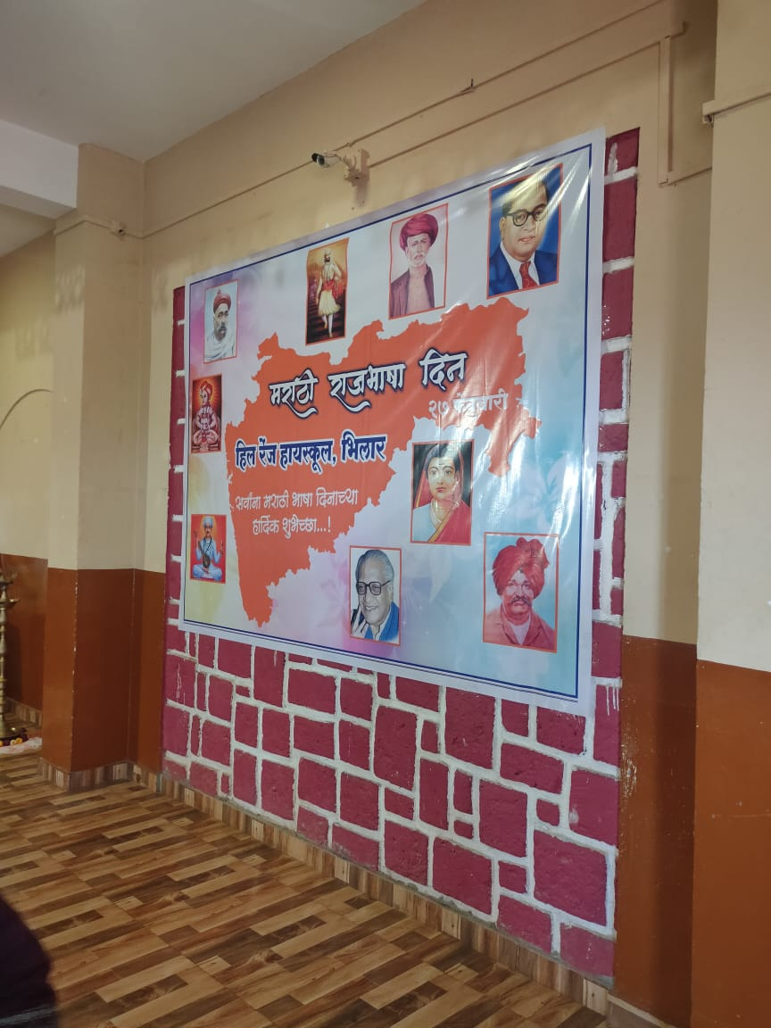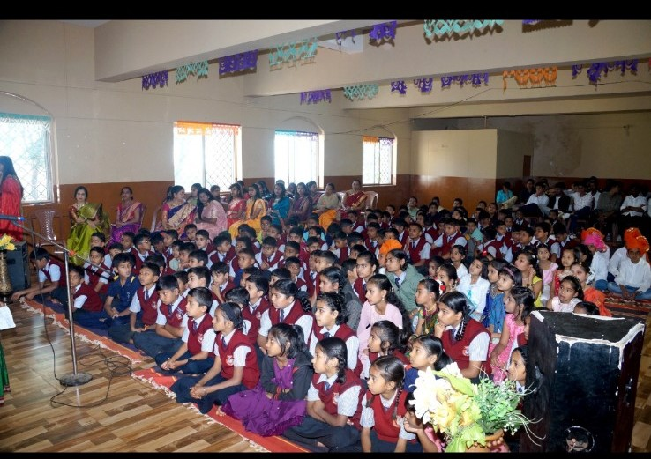
NEP Para 6.4, 6.5, and 6.6: Encouraging Voluntary Participation:
Community involvement:
Schools need to raise community awareness and promote community ownership in reading culture to ensure long-term impact and sustainability. This can broadly be done through community participation and contribution. Some of the measures for the same may be:
- Organizing collaborative community-wide reading events and literacy fairs involving parents and community members
- Organizing monthly story-telling or reading sessions in schools by involving parents and community members
- Encouraging parents to read their children at home, wherever feasible
- Showcasing children’s accomplishments (in reading, writing, numeracy etc) in community events
- Faciliting scheduled meeting on regular basis with families and community members to help promote active use of the library.
- Connecting reading and writing with parents, community life, festivals, current events, and engagement with local knowledge needs
- Facilitating crowd-sourcing contributions in kind for library development such as books, furniture, lamps /lights, fans, etc
Further. two innovative steps could be helpful for community involvement in promoting reading.
This is an initiative to boost community and private-sector involvement in government-run elementary schools across the country. Under this initiative, retired teachers/government officials/professionals, youth icons, alumni, parents, and college students offer their voluntary services in conducting various co-scholastic activities revolving around reading for school children. Examples of such activities are:
- Reading to children
- Helping children with creative writing
- Play acting
- Prearing story books with children

Inclusion: Tribal children's experience with the library
Prapti Shamkuwar

“Inclusive, good-quality education is a foundation for dynamic and equitable societies”

— Desmond Tutu

The implementation of the Right to Education Act (RTE)2009 and Article 21 which made the Right to Education a fundamental right, has the aim of providing education accessible for all children up to the age of 6 to 14 years, similarly, it has the broader concept of Universalization of Education. The concept of providing access to all children and achieving this aim many inclusive practices are started through various policies from the central government level to the school level starting with the different schemes and projects in different ways.

The concept of inclusion is the new step towards making primary education accessible for all students belonging to diverse backgrounds. The inclusiveness of all the students in the classroom with innovative educational practices in the school. However, the effectiveness of inclusiveness has to be measured from the different levels in the context of forming new learning opportunities to support and availability of appreciation of the student's talents since teachers need to allow students to make their own choices for learning new things. for observing the inclusiveness practices in tribal government schools especially in the context of the library, with innovative practices, challenges, advantages, and disadvantages. We observed some government schools in one of the aspirational districts ‘Gadchiroli’ of Maharashtra. The Gadchiroli district is a recently growing and developing district. Under the UNICEF (Story of School Library) Project Maharashtra is trying to measure or analyze the effectiveness of the implementation of the policies and programs in this Aspirational District Gadchiroli especially in Government schools working for Library access and the effectiveness of the library.

Background and Introduction of Gadchiroli District:
The Gadchiroli district was created on August 26, 1982, It is situated in the Northeastern part of Maharashtra state, and has the state borders of Telangana and Chhattisgarh. The Gadchiroli district is especially known and categorized as a Tribal and undeveloped district, similarly, people of the district mentioned that Naxalism is highly prevalent in this district, it is also due to the dense forest and hills areas it helps Naxalites to shelter in the dense forest.

The Total population of the district is 10,72,942. The male and female population is 5,41,328 and 5,31,614, respectively(Census 2011). SC and ST population in the District is 1,20,754 and 4,15,306 (As per the 2011 Census ). The district's literacy rate is 74.4%(as per census 2011). The percentage of Scheduled Castes and Scheduled Tribes community population that resides in the district is 11.25% and 38.7% respectively. Similarly, there are seven languages spoken in the Gadchiroli district Gondi, Madiya, Marathi, Hindi, Telugu, Bengali, and Chattisgadi (Census 2011).

As per literacy rate and Tribal population in Gadchiroli District our analysis is based on the four aspects

1. Children's Enrollment and Dropout Rate for Accessing Education:
There is a core relationship between education with awareness and poverty. In Gadchiroli district most of the population is tribal which is having their forest love and they are coming from a marginalized background. It is difficult to access education facilities for children due to a lack of facilities and awareness. It seems that two out of five drop out before completing their elementary school education. Moreover, this number is more for children from the disadvantaged group. These children have mostly poor learning outcomes, it is also due to poor facilities and discrimination happening in the school with the children. On the way of inclusiveness of education, the government started many programs but the implementation of these programs at the ground approach has to be checked. Because the facilities towards each child have to be done. In our observation, we saw that many facilities are approved by the government but it takes a lot of time to approach each child. Moreover, the exposure required for the students at the foundational learning level such as literacy material like books, stories, and formal access to the language, reading, and writing development is not on time. Hence they are felt somewhat backward from their privileged peers.
Similarly, students face difficulty in reading and writing most of the content in the library except story-related books, other contents are not relevant to them for their age level such as novels and biographies which are extra added by the teacher in the school library to make the library cupboard full.

Figure. 1 Biographies in English

It is difficult for students of classes 5 to 8th to understand the language and content in the books. In aspirational districts, special children come from marginalized backgrounds where students face special challenges. Students who are behind academically, who are living in poverty, who have unstable family lives, or who are marginalized because of their race, ethnicity, or identity may need the school library more than anyone. Children do not understand the academics properly they create disinterest in academics this is also one of the reasons for the drop out of Adivasi children from school.

Similarly for their occupation, Most of the people are not aware of the opportunities, since most of the people migrated from the district in search of work in the different parts of the state or other parts of the country. Moreover, their children also joined them for work and form discontinuation in their studies which resulted in an increase in drop out from school. The education of the students has not continued to create a gap, and children lose their interest in school.

Since as per our observation and many reports mentioned after the implementation of the RTE, 2009 and Mid Day Meal (MDM) scheme the enrollment of the children increased but the quality of the learning or education somewhat decreased. Some of the reasons for it are the language barrier in the school, most of the schools use Marathi, English, and Hindi, but as they are mostly first-generation learners from the tribal community in the Gadchiroli district, it is difficult for children to adapt to other languages so easily. It creates disinterest in the students towards school.
2. School Observation and School-Inclusive Practices for the Library:
As we observed in the Gadchiroli district, some schools have separate rooms for the library. This is one of the initiatives of the District Educational Officer and some private organization collaboration with the government. The library does not have any librarian for maintenance, it is assigned to one of the regular teachers of the school. Since teachers had duties of teaching other than maintenance of the library, most of the time the library is closed. It is open once a week and weekly activities are planned by teachers.
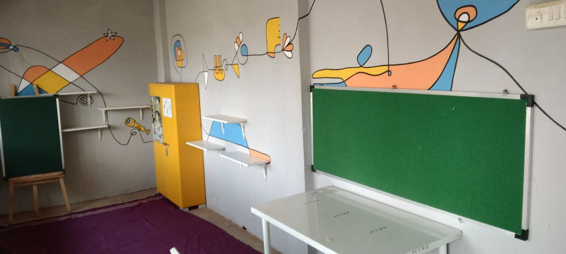
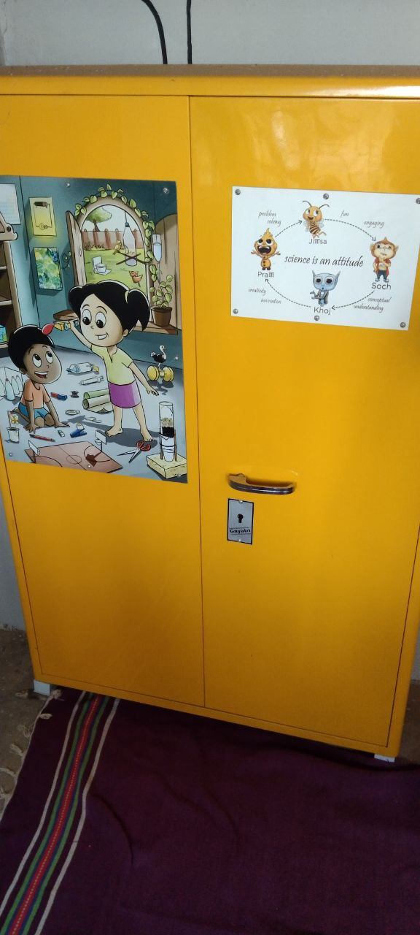

Figure. 2 Weekly open library
One teacher sharing his experience mentioned that he had the responsibility of the 3 classrooms at a time, when they have to teach math, and science which are the vast subject, with the addition of the extra duties of the library because they did not have a librarian have can we expecting library will be open all the day. People are expecting so much work from the teacher, with the addition of good learning outcomes, which is how teachers can fulfill them. The insufficient time that teacher has also has a major effect on marginalized students, since they are poor in background their access to resources is limited, if the teacher does not have time for students to make the library more accessible and create more learning opportunities. It is difficult for the students to form good learning outcomes.

The Samgra Siksha has the provision of providing curriculum-related books to the Zilla Parishad school, and also has to provide library-related extra books by the government. As per our observations in the school. Curriculum-related books are provided on time before the school session starts, but the extra books which are to be in the library are not on time or sometimes they are not even provided at all. We also note that library extra books are bought by the school in the gap of 2 to 3 years. This is not in sufficient amounts. For instance, if the school has 200 children then they have 120, which is not even one book for one child. Furthermore, the teacher shared that most of the contents of the book are similar, generally stories, novels, books, pictures, etc. which are not for the higher grades. The books are directly provided from the center level so, there is no role of the teacher in the content of the book or which books are needed by the students. It is important to note that every time the needs of the students and the content in the book need to be changed, which is more known by the teacher.

3. Curriculum Inclusiveness of Tribal Literature in the Textbook:
The Tribal community or Adivasis are known for their true relationship with Nature. Education helps to enhance freedom by inspiring people to organize themselves against their backwardness and overcome traditional inequality of caste, class, and gender (Engels,1845). It is important to know what kind of curriculum we are learning. However, it seems that there is no such curriculum content based on the Adivasis in the textbook, which is the show curriculum provided for the Adivasi children seems to distort their identity as Adivasi or assimilate them into the ideology of the school provider.

As per the census record, there are seven tribal languages spoken in the Gadchiroli district, similar as on RTE mentioned that children should get primary education in the mother tongue but as per our observation and interview with the teacher mentioned, there are only three languages used in the school such as Hindi, Marathi, and English for learning and spoken languages in the school. there are no used tribal languages such as Madi, Gond, etc. Some of the tribal communities such as Gond, Madia, Pardhan, and Kolam are the four major tribal communities in the district. They speak their dialects, such as Gondi and Madiya. However, languages have an effective impression on children. Similarly, tribal students receive education through Zilla Parishad School and Ashram School, in the Gadchiroli district. Instructive languages in the school are mostly Hindi, English, and Marathi, similarly, the examination is conducted in these languages but none of the Tribal languages find a place in the curriculum. As a result, the language of the teacher and the textbooks remain alien to the Adivasi children. It is important to At least first some classes they should need in their familiar language or some familiar part in the curri culum, as it helps them to create interest in the school.
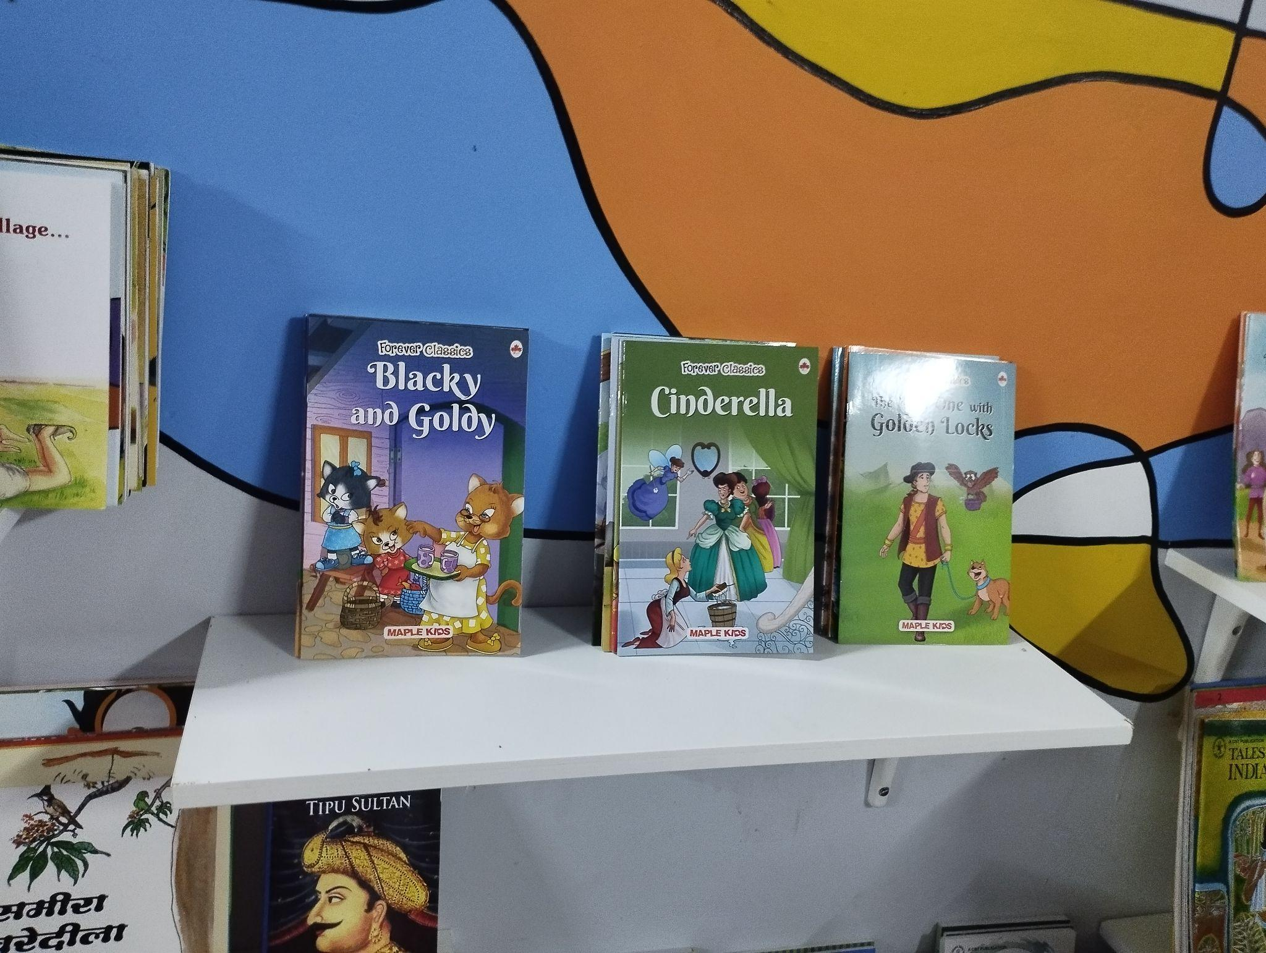
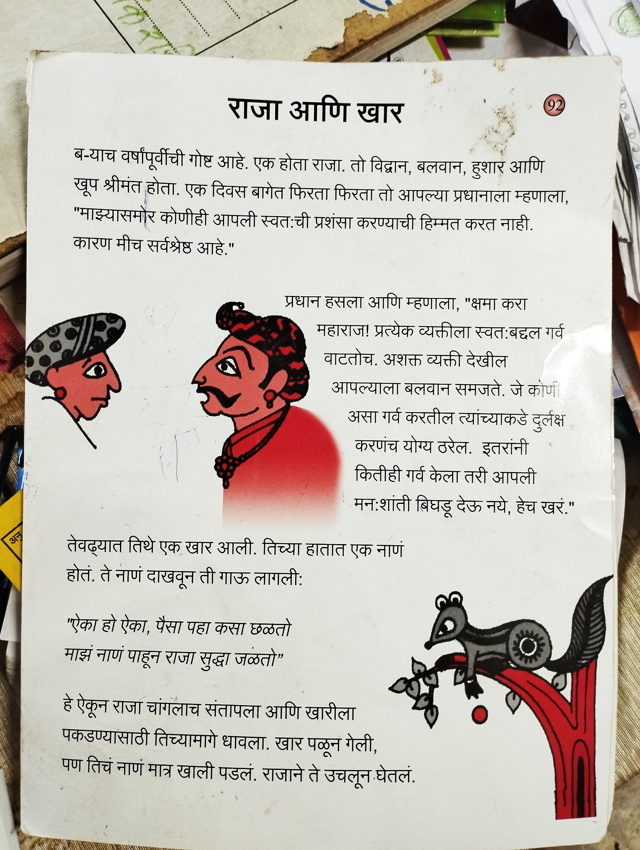
P
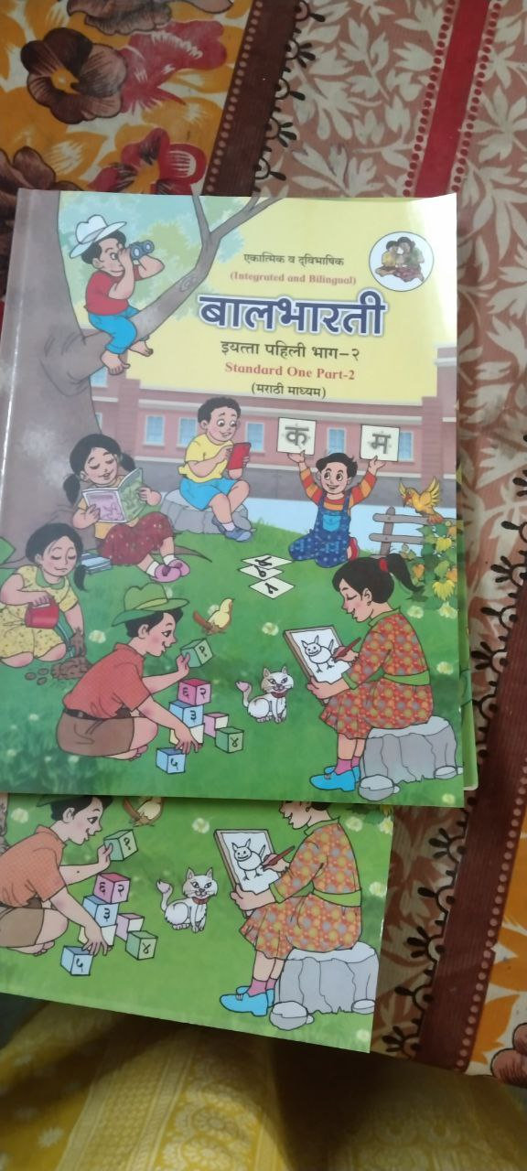
Figure. 3 Integrated and Bilingual Textbook

Similarly one of the teachers shared his experience when he was newly appointed as a teacher in a very remote area of the Gadchiroli district where predominantly tribal language is used, he mentioned that when he first joined the job the location is very different from his background and he faced many difficulties for the conversation and teaching in the classroom. he does not understand the children's language and vice versa. He was required 3 to 4 weeks to learn and understand the village's language after that he began to teach students. It is one of the disadvantages of languages not having at least introductory information in the curriculum or teacher training. at least for the teacher who is assigned to that location. Here we can see the Hindarness of Adivasicy's mother tongue. However, in the textbook we can find no such information in the Adivacy literature or information. For instance, there is always a tribal mentioned in the forest in the textbook. There should be the requirement of mentioning triple evolution from forest to the responsible human being in the social world and their participation in the social activities (economic, political, cultural, social, educational, etc.) of the society in which they live.

According to NCF (2005), various regions and socioeconomic groups must be able to relate to the textbooks in a heterogeneous nation like India. Every community has access to a wealth of cultural resources, including knowledge, history, art, folklore, music, and riddles. All of which can enhance students' linguistic and academic skills. As a result, relevant local material should be included in the teaching-learning process.

However, the curriculum and textbooks created for them do not adequately represent Adivasi life, customs, history, knowledge, or educational methods, deepening the divide between their home and school cultures. These schools do not have their own developed school library, which helps students to access the required basic material. As such these students coming from the marginalized background do not have access to print reading material in their mother tongue or first language. Similarly, the school does not appreciate the multilingual language, which is important for the first-generation learner to make a familiar school environment. This is a prominent issue in the tribal and marginalized communities. It is important to note that the implementation of different cultural literature and making it more visible in the school library for marginalized students to create interest in the school.
.
4. Teachers' Experiences with The Assessment of the Students:
Generally, most of the schools including Zilla Parishad School have summative and formative assessment patterns. Furthermore, having school projects, competitions, and activities which are not that much in focus. The school which we observed has the same way of assessment.
Similarly, for the library assessment, they carried out different activities in the months and each Saturday is celebrated as a “day without a school bag”. Furthermore on Saturday school carried out different programs and activities. When students are reading books and writing a summary of it, sometimes they play a story role, etc. since school has different books such as autobiographies, biographies, stories, and picture books, which are not that much related to the particular grade level. Similarly, based on this, they have carried out activities. But in our observation, we found out that the students are learning to write and read from the story books and activities but about the academic performance of the particular subject. Since mathematics, science, and social studies books are very limited, how can students get benefits after using a library?
Also, the assessment pattern only takes activities and summary writing of the story; it will not help students in their subject knowledge. The teacher and other administrators should have to make the library more accessible for the students with the curriculum content which helps them indirectly to increase their learning outcomes.
5. Integration of Private Organizations in Library Access:
The school library itself is not that developed in the school. But similarly, Other private organizations have good collaboration with the school for library development. Some private organizations such as the Learning Link Foundation and Prayag Library (Tata Trust) have collaborated with the school, They created their library as name Parag Library, which is parallelly working with the school library. As we observed Tata Trust is the main funding agency for this library, which they are providing material to the library and training for one of the school teachers. This library has many materials such as books, learning materials, TLMs, etc.
Furthermore, content-wise, there is no such inclusion of different languages other than Marathi, English, and Hindi. The library does not have tribal literature or any book in other languages. Similarly, the assessment or outcome from the library is not much measurable by the teacher.

Conclusion:
The country's goal of providing education for all children through the 2009 Right of Children to Free and Compulsory Education Act has led to more students enrolling in schools. However, just giving access to education is not enough; we must also ensure that the education provided is of good quality. This is especially important for children from marginalized backgrounds. These students often rely on schools and libraries as their main sources of education. Therefore, it is crucial to improve the quality and availability of school libraries, making the learning environment more inclusive and familiar for them. The language and books used in schools and libraries also play a significant role in helping students learn and grow. Enhancing school libraries can provide additional educational support for marginalized students.

References:

- Government of India. (2009). The Right to Education Act.
- NCERT, T. (2007). National curriculum framework 2005 (No. id: 1138).
- https://www.censusindia2011.com/maharashtra/gadchiroli-population.html (census India 2011)
- Khaparde, M. S., Srivastava, A. K., & Meganathan, R. (2004). Successful school management in India: case Studies of Navodaya Vidyalayas. Educational Research for Policy and Practice, 3, 243-265.
- Engels (1845) (as cited in Cole, 2008) and Dreze & Sen (2002)

School Libraries and Linguistic Approach
Riya Wasnik
I used to attend a government school where I had the opportunity to observe the current situation of the library. During my visit, I noticed several aspects, including the infrastructure of the school. As I inquired about the student's post-school activities, they informed me that many of them are engaged in various things. When we asked about the language of instruction, the school authorities stated that they teach the students in Hindi, and Marathi while we were curious about the language spoken within the school premises.
They mentioned that the language of conversation among the staff and students is Korku. so if users see an NEP 2020 that has mentioned that 3 language formula and they also focus on mother tough so after a discussion with teachers they said they we make them understand in Korku (tribal language) language whatever we know. but many of the words we don’t know in Korku so it gets a little difficult to make them understand in Korku language.
Furthermore, I also observed that the library in the government school was well-maintained and stocked with a diverse collection of books. It seemed to serve as a valuable resource for the students, offering them opportunities to expand their knowledge and enhance their reading skills. The school administration seemed committed to providing an enriching educational environment for the students, and their emphasis on maintaining the library was certainly commendable.
In addition to the library, I noticed other positive aspects of the school's infrastructure. The classrooms were clean and adequately furnished, providing a conducive learning environment for the students. The school premises appeared well-maintained, and the presence of various facilities such as a playground and a science laboratory indicated the school's commitment to holistic education.
Overall, my visit to the government school allowed me to gain insights into the educational environment, and I was pleased to see the efforts made to promote learning and development
among the students. The emphasis on the Korku language within the school community reflects the cultural diversity and inclusivity of the region, ensuring that students feel connected to their heritage while receiving education in Hindi When we inquired about the students' language-related challenges, the school authorities confirmed that some students did face difficulties. We further questioned whether the students encountered difficulties in their overall education,and they simply responded with repeated affirmations. Sensing their general agreement, we shifted the conversation to a more casual tone.
During our conversation, we explored whether the students could relate to the syllabus, particularly considering that it contained images of cities and digital concepts, while their immediate environment differed significantly.
In response, authorities acknowledged that the students struggled to connect with the syllabus. It resonated with my own observation that the syllabus seemed detached from their familiar surroundings. It became evident that the students found it challenging to establish a meaningful connection between their daily lives and the curriculum they were taught, as it predominantly reflected the initial board school curriculum. This disconnect between the syllabus and the student's immediate environment underscored the need for an educational approach incorporating their unique cultural and environmental context. It became clear that by integrating their surroundings, experiences, and language into the curriculum, the students would be better equipped to engage with and grasp the educational material.
This approach would not only enhance their learning experience but also foster a stronger sense of belonging and relevance within the educational system. Recognizing these challenges, it becomes imperative for educators and policymakers to address the gap between the syllabus and the student's environment. By incorporating elements that resonate with their cultural and geographical surroundings, the educational system can become more inclusive and effective, enabling students to connect more deeply with their studies and fostering a holistic learning experience.
In the context of language, it appears that the students primarily speak Korku, but the teachers instruct in Marathi. The teachers mentioned that they sometimes use the Korku language whenever possible. However, it is important to note that this language barrier could potentially hinder effective communication and learning between teachers and students. During the conversation, a member of the School Management Committee (SMC) expressed that education is not the primary priority for the community, as their first concern is obtaining food. This statement sheds light on the challenging circumstances faced by the students and their families. It suggests that the community's socio-economic conditions often overshadow the importance of education.
The SMC member further elaborated that the environment in the area is not conducive to promoting education. Many children are engaged in work rather than attending school. Additionally, household responsibilities, particularly for girls, take precedence due to their parents' absence form work. These girls are burdened with managing household tasks and are unable to attend school regularly. This situation highlights the persistent challenges faced by the community, where the need for survival and immediate responsibilities take precedence over education. Hearing these accounts, it becomes evident that the cycle of socioeconomic struggles and limited access to education still persists in the community. To address these issues, it is crucial to implement comprehensive measures that address food security, and financial stability, and create a supportive educational environment. Collaborative efforts from the government, community organizations, and educational institutions are necessary to break this cycle and provide opportunities for quality education and a brighter future for the children in the community. It is disheartening to witness the challenges faced by certain communities, where basic needs take precedence over education.
The teacher's account of parents migrating for work during holidays and taking their children along resonates with the harsh reality faced by many families. In such circumstances, it becomes incredibly challenging for children to receive a consistent education. The constant movement and instability disrupt their schooling, making it difficult for them to access quality education and hindering their academic progress. These situations underscore the pressing need for comprehensive support systems that address not only the educational needs but also the overall well-being of such marginalized communities.
Library Material about various Languages:-
When I visited some of the schools I found a separate room for their library, and it was well-maintained and stocked with a variety of books. The presence of Kishor Masika and books from the Samagra Shiksha Abhiyan indicate a diverse collection for the students to explore. While the absence of dedicated library periods was mentioned, it is positive to learn that some students utilize the library during their free time, particularly after 4 o'clock, when a practical experience session (karyanubhav) takes place. This indicates that there is an opportunity for students to engage with books and utilize the library space . Regarding the availability of new books, it is remarkable that the teachers and individuals in the community have contributed to the library's collection through donations.
The presence of new books suggests an effort to ensure that the students have access to updated and relevant reading materials. It is important to recognize the unique challenges faced by students coming from tribal areas, where the environment may not be conducive to studying. The teachers' comment about the students not being accustomed to studying highlights the need for additional support and resources to bridge the educational gap and create a more conducive learning environment. By exploring the teachers' insights and continuing to support initiatives such as the library, there is an opportunity to improve educational outcomes and create a more nurturing environment for students from tribal areas. Collaborative efforts between the school, community, and relevant stakeholders can further enhance the educational opportunities and overall development of the students.If I talk about different language book so in ost of the school I found that most of the book in the Marathi ,Hindi ,English .but there we marathi books are more then hind and english book and all the book was stories books .
Reading Material and Languages:
I interact with the students after the assembly. It's great to hear that they were open to answering questions. When asked about their reading habits, some of the students mentioned that they have read books from the library. One girl specifically mentioned a book titled "Durukashisodvavi," and others expressed their interest in reading stories.There was a reading corner in the library with benches, which provides a comfortable space for students to sit and read. Additionally, the presence of an LED suggests a well-lit environment that encourages reading. When I examined the books, I observed that most of them were in a new condition.
This indicates that the books have been well-maintained and possibly acquired recently. The library keeps a record of students who borrow books, with their names written on the 7th date, although without their signatures. The reason given by the staff was that the students had informed them in advance about borrowing the books. It's commendable that the students utilize the library regularly, even if they can't visit every day. The school has implemented a system where students are allowed to take a book on Saturdays and return it the following Saturday. This ensures that each student has an opportunity to access and read books from the library. To accommodate younger students who might struggle with reading, older them by managing the books and dividing reading days among themselves.
Language and Subjects: -
The availability of various genres, including storybooks, history books, Kishor books, and English books, shows a diverse collection catering to different reading interests. The presence of books from the Samagra Shiksha Abhiyan further indicates the efforts made to provide quality resources.
Library and Learning Languages:
When I asked the students if they use the library, they confirmed that they do. then I inquired about the books they had read and asked for a summary. Some students shared the stories they had read, providing a glimpse into their engagement with the library's books. I also asked if any activities related to reading or the library took place, and the students mentioned that every day during assembly, they share stories. When I asked who had shared a story the previous day, they provided the name of the student and mentioned that the story was from a mobile device.
When I inquired about the students' library visits, one girl mentioned that they come to the library on Mondays. I questioned if they don't come daily, and she replied that it has been happening for a long time during the prayer assembly. Overall, it seems that the students indeed utilize the library and engage with the books to some extent. My observations and conversations with the students provide evidence of their involvement in reading activities. Later, during the assembly, you witnessed a unique and interactive format. Students shared various educational elements such as multiplication tables, English conversations, stories they had read, and even advertisements. This approach not only encouraged active learning but also helped build confidence in the students who presented their work.
assembly appeared to be a valuable platform for knowledge-sharing and skill development.we asked which books who have read so some of the students said some book names, and then we asked which types of books you like to read so most of the students said they like to read stories books we asked do you read syllabus book or other books so student said school book then we asked which other book you have read so they said they read Kishor Masika then we asked what was in that Kishor Masika so they said there was drawing, lesson, and all. someone said we read the story of the rabbit, someone said we read Balbharti, Prakashmadhe tare and all. Then we asked do you take books from the library so they said yes .then we asked hich books you want to read and they said they like story books someone said science books, we asked who read more books some students say 2 someone said 3 Do you go to the library and do you go to other libraries one girl said she went to library .some of the student said they read a book on wachan divas on 15 October. It's wonderful to hear that the ZP School in Gandhigram has a separate room for the library, and during your visit, you found the library well-organized with a wide variety of books, particularly storybooks.
The books were neatly arranged on benches, making it convenient for students to access and choose the books they wanted to read. You engaged in conversation with the students and asked them about their reading habits. Some students mentioned having read 10 books, while others mentioned reading 9 books. When asked about specific book titles, one student mentioned reading books like "Sihh," "Katanga Chuhh," and "Kahu." Inquiring about their preferences, you found that the students liked both picture books and written books. They expressed a desire for different types of books, with some mentioning wanting books about queens, grandmother stories, elephants, and various animal-related books. These observations highlight the enthusiasm and interest of the students in reading and utilizing the library's resources.
The variety of books and the opportunity to choose according to their preferences further enhance their engagement with reading. The student's involvement in arranging the books demonstrates their sense of ownership and responsibility towards the library.
Public Library and Languages -
During my conversation with the SMC member responsible for handling the public library, he
shared insights into the challenges he faced in managing the library. He mentioned that although the government has designated it as a "Gaav tithe vachanalay" (village-level library), he felt that the government was neglecting its responsibilities in supporting the library adequately. He explained that the government provides funds, but there are numerous challenges that make it difficult to carry out the necessary work. The SMC member mentioned that he has one librarian who manages the library in the evenings, and they also employ a guard. However, the funds received are insufficient to cover all expenses. Additionally, the government mandates the purchase of 25% of new books each year, but the library lacks sufficient space to store them, further adding to the challenges faced. You inquired about the usage of the library by the students, and the SMC member confirmed that both teachers and students, including boys and girls, borrow books from the library. However, he mentioned that the general public visiting the library mainly reads newspapers.
The competitive exam books available in the library are utilized, but due to the low student population in the village, the demand for books is relatively low. The SMC member also highlighted the absence of a reading room in the public library, which poses a further imitation of the library's facilities and offerings. However, he mentioned that initially, he took the initiative to open and run the library according to his own vision. It was only later, after presenting proposals to the government, that they began to provide.
He mentioned that the students are in need of books, and currently, they have to travel to other places to access the required books. This indicates that having a public library in the village would be beneficial for the students, as it would save them time and effort in seeking resources elsewhere. Regarding the school library, the SMC member shared that they are working on improving it.
Their plan is to allocate a corner for books in every class, but they face challenges due to the limited number of teachers available to manage the books and encourage reading among students. However, they are determined to make progress in this area and mentioned that they have various types of books available for the students.
Library to improve the Language:-

=*Teachers' experience with the assessment of students (what use of the library in the assessment process to students)The assessment of students plays a crucial role in the educational process.
I am writing about teachers' experience with assessing students in the context of the library in Gadchiroli district. What role does the library play in the student's assessment process? I found the answer and comments to the question through the teacher's interview and talked with some students. These assessments, curriculum books and other books should be there, like skills development books, some motivational books, culture-related story books in their language, and subject-related books. Also, the teachers' involvement in library activities is a matter. I will discuss the curriculum, Material in the library, teachers' involvement, issues, and solutions I discuss with teachers and students.
Curriculum, materials, teachers' involvement :

Curriculum refers to lessons and academic content taught in a school or specific course. So the curriculum is more important in the school context for child development.
In the Gadchiroli district 2011, the census of India given that 54.38% of the population in the district spoke Marathi, 23.68% Gondi, 10.87% Telugu, 5.12% Bengali, 2.15% Hindi, and 1.69% Chhattisgarhi and in other languages(Nadiya). NEP and RTE have given the native language to primary students. In this district, most of the population is tribal, and it is famous for aspirational districts. Moreover, our NCERT curriculum has three languages: Marathi, English, and Hindi. This is why their students cannot cover or understand this language quickly, and in their assessment, they do not perform better. This is the reply teachers gave in their interview. Also, one of the teachers told their experience of their provision school experience when sir joined that school. Their child did not know the Marathi language; another problem was that the sir did not know their native language media. Then we asked how did you teach their child. They said I gave eight days of training in the media language. He said that in 8 days, he would learn the Madiya language. It is true that no one learns any new language during eight training days. Then we asked how did you overcome them. Sir said I learned on my own, and after one and half months, I learned, and I know some of their language of words and their language. In the assessment, they also said the students in the Marathi and Hindi subjects did not get good marks; some students got only 5 or 6 marks.
For that, students, sir, took extra classes. After that, the students understood Hindi and Marathi language. So for this reason, the library provides language books that should be bilingual, like marathi+madiya, hindi+madiya, marathi+gondi, hindi+gondi, english+ gondi/madiya. If that is available in the library, then that can be helpful for students and teachers. Our observation found that only one school library had 4-5 books in the Gondi language. The library did not provide books in their language. However, I discuss the above through different NGOs that provide books and help them understand. Through the interview with teachers and students, they could not tell how helpful the library was for the assessment process because some teachers said we have extra administration work so we can give time to students in the library. However, if this is extra work or if you take one librarian in the school library, then it is possible. Now if I talk about the books in the library, I genuinely say it was not helpful for the assessment process and even reading because when students are at the primary level, they cannot read high-level books. We saw some science-related competitive exams, but we did not find many storybooks in their language. If the NEP and RTE are given, we can teach primary students in their native language. Then for that, Samagra should be provided books in their native language that students can understand, relate or help during their exam time. The curriculum and teachers should be good so a child can quickly develop.
I do not think the same curriculum fits every student body. -Louis Menand
This line is accurate because not every student has the same background, culture, or location. So that is why from that perspective, the curriculum should be made. Moreover, that type of book should be provided in the library. Then the students and teachers can be understood easily. The curriculum should be the use of a library where students can learn or use the library also they can be used to book reading or other library activities.
I discussed the above Material as we talked with teachers. They said that using the library with students is time-consuming because they have extra work and pressure to complete the subject, mainly when dealing with large class sizes and limited resources. They face a struggle to provide timely feedback or grades to students. For this assessment process in the library context, teachers can not be involved and help. So for this issue, some teachers gave their view that some teachers said we should not give extra academic work to one subject in the library.
Moreover, one teacher said we have to give training in the library on how we should be involved with students because they said we still do not know how to take activities there. That suggests one teacher gave us, which is a valid point because the teachers did not use it or did not know how to give students activities rather than readings.
* Inclusiveness of Non-governmental organizations (NGO) in the context of library
Me and Prapti when we visited the schools in the Gadchiroli district there, we found non-governmental organizations (NGOs) that collaborated with the school's library. Gadchiroli is an aspirational district, so that is why there are more NGOs doing work in schools. The List of organizations working: Magic Bus, Umeed, TATA TRUST (Parag library), Learning Link Foundation, Sathilal Mukta Foundation, and Kaivalya education foundation, these NGO working. Moreover, they provide materials to the library and train school teachers (any one teacher). In this chapter, I will discuss how NGOs work in the context of libraries, teachers' experiences, what benefits they get, and what disadvantages.
As we know, the Gadchiroli district is known as a Tribal and undeveloped district. For that reason, nonprofit organizations (NGOs) and governments are conducting new programs/projects. When we visited their schools and talked/interviewed teachers, students, Education officers, District Institute for Education and Training (DIET), Block Resource Centres (BRCs) and Cluster Resource Centres (CRCs) members, district coordinator, and school management committee (SMC), we got shocking information, and we learned and saw new things.
In the library context, when we talked with the above people, some people said that we never thought about the library for primary students, and some parents who were smc members said that small children can use the library. However, through this NGO, they understand the students can use the library; most importantly, it is a good thing this answer gave. When we saw their work, even teachers also said we spend more time there, and For that reason, they said some subjects could not be completed.
During the school visit, we met with magic bus facilitators and had a chance to talk with them. Moreover, there were two; both facilitators were very active when we asked them to tell me about the magic bus and their work and how? Both were told from the established period of magic bus work, and then they told us what they were doing. So basically, their work is on Numeracy and literacy. Students struggle for those students to help.
Moreover, they provide books. There they visit the school two times a week, and they take a session before school time. They teach students how to use the library. They said we were taking activities in the library session, and the students were reading the books. Also, they were doing the "Bal Panchayat" program/project. It was exciting. Here, they take students' elections, and students get positions like presidents, vice presidents, and other positions they take. In this project, they were working on their problem, like any mental or subject regarding also one interesting thing. Here they were invited to parents, and they shared their problems. So from this project, their teachers said students are interested in their studies and can also take design. In the libraries, they read books. Basically, through this, the problems students are solving in the real world. From this, school attendance increased.
Another NGO provides books in the school, Parag, Library, which was initiated by tata trust. Learning link foundation provides books in libraries and also provides physical facilities. Samagra also provided books. Sathilal Mukta Foundation works on the quality of students, Kaivalya education foundation supports schools. In that school, the kaivalya education foundation supported their libraries. The school had no space for putting books, and even though the school building was not good, some books were in the box. Teachers said we in the school have no space. Even there in one class had one and 2 grade students sitting together, and also in that classroom was the library. This is the reality we saw.
Moreover, in the Gondia district, there was a lack of library materials, and no organization was working. Above this topic, I discussed the book's quality. That is why I am here, not to mention.
In the Gadchiroli district 2016-batch, IAS officer Kumar Ashirwad initiated the program "FULORA" here, an activity-based learning method for children studying and aim of improving math and language skills in classes 1-7 in all the government schools in Gadchiroli district. In this course, the students who could not read, write and speak and solve mathematical problems could do that.
In the overall program and organization, students learn basic knowledge but are not taking more knowledge. Also, through this program, teachers and students sometimes do extra work rather than their textbooks, like the flora program of data write-down and other administration works they were doing, so in the interview, some teachers said we could not manage those things sometimes. Also, when we did FGD with brc/CRC members, they also said we were tired of this new organization. Because they said if some organization or program tells us we should work on that correctly, it can benefit that program. Then the program will output. One benefit of this NGO is that they engage with the community and take activities to promote reading and library usage. They also help improve the infrastructure, purchase books, and upgrade library technology. Some NGO facilitators conduct workshops, mentor students, and organize reading programs that they help.
Lastly, NGOs are essential for the libraries run because the NEP gives the library the importance of reading, but they do not provide for a librarian. This is the gap in our nep. So this gap can be recovered through these NGO and program projects.
Sources:
● Curriculum Definition & Meaning - Merriam-Webster
● Gadchiroli ZP’s unique edu drive Fulora in final stages for PM award | Nagpur News - Times of India (indiatimes.com)
● NEP2020

=*Teachers' experience with the assessment of students (what use of the library in the assessment process to students)

The assessment of students plays a crucial role in the educational process.
I am writing about teachers' experience with assessing students in the context of the library in Gadchiroli district. What role does the library play in the student's assessment process? I found the answer and comments to the question through the teacher's interview and talked with some students. These assessments, curriculum books and other books should be there, like skills development books, some motivational books, culture-related story books in their language, and subject-related books. Also, the teachers' involvement in library activities is a matter. I will discuss the curriculum, Material in the library, teachers' involvement, issues, and solutions I discuss with teachers and students.
Curriculum, materials, teachers' involvement:
Curriculum refers to lessons and academic content taught in a school or specific course. So the curriculum is more important in the school context for child development.
In the Gadchiroli district 2011, the census of India given that 54.38% of the population in the district spoke Marathi, 23.68% Gondi, 10.87% Telugu, 5.12% Bengali, 2.15% Hindi, and 1.69% Chhattisgarhi and in other languages(Nadiya). NEP and RTE have given the native language to primary students. In this district, most of the population is tribal, and it is famous for aspirational districts. Moreover, our NCERT curriculum has three languages: Marathi, English, and Hindi. This is why their students cannot cover or understand this language quickly, and in their assessment, they do not perform better. This is the reply teachers gave in their interview. Also, one of the teachers told their experience of their provision school experience when sir joined that school. Their child did not know the Marathi language; another problem was that the sir did not know their native language media. Then we asked how did you teach their child. They said I gave eight days of training in the media language. He said that in 8 days, he would learn the Madiya language. It is true that no one learns any new language during eight training days. Then we asked how did you overcome them. Sir said I learned on my own, and after one and half months, I learned, and I know some of their language of words and their language. In the assessment, they also said the students in the Marathi and Hindi subjects did not get good marks; some students got only 5 or 6 marks.
For that, students, sir, took extra classes. After that, the students understood Hindi and Marathi language. So for this reason, the library provides language books that should be bilingual, like marathi+madiya, hindi+madiya, marathi+gondi, hindi+gondi, english+ gondi/madiya. If that is available in the library, then that can be helpful for students and teachers. Our observation found that only one school library had 4-5 books in the Gondi language. The library did not provide books in their language. However, I discuss the above through different NGOs that provide books and help them understand. Through the interview with teachers and students, they could not tell how helpful the library was for the assessment process because some teachers said we have extra administration work so we can give time to students in the library. However, if this is extra work or if you take one librarian in the school library, then it is possible. Now if I talk about the books in the library, I genuinely say it was not helpful for the assessment process and even reading because when students are at the primary level, they cannot read high-level books. We saw some science-related competitive exams, but we did not find many storybooks in their language. If the NEP and RTE are given, we can teach primary students in their native language. Then for that, Samagra should be provided books in their native language that students can understand, relate or help during their exam time. The curriculum and teachers should be good so a child can quickly develop.
I do not think the same curriculum fits every student body. -Louis Menand
This line is accurate because not every student has the same background, culture, or location. So that is why from that perspective, the curriculum should be made. Moreover, that type of book should be provided in the library. Then the students and teachers can be understood easily. The curriculum should be the use of a library where students can learn or use the library also they can be used to book reading or other library activities.
I discussed the above Material as we talked with teachers. They said that using the library with students is time-consuming because they have extra work and pressure to complete the subject, mainly when dealing with large class sizes and limited resources. They face a struggle to provide timely feedback or grades to students. For this assessment process in the library context, teachers can not be involved and help. So for this issue, some teachers gave their view that some teachers said we should not give extra academic work to one subject in the library.
Moreover, one teacher said we have to give training in the library on how we should be involved with students because they said we still do not know how to take activities there. That suggests one teacher gave us, which is a valid point because the teachers did not use it or did not know how to give students activities rather than readings.

* Inclusiveness of Non-governmental organizations (NGO) in the context of library
Bhavana
Me and Prapti when we visited the schools in the Gadchiroli district there, we found non-governmental organizations (NGOs) that collaborated with the school's library. Gadchiroli is an aspirational district, so that is why there are more NGOs doing work in schools. The List of organizations working: Magic Bus, Umeed, TATA TRUST (Parag library), Learning Link Foundation, Sathilal Mukta Foundation, and Kaivalya education foundation, these NGO working. Moreover, they provide materials to the library and train school teachers (any one teacher). In this chapter, I will discuss how NGOs work in the context of libraries, teachers' experiences, what benefits they get, and what disadvantages.
As we know, the Gadchiroli district is known as a Tribal and undeveloped district. For that reason, nonprofit organizations (NGOs) and governments are conducting new programs/projects. When we visited their schools and talked/interviewed teachers, students, Education officers, District Institute for Education and Training (DIET), Block Resource Centres (BRCs) and Cluster Resource Centres (CRCs) members, district coordinator, and school management committee (SMC), we got shocking information, and we learned and saw new things.
In the library context, when we talked with the above people, some people said that we never thought about the library for primary students, and some parents who were smc members said that small children can use the library. However, through this NGO, they understand the students can use the library; most importantly, it is a good thing this answer gave. When we saw their work, even teachers also said we spend more time there, and For that reason, they said some subjects could not be completed.
During the school visit, we met with magic bus facilitators and had a chance to talk with them. Moreover, there were two; both facilitators were very active when we asked them to tell me about the magic bus and their work and how? Both were told from the established period of magic bus work, and then they told us what they were doing. So basically, their work is on Numeracy and literacy. Students struggle for those students to help.
Moreover, they provide books. There they visit the school two times a week, and they take a session before school time. They teach students how to use the library. They said we were taking activities in the library session, and the students were reading the books. Also, they were doing the "Bal Panchayat" program/project. It was exciting. Here, they take students' elections, and students get positions like presidents, vice presidents, and other positions they take. In this project, they were working on their problem, like any mental or subject regarding also one interesting thing. Here they were invited to parents, and they shared their problems. So from this project, their teachers said students are interested in their studies and can also take design. In the libraries, they read books. Basically, through this, the problems students are solving in the real world. From this, school attendance increased.
Another NGO provides books in the school, Parag, Library, which was initiated by Tata Trust. Learning Link Foundation provides books in libraries and also provides physical facilities. Samagra also provided books. Sathilal Mukta Foundation works on the quality of students, and Kaivalya Education Foundation supports schools. In that school, the Kaivalya Education Foundation supported their libraries. The school had no space for putting books, and even though the school building was not good, some books were in the box. Teachers said we in the school have no space. Even there in one class had one and 2 grade students sitting together, and also in that classroom was the library. This is the reality we saw.
Moreover, in the Gondia district, there was a lack of library materials, and no organization was working. Above this topic, I discussed the book's quality. That is why I am here, not to mention.
In the Gadchiroli district 2016-batch, IAS officer Kumar Ashirwad initiated the program "FULORA" here, an activity-based learning method for children studying and aim of improving math and language skills in classes 1-7 in all the government schools in Gadchiroli district. In this course, the students who could not read, write speak, and solve mathematical problems could do that.( FULORA project photographs ) Significance of the FULORA activity )
In the overall program and organization, students learn basic knowledge but do not take more knowledge. Also, through this program, teachers and students sometimes do extra work rather than their textbooks, like the flora program of data write-down and other administration works they were doing, so in the interview, some teachers said we could not manage those things sometimes. Also, when we did FGD with brc/CRC members, they also said we were tired of this new organization. Because they said if some organization or program tells us we should work on that correctly, it can benefit that program. Then the program will output. One benefit of this NGO is that they engage with the community and take activities to promote reading and library usage. They also help improve the infrastructure, purchase books, and upgrade library technology. Some NGO facilitators conduct workshops, mentor students, and organize reading programs that they help.
Lastly, NGOs are essential for the libraries run because the NEP gives the library the (NEP guideline of the library should mention) importance of reading, but they do not provide for a librarian. This is the gap in our nep. So this gap can be recovered through these NGO and program projects.

Sources:
● Curriculum Definition & Meaning - Merriam-Webster
● Gadchiroli ZP’s unique edu drive Fulora in final stages for PM award | Nagpur News - Times of India (indiatimes.com)
● NEP2020

=BMC: Urban Settlement of School Library
Maitrayee Pan

Introduction:
For the study on school libraries in Maharashtra, Samagra Shiksha Abhiyan gave a list of thirty schools across sixteen districts that we could visit. In Mumbai, we were given Ramkrishna Paramhans Marathi School (Bandra East) and Ramabai Sahakar Nagar Maha Nagar Palika (MNP) Upper Primary Marathi School (Ghatkopar). During our initial communications, both school heads mentioned not having any prior information about the study. Both school heads, however, welcomed us into the school. In the first school, teachers did not want their interviews to be recorded. In the second school, we could only meet the headmistress.

Idea and structure of BMC school:
The schools attended in Mumbai were at Bandra East and Ramabai Sahkar Nagar respectively. Both of them are run by the Brihanmumbai Municipal Corporation. The first school has recently been renovated through DMart's CSR initiative. DMart is also running a library and computer lab in this school. Librarians and computer teachers are also trained and employed by DMart. The school has a total of 618 students with sixteen teachers. The medium of instruction till class 6 is Marathi and there semi-English. It is in a relatively affluent area compared to other schools. The school has better enrollment than private schools in the area, according to the Headmistress.( Write narratives )\

The school at Ramabai Nagar is a Marathi medium school. It is adjacent to two other schools of Urdu and Hindi medium. This school has 326 students with 9 permanent teachers. The library in this school is run and maintained by "Room to Read". The students of this school are mostly children of daily wage laborers. The area also has a history of communal riots. The school principal believed that the parents of these students could not afford to participate in school activities, as many of them were on daily wages.

School Library arrangement: In Ramkrishna Paramhansu school, the library consisted of a room with round tables with 4 to 5 chairs on each table. The tables were numbered and students’ positions were fixed. Students were sat in different tables based on their learning needs which was determined by the librarian. For example in the primary classes, students who were just starting to read small words were sat on one table, students who could only read alphabets were sat on one table, and students who could read full sentences on another table and so on. Such a seating arrangement would allow for discussions among students, peer collaboration. At the same time, the teacher is also aware of the students’ learning needs and can tailor instructions for each table accordingly. As we observed how different learning goals were set for every table to bring them to the next higher level. Resources and instructions for different tables were different according to their needs. However, some activities were common for all groups. The instructions were therefore meant to bring students to their Zone of Proximal Development. These activities are in accordance with differentiated instruction for content, process and outcomes. Differentiated instruction helps students to achieve learning goals better. There was a fixed library period scheduled for every class, weekly; which was being followed during the days I observed. Books in the library were kept on glass shelves. Students are not asked to choose books from the shelves. Instead they are given by the librarian. However, students can choose books from the shelves as well, if they wish to. Books in the library include Room to Read books, as well as those given by SCERT. The shelves are again divided into reading levels. The activities and the arrangement of books and TLMs make the library a very inviting place for the students.
In Ramabai Sahakar Nagar Upper Primary MNP, the library consists of a single room, with mini tables to read on the floor. The floor is carpeted so students can sit there. Though a timetable and book issue registers for the library are there in the room, by the headmistress’ own admission, the room is mostly locked and books are not given for fear of damage by students. So we can see that the facilities and infrastructure required in the library are there. Staff shortages, and administrative duties do not allow teachers to utilize these resources optimally and thus the library remains shut most of the time. Additionally, teachers also feel tied up as they are answerable for the account of all the resources within the schools.
“In case of books coming from the government, an account of books needs to be maintained. If books go missing, we are required to pay for them, and therefore we are hesitant to let students borrow them.”
(Reference Samagra Policy 2020 )
This scenario clearly shows that having a library is not enough. How effective would a library be if it is kept locked due to administrative difficulties. In the previous chapters we have seen schools with cupboards for libraries or just books kept on strings, but here we have a library with age appropriate books and inviting decor just locked behind doors. The question here then becomes as to who should take the responsibility of keeping the library active and running. In a discussion with DIET faculty in Aurangabad, we came across a suggestion that students be given this charge.

Resources/Spaces:

The school in Bandra East has a library with a librarian. Students of every class have a library period once a week during which they are engaged in various activities. Students are also allowed to borrow books from the library and take them home. Apart from this, they also have reading corners in every classroom. Books from the reading corners are given to students on a rotational basis. The reading corners also have Teaching Learning Materials (TLMs). Moreover, this school had an active School Management Committee. There were regular meetings. I had an opportunity to attend one such meeting. During the SMC meeting, the headmistress discussed various initiatives of the school including their participation in various extracurricular activities at inter-school and district levels as well as their performance in scholarship. This shows a school culture that values students' participation and contributions in both curricular and extracurricular fields. A functioning library also has a role to play in maintaining such a culture. Going through the books we found that the books are in accordance with the students’ age and reading levels. The school also had bilingual books. Such resources coupled with activities in the library, encourage students to read independently and confidently.
Ghatkopar BMC school has a library room, but no librarian. The library is mostly locked. Room to Read workers come twice a month to check records and engage with students.

Activities related to the library:

In the school, at Bandra East, during the library period, the librarian would engage the students in various activities related to language and reading. On the day of my visit, I had the opportunity to see students of classes 1 and 7. During these classes, the librarian made students sit in groups. The students were assigned groups based on their reading abilities. She began by reading aloud a story while telling students the meanings of difficult words. Every week a theme was decided around which words were discussed. After this, activities were done. For the lower classes, it was mostly reading words or identifying letters. For higher classes, activities like text prediction were done. During the library period and afterward, I could observe that students here could read both Marathi and English quite well. This shows how big a role a functional library can play in improving students’ reading, especially in the light of the current focus on Foundational Literacy and Numeracy in NEP 2020. Apart from these, there is also a celebration of language days and mathematics days in the school, which is again reinforced by the presence of a functioning library. The librarian also conducts non-literary activities like greeting card making during the library periods. Such activities play a very important role in promoting a reading culture among students. School wide participation in the many literary and non-literary activities also help in holistic development of the students. In the Ghatkopar school, we could not see evidence of any such thing. Moreover, the headmistress said that:( Write Narrtives )

Thus, we see that despite the infrastructure and resources being present, due to the absence of a dedicated librarian, they do not get optimally used.
schools regarding libraries:
As mentioned previously, libraries in both schools have been made available through non-government initiatives. Both school heads also mentioned that as a result in the future, they might shut down if the -organization running or funding it terminates their association.
The government mostly contributes to the library only through books. In the past 5 years,

there has been no financial aid specifically for libraries.

School teachers’ approach with parents:
Ramkrishna Paramhansu School has an active School Management Committee, with regular meetings. Apart from these, parents are welcome at school. During my school visit, I observed that some students’ parents were called to inform them about their wards’ behavior in the school. I also saw parents coming to the school of their own volition to talk to the teachers about their wards’ progress. Parent members of the SMC also actively helped in increasing enrollment in the school, by informing the school heads about dropout students in the area and suggesting this school to parents of these children.

In Ramabai Sahakar Nagar MNP Upper Primary School, the headmistress mentioned that the parents are daily wage earners. They cannot afford to come to school, as that would lead to them losing their earnings for the day. As for any parent’s parent committee in the school, she mentioned that an NGO runs a Mata Palak Gat (Mother’s collective), not connected to the school.

School teachers’ approach to children:
In Ramkrishna Paramhansu School, teachers, and the school head were very involved in student affairs. Teachers carry out many academic, cultural, and social activities in the school. As it is an area with major minority communities, teachers use bilingual modes of teaching and communication in both Hindi and Marathi, despite being a Marathi medium school.

=

=Acknowledgment: My virtual meetings with my guide on the field:
The development of this report took the effort, support, and guidance of many people whom I wish to thank. I am incredibly grateful to Asst Professor Anusha Ramanathan, Sheetal Ma’am, and Dinesh Chand sir, who allowed me to work on the TISS-UNICEF Shala-Granthalaya Chi Ghosti (The Story of School Libraries) Project and for providing me with the continuous
feedback and support during my FA. A special thanks to the team of Samagra Shiksha Abhiyan. This field attachment would not have been possible without TISS(CETE)-UNICEF-Samagra Shiksha Abhiyan. Collaboration who arranged the FA. I cannot end this list without thanking the lower and upper-primary students participating in the interactive session.

My virtual meetings with my guide on the field:
The project had ’2’ field mentors, namely Sheetal Ma’am and Dinesh sir, and I used to connect with Sheetal Ma’am via Zoom meetings regarding my progress on FA. After discussing all three of the above-mentioned people's doubts and ideas, Sheetal Ma’am met me virtually every day to clarify my doubts and discuss my plan of action, doubts, ideas, and hurdles that I was facing
while understanding the field in person. I did not find any hierarchy while performing the FA. Every member was free to discuss their ideas, and they always encouraged me to express my views and ideas. My FA was overall a fantastic experience.

What was the Purpose of this particular project?
In response to a request from UNICEF for proposals to evaluate the ‘School Libraries’ in ‘Government Primary Schools’ in Maharashtra, a study known as Shala Granthalaya chi Ghosti (The Story of School Libraries) was conducted in the Maharashtra state’s; districts allotted by Samagra Shiksha Abhiyan.
=Overview of Field Attachment:

Concerning the above objectives, the study on Shala Granthalaya chi Ghosti brought to me by TISS-UNICEF was conducted in Government schools consisting of Lower(1st-4th) and Upper Elementary (5th-8th) grades in 15 districts (Aurangabad, Osmanabad, Beed, Pune, Ahmednagar, Nandurbar, Thane, Ratnagiri, Mumbai, Akola, Amravati, Gondia, Gadchiroli, Satara, Kolhapur) mainly two schools in each district; this decision was made based on a purposive sampling to fairly represent Rural, Urban, and Tribal sites of Maharashtra, which were proposed from the
stakeholders (Samagra Shiksha Abhiyan- a comprehensive program that supports States'
educational needs from early childhood through senior high school), trends revealed by the fast survey, and recommendations from UNICEF.

The School Headmaster, Instructors, Students, and Anybody else working in the school's Library—including Local leaders, representative NGOs, District officials (DIET and EO office),
Block and Cluster officials, and other pertinent parties working in the schools (including
community members) —were the study's primary responders. Because of this, Interviews and focus group discussions were the main tools I employed on Field. Data collection focused on qualitative and quantitative methodologies, Analysis was based on observation of students using

Revised Guidelines for Promoting Libraries, MoE, 2020
https://www.moneycontrol.com/news/trends/the-story-of-indias-community-libraries-spurned-by-state-struck-by-lockdown-5824791.html
M.A. In Development Studies Tata Institute of Social Sciences
M.A in Edcuation, Tata Institute of Social Sciences Mumbai
Post Doctoral Fellow/Senior Research Associate, Tata Institute of Social Sciences, Mumbai
B.Ed-M.Ed (Center for Excellence in Teacher Education), Tata Institute of Social Sciences Mumbai

